SPRING DATA

# 1. Database Access with JDBC (Java DataBase Connectivity)

JDBC дава възможност да се свързваме към всякакъв вид бази

## 1.1. Intro

JDBC is a standard interface for connecting to relational databases from Java

* The JDBC Core API package is **java.sql**
* JDBC 2.0 Optional Package API is **javax.sql**
* JDBC 3.0 API includes the Core API and Optional Package API
* Latest version is JDBC 4.3
* JDBC is a standard Java API for database-independent connectivity
* Includes APIs for:
  + Making a connection to a database
  + Creating and executing **SQL** queries in the database
  + Viewing & Modifying the resulting records

## 1.2. Accessing Data Via Client Application

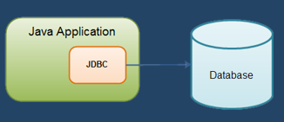

### ORM (Object relational mapping) Frameworks Overview

* In development, programmers use **object relational mapping** frameworks.
  + Mapping Java classes and data types to **DB tables** and **SQL data types**
  + Generate SQL calls and **relieves** the developer from the **manual** **handling**
    - E.g. (pseudo-code)



* ORM frameworks **do not** drop the need to write SQL!
  + At some point you might need some **manual query optimization**
* ORM Frameworks **examples**:
  + Java – **Hibernate**, EclipseLink, TopLink, OpenJP…
  + .NET – Entity Framework, NHibernate…
  + PHP – Doctrine, Laravel(Eloquent)...

### Java bin концепция/конвенция

Кое пропърти от класа на кое място в базата данни да отива

Клас към таблица

## 1.3. Client Access to a Database

### JDBC Architecture

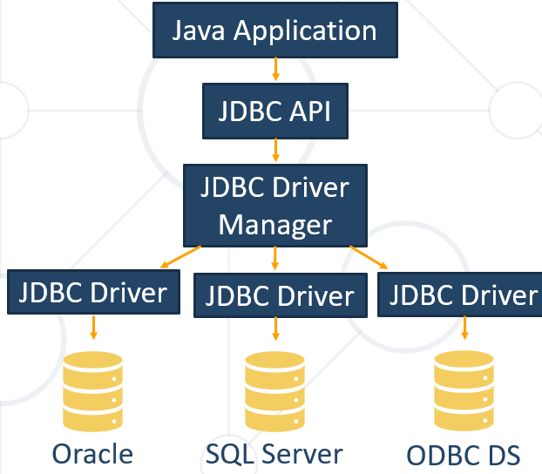

Write once, runs it anywhere – sun microsystems Java

* **JDBC API** – provides the connection between the application and the driver manager
* **JDBC Driver Manager** – establishes the connection with the correct driver
  + Supports multiple drivers connected to different types of databases
* **JDBC Driver** - **handles the communications with the database**

### JDBC drivers

**Four types of JDBC drivers:**

От 1 към 4 се намалява нивото на абстракция.

* Type 1: JDBC:**ODBC** bridge driver - използва се Object Database Connectivity API **protocol** (спецификация) - имплементирано от повечето големи бази данни като MySQL, PostgreSQL, Oracle.

ODBC спецификацията е независима от конкретния програмен език - било то Java, Python, etc.

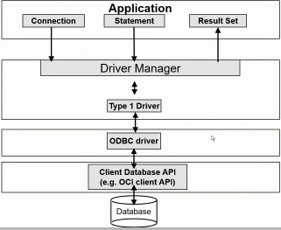

* Type 2: **Native API driver** (native client library provided for database) - конкретна клиентска библиотека специфична за дадената база данни. Самата база данни си има специфична библиотека, и JDBC работи с тази специфична библиотека.

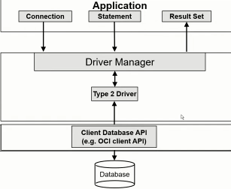

* Type 3: **Network protocol driver** (driver talks to middleware) - на мрежово ниво, самия JDBC driver комуникира с това междинно ниво, а не директно с базата данни

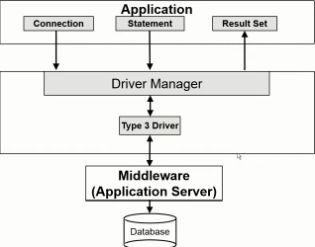

* Type 4: **Database protocol driver** - имплементация на/от JDBC, която работи директно с протокол на базата данни

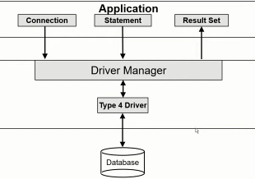

### JDBC API

* JDBC API provides several interfaces and classes:
  + **DriverManager** – matches requests from the application with the proper DB driver
  + **JDBC Driver** – handles the communication with the DB server
  + **Connection** – all methods for contacting a database
  + **Statement and PreparedStatement** – methods and properties that enable you to send SQL
  + **ResultSet** – retrieved data (set of table rows)
  + **SQLException**

Driver Manager - loads database drivers, and manages the connection between application & driver

JDBC Driver - translates API calls to operations for a specific data source (database abstraction)

Connection - a session between an application and the relational database

Statement - a representation of an SQL statement

**Metadata** - information about the returned data, driver and database

Result Set - logical set of columns and rows returned by executing a statement

### Java.sql* and MySQL Driver

* The java.sql package provides all previously mentioned JDBC classes
* In order to work with JDBC we need to download a MySQL Driver – Connector/J
  + It can be found on the following webpage:

[**https://dev.mysql.com/downloads/connector/j/**](https://dev.mysql.com/downloads/connector/j/)

### Setting Up the Driver in IntelliJ IDEA

* Add the driver as an external library:
  + "File" -> "Project Structure" -> "Libraries"

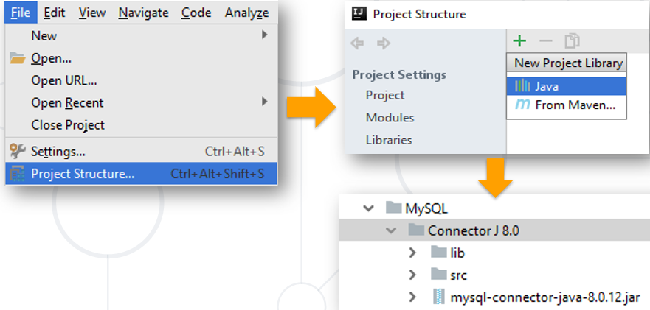

## 1.4. JDBC API - Querying the Database

### Stage 1: loading the JDBC driver

Loading the JDBC driver is done by a single line of code:

Class.forName("<jdbc driver class>");

Your driver documentation will give you the class name to use. Loading MySQL and Oracle driver (we can google it to see the right version):

Class.forName("com.mysql.jdbc.Driver");

Class.forName("oracle.jdbc.driver.OracleDriver");

Optional!!!!

### Stage 2: establishing a connection

#### Main info

* Connection with the database is established via **connection** **string**
  + jdbc:<driver protocol>:<connection details>
  + E.g. connection from previous demo:

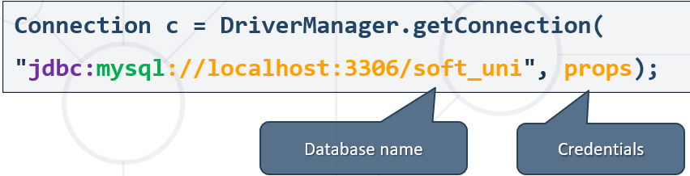

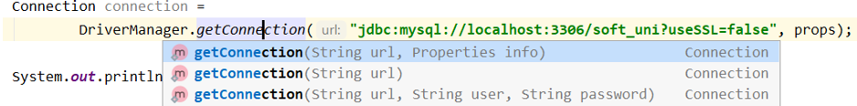

JDBC **connection string** components

Jdbc : <driver protocol> : <connection details>

The following line of code illustrates the process:

Connection connection = DriverManager.getConnection("url", “user”, “pass”);

If you are using a JDBC-ODBC bridge driver, the JDBC URL will start with jdbc:odbc:

* ODBC data source is called “Library”
* DBMS login name is “admin”
* The password is “secret”

Connection connection = DriverManager

       .getConnection("jdbc:odbc:Library",

               "admin",

               "secret");

If you are using a JDBC driver developed by a third party, the documentation will tell you what sub-protocol to use.

You can also use this website for help - <https://www.connectionstrings.com/>

If you want to connect to MySQL

* The db server is MySQL 5.6, 5.7 or 8.0, locally installed
* MySQL database schema is called “soft_uni”
* The user and password is “hr”

Connection connection = DriverManager

       .getConnection("jdbc:mysql://localhost:3306/soft_uni?” + “user=hr&password=hr");

If you want to connect to Oracle database

* The db server is 10g Express Edition, locally installed
* Oracle database schema is called “HR”
* The user and password is “hr”

Connection connection = DriverManager

       .getConnection("jdbc:oracle:thin:@localhost:1521/HR?”, “hr”, “hr");

A JDBC connection string is **used to load the driver and to indicate the settings that are required to establish a connection to the data source**. These settings are referred to as connection properties.

What is a JDBC connection string?

1. **A string containing database connection settings**
2. A string containing database host and port
3. A string containing database type, host and port
4. A connection string having all database connection settings

#### IntelliJ IDE

##### Connection to DB Via Java App Demo – part 1

Import-ваме базата данни чрез Plug-in -a Database отдясно отстрани

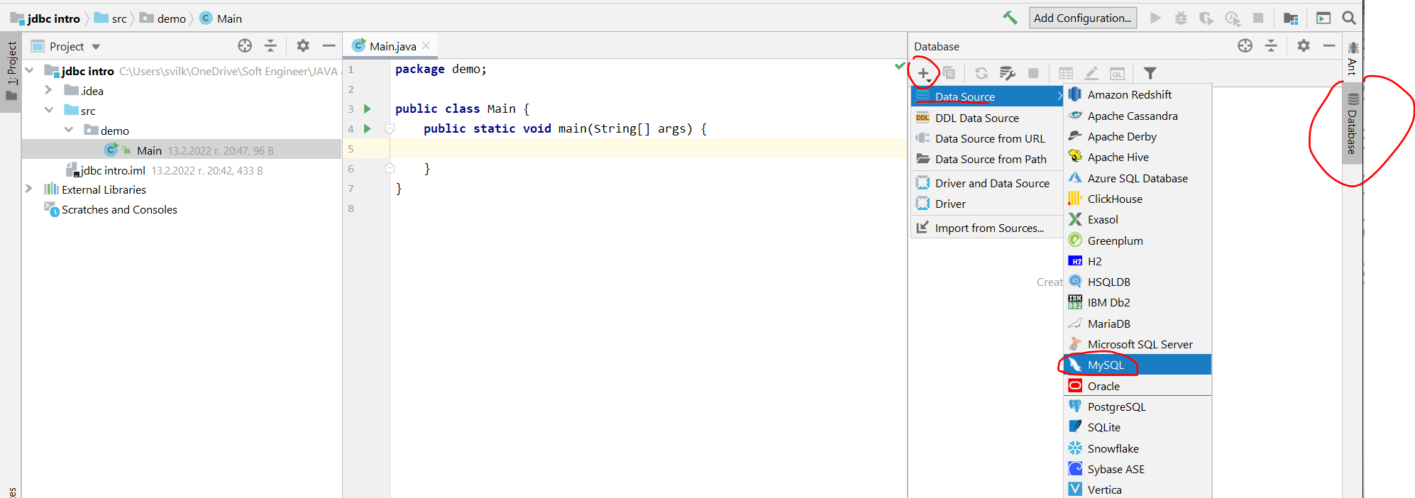

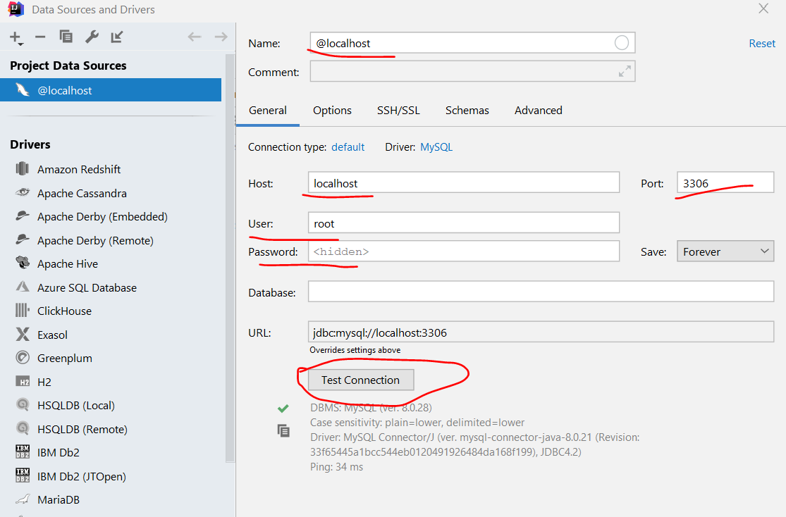

**Избираме диалекта – MySQL / Maria DB match best**

**Изпълнение на sql скрипт/заявка в IntelliJ**

**Ctrl + A – select all text**

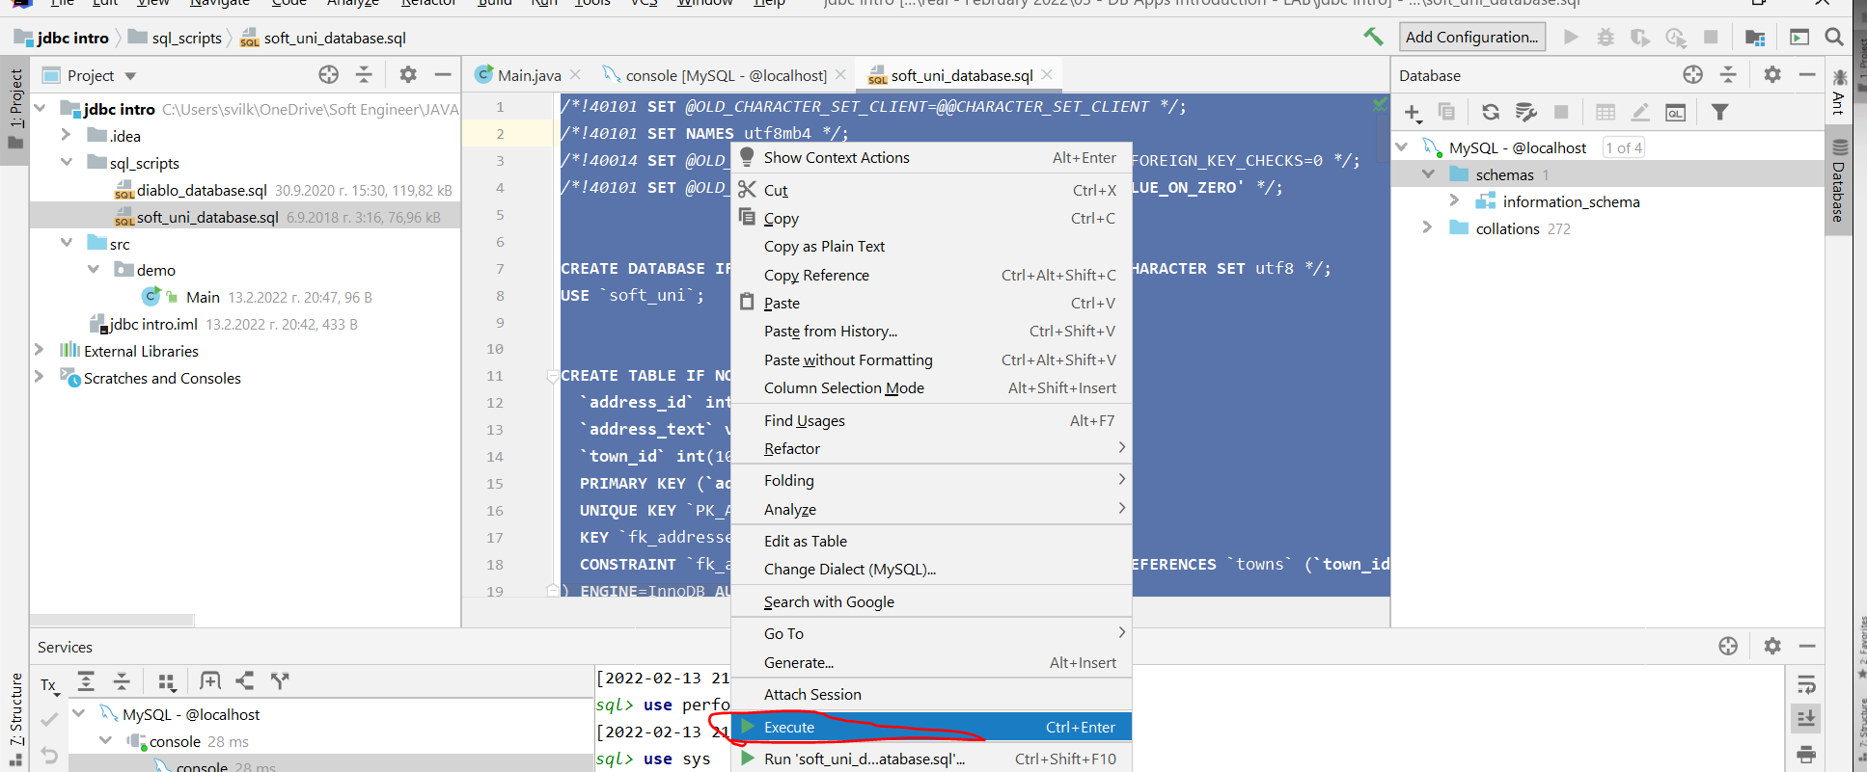

**MySQL -> console**

##### Connection to DB Via Java App Demo – part 2

**Първо обясненията, след това целият код написан на Java**

* You are given a simple application that:
  + Establishes connection with the "soft_uni" DB
  + Executes simple MySQL statement to retrieve the employees names by given salary criteria
* Let's analyze the program:

Connection to DB is established by asking the user to give credentials:

* Using an external library (**MySQL Connector/J**) we make a connection via a **DriverManager** and a **Connection** class.

Новият и старият driver:

– за MySQL 8 e "com.mysql.cj.jdbc.Driver"

* за MySQL 5.0 и надолу е другия. То само си ги разпознава.

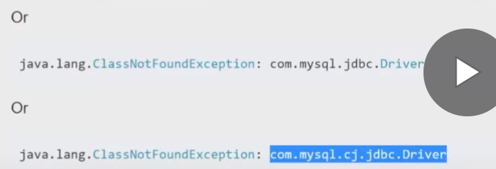

Plain Инсталиране/слагане на **JAVA driver-а** в IntelliJ за **MySQL Connector/J**

File -> Project structure …..

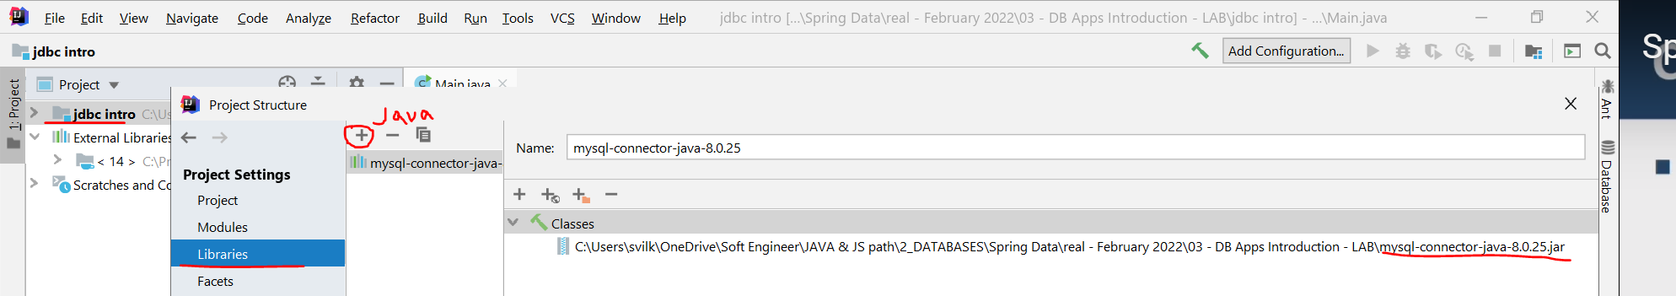

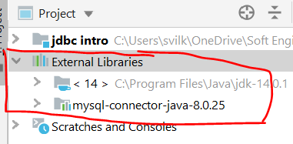

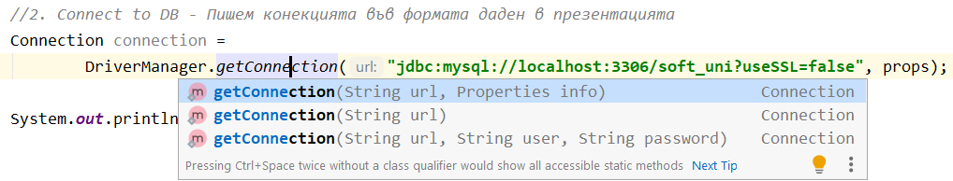

#### Properties object

You can pass database specific information to the database by using Properties object. Example for oracle database:

java.util.Properties **props** = new java.util.Properties();

props.put("user", "Scott");

props.put("password", "tiger123");

props.put("defaultRowPrefetch", "30");

props.put("defaultBatchValue", "5");

Connection dbConn = DriverManager.*getConnection*("jdbc:oracle:thin:@hoststring", **props**);

### Stage 3: creating a statement

A statement object sends the SQL commands to the DBMS.

* executeQuery() is used for SELECT statements
* executeUpdate() is used for statements that create/modify tables

An instance of active Connection is used to create a Statement object

Connection conn = DriverManager

       .getConnection("jdbc:odbc:Library", "admin", "secret");

Statement stmt = **conn.createStatement()**; //изпраща заявката към базата данни

### Stage 4: executing a statement

**executeQuery**() executes SQL command through a previously created statement

Returns the results in a ResultSet object

Connection conn = DriverManager

       .getConnection("jdbc:odbc:Library", "admin", "secret");

Statement stmt = **conn.createStatement()**; //изпраща заявката към базата данни

//never returns null

ResultSet rs = stmt.**executeQuery**("SELECT first_name FROM employees");

//either (1) the row count for SQL Data Manipulation Language (DML) statements or (2) 0 //for SQL statements that return nothing

**executeUpdate**() is used to submit DML/DDL SQL statements

* DML is used to manipulate existing data in objects (using UPDATE, INSERT, DELETE statements)
* DDL is used to manipulate database objects (CREATE, ALTER, DROP)

Connection conn = DriverManager

       .getConnection("jdbc:odbc:Library", "admin", "secret");

Statement stmt = **conn.createStatement()**; //изпраща заявката към базата данни

При  executeUpdate връща дали е успешно или не (0 или 1)

int rowsAffected = stmt.**executeUpdate**("UPDATE employees SET salary = salary * 1.2");

### Stage 5: processing the result

**The ResultSet object**

* ResultSet maintains a **cursor** pointing to its **current row of data**
  + Not updatable
  + Iterable only once and only from the first row to the last row
* Provides getter methods for retrieving column values from the current row

*//Iterating over the result – one way forward and only – не натоварва така паметта:* **while** (rs.next()) {  
 System.***out***.printf(**"| %-15.15s | %-15.15s | %10.2f\n"**,  
 rs.getString(**"first_name"**), *//column label – може и по позиция на колона* rs.getString(**"last_name"**), *//column label* rs.getDouble(**"salary"**)); *//get by column label* }

* Retrieved information is reached by getter methods:
  + E.g.:
    - getString("column_name")
    - getDouble("column_name")
    - getBoolean("column_name") etc.
* The driver converts the underlying data to the Java type

ResultSet resultSet = stmt.executeQuery("SELECT last_name, salary FROM employees");

while (resultSet.next()){  *//Returns: true if the new current row is valid; false if there are no more rows.* ***Moves the cursor to the first row of the result***

String lastName = resultSet.getString("last_name"); *//column label*

double salary = resultSet.getDouble("salary");

   System.*out*.println(lastName+ " " + salary);

}

* We retrieve the result with the **ResultSet** and the **PreparedStatement** classes.

Всяка въпросителна е пореден параметър.

**За база данни, номер на позицията винаги започва от 1, а не от 0.**

In the following example of setting a parameter, connection represents an active connection:

public interface PreparedStatement extends Statement;

PreparedStatement pstmt = connection.prepareStatement(**"UPDATE EMPLOYEES SET** SALARY = ? **WHERE** ID = ?**"**);  
pstmt.setBigDecimal(1, 153833.00);  
pstmt.setInt(2, 110592);

### Stage 6: closing the connection

**Explicitly close** a Connection, Statement and ResultSet to release resources that are no longer needed.

Ако не затворим връзката, може да имаме memory leak.

try {

   Connection conn = ...;

   Statement stmt = ...;

   ResultSet resultSet = ...;

} finally {

*// clean up*

resultSet.close();

   stmt.close();

   conn.close();

}

### SQLException

SQL statements can throw java.sql.SQLEception during their execution.

try {

   Connection conn = ...;

   Statement stmt = ...;

   ResultSet resultSet = ...;

} catch (SQLException sqlex) {

   ... *//Handle SQL errors here*

} finally {

*// clean up all used resources*

try {

       if (resultSet != null) resultSet.close();

       if (stmt != null) stmt.close();

       if (conn != null) conn.close();

   } catch (SQLException sqlex){

       ... *// Ignore closing errors*

}

}

## 1.5. JDBC API - Modifying the Database

### To execute a DML statement

#### Delete заявка

Statement stmt = **conn.createStatement()**; //изпраща заявката към базата данни

// either (1) the row count for SQL Data Manipulation Language (DML) statements or (2) 0 for SQL statements that return nothing

int rowsDeleted = stmt.**executeUpdate**("DELETE FROM order_items WHERE order_id = 2354");

#### Insert заявка

**private static int** getOrInsertTown(Connection connection, String minionTown) **throws** SQLException {  
 PreparedStatement **selectTownStatement** = connection.prepareStatement(  
 **"SELECT id FROM towns WHERE name=?"**);  
 selectTownStatement.setString(1, minionTown);  
  
 ResultSet townSet = selectTownStatement.executeQuery();  
  
 **int** townId = 0;  
 *//Ако няма такъв град* **if** (!townSet.next()) {  
 PreparedStatement **insertTownStatement** = connection.prepareStatement(**""** +  
 **"INSERT INTO towns(name) VALUES(?)"**);  
 insertTownStatement.setString(1, minionTown);  
 insertTownStatement.**executeUpdate();** ***//в случая с тази заявка Добавяме град Insert***ResultSet newTownSet = **selectTownStatement**.**executeQuery(); // Select**  
 newTownSet.next(); ***//премести показателя на последния добавен град***townId = newTownSet.getInt(**"id"**);  
 System.***out***.println(String.*format*(**"Town %s was added to the database."**, minionTown));  
 } **else** {  
 townId = townSet.getInt(**"id"**);  
 }  
  
 **return** townId;  
}

#### Update заявка

PreparedStatement **updateTownNames** = connection.prepareStatement(**"UPDATE towns\n"** +  
 **"SET name =** *UPPER***(name)\n"** +  
 **"WHERE country = ?;"**);  
updateTownNames.setString(1, countryName);  
  
**int** updatedCount = updateTownNames.**executeUpdate();** *//връща броя на update-ваните записи или 0 ако не се Update-ва нищо*System.***out***.println(updatedCount);  
  
**if** (updatedCount == 0) {  
 System.***out***.println(**"No town names were affected."**);  
 **return**;  
}  
  
System.***out***.println(updatedCount + **" town names were affected."**);

### To execute a DDL statement

Statement stmt = **conn.createStatement()**; //изпраща заявката към базата данни

int rowsDeleted = stmt.**executeUpdate**("CREATE TABLE temp(

col1 NUMBER(5,2), col2 VARCHAR(30))");

### To execute an unknown statement

Statement stmt = **conn.createStatement()**; //изпраща заявката към базата данни

// **true if the first result is a ResultSet object; false if it is an update count or there are no results**

boolean result = stmt.execute(SQLstatement);

if (result) { *// was a query - process results*

*// Returns: the current result as a ResultSet object or null if the result is an update count or there are no more results*

ResultSet resultSet = stmt.getResultSet();

} else { *// was an update or DDL - process result*

*// Returns: the current result as an update count; -1 if the current result is a ResultSet object or there are no more results*

int count = stmt.getUpdateCount();

}

Само stmt.execute() изпълняваме и при stored procedures

### Prepared statement

Used to:

* Execute a statement that takes parameters
* Execute a given statement many times

Така наречената шаблонна заявка. Т.е. създаваме типизирани заявки.

**Example 1:**

Connection conn = DriverManager.*getConnection*("jdbc:odbc:Library", "admin", "secret");

String insertSQL = "INSERT INTO employees (first_name, last_name, salary) VALUES(?,?,?)";

PreparedStatement prepStatement = conn.prepareStatement(insertSQL);

prepStatement.setString(1, "Martin"); *//parameter index 1*

prepStatement.setString(2, "Toshev"); *//parameter index 2*

prepStatement.setDouble(3, 1000.0); *//parameter index 3*

prepStatement.**executeUpdate()**; при модификация insert

**Предпазваме се от SQL injection чрез използването на PreparedStatement!**

**Example 2:**

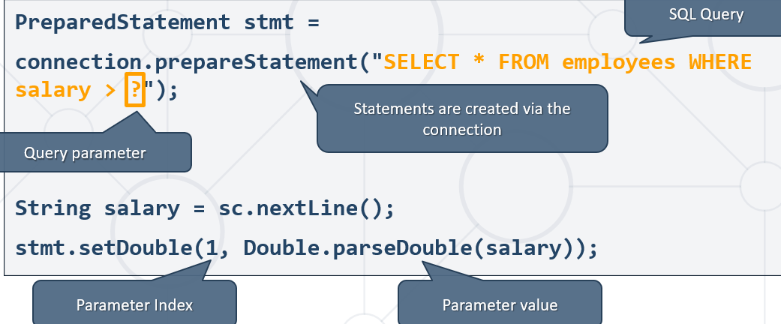

***//3.PreparedStatement – класът, който отговаря НО САМО за една SQL заявка***PreparedStatement stmt = connection.prepareStatement(  
 **"SELECT v.name,** *COUNT***(DISTINCT mv.minion_id) AS `count_of_minions`\n"** +  
 **"FROM minions_db.villains AS v\n"** +  
 **"LEFT JOIN minions_db.minions_villains AS mv\n"** +  
 **"ON v.id = mv.villain_id\n"** +  
 **"GROUP BY mv.villain_id\n"** +  
 **"HAVING `count_of_minions` >15\n"** +  
 **"ORDER BY `count_of_minions` DESC;"**);  
  
ResultSet rs = stmt.**executeQuery()**; //при SELECT sql заявка  
  
**while** (rs.next()) {  
 System.***out***.printf(**"%-15.15s %d\n"**,  
 rs.getString(**"name"**),  
 rs.getInt(**"count_of_minions"**)); //по приятен начин за get-ване като сме използвали в заявката AS **`count_of_minions`**

### Auto increment primary key column

Many databases support “auto increment” primary key columns.

* E.g. MS SQL Server, MS Access. MySQL, PostgreSQL
* JDBC can retrieve auto generated keys

Connection conn = DriverManager.*getConnection*("jdbc:odbc:Library", "admin", "secret");

Statement stmt = conn.createStatement();

*// Insert row and return PK*

int rowsCount = stmt.executeUpdate("INSERT INTO Messages(Msg) VALUES('Test')",

       Statement.*RETURN_GENERATED_KEYS*); *//The constant indicating that generated keys should be made available for retrieval.*

*// Get the auto generated PK*

ResultSet rs = stmt.getGeneratedKeys();

rs.next(); *//Moves the cursor forward one row from its current position. A ResultSet cursor is initially positioned before the first row; the first call to the method next makes the first row the current row;*

long primaryKeyFromColumnIndex = rs.getLong(1);

long primaryKeyFromColumnLabel = rs.getLong("Msg");

**Oracle does not support “auto increment” primary key**. Use sequences to generate unique values.

Statement stmtSeq = dbConnection.createStatement();

ResultSet resultSetNextId = stmtSeq.executeQuery("SELECT **<some_sequence>**.nextval FROM dual");

resultSetNextId.next();

long nextId = resultSetNextId.getLong(1); *//column index*

PreparedStatement psInsert = dbConnection.prepareStatement("INSERT INTO Table(id, name) VALUES (?,?)");

psInsert.setLong(1, nextId);

psInsert.setString(2, "Svilen");

psInsert.execute();

### Calling stored procedures

CallableStatement interface

* Is used for executing stored procedures
* Can pass input parameters
* Can retrieve output parameters

Demo 1

Connection dbConn = DriverManager.*getConnection*("jdbc:odbc:Library", "admin", "secret");

CallableStatement callableStmt = dbConn.**prepareCall**("call SP_Insert_Msg(?,?)");

callableStmt.setString(1, msgText);

callableStmt.**registerOutParameter**(2, Types.*BIGINT*); //ако базата данни го поддържа

callableStmt.**executeUpdate(); за модификация insert**

long id = callableStmt.getLong(2);

Demo 2

**import** java.sql.*;  
**import** java.util.Scanner;  
  
**public class** _09_IncreaseAgeStoredProcedure {  
 **public static void** main(String[] args) **throws** SQLException {  
 Connection connection =  
 DriverManager.*getConnection*(**"jdbc:mysql://root:@localhost:3306/minions_db?useSSL=false"**);  
  
 Scanner sc = **new** Scanner(System.***in***);  
 **int** idMinionToUpdate = Integer.*parseInt*(sc.nextLine());  
  
 ***//Създаване на процедура***String createProcedure =  
 **"CREATE PROCEDURE usp_get_older(minion_id INT) \n"** +  
 **"BEGIN\n"** +  
 **"\tUPDATE minions\n"** +  
 **"\tSET age=age+1 \n"** +  
 **"\tWHERE id=minion_id;\n"** +  
 **"END"**;  
 Statement stmt = connection**.createStatement();**  
 stmt.**executeUpdate(createProcedure);**  
  
 ***//prepare and execute CallableStatement*****CallableStatement** callableStatement = **connection.prepareCall**(**"{CALL** *usp_get_older***(?)}"**);  
 **callableStatement**.setInt(1, idMinionToUpdate);  
 **callableStatement.executeQuery(); или callableStatement.execute(); за get sql заявка!!**  
  
 *//output the result* PreparedStatement selectOutputUpdatedMinion = connection.prepareStatement(  
 **"SELECT name, age FROM minions WHERE id=?"**);  
 selectOutputUpdatedMinion.setInt(1, idMinionToUpdate);  
 ResultSet resultSet = selectOutputUpdatedMinion.executeQuery();  
 resultSet.next();  
 System.***out***.println(resultSet.getString(**"name"**) + **" "** + resultSet.getString(**"age"**));

*//dropping the procedure*String queryDrop = **"DROP PROCEDURE IF EXISTS usp_get_older"**;  
Statement stmtDrop = connection**.createStatement();**  
System.***out***.println(**"Calling DROP PROCEDURE"**);  
stmtDrop.**execute(queryDrop);**

}  
}

## 1.6. Statement, PreparedStatement, CallableStatement

The JDBC **Statement interface** defines the methods and properties that enable you to send SQL commands to the database.

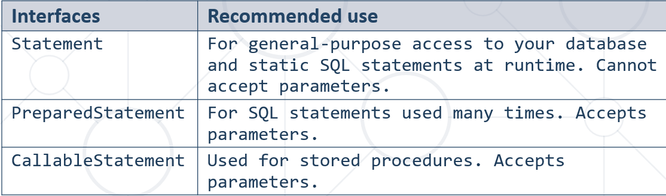

## 1.7. Executing queries in JDBC

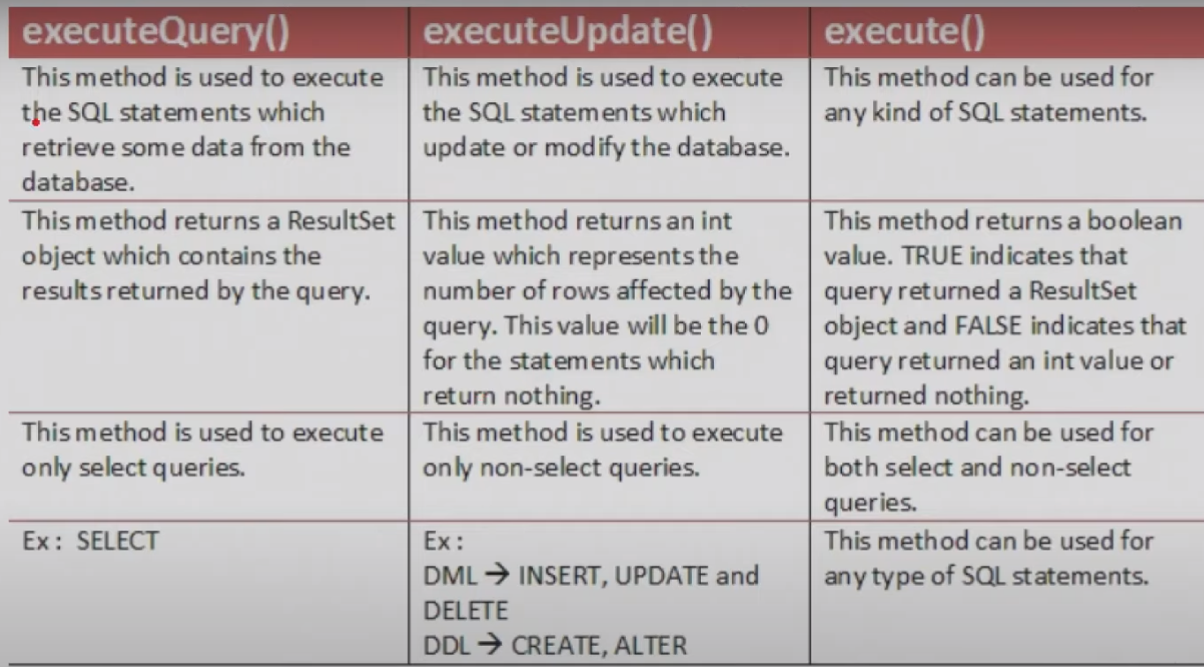

## 1.8. DEMOS

### The whole Demo itself

**package** demo;  
  
**import** java.sql.*;  
  
**import** java.util.Properties;  
**import** java.util.Scanner;  
  
**public class** Main {  
 **public static void** main(String[] args) **throws** SQLException {  
 Scanner sc = **new** Scanner(System.***in***);  
 System.***out***.print(**"Enter username default (root): "**);  
 String user = sc.nextLine().trim();  
 user = user.equals(**""**) ? **"root"** : user;  
 System.***out***.print(**"Enter password default (empty):"**);  
 String password = sc.nextLine().trim();  
  
 Properties props = **new** Properties();  
 props.setProperty(**"user"**, user);  
 props.setProperty(**"password"**, password);  
  
 *//****1. Load jdbc driver - optional*****try** {  
 Class<?> aClass = Class.*forName*(**"com.mysql.cj.jdbc.Driver"**);

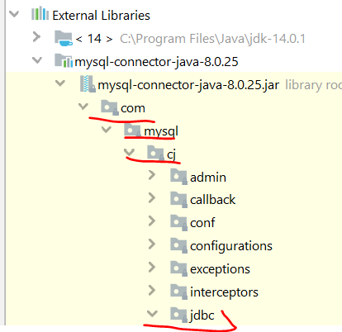  
 } **catch** (ClassNotFoundException e) {  
 e.printStackTrace();  
 System.*exit*(0);  
 }  
 System.***out***.println(**"Driver loaded successfully"**);  
  
  
 *//****2. Connect to DB - Пишем конекцията във формата даден в презентацията***Connection connection =  
 DriverManager.*getConnection*(**"jdbc:mysql://localhost:3306/soft_uni?useSSL=false"**, props);

*//Вариант без props - username root, след това двоеточие, след това парола, след това @*Connection connection =  
 DriverManager.*getConnection*(**"jdbc:mysql://root:@localhost:3306/soft_uni?useSSL=false"**);

System.***out***.println(**"Connected successfully"**);  
  
  
 ***//3.PreparedStatement – класът, който отговаря НО САМО за една SQL заявка***PreparedStatement stmt = connection.prepareStatement(**"SELECT** *\** **FROM employees WHERE salary > ?"**); *//SQL Query* System.***out***.print(**"Enter minimal salary (default 20 000): "**);  
 String salaryStr = sc.nextLine().trim();  
 **double** salary = salaryStr.equals(**""**) ? 20000 : Double.*parseDouble*(salaryStr);  
 stmt.setDouble(1, salary); **//сетваме на първата въпросителна дадена стойност**  
 ResultSet rs = stmt.**executeQuery()**;***//Runs the SQL statement and returns retrieved result***

rs.**getMetaData()**; //взема неща за самата таблица, като имена на колони (но ние можем да си ги видим и от plugin-a на IntelliJ Database, както и от друг клиент на базата данни). И все пак:



***//Iterating over the result*** *– one way forward only and not updatable – не натоварва така паметта:*

**if***(*rs.next()*)* **while** (rs.next()) {  
 System.***out***.printf(**"| %-15.15s | %-15.15s | %10.2f\n"**,  
 rs.getString(**"first_name"**), *//column label – може и по позиция на колона* rs.getString(**"last_name"**), *//column label* rs.getDouble(**"salary"**)); *//get by column label* }  
  
 connection.close();  
 }  
}

Изходът от конзолата

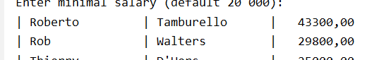

### The whole DEMO with try with resources (try-with-resources)

**package** demo;  
  
**import** java.sql.*;  
**import** java.util.Properties;  
**import** java.util.Scanner;  
  
**public class** Main1 {  
 **public static void** main(String[] args) **throws** SQLException {  
 Scanner sc = **new** Scanner(System.***in***);  
 System.***out***.print(**"Enter username default (root): "**);  
 String user = sc.nextLine().trim();  
 user = user.equals(**""**) ? **"root"** : user;  
 System.***out***.print(**"Enter password default (empty):"**);  
 String password = sc.nextLine().trim();  
  
 Properties props = **new** Properties();  
 props.setProperty(**"user"**, user);  
 props.setProperty(**"password"**, password);  
  
 *//1. Load jdbc driver - optional* **try** {  
 Class<?> aClass = Class.*forName*(**"com.mysql.cj.jdbc.Driver"**);  
 } **catch** (ClassNotFoundException e) {  
 e.printStackTrace();  
 System.*exit*(0);  
 }  
 System.***out***.println(**"Driver loaded successfully"**);  
  
 *//Using try with resources  
 //2. Connect to DB and 3. PreparedStatement in try with resources  
 //Interface-а Connection e AutoCloseable* **try** (Connection connection = DriverManager  
 .*getConnection*(**"jdbc:mysql://localhost:3306/soft_uni?useSSL=false"**, props);  
 PreparedStatement stmt =  
 connection.prepareStatement(**"SELECT** *\** **FROM employees WHERE salary > ?"**)) {  
 System.***out***.println(**"Connected successfully"**);  
  
 System.***out***.print(**"Enter minimal salary (default 20 000): "**);  
 String salaryStr = sc.nextLine().trim();  
 **double** salary = salaryStr.equals(**""**) ? 20000 : Double.*parseDouble*(salaryStr);  
 stmt.setDouble(1, salary);  
 ResultSet rs = stmt.executeQuery();*//Runs the SQL statement and returns retrieved result* **while** (rs.next()) {  
 System.***out***.printf(**"| %-15.15s | %-15.15s | %10.2f\n"**,  
 rs.getString(**"first_name"**), *//column label* rs.getString(**"last_name"**), *//column label* rs.getDouble(**"salary"**)); *//get by column label* }  
 }  
 }  
}

### The whole DEMO with external file

**import** java.io.FileInputStream;  
**import** java.io.IOException;  
**import** java.sql.*;  
**import** java.util.Properties;  
  
**public class** Main2 {  
 **public static void** main(String[] args) **throws** SQLException, IOException {  
 Properties props = **new** Properties();

//търси го в out/production когато програмата е заредила/компилирала  
 String appConfigPath = Main2.**class**.getClassLoader()  
 .getResource(**"db.properties"**).getPath();

String appConfigPath = **"C:\\Users\\svilk\\OneDrive\\Soft Engineer\\JAVA & JS path\\2_DATABASES\\Spring Data\\real - February 2022\\03 - DB Apps Introduction - LAB\\jdbc intro\\src\\db.properties"**;

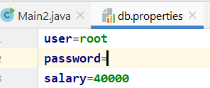  
  
 props.load(**new** FileInputStream(appConfigPath));  
*// props.loadFromXML(new FileInputStream(appConfigPath));  
  
 //1. Load jdbc driver - optional* **try** {  
 Class<?> aClass = Class.*forName*(**"com.mysql.cj.jdbc.Driver"**);  
 } **catch** (ClassNotFoundException e) {  
 e.printStackTrace();  
 System.*exit*(0);  
 }  
 System.***out***.println(**"Driver loaded successfully"**);  
  
 *//Using try with resources  
 //2. Connect to DB and 3. PreparedStatement in try with resources  
 //Interface-а Connection e AutoCloseable* **try** (Connection connection = DriverManager  
 .*getConnection*(**"jdbc:mysql://localhost:3306/soft_uni?useSSL=false"**, props);  
 PreparedStatement stmt =  
 connection.prepareStatement(**"SELECT** *\** **FROM employees WHERE salary > ?"**)) {  
 System.***out***.println(**"Connected successfully"**);  
  
 System.***out***.print(**"Enter minimal salary (default 20 000): "**);  
 String salaryStr = props.getProperty(**"salary"**, **"20000"**);  
 **double** salary = Double.*parseDouble*(salaryStr);  
 stmt.setDouble(1, salary);  
 ResultSet rs = stmt.executeQuery();*//Runs the SQL statement and returns retrieved result* **while** (rs.next()) {  
 System.***out***.printf(**"| %-15.15s | %-15.15s | %10.2f\n"**,  
 rs.getString(**"first_name"**), *//column label* rs.getString(**"last_name"**), *//column label* rs.getDouble(**"salary"**)); *//get by column label* }  
 }  
 }  
}

### Demo Conclusion

* We can access databases on a programmer level.
  + No manual actions needed
* In a bigger applications we can:
  + Encapsulate custom SQL logic in methods
  + Achieve database abstraction

SSL – Security Socket Layer – двойка mapping key

TLS - Transport Layer Security

## 1.9. SQL Injection

### What is SQL Injection?

* Placement of **malicious** code in SQL Statements
  + Usually done via user input
* To protect our data, we can place parameters in our statements
  + We can do it by using **PreparedStatement**

### Example

Kогато външен потребител зададе грешна заявка и нещата в базата могат да се объркат ако не ползваме PreparedStatement. При целенасочена атака, обикновено се връща GET заявка с чувствителна информация за даден потребител.

PreparedStatement един вид санитизира да не може да се подаде някаква различна или вложена заявка от рода на “WHERE 1 = 1” и така да се върнат всички записи например.

* Do not build a query using the “+” operator
* Prefer named parameters

String insertSQL = "INSERT INTO employees (first_name, last_name) VALUES(@fn,@ln)";

PreparedStatement prepStatement = conn.prepareStatement(insertSQL);

prepStatement.setString("@fn", "Martin"); *//named parameter fn*

prepStatement.setString(“@ln”, "Toshev"); *//named parameter ln*

prepStatement.executeUpdate();

### Example: Login Form Input by User

* Ask the user to input username and password in fields
  + If we don't secure our statements, we risk SQL Queries to be written as an input
  + E.g. :
    - username: "example_user "
    - password: "12345"
    - The following query will be built and executed to the data source:

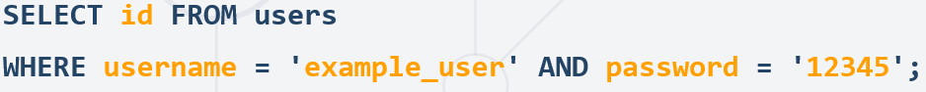

----------------

* In result the **id of the user** will be returned.
  + User will be authenticated to do actions in the application
* Without validating and securing our statements information might get exposed:
  + Value for password: ''1' OR username = 'admin';'
  + The following query will be executed:

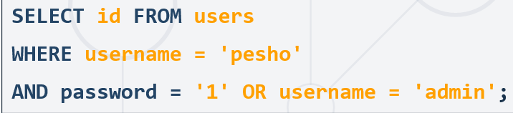

-------------

* In result the id **an admin** will be returned
  + Will permit actions to the user that can harm our application and database
* We can validate the input by setting rules
  + Length, special characters, digits etc.
  + Set up validation in our code in different layers (front-end, back-end etc.)

## 1.10. Retrieving database metadata

* Each RDBMS provides a way to retrieve database metadata (i.e. list of tables in the database or list of columns in table). In Oracle this is the database dictionary.
* JDBC provides a way to retrieve RDBMS metadata independent of the particular RDBMS implementation
* To retrieve metadata from the connection (e.g. user schemas, schema tables)

   Connection dbConn = DriverManager.*getConnection*(............);

   DatabaseMetaData metaData = dbConn.getMetaData();

   ResultSet hrmTables = metaData.**getTables**(null, "HRM", null, null);

* To retrieve metadata from the result set (e.g. table column names and types)

Connection dbConn = DriverManager.*getConnection*(.............);

DatabaseMetaData metaData = dbConn.**getMetaData()**;

ResultSet hrmTables = metaData.**getTables**(null, "HRM", null, null);

**ResultSetMetaData** resultMetadata = hrmTables.**getMetaData()**; //мета данни на метаданни!!!

int columnCount = resultMetadata.getColumnCount();

ResultSet procedures = metaData.**getProcedures**(........);

ResultSetMetaData class

Used to get information about the types and properties of the columns in a ResultSet object

Statement stmt = conn.createStatement();

ResultSet resultSet = stmt.executeQuery("SELECT * FROM employees");

ResultSetMetaData resultSetMetaData = resultSet.**getMetaData()**; //мета данни на реални данни

int columnCount = resultSetMetaData.**getColumnCount**();

for (int i = 0; i < columnCount; i++) {

   System.*out*.println(resultSetMetaData.**getColumnName**(i));

System.*out*.println(resultSetMetaData.**getColumnTypeName**(i));

}

## 1.11. Handling Transactions and DAO Pattern

### JDBC Transaction Pattern

* Every JDBC Connection is set to **auto-commit** by default
  + SQL statements are committed on completion
* In bigger applications we want greater control
  + If and when changes are applied to the database
* Turn off auto-commit:

connection.setAutoCommit(**false**);

* Example (**pseudo** **code**):

**try** {  
 connection.**setAutoCommit**(**false**);

Statement stmt = conn.createStatement();  
 String sql = **"…"**;  
 stmt.**executeUpdate**(sql);  
 *// If there is no error* connection.**commit();**  
} **catch**(SQLException se){  
 *// If there is any error* conn.**rollback();**  
}

A database transaction is a set of database operations that must be either entirely completed or aborted.

A simple transaction is usually in this form:

1. Begin the transaction
2. Execute several SQL **DML** statements
3. Commit the transaction

If one of the SQL statements fails, rollback the entire transaction.

JDBC transaction mode:

* Auto-commit by default
* Can be turned off by calling connection.setAutoCommit(**false**);

In auto-commit mode each statement is treated as a separate transaction.

If the auto-commit mode is off, no changes will be committed until the commit() is invoked.

Auto-commit mode can be turned back on by calling connection.setAutoCommit(true).

По подразбиране auto commit e true. Ако искаме да използваме трансакции, то се налага да сменим тази настройка!

### Delete заявка + Транзакция в Java

Първо трием мапинг таблицата, след това едната таблица с foreign key, след това и втората таблица с foreign key!!!

Connection connection =  
 DriverManager.*getConnection*(**"jdbc:mysql://root:@localhost:3306/minions_db?useSSL=false"**);

connection.**setAutoCommit**(**false**);  
  
**try** {  
 PreparedStatement deleteMinionsVillains = connection.prepareStatement(  
 **"DELETE FROM minions_villains WHERE villain_id=?"**);  
 deleteMinionsVillains.setInt(1, villainId);  
 **int** countReleasedMinions = deleteMinionsVillains.**executeUpdate();**  
  
 PreparedStatement deleteVillain = connection.prepareStatement(  
 **"DELETE FROM villains WHERE id=?"**);  
 deleteVillain.setInt(1, villainId);  
 deleteVillain.executeUpdate();  
  
 connection.**commit();**  
 System.***out***.println(villainName + **" was deleted"**);  
 System.***out***.println(countReleasedMinions + **" minions released"**);  
} **catch** (SQLException e){  
 connection.**rollback();**  
}

## 1.12. JDBC Advanced features

### Connection pool

Кънекциите към базата са скъпи обекти/ изискват ресурси. Затова можем да използваме connection pool.

Connection pool contains a number of open database connections.

There are a few choices when using connection pool:

1. Depends on application server - т.е. когато не използваме директно JDBC за връзка с базата данни, а връзката се менъджира от т.наречения application server, който използва pools
2. Use JDBC 2.0 interfaces (javax.sql.ConnectionPoolDataSource;

javax.sql.PooledConnection;)

1. Create your own connection pool

### Transaction isolation level

You can set the transaction isolation level by calling:

dbConn.setTransactionIsolation(level);

level – one of the following Connection constants:

Connection.TRANSACTION_READ_UNCOMMITTED,

Connection.TRANSACTION_READ_COMMITTED,

Connection.TRANSACTION_REPEATABLE_READ,

or Connection.TRANSACTION_SERIALIZABLE.

(Note that Connection.TRANSACTION_NONE cannot be used because it specifies that transactions are not supported.)

До каква степен трансакциите виждат промяната от текущата трансакция. Аналогия може да се каже - синхронизация на трансакциите.

TRANSACTION_SERIALIZABLE е с най-високо ниво на изолация - невлияещо се от нито една друга трансакция докато не приключи текущата трансакция. Но пък и е по-бавно това ниво.

Нивото зависи и от конкретната база данни, която използваме.

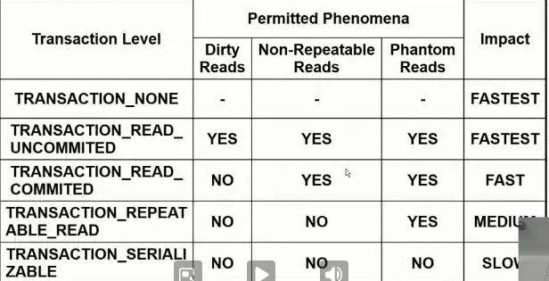

## 1.13. Query заявка и String.format

**String query** = String.*format*(**"UPDATE minions\n SET age=age+1, name=LOWER(SUBSTRING(name, 1))\n WHERE id IN %s;"**, minionsIDsUpdate);  
  
PreparedStatement updateSepcifiedMinions = connection.prepareStatement(**query**);  
updateSepcifiedMinions.executeUpdate();

## 1.14 JDBC best practices

### Close your connection

* Closing connections, statements and result sets explicitly allows garbage collector to recollect memory and resources as early as possible
* Close statement object as soon as you finish working with them
* Use **try-finally** statement to guarantee that resources will be freed even in case of exception
* Possible to be managed also via the connection pool

### Use proper statements

* Use *PreparedStatement* when you execute the same statement more than once
* Use *CallableStatement* when you want to result from multiple and complex statements for a single request

### Batch your queries

* Send multiple queries to reduce the number of JDBC calls and improve performance - изпращаме накуп няколко заявки

connection.setAutoCommit(**false**);

Statement stmt = conn.createStatement();

stmt.**addBatch**("sql_query1");

stmt.**addBatch**("sql_query2");

stmt.**addBatch**("sql_query3");

stmt.**executeBatch()**;

* **You can improve performance by increasing number of rows to be fetched at a time**

Statement stmt = conn.createStatement();

stmt.setFetchSize(30);

* **Get only necessary columns, not all columns of the entity.**

Statement stmt = **conn.createStatement()**;

BAD

ResultSet rs = stmt.**executeQuery**("SELECT * FROM employees WHERE ID=1");

GOOD

ResultSet rs = stmt.**executeQuery**("SELECT NAME, SALARY FROM employees WHERE ID=1");

## 1.15. Demo with batches

**public class** App {

**public static void** main(String[] args) {

       System.***out***.println(**"Hello World!"**);

       java.sql.Connection connection = **null**;

**try** {

           connection = java.sql.DriverManager.*getConnection*(**"jdbc:h2:file:./sample;DB_CLOSE_DELAY=-1;AUTO_SERVER=TRUE"**, **""**, **""**);

*//            connection = java.sql.DriverManager.getConnection("jdbc:h2:mem:sample");*

createLogsTable(connection, 10);

           System.***out***.println(*countLogs*(connection));

       } **catch** (Exception ex) {

*//            if (connection != null) {*

*//                jdbc.test.JDBCUtil.closeConnection(connection);*

*//            }*

System.***out***.println(**"I AM EXCEPTION: "** + ex.getMessage());

       }

   }

**public static void** createLogsTable(java.sql.Connection connection, **int** entriesCount) **throws** java.sql.SQLException {

       connection.setAutoCommit(**false**);

       java.sql.Statement stmt = connection.createStatement();

       stmt.executeUpdate(**"CREATE TABLE Logs(Id INT, Message VARCHAR(1000))"**);

**//batches and PreparedStatement**

       java.sql.PreparedStatement prepStatement = connection.prepareStatement(**"INSERT INTO Logs(Id, Message) VALUES(?,?)"**);

**for** (**int** i = 1; i <= entriesCount; i++) {

           prepStatement.setInt(1, i);

           prepStatement.setString(2, **""**);

           prepStatement.**addBatch()**;

       }

       prepStatement.**executeBatch()**;

       connection.commit();

   }

**public static void** createLogsTable(java.sql.Connection connection, **int** entriesCount) **throws** java.sql.SQLException {

       java.sql.Statement stmt = connection.createStatement();

       stmt.executeUpdate(**"CREATE TABLE Logs(Id INT, Message VARCHAR(1000))"**);

       String insertSQLString = **"INSERT INTO Logs(Id, Message) VALUES(?, ?)"**;

       java.sql.PreparedStatement prepStatement = connection.prepareStatement(insertSQLString);

**for** (**int** i = 1; i <= entriesCount; i++) {

           prepStatement.setInt(1, i);

           prepStatement.setString(2, **""**);

           prepStatement.**executeUpdate()**;

           prepStatement.**clearParameters()**;

       }

   }

**public static void** createLogsTable(java.sql.Connection connection, **int** entriesCount) **throws** java.sql.SQLException {

       connection.setAutoCommit(**false**);

java.sql.Statement stmt = connection.createStatement();

       stmt.addBatch(**"CREATE TABLE Logs(Id INTEGER, Message VARCHAR(1000))"**);

**//batches and Statement**

       String insertSQLString = **"INSERT INTO Logs(Id, Message) VALUES(%d, '')"**;

**for** (**int** i = 1; i <= entriesCount; i++) {

           stmt.**addBatch**(insertSQLString.formatted(i));

       }

       stmt.**executeBatch()**;

       connection.commit();

       connection.setAutoCommit(**true**);

   }

public static void createLogsTable(java.sql.Connection connection, int entriesCount) {

   try {

       java.sql.Statement stmt = connection.createStatement();

       stmt.executeUpdate("CREATE TABLE IF NOT EXISTS Logs(Id INTEGER, Message VARCHAR(1000))");

       stmt.executeUpdate("DELETE FROM Logs");

       String insertSQLString = "INSERT INTO Logs(Id, Message) VALUES(%d, '')";

       for (int i = 1; i <= entriesCount; i++) {

           stmt.executeUpdate(insertSQLString.formatted(i));

       }

   } catch (java.sql.SQLException e) {

   }

}

**public static int** countLogs(java.sql.Connection connection) **throws** java.sql.SQLException {

       java.sql.Statement stmt = connection.createStatement();

       java.sql.ResultSet rs = stmt.executeQuery(**"SELECT count(*) FROM Logs"**);

       rs.next();

**return** rs.getInt(1);

   }

}

# 2. ORM Fundamentals

## 2.1. ORM Introduction - Object-Relational Mapping

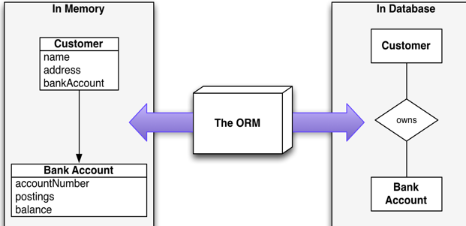

### What is ORM?

* **Technique** for **converting data** betweenincompatible type systems using **object-oriented programming** languages
* **Object-Relational Mapping** (ORM) allows manipulating databases **using common classes and objects**
  + **Java/C#/etc. classes** 🡺 **Database Tables**
  + **Database Tables** 🡺 **Java/C#/etc. classes**

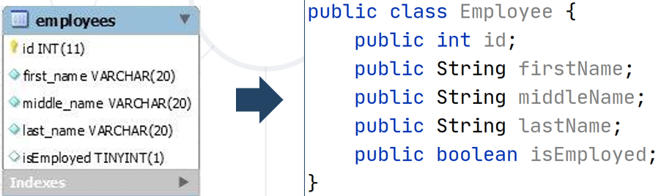

### Why do we need ORM?

* In OOP, data-management tasks act on **objects** that are almost always **non-scalar** values
* Many **database** can only store and manipulate **scalar** values, organized within **tables – scalar са обикновените данни, а non-scalar са релационни данни примерно**
* We must **manually** convert values into groups of simpler values to store in DB and convert them back when we retrieve data

### JDBC and ORM

* The main difference, between JDBC and ORM, is **complexity**
* **JDBC/SQL**
  + If the application is simple as to present data directly from the database
* **ORM**
  + If the application is domain driven and the relations among objects is complex

### Application Architecture

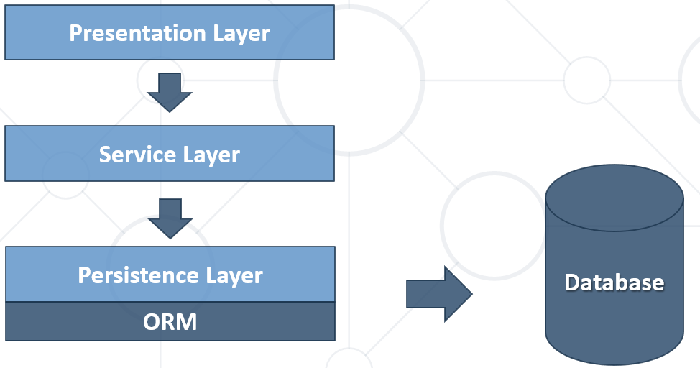

### ORM Frameworks: Features

* **ORM frameworks** typically **provide** the following functionality:
  + **Automatically generate SQL** to perform data operations as:
    - persist, update, delete, merge, createQuery and so on.
  + **Object model from database schema** (**DB First model**)
  + **Database schema from object model** (**Code First model**)

### Perform data operations with ORM

* + **Automatically generate SQL** to perform data operations

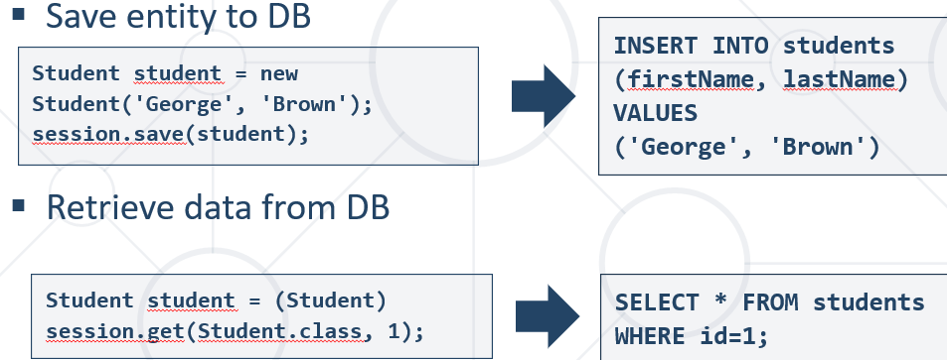

* + We can use and specific ORM Query Language as **HQL** or **SQL**

**Hybernate QueryLanguage = HQL**

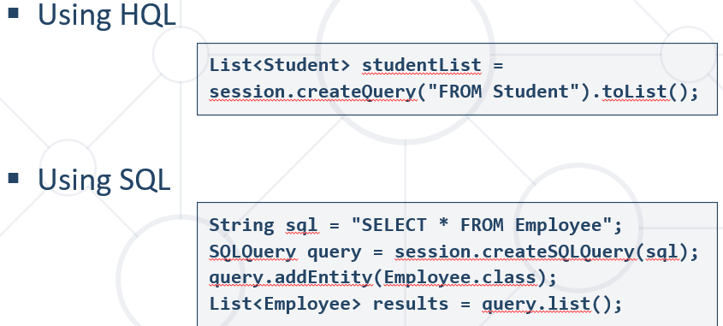

### Как става в mapping-a - POJO + XML

* A bit old-fashioned, but very powerful
* Implemented in the "classical" ORM

Преди време, xml са свързвали информацията на класа към базата данни.

**...**

**<description>Mapping file</description>**

**<entity class="Employee">**

**<table name="EMPLOYEETABLE"/>**

**<attributes>**

**<id name="id">**

**<generated-value strategy="TABLE"/>**

**</id>**

**<basic name="name">**

**<column name="EMP_NAME" length="100"/>**

**</basic>**

**<basic name="salary">**

**</basic>**

**</attributes>**

**</entity>**

**...**

### POJO Mapped to DB Tables – using Annotations/Decorators

* Based on Java annotations and XML
* Easier to implement and maintain

@Entity  
@Table(name = **"employees"**)  
**public class** Employee {  
 @Id  
 **private int id**;  
 @Column(name = **"name"**)  
 **private** String **name**;  
 @Column(name = **"position"**)  
 **private** String **position**;  
}

### Code First Model

* **Models** the database after the entity classes – класове в java, които да бъдат съхранявани след това в база данни. Логиката да е същата.

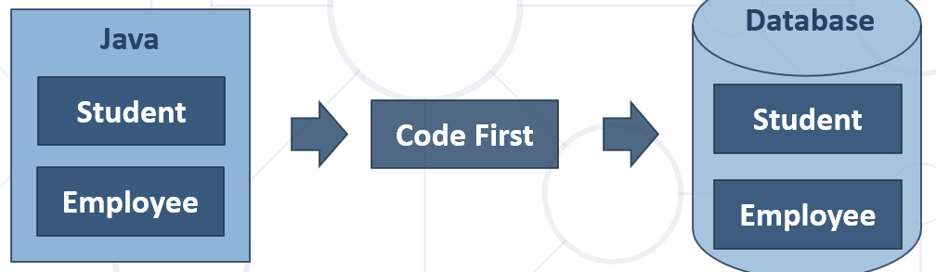

## 2.2. ORM Advantages and Disadvantages

### ORM Advantages

* **Productivity**
  + Eliminates repetitive code
  + Generates database automatically
* **Maintainability**
  + Fewer lines of code
  + Easier to manage object model changes
* **Performance**
  + Lazy loading – докате не извикаме next(), не дърпаме информация от базата/сървъра
  + Caching
* **Database vendor independence – спирам да пиша SQL код без значение на SQL езика!!!**
  + The database is abstracted
  + Can be configured outside the application

### ORM Disadvantages

* **Reduced performance** 
  + Due to overhead or auto generated SQL
* **Reduces flexibility** 
  + Some operations are hard to implement
* **Lose understanding** 
  + What the code is actually doing - the developer is more in control using SQL

## 2.3. custom-orm with Maven(мениджър на нашите библиотеки)

**Имената на елементите на анотациите са имената на променливите в базата данни!!!**

Следната задача не е рефактурирана с цел – че няма да мога да се ориентирам ако изнесем в много методи

### pom.xml файла

<**project xmlns="http://maven.apache.org/POM/4.0.0"  
 xmlns:xsi="http://www.w3.org/2001/XMLSchema-instance"  
 xsi:schemaLocation="http://maven.apache.org/POM/4.0.0 http://maven.apache.org/xsd/maven-4.0.0.xsd"**>  
 <**modelVersion**>4.0.0</**modelVersion**>  
  
 <**groupId**>org-example</**groupId**>  
 <**artifactId**>custom-orm</**artifactId**>  
 <**version**>1.0-SNAPSHOT</**version**>  
  
 <**properties**>  
 <**maven.compiler.source**> 14 </**maven.compiler.source**>  
 <**maven.compiler.target**> 14 </**maven.compiler.target**>  
 </**properties**>  
  
 <**dependencies**>  
 <**dependency**>  
 <**groupId**>junit</**groupId**>  
 <**artifactId**>junit</**artifactId**>  
 <**version**>4.12</**version**>  
 <**scope**>test</**scope**>  
 </**dependency**>

//това ни добавя driver за mysql конектора  
 <**dependency**>  
 <**groupId**>mysql</**groupId**>  
 <**artifactId**>mysql-connector-java</**artifactId**>  
 <**version**>8.0.25</**version**>  
 </**dependency**>  
  
 </**dependencies**>  
</**project**>

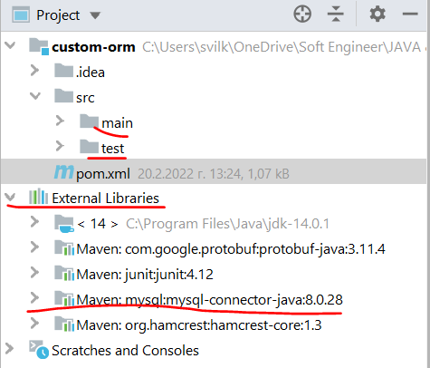

Можем да заредим dependency и чрез сайта mvnrepository.com/

<https://mvnrepository.com/artifact/mysql/mysql-connector-java>

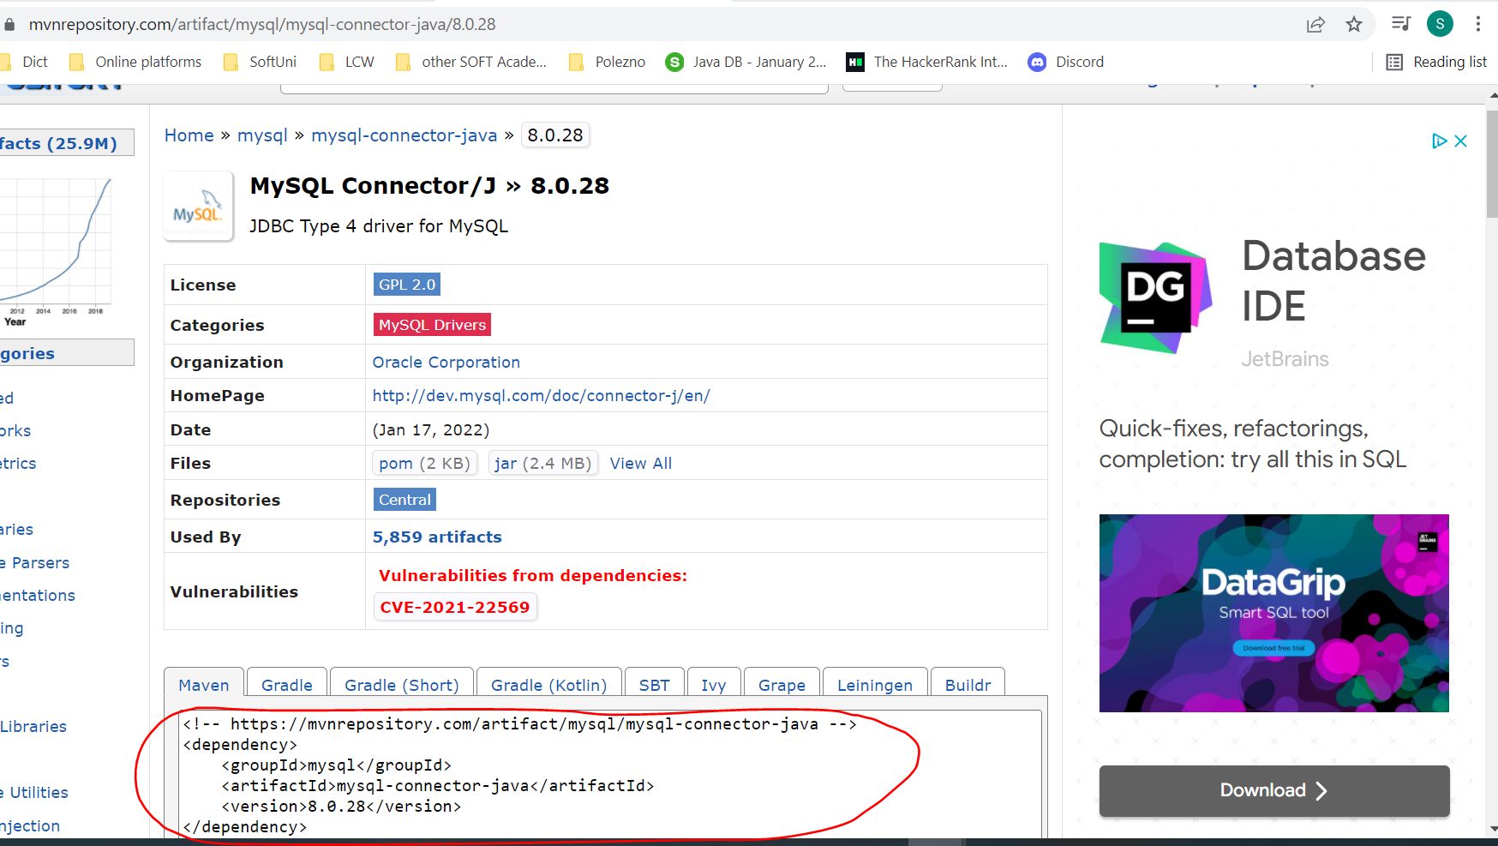

### Create Database Connection

**package** orm;  
  
**import** java.sql.Connection;  
**import** java.sql.DriverManager;  
**import** java.sql.SQLException;  
**import** java.util.Properties;  
  
**public class** MyConnector {  
 **private static** Connection *connection*;  
 **private static final** String ***jdbcString*** = **"jdbc:mysql://localhost:3306/"**;

//Прилагане на Singleton  
 *//всеки път ще работим с комплекта, който сме създали* **private** MyConnector() {} *// конструкторът по подразборане да не може да се инициализира*  
  
 **public static void** createConnection(String user, String password, String dbName) **throws** SQLException {  
 Properties properties = **new** Properties();  
 properties.setProperty(**"user"**, user);  
 properties.setProperty(**"password"**, password);  
  
 *connection* = DriverManager.*getConnection*(***jdbcStrin*** + dbName, properties);  
 }  
  
 **public static** Connection getConnection() {

//Прилагане на Singleton  
 **if** (*connection* == **null**){  
 **new** MyConnector.createConnection();*//ала бала* }  
  
 **return** *connection*;  
 }  
}

### Create Database Context

**package** orm;  
  
**public interface** DBContext<E> {  
 **boolean** persist(E entity);  
  
 Iterable<E> find(Class<E> table);  
  
 Iterable<E> find(Class<E> table, String where);  
  
 E findFirst(Class<E> table);  
  
 E findFirst(Class<E> table, String where);  
}

### Create annotation interfaces

@Retention(RetentionPolicy.***RUNTIME***)  
@Target(ElementType.***FIELD***)  
**public** @**interface** Column {  
 String name();  
}

@Retention(RetentionPolicy.***RUNTIME***)  
**public** @**interface** Entity {  
 String name();  
}

@Retention(RetentionPolicy.***RUNTIME***)  
@Target(ElementType.***FIELD***)  
**public** @**interface** Id {  
  
}

### Create class User and class Address and annotate on with the annotations interfaces

**import** annotations.Column;  
**import** annotations.Entity;  
**import** annotations.Id;  
  
**import** java.time.LocalDate;  
  
@Entity(name = **"users"**) *//в базата данни таблица users – грешно, винаги да използваме и @Table***public class** User {  
 @Id  
 @Column(name = **"id"**)  
 **private long id**;  
  
 @Column(name = **"username"**) *//в базата данни колона username– грешно, винаги да използваме и @Table* **private** String **username**;  
  
 @Column(name = **"age"**) *//в базата данни колона age* **private int age**;  
  
 @Column(name = **"registration_date"**) *//в базата данни колона registration_date* **private** LocalDate **registrationDate**;  
  
 *//Add new field when adding column to the database - we change only in the User class* @Column(name = **"last_logged_in"**)  
 **private** LocalDate **lastLoggedIn**;

**public** User(String username, **int** age, LocalDate registrationDate) {  
 **this**.**username** = username;  
 **this**.**age** = age;  
 **this**.**registrationDate** = registrationDate;  
 **this**.**lastLoggedIn** = LocalDate.*now*();  
 }

getters and setters here

}

@Entity(name = **"addresses"**) *//в базата данни таблица address****es -*** *грешно, винаги да използваме и @Table***public class** Address {  
 @Id  
 @Column(name = **"id"**)  
 **private int id**;  
  
 @Column(name = **"street"**) *//в базата данни колона street* **private** String **street**;  
  
 @Column(name = **"street_number"**) *//в базата данни колона street_number* **private int streetNumber**;  
  
 @Column(name = **"city"**) *//в базата данни колона city* **private** String **city**;  
  
 @Column(name = **"postal_code"**) *//в базата данни колона postal_code* **private** String **postalCode**;  
  
 **public** Address() {  
 }

### CREATE ENTITY MANAGER

**package** orm;  
  
**import** annotations.Column;  
**import** annotations.Entity;  
**import** annotations.Id;  
  
**import** java.lang.reflect.Field;  
**import** java.lang.reflect.InvocationTargetException;  
**import** java.sql.Connection;  
**import** java.sql.PreparedStatement;  
**import** java.sql.ResultSet;  
**import** java.sql.SQLException;  
**import** java.time.LocalDate;  
**import** java.util.*;  
**import** java.util.stream.Collectors;  
  
**public class** EntityManager<E> **implements** DBContext<E> {  
 **private** Connection **connection**;  
  
 **public** EntityManager(Connection connection) {  
 **this**.**connection** = connection;  
 }  
  
 *//Part 1* @Override  
 *//Persist Object in the Database - insert a new row or update an existing row* **public boolean** persist(E entity) **throws** IllegalAccessException, SQLException {  
*// ensureTable(); - може да си го разпишем* Field pk_idColumn = getIdColumn(entity.getClass());  
 pk_idColumn.setAccessible(**true**);  
 Object idValue = pk_idColumn.get(entity); *//вземи стойността на полето id* **if** (idValue == **null** || (**long**) idValue <= 0) {  
 **return** doInsert(entity);  
 }  
  
 **return** doUpdate(entity, (**long**) idValue); *//cast-ни го на long* }

### //Insert a new row in the database

**private boolean** doInsert(E entity) **throws** SQLException, IllegalAccessException {  
 String tableName = getTableName(entity.getClass());  
 List<String> tableFields = getColumnsWithoutId(entity.getClass()); *//username, age, registration_date* List<String> tableValues = getColumnsValuesWithoitId(entity);  
  
 String insertQuery = String.*format*(**"INSERT INTO %s (%s) VALUES (%s)"**, tableName,  
 String.*join*(**","**, tableFields),  
 String.*join*(**","**, tableValues));  
  
 **return connection**.prepareStatement(insertQuery).execute();  
 }

### //Update a specific row in the database

**private boolean** doUpdate(E entity, **long** idValue) **throws** IllegalAccessException, SQLException {  
 String tableName = getTableName(entity.getClass());  
 List<String> tableFields = getColumnsWithoutId(entity.getClass()); *//username, age, registration_date* List<String> tableValues = getColumnsValuesWithoitId(entity);  
  
  
 List<String> setStatements = **new** ArrayList<>();  
 **for** (**int** i = 0; i < tableFields.size() - 1; i++) {  
 setStatements.add(tableFields.get(i) + **"="** + tableValues.get(i));  
 }  
  
 String updateQuery = String.*format*(**"UPDATE %s SET %s WHERE id=%d"**,  
 tableName,  
 String.*join*(**","**, setStatements),  
 idValue);  
  
  
 **return connection**.prepareStatement(updateQuery).execute();  
 }  
  
 **private** List<String> getColumnsWithoutId(Class<?> aClass) {  
 List<String> collect = Arrays.*stream*(aClass.getDeclaredFields())  
 .filter(f -> !f.isAnnotationPresent(Id.**class**))  
 .filter(f -> f.isAnnotationPresent(Column.**class**)) *//само ги филтрирай - тези полета, които са анотирани с Column анотация* .map(f -> f.getAnnotationsByType(Column.**class**)) *//след като са налични полетата, ги вземи* .map(a -> a[0].name()) *//Вземи името на полето - само веднъж имаме върху класа User анотация с Entity анотация, или анотация Entity се използва само на един клас за момента* .collect(Collectors.*toList*());  
  
 **return** collect;  
 }  
  
 **private** List<String> getColumnsValuesWithoitId(E entity) **throws** IllegalAccessException {  
 Class<?> aClass = entity.getClass();  
 List<Field> fields = Arrays.*stream*(aClass.getDeclaredFields())  
 .filter(f -> !f.isAnnotationPresent(Id.**class**))  
 .filter(f -> f.isAnnotationPresent(Column.**class**))  
 .collect(Collectors.*toList*());  
  
 List<String> values = **new** ArrayList<>();  
 **for** (Field field : fields) {  
 field.setAccessible(**true**);  
 Object o = field.get(entity);  
  
 **if** (o **instanceof** String || o **instanceof** LocalDate) {  
 values.add(**"'"** + o + **"'"**);  
 } **else** {  
 values.add(o.toString());  
 }  
 }  
  
 **return** values;  
 }  
  
 **private** Field getIdColumn(Class<?> clazz) {  
 Field[] declaredFields = clazz.getDeclaredFields();  
 **for** (Field declaredField : declaredFields) {  
 **boolean** annotationPresent = declaredField.isAnnotationPresent(Id.**class**);  
 **if** (annotationPresent) {  
 **return** declaredField;  
 }  
 }  
  
 **throw new** UnsupportedOperationException(**"Entity does not have primary key"**);  
 }  
  
 **private** String getTableName(Class<?> aClass) {  
 Entity[] annotationsByType = aClass.getAnnotationsByType(Entity.**class**);  
 **if** (annotationsByType.**length** == 0) {  
 **throw new** UnsupportedOperationException(**"Class must be Entity"**);  
 }  
  
 **return** annotationsByType[0].name();  
 }

### //Fetching Results – findFirst and Find

@Override  
**public** Iterable<E> find(Class<E> table) **throws** InvocationTargetException, SQLException, InstantiationException, IllegalAccessException, NoSuchMethodException {  
 **return** find(table, **null**);  
}  
  
@Override  
**public** Iterable<E> find(Class<E> table, String where) **throws** SQLException, NoSuchMethodException, IllegalAccessException, InvocationTargetException, InstantiationException {  
 **return** find(table, where, **null**);  
}  
  
@Override  
**public** Iterable<E> find(Class<E> table, String where, String... colsToDisplay) **throws** SQLException, NoSuchMethodException, IllegalAccessException, InvocationTargetException, InstantiationException {  
 String tableName = getTableName(table);  
  
 String **selectedCols**;  
 **if** (colsToDisplay == **null**) {  
 selectedCols = **"*"**;  
 } **else** {  
 selectedCols = Arrays.*stream*(colsToDisplay).collect(Collectors.*joining*(**","**));  
 }  
  
 String selectQuery = String.*format*(**"SELECT %s FROM %s %s"**,  
 **selectedCols**,  
 tableName,  
 where != **null** ? **"WHERE "** + where : **""**);  
  
 PreparedStatement statement = **connection**.prepareStatement(selectQuery);  
 ResultSet resultSet = statement.executeQuery();  
  
 List<E> output = **new** ArrayList<>();  
 **while** (resultSet.next()) {  
 *//resultEntity - като го променим в метода fillEntity, той ще се промени и тук в метода findFirst* E resultEntity = table.getDeclaredConstructor().newInstance(); *//new instance of class the object/instance of which is table* fillEntity(table, resultSet, resultEntity);  
 output.add(resultEntity);  
 }  
  
 **return** output;  
}

@Override  
 **public** E findFirst(Class<E> table) **throws** InvocationTargetException, SQLException, InstantiationException, IllegalAccessException, NoSuchMethodException {  
 **return** findFirst(table, **null**);  
 }  
  
 @Override  
 **public** E findFirst(Class<E> table, String where) **throws** SQLException, NoSuchMethodException, IllegalAccessException, InvocationTargetException, InstantiationException {  
 String tableName = getTableName(table);  
  
 String selectQuery = String.*format*(**"SELECT * FROM %s %s LIMIT 1"**, tableName,  
 where != **null** ? **"WHERE "** + where : **""**);  
  
 PreparedStatement statement = **connection**.prepareStatement(selectQuery);  
 ResultSet resultSet = statement.executeQuery();  
  
 resultSet.next();  
  
 *//resultEntity - като го променим в метода fillEntity, той ще се промени и тук в метода findFirst* E resultEntity = table.getDeclaredConstructor().newInstance(); *//new instance of class the object/instance of which is table* fillEntity(table, resultSet, resultEntity);  
  
 **return** resultEntity;  
 }  
  
 **private void** fillEntity(Class<E> table, ResultSet resultSet, E resultEntity) **throws** SQLException, IllegalAccessException {  
 Field[] declaredFields = table.getDeclaredFields();

#### //използване на getMetaData за селекция на колони за дисплейване

ResultSetMetaData metaData = **resultSet.getMetaData();**  
 **int** columnCount = **metaData.getColumnCount();**  
 List<String> sqlSelectColumns = **new** ArrayList<>();  
 **for** (**int** i = 1; i <= columnCount ; i++) {  
 String columnName = metaData.getColumnName(i);  
 sqlSelectColumns.add(columnName);  
 }  
  
 **for** (Field declaredField : declaredFields) {  
 String fieldNameClass = declaredField.getAnnotationsByType(Column.**class**)[0].name();  
 **if** (**sqlSelectColumns.contains(fieldNameClass))** {  
 declaredField.setAccessible(**true**);  
 fillField(declaredField, resultSet, resultEntity);  
 }  
 }  
}

*//from SQL type we convert to JAVA data type - for each field - обратното на getSQLType метода* **private void** fillField(Field declaredField, ResultSet resultSet, E resultEntity) **throws** SQLException,  
 IllegalAccessException {  
 Class<?> fieldType = declaredField.getType();  
 *//String fieldName = declaredField.getName(); //връща името на полета на изкуствената инстанция, която е взела имена на полетата от SQL базата/таблицата* String fieldName = declaredField.getAnnotationsByType(Column.**class**)[0].name(); *//чрез използване на анотация връща името на полето от изкуствената инстанция на класа* **if** (fieldType == Integer.**class** || fieldType == **int**.**class**) {  
 **int** value = resultSet.getInt(fieldName); *//a java.sql command  
  
 //resultEntity e инстанция на table  
 //declared field е едно от полетата на table  
 //fieldName e името на полето  
 //value е резултат от SQL заявка (java.sql)* declaredField.set(resultEntity, value);  
 } **else if** (fieldType == **long**.**class**) {  
 **long** value = resultSet.getLong(fieldName); *//a java.sql command* declaredField.set(resultEntity, value);  
 } **else if** (fieldType == LocalDate.**class**) {  
 LocalDate value = LocalDate.*parse*(resultSet.getString(fieldName));  
 declaredField.set(resultEntity, value);  
 } **else** {  
 String value = resultSet.getString(fieldName);  
 declaredField.set(resultEntity, value);  
 }  
 }

*//Part 2*

### //Create Table

**public void** doCreate(Class<E> entityClass) **throws** SQLException {  
 String tableName = getTableName(entityClass);  
 String fieldsWithTypes = getSQLFieldsWithTypes(entityClass);  
  
 String createQuery = String.*format*(**"CREATE TABLE %s ("** +  
 **"id INT PRIMARY KEY AUTO_INCREMENT, %s)"**, tableName, fieldsWithTypes);  
  
 PreparedStatement statement = **connection**.prepareStatement(createQuery);  
 statement.execute();  
 }  
  
 **private** String getSQLFieldsWithTypes(Class<E> entityClass) {  
 **return** Arrays.*stream*(entityClass.getDeclaredFields())  
 .filter(f -> !f.isAnnotationPresent(Id.**class**)) *//без id-то на класа* .filter(f -> f.isAnnotationPresent(Column.**class**))  
 .map(field -> {  
 String fieldName = field.getAnnotationsByType(Column.**class**)[0].name(); *//тези полета на класа User, които са анотирани с Column анотация  
  
 //Определяме SQL типа на база JAVA типа* String sqlType = getSQLType(field.getType());  
  
 **return** fieldName + **" "** + sqlType;  
 })  
 .collect(Collectors.*joining*(**","**));  
 }  
  
 *//Определяме SQL типа на база JAVA типа - от Java към SQL тип* **private** String getSQLType(Class<?> type) {  
 String sqlType = **""**;  
 **if** (type == Integer.**class** || type == **int**.**class**) {  
 sqlType = **"INT"**;  
 } **else if** (type == String.**class**) {  
 sqlType = **"VARCHAR(200)"**;  
 } **else if** (type == LocalDate.**class**) {  
 sqlType = **"DATE"**;  
 }  
 **return** sqlType;  
 }

### //Alter Table – add new columns

**public void** doAlter(Class<E> entityClass) **throws** SQLException {  
 String tableName = getTableName(entityClass);  
 String addColumnStatements = getAddColumnStatementsForNewFields(entityClass);  
  
 String alterQuery = String.*format*(**"ALTER TABLE %s %s"**, tableName, addColumnStatements);  
  
 PreparedStatement statement = **connection**.prepareStatement(alterQuery);  
 statement.execute();  
 }  
  
 **private** String getAddColumnStatementsForNewFields(Class<E> entityClass) **throws** SQLException {  
 Set<String> sqlColumns = getSQLColumnNames(entityClass);  
  
 List<Field> fields = Arrays.*stream*(entityClass.getDeclaredFields())  
 .filter(f -> !f.isAnnotationPresent(Id.**class**)) *//без id-то на класа* .filter(f -> f.isAnnotationPresent(Column.**class**))  
 .collect(Collectors.*toList*());  
  
 List<String> allAddStatements = **new** ArrayList<>();  
 **for** (Field field : fields) {  
 String fieldName = field.getAnnotationsByType(Column.**class**)[0].name(); *//тези полета на класа User, които са анотирани с Column анотация* **if** (sqlColumns.contains(fieldName)) {  
 **continue**;  
 }  
  
 *//Определяме SQL типа на база JAVA типа - от Java към SQL тип* String sqlType = getSQLType(field.getType());  
  
 String addStatement = String.*format*(**"ADD COLUMN %s %s"**, fieldName, sqlType);  
 allAddStatements.add(addStatement);  
 }  
  
 **return** allAddStatements.stream().collect(Collectors.*joining*(**","**));  
 }  
  
 **private** Set<String> getSQLColumnNames(Class<E> entityClass) **throws** SQLException {

String tableName = getTableName(entityClass);  
  
*//вземи всички имена на колони без id-то - SQL заявка*String schemaQuery = String.*format*(**"SELECT `COLUMN_NAME` FROM `information_schema`.`columns`\n"** +  
 **"WHERE `TABLE_SCHEMA` = 'custom-orm' AND `COLUMN_NAME` != 'id'\n"** +  
 **"AND `TABLE_NAME` = %s;"**, tableName);  
  
*/*String schemaQuery = "SELECT `COLUMN_NAME` FROM `information_schema`.`columns`\n" +  
 "WHERE `TABLE_SCHEMA` = 'custom-orm' AND `COLUMN_NAME` != 'id'\n" +  
 "AND `TABLE_NAME` = 'users';"; */*

PreparedStatement statement = **connection**.prepareStatement(schemaQuery);  
  
 ResultSet resultSet = statement.executeQuery();  
  
 Set<String> result = **new** HashSet<>();  
 **while** (resultSet.next()) {  
 String columnName = resultSet.getString(**"COLUMN_NAME"**);  
 result.add(columnName);  
 }  
  
 **return** result;  
 }

### //Delete row

@Override  
 **public boolean** delete(E userToDelete) **throws** IllegalAccessException, SQLException {  
 String tableName = getTableName(userToDelete.getClass());  
 Field idColumn = getIdColumn(userToDelete.getClass());  
  
 String idColumnName = idColumn.getAnnotationsByType(Column.**class**)[0].name(); *//чрез използване на анотация връща името на полето от изкуствената инстанция на класа* idColumn.setAccessible(**true**);  
 Object idColumnValue = idColumn.get(userToDelete);  
  
 String queryDelete = String.*format*(**"DELETE FROM %s WHERE %s = %s"**,  
 tableName,  
 idColumnName,  
 idColumnValue);  
  
 **return connection**.prepareStatement(queryDelete).execute();  
 }  
  
}

### Test Insert a row

**public class** Main {  
 **public static void** main(String[] args) **throws** SQLException, IllegalAccessException {  
 MyConnector.*createConnection*(**"root"**, **""**, **"custom-orm"**);  
 Connection connection = MyConnector.*getConnection*();  
  
 EntityManager<User> userEntityManager = **new** EntityManager<>(connection);  
  
 User user = **new** User(**"pesho"**, 25, LocalDate.*now*());  
 userEntityManager.persist(user);

connection.close();

}  
}

### Test Update a row

**public class** Main {  
 **public static void** main(String[] args) **throws** SQLException, IllegalAccessException {  
 MyConnector.*createConnection*(**"root"**, **""**, **"custom-orm"**);  
 Connection connection = MyConnector.*getConnection*();  
  
 EntityManager<User> userEntityManager = **new** EntityManager<>(connection);  
  
 User user = **new** User(**"pesho"**, 25, LocalDate.*now*());  
 user.setId(2); **//user с id 2 му променяме**  
 user.setUsername(**"pesho_new_new"**); **//променяме името му**userEntityManager.persist(user);

connection.close();  
 }  
}

### Test Create new table

**public class** Main {  
 **public static void** main(String[] args) **throws** SQLException, IllegalAccessException {  
 MyConnector.*createConnection*(**"root"**, **""**, **"custom-orm"**);  
 Connection connection = MyConnector.*getConnection*();  
  
 EntityManager<User> userEntityManager = **new** EntityManager<>(connection);  
  
 User user = **new** User(**"pesho"**, 25, LocalDate.*now*());  
 userEntityManager.doCreate(User.**class**);  
 userEntityManager.persist(user);

connection.close();  
 }  
}

### Test Alter existing table – add new columns

**public class** Main {  
 **public static void** main(String[] args) **throws** SQLException, IllegalAccessException {  
 MyConnector.*createConnection*(**"root"**, **""**, **"custom-orm"**);  
 Connection connection = MyConnector.*getConnection*();  
  
 EntityManager<User> userEntityManager = **new** EntityManager<>(connection);  
  
 User user = **new** User(**"pesho"**, 25, LocalDate.*now*());  
 userEntityManager.doAlter(User.**class**);  
 userEntityManager.persist(user); //изпълнява се задължително

connection.close();  
 }  
}

*//Add new field when adding column to the database - we change only in the* ***User class***@Column(name = **"last_logged_in"**)  
 **private** LocalDate **lastLoggedIn**;

### Test Find First

**public class** Main {  
 **public static void** main(String[] args) **throws** SQLException, IllegalAccessException, NoSuchMethodException, InstantiationException, InvocationTargetException {  
 MyConnector.*createConnection*(**"root"**, **""**, **"custom-orm"**);  
 Connection connection = MyConnector.*getConnection*();  
  
 EntityManager<User> userEntityManager = **new** EntityManager<>(connection);  
  
 User user = **new** User(**"pesho"**, 25, LocalDate.*now*());  
 User first = userEntityManager.findFirst(User.**class**, **"id = 2"**);  
 System.***out***.println(first);

connection.close();  
}  
}

### Test Find

**public class** Main {  
 **public static void** main(String[] args) **throws** SQLException, IllegalAccessException, NoSuchMethodException, InstantiationException, InvocationTargetException {  
 MyConnector.*createConnection*(**"root"**, **""**, **"custom-orm"**);  
 Connection connection = MyConnector.*getConnection*();  
  
 EntityManager<User> userEntityManager = **new** EntityManager<>(connection);  
  
 User user = **new** User(**"Svilen"**, 36, LocalDate.*now*());  
Iterable<User> first = userEntityManager.find(User.**class**, **"id<5"**);

Iterable<User> first = userEntityManager.find(User.**class**, **"id<5",** );  
 System.***out***.println(first);

Iterable<User> testDisplayingSpecificColumns = userEntityManager.find(User.**class**, **"age>27"**,  
 **"age"**, **"registration_date"**);  
System.***out***.println(testDisplayingSpecificColumns);

[User{id=0, username='null', **age=28, registrationDate=2022-02-28**, lastLoggedIn=null}, User{id=0, username='null', **age=36, registrationDate=2022-02-23**, lastLoggedIn=null}]

connection.close();}  
}

### Test Delete – a specific row from the table

**public class** Main {  
 **public static void** main(String[] args) **throws** SQLException, IllegalAccessException, NoSuchMethodException, InstantiationException, InvocationTargetException {  
 MyConnector.*createConnection*(**"root"**, **""**, **"custom-orm"**);  
 Connection connection = MyConnector.*getConnection*();  
  
 EntityManager<User> userEntityManager = **new** EntityManager<>(connection);  
  
 User user = **new** User(**"Ala bala"**, 36, LocalDate.*now*());  
User userToDelete = userEntityManager.findFirst(User.**class**, **"id=6"**);  
 System.***out***.println(userToDelete);  
 userEntityManager.delete(userToDelete);

connection.close();  
}  
}

# 3. Hibernate Introduction

## 3.0. Особености

И при HQL и при JPQL, работим с имената на класовете и с имената на полета на тези класове, вместо с името на таблицата от базата данни и имената на колоните от таблиците от базата данни.

Java типовете стоят в QL заявката!!!

## 3.1. Maven - Project Management and Comprehension

### Maven Overview

* Maven is a built automation tool.
  + Describes how software is built and its dependencies
  + Uses XML files
* Dynamically downloads **Java libraries** and **Maven plug-ins**
  + Projects are configured using a **P**roject **O**bject **M**odel, which is stored in a **pom.xml** file

### Setup – Creating a Maven Project

* Select "Maven" project from the new project panel:

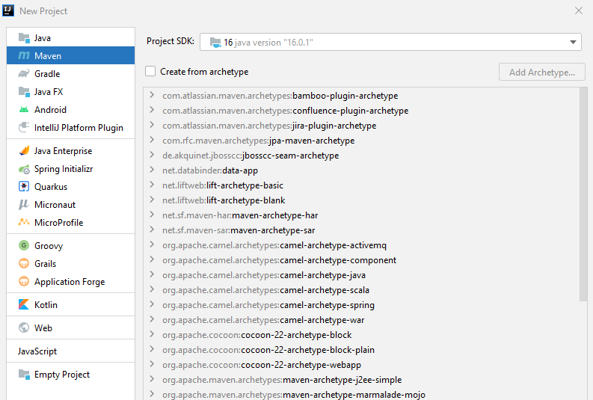

**GroupId** – името на организацията, в която ранотим

**ArtefactId** – ако имаме различни проекти в нашата организация, то името на конкретния проект/библиотека

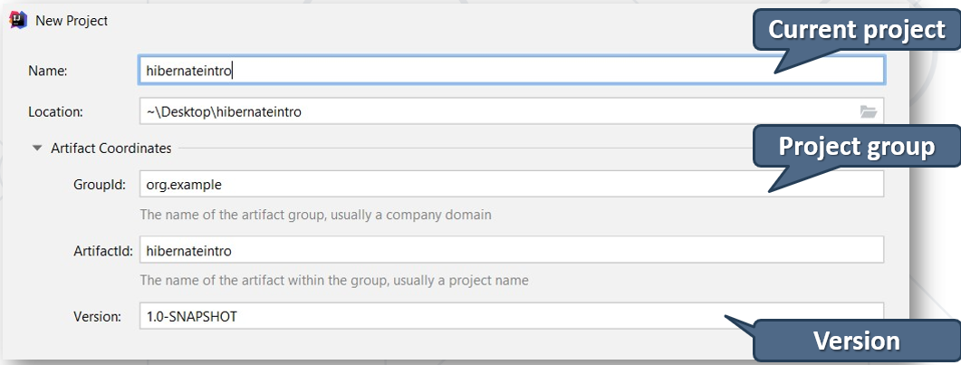

### Maven Configurations

* A **P**roject **O**bject **M**odel(**POM**) is the fundamental unit of work in Maven
* **Configurations** are held in the **pom.xml** file
* When executing a task or goal, Maven looks for the POM file in the current directory

### pom.xml файла с есктри

<**project xmlns="http://maven.apache.org/POM/4.0.0"  
 xmlns:xsi="http://www.w3.org/2001/XMLSchema-instance"  
 xsi:schemaLocation="http://maven.apache.org/POM/4.0.0 http://maven.apache.org/xsd/maven-4.0.0.xsd"**>  
 <**modelVersion**>4.0.0</**modelVersion**>  
  
 <**groupId**>org-example</**groupId**>  
 <**artifactId**>custom-orm</**artifactId**>  
 <**version**>1.0-SNAPSHOT</**version**>

<**packaging**>jar</**packaging**> //ако искаме да deploy-ваме

**Properties обобщават долуизброените, и ако се наложи да се променя на много места, то можем да направим грешка. А тук само на едно място променяме версията**  
<**properties**>  
 <**maven.compiler.source**> 14 </**maven.compiler.source**>  
 <**maven.compiler.target**> 14 </**maven.compiler.target**>  
 <**hibernate.version**>5.4.30.Final</**hibernate.version**>  
 <**msql.version**>8.0.25</**msql.version**>  
 <**jaxb.version**>2.2.11</**jaxb.version**> //три dependencies или повече могат да използват това  
</**properties**>

<**build**>  
 <**plugins**>  
 <**plugin**>  
 <**groupId**>org.apache.maven.plugins</**groupId**>  
 <**artifactId**>maven-compiler-plugin</**artifactId**>  
 <**version**>3.6.1</**version**> //слагаме и version number   
 <**configuration**>  
 <**source**>14</**source**>  
 <**target**>14</**target**>  
 <**annotationProcessorPaths**> //използване на lombok  
 <**path**>  
 <**groupId**>org.projectlombok</**groupId**>  
 <**artifactId**>lombok</**artifactId**>  
 <**version**>1.18.20</**version**>  
 </**path**>  
 </**annotationProcessorPaths**>  
 </**configuration**>  
 </**plugin**>  
 </**plugins**>  
</**build**>

<**dependencies**>

#### //това ни добавя hibernate-core

<**dependency**>  
 <**groupId**>org.hibernate</**groupId**>  
 <**artifactId**>hibernate-core</**artifactId**>  
 <**version**>${hibernate.version}</**version**>  
</**dependency**>

#### //това ни добавя driver за mysql конектора

<**dependency**>  
 <**groupId**>mysql</**groupId**>  
 <**artifactId**>mysql-connector-java</**artifactId**>  
 <**version**>${msql.version}</**version**>  
</**dependency**>

Как реферираме version от Properties

<**dependency**>  
 <**groupId**>com.sun.xml.bind</**groupId**>  
 <**artifactId**>jaxb-api</**artifactId**>  
 <**version**>${jaxb.version}</**version**>  
</**dependency**>  
  
<**dependency**>  
 <**groupId**>com.sun.xml.bind</**groupId**>  
 <**artifactId**>jaxb-core</**artifactId**>  
 <**version**>${jaxb.version}</**version**>  
</**dependency**>  
  
<**dependency**>  
 <**groupId**>com.sun.xml.bind</**groupId**>  
 <**artifactId**>jaxb-impl</**artifactId**>  
 <**version**>${jaxb.version}</**version**>  
</**dependency**>

**//Използване на lombok**

//генерира необходимите getters, setters, hashCode и т.н.

<**dependency**>  
 <**groupId**>org.projectlombok</**groupId**>  
 <**artifactId**>lombok</**artifactId**>  
 <**version**>1.18.12</**version**>  
 <**scope**>provided</**scope**> //няма смисъл да отива в jar файла. Служи само за компилация  
</**dependency**>

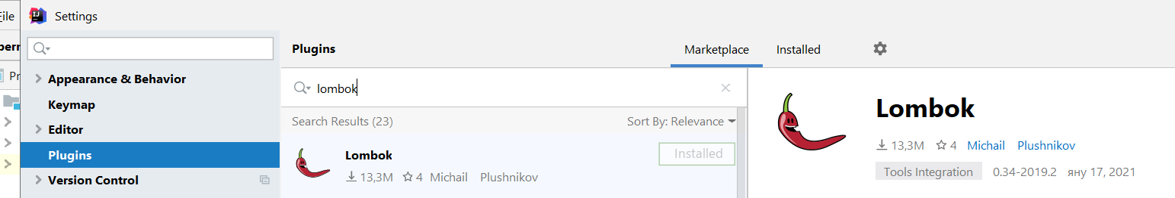

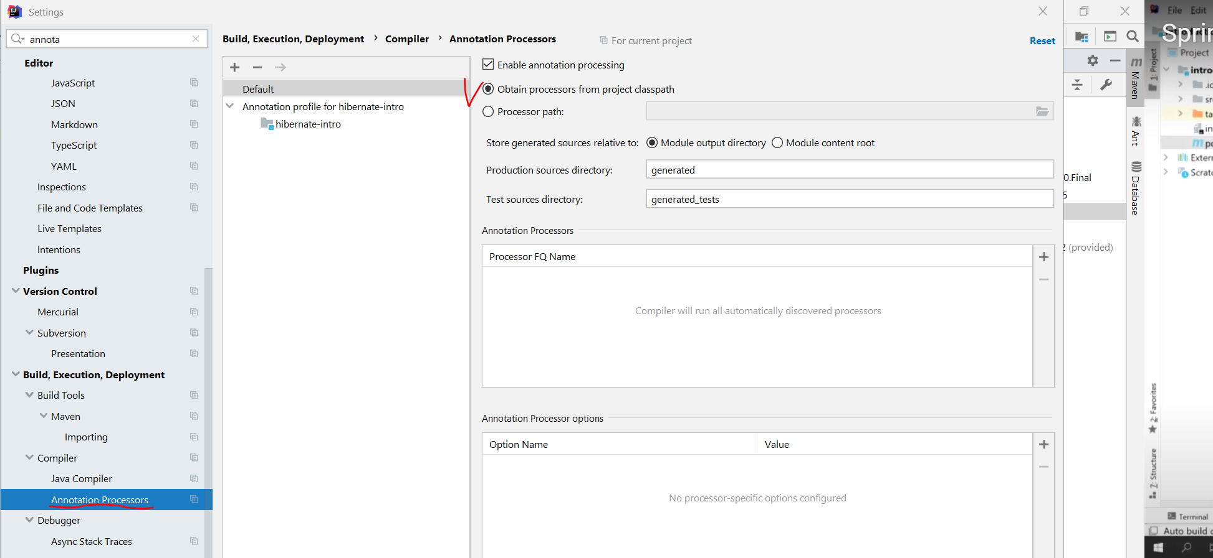



Можем да заредим dependency и чрез сайта mvnrepository.com/

<https://mvnrepository.com/artifact/mysql/mysql-connector-java>



## 3.2. Java ORM Approaches

* Different approaches to **Java** **ORM**:
  + **1) POJO (Plain Old Java Objects Without annotations) + XML mappings**
    - A bit old-fashioned, but very powerful
    - Implemented in the "classical" Hibernate without JPA
  + **2) Annotated Java classes (POJO) mapped to DB tables – имаме кое какво мапва на едно място, пример с класа User от custom-orm** 
    - Based on Java annotations and XML
    - Easier to implement and maintain
    - Implemented in **both Hibernate classical and Hibernate with JPA frameworks**
    - Code generation - tools

### 1) Classical Hibernate XML mappings using POJO (Plain Old Java Objects Without annotations)

#### student.hbm.xml – create it in **src/main/resources**

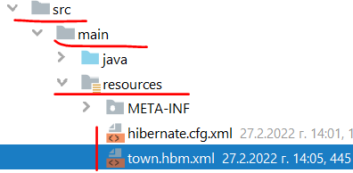

*<?***xml version="1.0" encoding="utf-8"***?>***<!DOCTYPE hibernate-mapping PUBLIC** //Mapping file **"-//Hibernate/Hibernate Mapping DTD//EN"  
 "http://www.hibernate.org/dtd/hibernate-mapping-3.0.dtd"*>***

//тук мапваме различните класове към базата данни<**hibernate-mapping**>   
 <**class name="entities.Student" table="students"**> //Class mapping – име на клас, след това име на таблица от базата

<**meta attribute="class-description"**>  
 This class contains the student details  
</**meta**>

<**id name="id" column="id"**> //Field mapping – име на поле от класа, след това име на колона на таблицата от базата

//показва, че е auto-generator/auto-generated

<**generator class="identity"**></**generator**> //когато няма body в тага, то можем да използваме съкратен запис както следва:

<**generator class="identity"** />  
 </**id**>

<**property name="name" column="first_name"** /> //Field mapping – име на поле от класа, след това име на колона на таблицата от базата

<**property name="registrationDate" column="registration_date" type="timestamp"**/> //Field mapping – име на поле от класа, след това име на колона на таблицата от базата, след това мапинг тип мапващ от Java към SQL

</**class**>  
</**hibernate-mapping**>

#### hibernate.cfg.xm – **create it in src/main/resources**



*<?***xml version='1.0' encoding='utf-8'***?>***<!DOCTYPE hibernate-configuration** //Configuration **PUBLIC "-//Hibernate/Hibernate Configuration DTD//EN"  
 "http://www.hibernate.org/dtd/hibernate-configuration-3.0.dtd"*>***<**hibernate-configuration**>  
 <**session-factory**>  
 <**property name="hibernate.dialect"**>  
 org.hibernate.dialect.MySQL8Dialect //SQL dialect  
 </**property**>

<**property name="hibernate.connection.driver_class"**>  
 com.mysql.cj.jdbc.Driver //driver  
 </**property**>

*<!-- Connection Settings -->* <**property name="hibernate.connection.url"**> jdbc:mysql://localhost:3306/school?createDatabaseIfNotExist=true //connection string  
 </**property**>

<**property name="hibernate.connection.username"**>  
 root //user  
 </**property**>

<**property name="hibernate.connection.password"**>  
 “” //pass  
 </**property**>

<**property name="hbm2ddl.auto"**>  
 update //auto-strategy  
 </**property**>

<**property name="show_sql"**>true</**property**> //за показване на конзолата самата заявка  
<**property name="format_sql"**>true</**property**>  
<**property name="use_sql_comments"**>true</**property**>

*<!-- List of XML mapping files -->* <**mapping resource="student.hbm.xml"**/> //mapping files  
 </**session-factory**>  
</**hibernate-configuration**>

#### pom.xml

Native Hibernate e hibernate-core

**<build>……..**

<**dependencies**>  
 <**dependency**>  
 <**groupId**>org.hibernate</**groupId**>  
 <**artifactId**>hibernate-core</**artifactId**>  
 <**version**>5.4.22.Final</**version**>  
 </**dependency**>  
  
 <**dependency**>  
 <**groupId**>mysql</**groupId**>  
 <**artifactId**>mysql-connector-java</**artifactId**>  
 <**version**>8.0.25</**version**>  
 </**dependency**>  
 </**dependencies**>  
  
</**project**>

#### NativeHibernateMain

**import org.hibernate**.Session;  
**import org.hibernate**.SessionFactory;  
**import org.hibernate**.cfg.Configuration;  
  
**public class** NativeHibernateMain {  
 **public static void** main(String[] args) {  
 Configuration cfg = **new** Configuration();  
 cfg.configure(); *//в скобите можем да сложим от кой файл искаме да го заредим* SessionFactory sessionFactory = cfg.buildSessionFactory();  
  
 Session session = sessionFactory.openSession();  
 session.beginTransaction();  
  
 Town town = session.get(Town.**class**, 1);  
  
 System.***out***.println(town);  
  
 session.getTransaction().commit();  
 session.close();  
 }  
}

### 2) Annotated Java classes (annotated POJO) mapped to DB tables

#### Entity Class: Student

@Entity

@Table(name = **"students"**) //set the class with name Student to be in the database as table students, подобно на xml mapping файла  
**public class** Student {  
 @Id //primary key  
 @GeneratedValue(strategy = GenerationType.IDENTITY) //identity  
 @Column(name = **"id"**) //column name  
 **private long id**;

@Column(name = **"name"**, length = 50) //column name and length  
 **private** String **name**;  
  
 *// Getters and setters //тук си създаваме конструктори/getters/setters ръчно*}

#### persistence.xml – create it in **src/main/resources/META-INF**

META-INF е стандартно име на папка в Java, в която папка биха стояли конфигурации

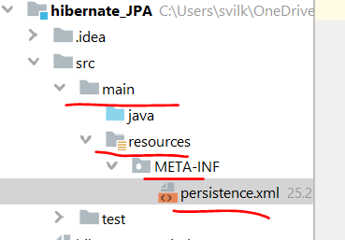

*<?***xml version="1.0" encoding="UTF-8"***?>*<**persistence xmlns="http://java.sun.com/xml/ns/persistence" version="2.0"**>  
 <**persistence-unit name="school"**> //persistence unit name  
 <**properties**>  
 <**property name="hibernate.connection.url"  
 value="jdbc:mysql://localhost:3306/school?createDatabaseIfNotExist=true"**/>  
 <**property name="hibernate.connection.driver_class" value="com.mysql.cj.jdbc.Driver"**/>  
 <**property name="hibernate.connection.username" value="root"**/>  
 <**property name="hibernate.connection.password" value=""**/>  
 <**property name="hibernate.dialect" value="org.hibernate.dialect.MySQL8Dialect"**/>

<**property name="hibernate.hbm2ddl.auto" value="update"**/>

<**property name="hibernate.hbm2ddl.auto" value="create-drop"**/> //изтрий таблицата и я пресъздай наново с новите/верните/променените колони

<**property name="hibernate.hbm2ddl.auto" value="validate"**/> //за валидиране на миграции на данни

<**property name="hibernate.show_sql" value="true"**/>

</**properties**>  
 </**persistence-unit**>  
</**persistence**>

#### pom.xml

JPA е javax.persistence-api

**<build>……..**

<**dependencies**>  
 <**dependency**>  
 <**groupId**>javax.persistence</**groupId**>  
 <**artifactId**>javax.persistence-api</**artifactId**>  
 <**version**>2.2</**version**>  
 </**dependency**>  
  
 <**dependency**>  
 <**groupId**>mysql</**groupId**>  
 <**artifactId**>mysql-connector-java</**artifactId**>  
 <**version**>8.0.25</**version**>  
 </**dependency**>  
 </**dependencies**>  
</**project**>

#### JpaHibernateMain

**import javax.persistence.**EntityManager;  
**import javax.persistence.**EntityManagerFactory;  
**import javax.persistence.**Persistence;  
  
**public class** JpaHibernateMain {  
 **public static void** main(String[] args) {  
 EntityManagerFactory emf = Persistence.*createEntityManagerFactory*(**"soft_uni"**);  
 EntityManager entityManager = emf.createEntityManager();  
  
 entityManager.getTransaction().begin();  
 Town town = entityManager.find(Town.**class**, 1);  
  
 System.***out***.println(town);  
  
 entityManager.getTransaction().commit();  
 entityManager.close();  
 }  
}

## 3.3. Hibernate Classical Framework (before JPA) - Classical Hibernate XML mappings using POJO

### Hibernate Framework

* Hibernate is a Java ORM framework
  + Mapping an object-oriented model to a relational database
    - It is implemented by the configuration of an **XML** **file** or by using **Java** **Annotations**
  + Maintain the database schema

### Използване на Lombok

**package** demos.hibernate.model;  
  
**import** lombok.Data;  
  
**import** java.util.Date;

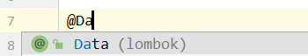  
@Data //пишем/избираме @Data анотация и не се налага да пишем след това getters, setters, etc за всеки елемент/поле/метод на класа – яко 😊

Но самите полета на класа не са анотирани в смисъл анотирани към базата данни, както е в следващата точка 3.4.  
@NoArgsConstructor //празен конструктор да има  
@RequiredArgsConstructor  
@AllArgsConstructor  
**public class** Student {  
 **private int id**;  
  
 @NonNull *//птрави полето name като required argument на конструктора* **private** String **name**;  
   
 **private** Date **registrationDate** = **new** Date();  
}

logger на Lombok - @Slf4j

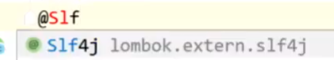

@Override  
**public void** run(String... args) **throws** Exception {  
 ***SAMPLE_USERS***.forEach(user -> **this**.**userService**.addUser(user));  
 ***log***.info(**"Created users: {}"**, **userService**.getUsers());  
}

Exclude - If present, do not include this field in the generated toString.

@OneToMany(mappedBy = **"author"**)  
@ToString.Exclude  
**private** Collection<Post> **author** = **new** ArrayList<Post>();

### Hibernate Configuration

#### pom.xml

##### //това ни добавя hibernate-core

<**dependency**>  
 <**groupId**>org.hibernate</**groupId**>  
 <**artifactId**>hibernate-core</**artifactId**>  
 <**version**>5.4.30.Final</**version**>  
</**dependency**>

##### //това ни добавя driver за mysql конектора

<**dependency**>  
 <**groupId**>mysql</**groupId**>  
 <**artifactId**>mysql-connector-java</**artifactId**>  
 <**version**>8.0.25</**version**>  
 </**dependency**>

#### hibernate.cfg.xm – **create it in src/main/resources**



*<?***xml version='1.0' encoding='utf-8'***?>***<!DOCTYPE hibernate-configuration** //Configuration **PUBLIC "-//Hibernate/Hibernate Configuration DTD//EN"  
 "http://www.hibernate.org/dtd/hibernate-configuration-3.0.dtd"*>***<**hibernate-configuration**>  
 <**session-factory**>  
 <**property name="hibernate.dialect"**>  
 org.hibernate.dialect.MySQL8Dialect //SQL dialect  
 </**property**>

<**property name="hibernate.connection.driver_class"**>  
 com.mysql.cj.jdbc.Driver //driver  
 </**property**>

*<!-- Connection Settings -->* <**property name="hibernate.connection.url"**> jdbc:mysql://localhost:3306/school?createDatabaseIfNotExist=true //connection string  
 </**property**>

<**property name="hibernate.connection.username"**>  
 root //user  
 </**property**>

<**property name="hibernate.connection.password"**>  
 “” //pass  
 </**property**>

<**property name="hbm2ddl.auto"**>  
 update //auto-strategy  
 </**property**>

<**property name="show_sql"**>true</**property**> //за показване на конзолата самата заявка  
<**property name="format_sql"**>true</**property**>  
<**property name="use_sql_comments"**>true</**property**>

*<!-- List of XML mapping files -->* <**mapping resource="student.hbm.xml"**/> //mapping files  
 </**session-factory**>  
</**hibernate-configuration**>

#### student.hbm.xml – create it in **src/main/resources**

*<?***xml version="1.0" encoding="utf-8"***?>***<!DOCTYPE hibernate-mapping PUBLIC** //Mapping file **"-//Hibernate/Hibernate Mapping DTD//EN"  
 "http://www.hibernate.org/dtd/hibernate-mapping-3.0.dtd"*>***

//тук мапваме различните класове към базата данни<**hibernate-mapping**>   
 <**class name="entities.Student" table="students"**> //Class mapping – име на клас, след това име на таблица от базата

<**meta attribute="class-description"**>  
 This class contains the student details  
</**meta**>

<**id name="id" column="id"**> //Field mapping – име на поле от класа, след това име на колона на таблицата от базата

//показва, че е auto-generator/auto-generated

<**generator class="identity"**></**generator**> //когато няма body в тага, то можем да използваме съкратен запис както следва:

<**generator class="identity"** />  
 </**id**>

<**property name="name" column="first_name"** /> //Field mapping – име на поле от класа, след това име на колона на таблицата от базата

<**property name="registrationDate" column="registration_date" type="timestamp"**/> //Field mapping – име на поле от класа, след това име на колона на таблицата от базата

</**class**>  
</**hibernate-mapping**>



### Hibernate Sessions

**import org.hibernate.Session;  
import org.hibernate.SessionFactory;  
import org.hibernate.cfg.Configuration;**  
  
**public class** HibernateDenoWithXMLNoAnnotationsMain {  
 **public static void** main(String[] args) {  
 Configuration cfg = **new** Configuration(); *//Service registry* cfg.configure(); *//в скобите можем да сложим от кой файл искаме да го заредим* SessionFactory sessionFactory = cfg.buildSessionFactory();  
  
 Session session = sessionFactory.openSession(); *//session* session.beginTransaction();  
  
 *// Your Code Here* session.getTransaction().commit(); *//transaction commit* session.close();  
 }  
}

### Hibernate Save Data

Има няколко начина – чрез **persist** или **merge** (част от JPA),

или чрез **строго специфичните за Hibernate неизискуеми от JPA** методи **save** и **update** и **saveorupdate**

#### Пример 1:

**public static void** main(String[] args) {  
 *//…* session.beginTransaction();  
  
 Student example = **new** Student();  
 session.**save**(example); //Save object  
  
 session.getTransaction().commit();  
 session.close();  
}

#### Пример 2

**import org.hibernate**.FlushMode;  
**import org.hibernate**.Session;  
**import org.hibernate**.SessionFactory;  
**import org.hibernate**.cfg.Configuration;  
  
**public class** HibernateDemoWithXMLNoAnnotationsMain {  
 **public static void** main(String[] args) {  
 Configuration config = **new** Configuration(); *//Service registry  
// config.configure("src/java/hibernate.cfg.xml"); //в скобите можем да сложим от кой файл искаме да го заредим* config.configure(); *//в скобите можем да сложим от кой файл искаме да го заредим  
  
 //try with resources / try-with-resources* **try** (SessionFactory sessionFactory = config.buildSessionFactory();  
 Session session = sessionFactory.openSession()) {  
  
 Student student = **new** Student(**"Ivan Petrov"**);  
 **try** {  
 session.**save**(student);  
 //session.persist(student);  
 //session.detach(student);  
 } **catch** (Exception e) {  
 **if** (session.getTransaction() != **null**) {  
 session.getTransaction().rollback();  
 }  
 **throw** e;  
 }  
  
 session.beginTransaction();  
 session.setHibernateFlushMode(FlushMode.***MANUAL***);  
 session.getTransaction().commit(); *//transaction commit* session.close();  
 }  
 }  
}

### Hibernate Retrieve Data by Get

**public static void** main(String[] args) {  
…  
  
 Student student = session.**get**(Student.**class**, 1L); //Get object  
  
 session.close();  
 }

### Hibernate Retrieve Data by Query

**public static void** main(String[] args) {  
 *// …* session.beginTransaction();  
  
 List<Student> studentList =  
 session.**createQuery**(**"FROM Student "**, Student.**class**).**list();**

**for** (Student student : studentList) {  
 System.***out***.println(student.**getId**());  
 }

session.getTransaction().commit();  
 session.close();  
}

### Hibernate Querying Language – HQL

Използваме имената на класовете и на техните полета вместо таблицата в базата данни с нейните имена колони

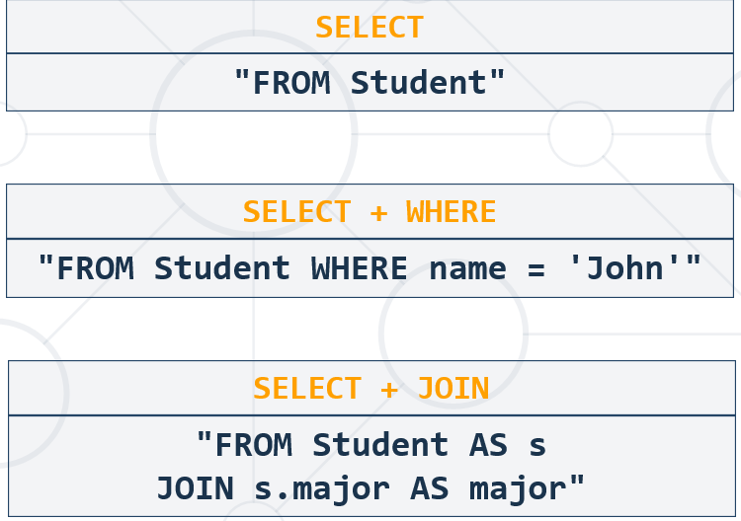

### Hibernate Retrieve Data by Criteria

**public static void** main(String[] args) {  
 *//…* session.beginTransaction();  
 **CriteriaBuilder** builder = session.getCriteriaBuilder(); **//by CriteriaBuilder it is type-safe**  
 **CriteriaQuery** criteria = builder.**createQuery()**;  
 **Root**<Student> r = criteria.**from**(Student.**class**);  
 criteria.**select**(r).**where**(builder.like(r.get(**"name"**), **"P%"**));

List<Student> studentList = session.createQuery(criteria).**getResultList();** //Get list of objects by criteria

**for** (Student student : studentList) {  
 System.***out***.println(student.getName());  
 }  
  
 session.getTransaction().commit();  
 session.close();  
}

## 3.4. JPA framework – Annotated Java classes (annotated POJO) mapped to DB tables

### About JPA – все едно огромно количество interface да се поддържат

* What is **Java Persistence API** (JPA)? – спецификация в Java казваща какво трябва да има един ORM, за да се класифицира като Java ORM
  + Database persistence technology for Java (**official** **standard**) – specific requirements/interfaces must be implemented so that we call it ORM engine acc. to Java official standard
    - Object-relational mapping (ORM) technology
    - Operates with POJO entities with annotations or XML mappings
    - **Implemented** by many **ORM** **engines**: **Hibernate**, **EclipseLink**, etc.
* JPA maps Java classes to database tables
  + Maps relationships between tables as associations between classes
* Provides **CRUD** functionality and queries
  + Create, read, update, delete + queries

### Entities in JPA

* A JPA entityis just a POJO class
  + Abstract or concrete **top level** Java class
  + Non-final fields/properties, **no-arguments constructor (задължително да има празен конструктор)**
  + No required interfaces
  + Direct field or property-based access
* Getter/setter can contain logic (e.g., validation)

### Entity Class: Student

@Entity

@Table(name = **"students"**) //set the class with name Student to be in the database as table students, подобно на xml mapping файла  
**public class** Student {  
 @Id //primary key  
 @GeneratedValue(strategy = GenerationType.IDENTITY) //identity  
 @Column(name = **"id"**) //column name  
 **private long id**;

@Column(name = **"name"**, length = 50) //column name and length  
 **private** String **name**;  
  
 *// Getters and setters //тук си създаваме конструктори/getters/setters ръчно*}

### Entity Class: Employee

**import javax.persistence.*;**  
**import** java.math.BigDecimal;  
**import** java.time.LocalDateTime;  
**import** java.util.Set;

**//прави впечатление, че няма анотация на private полетата, и само на getters има, а на setters няма, и пак работи**  
@Entity  
@Table(name = **"employees"**)  
**public class** Employee {  
 **private** Integer **id**;  
 **private** String **firstName**;  
 **private** String **lastName**;  
 **private** String **middleName**;  
 **private** String **jobTitle**;  
 **private** Department **department**;  
 **private** Employee **manager**;  
 **private** LocalDateTime **hireDate**;  
 **private** BigDecimal **salary**;  
 **private** Address **address**;  
 **private** Set<Project> **projects**;  
  
  
 @Id  
 @GeneratedValue(strategy = GenerationType.***IDENTITY***)  
 @Column(name = **"employee_id"**)  
 **public** Integer getId() {  
 **return id**;  
 }  
  
 **public void** setId(Integer id) {  
 **this**.**id** = id;  
 }  
  
 @Column(name = **"first_name"**)  
 **public** String getFirstName() {  
 **return firstName**;  
 }  
  
 **public void** setFirstName(String firstName) {  
 **this**.**firstName** = firstName;  
 }  
  
 @Column(name = **"last_name"**)  
 **public** String getLastName() {  
 **return lastName**;  
 }  
  
 **public void** setLastName(String lastName) {  
 **this**.**lastName** = lastName;  
 }  
  
 @Column(name = **"middle_name"**)  
 **public** String getMiddleName() {  
 **return middleName**;  
 }  
  
 **public void** setMiddleName(String middleName) {  
 **this**.**middleName** = middleName;  
 }  
  
 @Column(name = **"job_title"**)  
 **public** String getJobTitle() {  
 **return jobTitle**;  
 }  
  
 **public void** setJobTitle(String jobTitle) {  
 **this**.**jobTitle** = jobTitle;  
 }

### Entity Class: Student – вариант с lombok

**package** demos.hibernate.model;  
  
**import** lombok.Data;  
  
**import** java.util.Date;

  
@Data //пишем/избираме @Data анотация и не се налага да пишем след това getters, setters, etc за всеки елемент/поле/метод на класа – яко 😊

Но самите полета на класа не са анотирани в смисъл анотирани към базата данни, както е в следващата точка 3.4.  
@NoArgsConstructor //празен конструктор да има  
@RequiredArgsConstructor  
@AllArgsConstructor

@Entity

@Table(name = **"students"**)  
**public class** Student {

@Id //primary key  
 @GeneratedValue(strategy = GenerationType.IDENTITY) //identity  
 @Column(name = **"id"**) //column name  
 **private int id**;  
  
 @Column(name = **"name"**, length = 50) //column name and length**private** String **name**;

@Column(name = **"birth_date"**)

@Temporal(TemporalType.**TIMESTAMP**)  
 **private** Date **birthDate** = **new** Date();

//тук благодарение на Lombok, са ни генерирани *конструктори/getters/setters авитоматично*  
}

### Annotations

* **@Entity** - Declares the class as an entity or a table
* **@Table** - Declares table name
* **@Basic** - Specifies non-constraint fields explicitly
* **@Transient** - Specifies the property that is not persistent, i.e., the value is never stored in the database – да не се добавя в базата данни

**За Id полето**

* **@Id** - Specifies the property, use for identity (primary key of a table) of the class
  + **@GeneratedValue** - specifies how the identity attribute can be initialized
    - Automatic, manual, or value taken from a sequence table
* **@Column** -Specifies the column attribute for the persistence property – ако няма да го достъпваме/оказваме, то можем да пропуснем @Column анотацията. Но за да е видимо в базата данни, му слагаме все пак тази анотация

### JPA Configuration in Maven, in the pom.xml файла

#### [javax.persistence-api](https://mvnrepository.com/artifact/javax.persistence/javax.persistence-api)

<**dependency**>  
 <**groupId**>javax.persistence</**groupId**>  
 <**artifactId**>javax.persistence-api</**artifactId**>  
 <**version**>2.2</**version**>  
</**dependency**>

#### hibernate-core

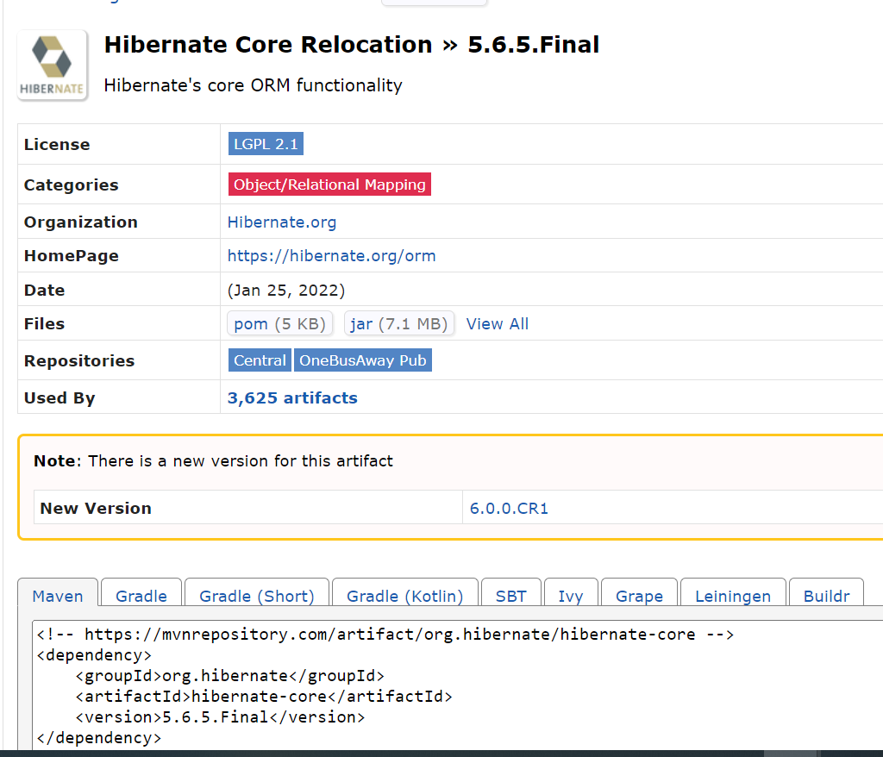

<**dependency**>  
 <**groupId**>org.hibernate</**groupId**>  
 <**artifactId**>hibernate-core</**artifactId**>  
 <**version**>5.4.30.Final</**version**>  
</**dependency**>

#### mysql-connector-java

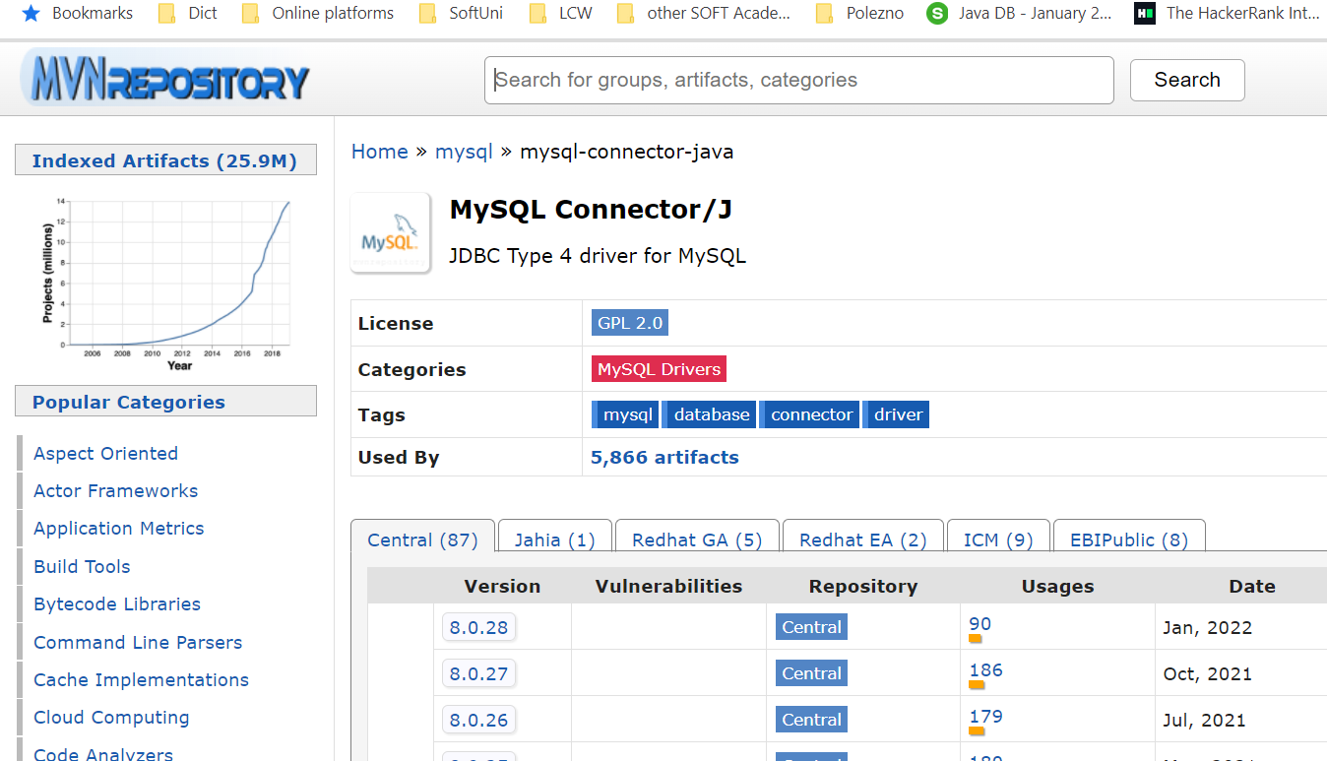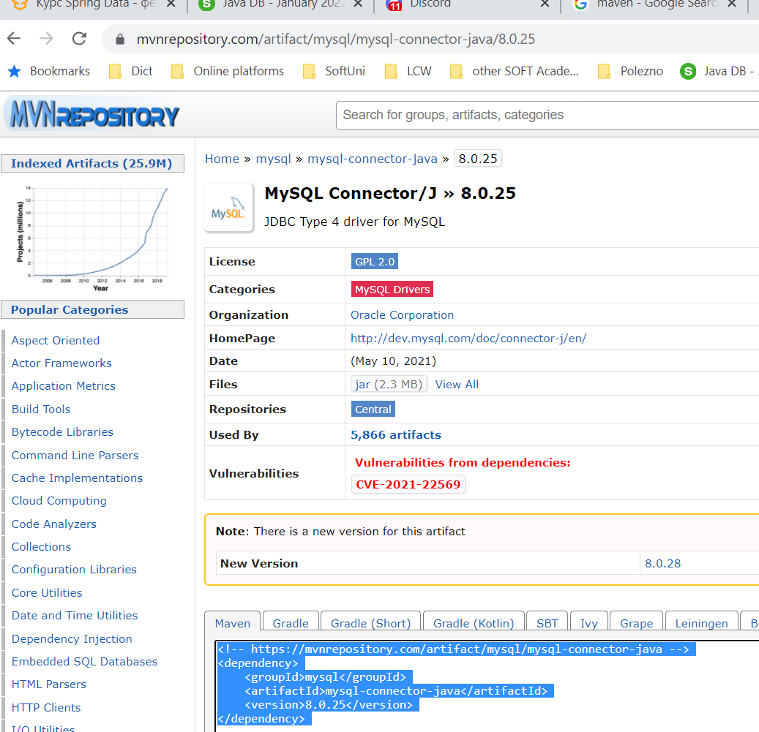

<**dependency**>  
 <**groupId**>mysql</**groupId**>  
 <**artifactId**>mysql-connector-java</**artifactId**>  
 <**version**>8.0.25</**version**>  
</**dependency**>

#### persistence.xml – create it in **src/main/resources/META-INF**

META-INF е стандартно име на папка в Java, в която папка биха стояли конфигурации



*<?***xml version="1.0" encoding="UTF-8"***?>*<**persistence xmlns="http://java.sun.com/xml/ns/persistence" version="2.0"**>  
 <**persistence-unit name="school"**> //persistence unit name  
 <**properties**>  
 <**property name="hibernate.connection.url"  
 value="jdbc:mysql://localhost:3306/school?createDatabaseIfNotExist=true"**/>  
 <**property name="hibernate.connection.driver_class" value="com.mysql.cj.jdbc.Driver"**/>  
 <**property name="hibernate.connection.username" value="root"**/>  
 <**property name="hibernate.connection.password" value=""**/>  
 <**property name="hibernate.dialect" value="org.hibernate.dialect.MySQL8Dialect"**/>

<**property name="hibernate.hbm2ddl.auto" value="update"**/>

<**property name="hibernate.hbm2ddl.auto" value="create-drop"**/> //изтрий таблицата и я пресъздай наново с новите/верните/променените колони

<**property name="hibernate.hbm2ddl.auto" value="validate"**/> //за валидиране на миграции на данни

<**property name="hibernate.show_sql" value="true"**/>

</**properties**>  
 </**persistence-unit**>  
</**persistence**>

### JPA Save Objects

**import** entities.Student;  
**import javax.persistence.**EntityManager;  
**import javax.persistence.**EntityManagerFactory;  
**import javax.persistence.**Persistence;  
  
**public class** Main {  
 **public static void** main(String[] args) {  
 EntityManagerFactory emf = Persistence.*createEntityManagerFactory*(**"school"**);

//persistence unit name e school  
  
 EntityManager em = emf.createEntityManager();  
 em.getTransaction().begin();  
  
 Student student = **new** Student(**"Teo"**);  
 em.persist(student);  
 em.getTransaction().commit();  
 em.close();  
 }  
}

### JPA schema – Java Persistence API

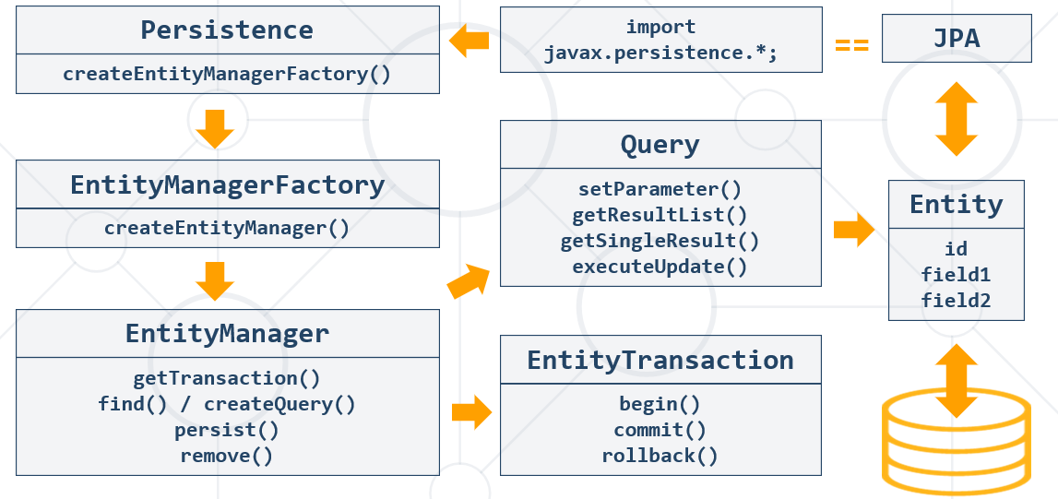

### Java Persistence Query Language = JPQL

Query query1 = entitymanager.createQuery(**"Select MAX(e.salary) from Employee e"**);

Query query = entitymanager.createQuery( **"Select e "** + **"from Employee e "** + **"where e.salary "** + **"Between 30000 and 40000"** );

### Persistence Context (PC) and Entities

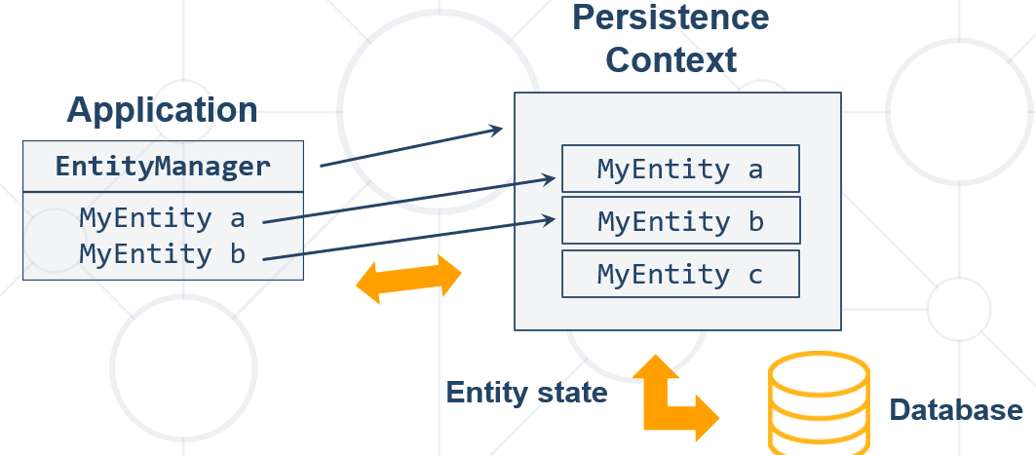

### Entity Object Life Cycle

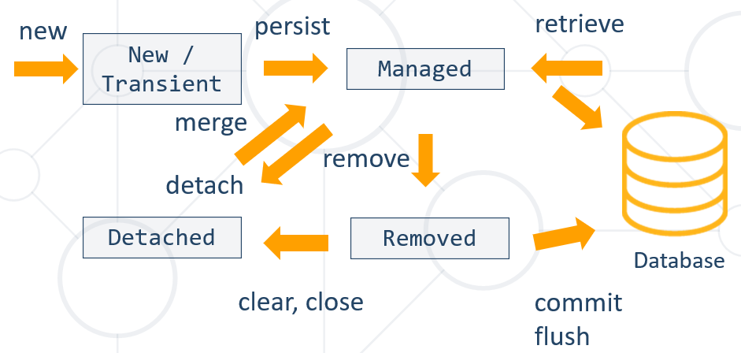

### JPA Write Data Methods

**Имената на елементите на анотациите са имената на променливите в базата данни!!!**

* **persist()** – persists given entity object into the DB (SQL INSERT)
* **remove()** – deletes given entity into the DB (SQL DELETE by primary key)
* **refresh()** – reloads given entity from the DB (SQL SELECT by primary key)
* **detach()** – removes the object from the persistence context(PC)
* **merge()** – synchronize the state of detached entity with the PC
* **contains()** - determine if given entity is managed by the PC
* **flush()** – writes the changes from PC (Persistence context) in the database

### JPA Read Data Methods

* + **find()** - execute a simple Select query by primary key – one item result onl

**import javax.persistence.**EntityManager;  
**import javax.persistence.**EntityManagerFactory;  
**import javax.persistence.**Persistence;

**public static void** main(String[] args) {  
 EntityManagerFactory emf = Persistence.*createEntityManagerFactory*(**"school"**);  
  
 EntityManager em = emf.createEntityManager();  
 em.getTransaction().begin();  
 em.**find**(Student.**class**, 1) //Get object  
 em.getTransaction().commit();  
}

### JPA Delete Objects

**import javax.persistence.**EntityManager;  
**import javax.persistence.**EntityManagerFactory;  
**import javax.persistence.**Persistence;

**public static void** main(String[] args) {  
 EntityManagerFactory emf = Persistence.*createEntityManagerFactory*(**"school"**);  
 EntityManager em = emf.createEntityManager();  
 em.getTransaction().begin();

Student student = em.find(Student.**class**, 1);  
 em.**remove**(student); //remove object  
 em.getTransaction().commit();

em.close();

}

### JPA Merge Objects

* Merges the state of **detached** entity into a **managed** **copy** of the detached entity. – ако сме изтрили(не изтрили, а детачнали !!!) дадено entity (инстанция на класа Student примерно), то изтритият обект стои в паметта и можем да го върнем с използване с командата **merge**
  + Returned entity has a different Java identity than the detached one
* May invoke SQL SELECT

**public** Student storeUpdatedStudent(Student student) {  
 **return** entityManager.**merge**(student);  
}

### JPA Retrieve Data by Criteria – more than one result

**import javax.persistence.**EntityManager;  
**import javax.persistence.**EntityManagerFactory;  
**import javax.persistence.**Persistence;

**public static void** main(String[] args) {  
EntityManagerFactory emf = Persistence.createEntityManagerFactory("school");

EntityManager em = emf.createEntityManager();

**em**.getTransaction().begin();

**CriteriaBuilder** builder = **em**.getCriteriaBuilder(); **//by CriteriaBuilder it is type-safe**  
 **CriteriaQuery** criteria = builder.**createQuery()**;  
 **Root**<Student> r = criteria.**from**(Student.**class**);  
 criteria.**select**(r).**where**(builder.like(r.get(**"name"**), **"P%"**));

List<Student> studentList = **em**.createQuery(criteria).**getResultList();** //Get list of objects by criteria

**for** (Student student : studentList) {  
 System.***out***.println(student.getName());  
 }  
  
 session.getTransaction().commit();  
 session.close();  
}

**Без да е type-safe вариантът**

**Навсякъде използваме име на клас, а не име на таблица**

Query from_town = entityManager.createQuery(**"SELECT t FROM Town t"**, Town.**class**);  
List<Town> resultList = from_town.getResultList();  
  
**for** (Town town : resultList) {  
 System.***out***.println(town);  
}

## 3.5. Transaction Log and BackUp

<https://liquibase.org/>

flyway

## 3.6. Differences between Hibernate without JPA (Hibernate existed before JPA) and only JPA

<https://vladmihalcea.com/jpa-persist-merge-hibernate-save-update-saveorupdate/>

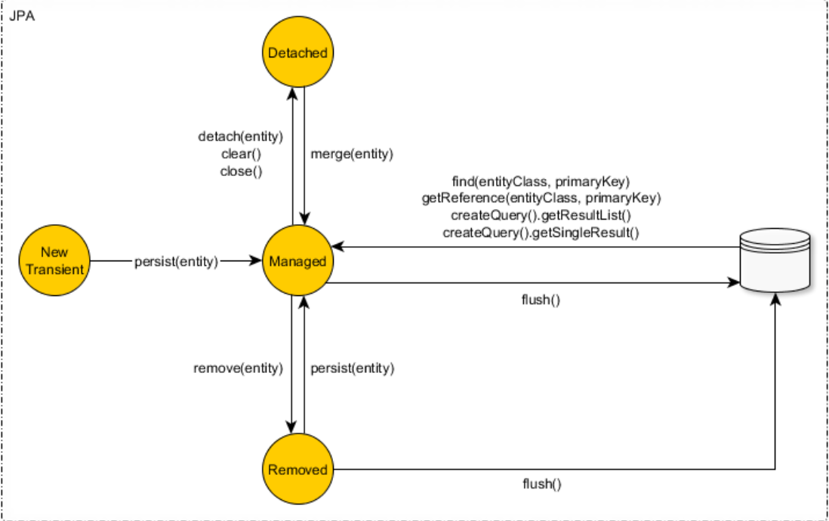

The Hibernate Session implements all the JPA EntityManager methods and provides some additional entity state transition methods like save, saveOrUpdate and update.

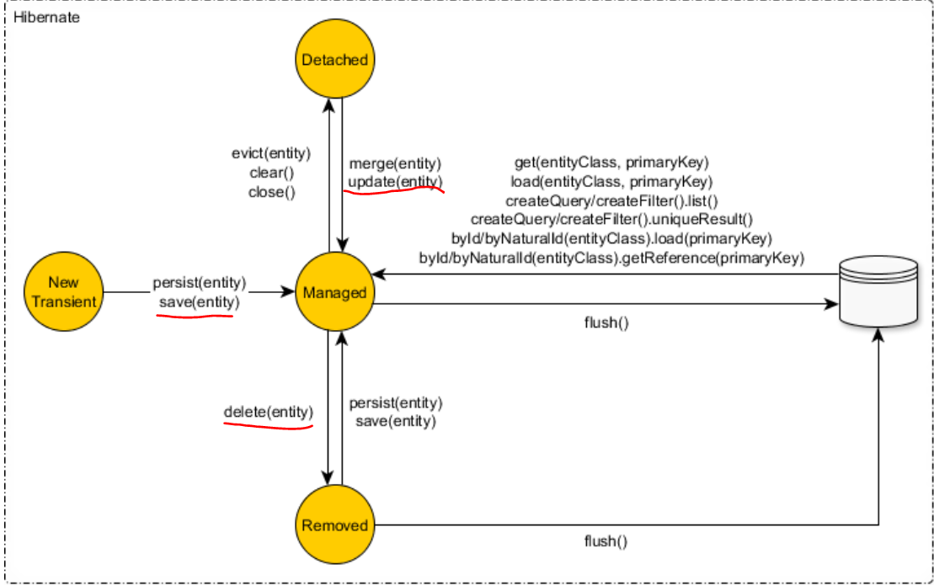

**JPA предоставя interfaces**, а Hibernate предоставя implementation.

Interface Session (hibernate) extends interface EntityManager(от JPA)

**interface** Session **extends** EntityManager

**Каквото има в JPA, може да се ползва и от hibernate. Но за да използваме вида mapping (xml или annotations), то трябва да използваме само единият от двата варианта.**

За повече универсалност, (да може да се ползва и от други системи), то е добре да използваме Hibernate винаги с JPA методите / само с JPA методите, без собствените методи на Hibernate.

Можем ако сме на Hibernate with JPA да го извадим/преобрaзуваме само на Hibernate и да си ползваме оригиналните методи на Hibernate, които не са част от JPA изискуемата спецификация.

<https://www.netsurfingzone.com/hibernate/get-session-from-entitymanager-in-spring-boot/>

Consider a scenario, we have Spring Boot Application and we need session object to perform some specific operation. In order to access Hibernate APIs(for example Session methods) from the JPA, we need a session object from javax.persistence.EntityManager. In this post, we will see How To get Hibernate Session From EntityManager in Spring Boot with Example.

**import javax.persistence.**EntityManager;  
**import javax.persistence.**EntityManagerFactory;  
**import javax.persistence.**Persistence;

**import org.hibernate.Session;**

**public static void** main(String[] args) {  
 EntityManagerFactory emf = Persistence.*createEntityManagerFactory*(**"school"**);  
 EntityManager em = emf.createEntityManager();

**Session** unwrap = em.unwrap(**Session**.**class**);

**Session** session = (**Session**) em.**getDelegate()**;

Когато в един проект сме имплементирали и Hibernate и JPA Hibernate

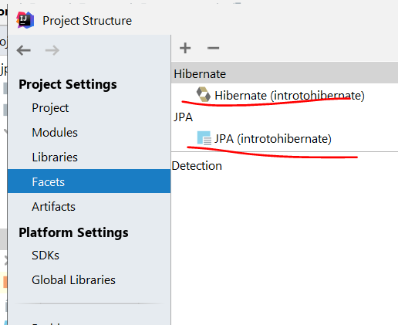

## 3.7. JPA’s 4 Lifecycle States

<https://thorben-janssen.com/entity-lifecycle-model/?fbclid=IwAR3s6VaYrscygTxriYJwhA13Mw__4HFQvh20M7zKWhXSnM9VK9NQkIqCbgw>

The lifecycle model consists of the 4 states –

**transient,**

**managed,**

**removed,**

**and detached.**

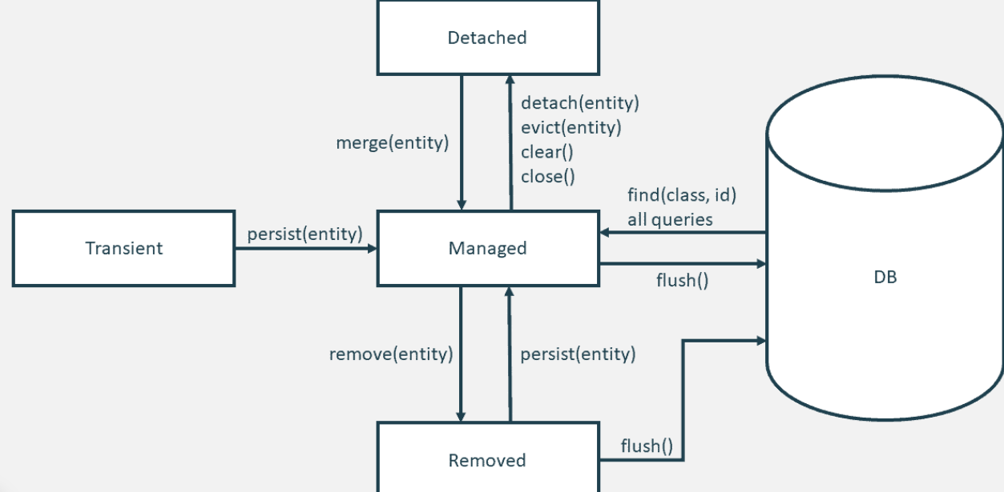

### Transient

The lifecycle state of a newly instantiated entity object is called transient. The entity hasn’t been persisted yet, so it doesn’t represent any database record.

Your persistence context doesn’t know about your newly instantiate object. Because of that, it doesn’t automatically perform an SQL INSERT statement or tracks any changes. As long as your entity object is in the lifecycle state transient, you can think of it as a basic Java object without any connection to the database and any JPA-specific functionality.

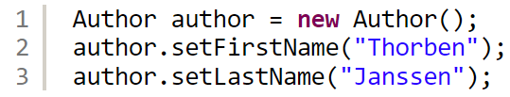

That changes when you provide it to the EntityManager.find method. The entity object then changes its lifecycle state to managed and gets attached to the current persistence context.

### Managed

All entity objects attached to the current persistence context are in the lifecycle state managed. That means that your persistence provider, e.g. Hibernate, will detect any changes on the objects and generate the required SQL INSERT or UPDATE statements when it flushes the persistence context.

There are different ways to get an entity to the lifecycle state managed:

#### 1. You can call the EntityManager.persist method with a new entity object.

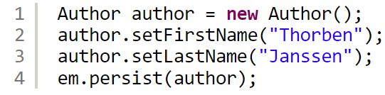

#### 2. You can load an entity object from the database using the EntityManager.find method, a [JPQL query](https://thorben-janssen.com/jpql/), a CriteriaQuery, or a [native SQL query](https://thorben-janssen.com/jpa-native-queries/).



*3. You can merge a detached entity by calling the*EntityManager.merge *method or update it by calling the*update *method on your Hibernate*Session*.*

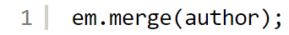

### Detached

An entity that was previously managed but is no longer attached to the current persistence context is in the lifecycle state detached.

An entity gets detached when you close the persistence context(not by removing it😊). That typically happens after a request got processed. Then the database transaction gets committed, the persistence context gets closed, and the entity object gets returned to the caller. The caller then retrieves an entity object in the lifecycle state detached.

You can also programmatically detach an entity by calling the detach method on the EntityManager.

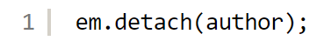

There are only very few performance tuning reasons to detach a managed entity. If you decide to detach an entity, you should first flush the persistence context to avoid losing any pending changes.

### Reattaching an entity

You can reattach an entity by calling the update method on your Hibernate Session or the merge method on the EntityManager. There are a few subtle differences between these operations that I explain in great detail in What’s the difference between persist, save, merge and update? Which one should you use?

In both cases, the entity changes its lifecycle state from detached to managed.

### Removed

When you call the remove method on your EntityManager, the mapped database record doesn’t get removed immediately. The entity object only changes its lifecycle state to removed.

During the next flush operation, Hibernate will generate an SQL DELETE statement to remove the record from the database table.

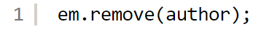

### Conclusion

All entity operations are based on JPA’s lifecycle model. It consists of 4 states, which define how your persistence provider handles the entity object.

New entities that are not attached to the current persistence context are in the transient state.

If you call the persist method on the EntityManager with a new entity object or read an existing record from the database, the entity object is in the managed state. It’s connected to the current persistence context. Your persistence context will generate the required SQL INSERT and UPDATE statement to persist the current state of the object.

Entities in the state removed are scheduled for removal. The persistence provider will generate and execute the required SQL DELETE statement during the next flush operation.

If a previously managed entity is no longer associated with an active persistence context, it has the lifecycle state detached. Changes to such an entity object will not be persisted in the database.

## 3.7. Подход при изпълняване на JPQL заявки

### Подход с CriteriaBuilder – it is type-safety

#### Пример за LIKE употреба

CriteriaBuilder builder = entityManager.getCriteriaBuilder(); *//by CriteriaBuilder it is type-safe*CriteriaQuery criteria = builder.createQuery();  
Root<Employee> r = criteria.from(Employee.**class**);  
CriteriaQuery **criteriaQuery** = criteria.select(r).where(builder.like(r.get(**"firstName"**),  
 String.*format*(**"%s"**, pattern) + **"%"**));  
  
*//We put the criteria query here*List<Employee> resultList = entityManager.createQuery(**criteriaQuery**)  
 .getResultList();  
  
**for** (Employee e : resultList) {  
 String toPrint = String.*format*(**"%s %s - %s - ($%.2f)"**, e.getFirstName(), e.getLastName(),  
 e.getJobTitle(), e.getSalary());  
 System.***out***.println(toPrint);  
}

### Подход с директна Update JPQL заявка в базата данни *// entityManager.createQuery("UPDATE Town t SET t.name=lower(t.name) WHERE length(t.name) >=5")***.executeUpdate();**

### Подход взимаме нещата от базата, правим нещо с данните, и записваме/update-ваме само, което ни трябва

Query from_town = entityManager.createQuery(**"SELECT t FROM Town t"**, Town.**class**);  
List<Town> resultList = from_town.getResultList();  
  
**for** (Town town : resultList) {  
 String name = town.getName();  
 **if** (name.length() <= 5) {  
 String toUpper = name.toUpperCase();  
 town.setName(toUpper);  
  
 entityManager.persist(town);  
 }  
}

## 3.8. Специфики при използване на JPA JPQL заявки

### Класът Employee

@Entity  
@Table(name = **"employees"**)  
**public class** Employee {  
 **private** Integer **id**;  
 **private** String **firstName**;  
 **private** String **lastName**;  
 **private** String **middleName**;  
 **private** String **jobTitle**;  
 **private** Department **department**;  
 **private** Employee **manager**;  
 **private** LocalDateTime **hireDate**;  
 **private** BigDecimal **salary**;  
 **private** Address **address**;  
 **private** Set<Project> **projects**;

### Set-ване на полета – вместо ? въпросче, то използваме :Име на параметър в JPA

вместо ? въпросче,

то използваме две точки: Име на параметър и след това set-ваме параметъра

Както казахме още в съвсем началото Hibernate и JPA използва заявки имената на класовете и имената полетата на класовете!!!

Long employeeCount = entityManager.createQuery(**"SELECT COUNT(e) FROM Employee e"** +  
 **" WHERE e.firstName = :first_name"** +  
 **" AND e.lastName = :last_name"**,  
 Long.**class**) //типа на връщания резултат, който си искаме да ни върне  
 .**setParameter**(**"first_name"**, searchFor[0])  
 .**setParameter**(**"last_name"**, searchFor[1])  
 .**getSingleResult**(); //върни един резултат  
  
**if** (employeeCount > 0L) {  
 System.***out***.println(**"Yes"**);  
} **else** {  
 System.***out***.println(**"No"**);  
}

### getSingleResult и getResultList in JPA

List<String> resultList = entityManager.createQuery(**"SELECT e.firstName FROM Employee e"** +  
 **" WHERE e.salary > 50000"**,  
 String.**class**) //върни getSingleResult да е от тип String  
 .**getResultList()**; //върни колкото резултати String има под формата на List<String>

### getResultStream и заобикаляне на JOIN

String department = **"Research and Development"**;  
  
entityManager.createQuery(**"SELECT e FROM Employee e"** +  
 **" WHERE e.department.name = :departmentName"** + //без да използваме join 😊  
 **" ORDER BY e.salary ASC, e.id ASC"**,  
 Employee.**class**)  
 .setParameter(**"departmentName"**, department)  
 .**getResultStream()**  
 .**forEach**(e -> {  
 String format = String.*format*(**"%s %s from %s - $%.2f"**,  
 e.getFirstName(), e.getLastName(), department, e.getSalary());  
  
 System.***out***.println(format);  
 });

### getResultStream и SET на полета на обекти, които се оказва се записват и в базата данни

List<String> updateCriteria = Arrays.*asList*(**"Engineering"**, **"Tool Design"**, **"Marketing"**, **"Information Services"**);  
  
entityManager.createQuery(**"SELECT e FROM Employee e"** +  
 **" WHERE e.department.name IN (:params)"**,  
 Employee.**class**)  
 .setParameter(**"params"**, updateCriteria)  
 .**getResultStream()**  
 .**forEach**(е -> **е.setSalary**(е.getSalary().multiply(BigDecimal.*valueOf*(1.12)))); // set на полета на обекти, които се оказва се записват и в базата данни

### executeUpdate и параметър като цял обект

String addressText = **"Vitoshka 15"**;  
Address address = **new** Address(); //цял обект  
address.setText(addressText);  
  
entityManager.persist(address);

*//без да type-cast-ваме – няма опция да му кажем какъв обект връща createQuery*entityManager.createQuery(**"UPDATE Employee e"** +  
 **" SET e.address = :addr"** +  
 **" WHERE e.lastName = :employeeName"**)   
 .setParameter(**"employeeName"**, lastName)  
 .setParameter(**"addr"**, address)  
 **.executeUpdate();**

### Заобикаляне на COUNT и LIMIT

entityManager.createQuery(**"FROM Address a"** +  
 **" ORDER BY a.employees.size DESC"**, *//Deprecated, новия JPQL синтаксис е SIZE(a.employees), COUNT(a.employees) става също* Address.**class**)  
 .**setMaxResults**(10) *//вместо LIMIT 10 в заявката* .getResultStream()

.limit(10) //тук вече сме преточили цялата база данни и от stream-а лимитираме 10  
 .forEach(System.***out***::println);

### IN в JPQL

**List<String>** updateCriteria = **Arrays.*asList***(**"Engineering"**, **"Tool Design"**, **"Marketing"**, **"Information Services"**);

List<Employee> resultList = entityManager.createQuery(**"SELECT e FROM Employee e"** +  
 **" WHERE e.department.name IN (:params)"**, //може и без скоби след IN  
 Employee.**class**)  
 .setParameter(**"params"**, updateCriteria)  
 .getResultList();  
  
resultList.stream()  
 .forEach(e -> System.***out***.println(String.*format*(**"%s %s ($%.2f)"**,  
 e.getFirstName(), e.getLastName(), e.getSalary())));

### TypedQuery

**public class** CustomEmployee {  
 **public** Department **department**;  
 **public** BigDecimal **salary**;  
  
 **public** CustomEmployee() {  
 }

String query = "FROM Employee e" +

                "  GROUP BY e.department" +

                " HAVING MAX(e.salary) NOT BETWEEN :min AND :max";

        TypedQuery<CustomEmployee> typQuery = entityManager.createQuery(query, CustomEmployee.**class**);

        typQuery.setParameter("min", 30000);

        typQuery.setParameter("max", 70000);

        List<CustomEmployee> resultList1 = typQuery.getResultList();

**for** (CustomEmployee customEmployee : resultList1) {

            System.out.println(String.format("%s %.2f", customEmployee.department.getName(), customEmployee.salary));

        }

### Върни List<Object[]> от SELECT параметрите

Правилният вариант не е да го конкатенираме или пък да използваме Object[].

Правилният вараинт е да се направи с ръчно генериране на интерфейс или клас със съответните необходими полета, и този клас да го цитираме в JPQL заявката!!! В SpringData преподавателят така каза, че е правилния вариант / добрия вариант!!! Но не сме го имплементирали все още правилно!!!

List<Object[]> resultList = entityManager.createQuery(**"SELECT e.department.name, MAX(e.salary) FROM Employee e"** +  
 **" GROUP BY e.department.id"** +  
 **" HAVING MAX(e.salary) NOT BETWEEN 30000 AND 70000"**,  
 Object[].**class**)  
 .getResultList();  
  
**for** (Object[] o : resultList) {  
 String departName = (String) o[0];  
 BigDecimal salary = (BigDecimal) o[1];  
 System.***out***.printf(**"%s %.2f%n"**, departName, salary);

### Подход дали да използваме заявка със Select или директно да връщаме класа започвайки с FROM

entityManager.createQuery(**"SELECT e FROM Employee e"**

И двата варианта са възможни.

### Заобикаляне на JOIN, плюс CONCAT и return String.class

List<String> resultList = entityManager.createQuery(**"SELECT CONCAT(d.name, ' ', MAX(e.salary)) FROM Employee AS e"** +  
 **" JOIN e.department AS d"** +  
 **" GROUP BY d.id"** +  
 **" HAVING MAX(e.salary) NOT BETWEEN 30000 AND 70000"**,  
 String.**class**)  
 .getResultList();  
  
**for** (String s : resultList) {  
 System.***out***.printf(**"%s%n"**, s);  
}

# 4. Hibernate (JPA) Code First Entity Relations - Advanced Mapping

По спецификация винаги трябва да имаме празен конструктор. Операцията persist не го изисква. Но съгласно custom-orm, при търсене примерно find създаваме getDeclaredConstructor().newInstance(); и тук търси празен конструктор, който ние трябва да сме декларирали ръчно също.

## 4.0. Когато слагаме много полета в клас, то по-добре е самите полета да не са анотирани, а да анотираме само getters – по четимо е така

@Entity  
@Table(name = **"employees"**)  
**public class** Employee {  
 **private** Integer **id**;  
 **private** String **firstName**;  
 **private** String **lastName**;  
 **private** String **middleName**;  
 **private** String **jobTitle**;  
 **private** Department **department**;  
 **private** Employee **manager**;  
 **private** LocalDateTime **hireDate**;  
 **private** BigDecimal **salary**;  
 **private** Address **address**;  
 **private** Set<Project> **projects**;  
  
  
 @Id  
 @GeneratedValue(strategy = GenerationType.***IDENTITY***)  
 @Column(name = **"employee_id"**)  
 **public** Integer getId() {  
 **return id**;  
 }  
  
 **public void** setId(Integer id) {  
 **this**.**id** = id;  
 }  
  
 @Column(name = **"first_name"**)  
 **public** String getFirstName() {  
 **return firstName**;  
 }  
  
 **public void** setFirstName(String firstName) {  
 **this**.**firstName** = firstName;  
 }

## 4.1. Java Persistence API Inheritance

Fundamental Inheritance Concepts

### Inheritance

* Inheritance is a fundamental concept in most programming languages
  + SQL does not support this kind of relationships
* Implemented by any JPA framework by **inheriting** and **mapping** **Entities**

### JPA Inheritance Strategies

* Implemented by the **javax.persistence.Inheritance** annotation
* The following mapping strategies are used to map the entity data to the underlying database:
  + MappedSuperclass
  + A single **table per class** hierarchy – една таблица за клас
  + A table per **concrete entity class**
  + "**Join**" strategy – mapping common fields in a single table

### 0. ***@MappedSuperclass*** Strategy

@MappedSuperclass and provides the shared attributes with their mapping annotations. As you can see, Publication has no @Entity annotation and will not be managed by the persistence provider.

@MappedSuperclass  
**public abstract class** Publication {  
  
 @Id  
 @GeneratedValue(strategy = GenerationType.AUTO)  
 @Column(name = “id”, updatable = **false**, nullable = **false**)  
 **protected** Long **id**;  
  
 @Column  
 **protected** String **title**;  
  
 @Version  
 @Column(name = “version”)  
 **private int version**;  
  
 @Column  
 @Temporal(TemporalType.DATE)  
 **private** Date **publishingDate**;  
   
 …  
}

### 1. ***TABLE_PER_CLASS*** Strategy

The table per class strategy is similar to the mapped superclass strategy. The main difference is that the superclass is now also an entity.

This mapping allows you to use polymorphic queries and to define relationships to the superclass. But the table structure adds a lot of complexity to polymorphic queries, and you should, therefore, avoid them!

* **Table creation for each entity**
  + A table defined for each concrete class in the inheritance
  + Allows inheritance to be used in the object model, when it does not exist in the data model
* Querying root or branch classes can be very difficult and **inefficient**

#### Sample:

**import** javax.persistence.*;  
  
@Entity

@Table(name = **"vehicles"**)

@Inheritance(strategy = InheritanceType.***TABLE_PER_CLASS***)  
**public abstract class** Vehicle {  
 @Id *// auto_increment*  
 @GeneratedValue(strategy = GenerationType.***TABLE***) //*пазим уникални ключове измежду много таблици*  
 **private int id**;  
  
 @Basic  
 **private** String **type**;

}

**import** javax.persistence.Entity;  
**import** javax.persistence.Table;  
  
@Entity  
@Table(name = **"bikes"**)  
**public class** Bike **extends** Vehicle {  
 **private static final** String ***BIKE_TYPE*** = **"Bike"**;  
  
 **private int gearCount**;  
  
 **public** Bike(**int** gearCount) {  
 **super**(***BIKE_TYPE***);  
 **this**.**gearCount** = gearCount;  
 }

}

**import** javax.persistence.Entity;  
**import** javax.persistence.Table;  
  
@Entity  
@Table(name = **"cars"**)  
**public class** Car **extends** Vehicle {  
 **private static final** String ***CAR_TYPE*** = **"Car"**;  
  
 **private int doors**;  
  
 **public** Car(**int** doors) {  
 **super**(***CAR_TYPE***);  
 **this**.**doors** = doors;  
 }

EntityManagerFactory emf = Persistence.*createEntityManagerFactory*(**"soft_uni"**);  
EntityManager entityManager = emf.createEntityManager();  
  
entityManager.getTransaction().begin();  
Bike bike = **new** Bike(21);  
Car car = **new** Car(5);  
  
entityManager.persist(bike);  
entityManager.persist(car);  
  
entityManager.getTransaction().commit();  
entityManager.close();

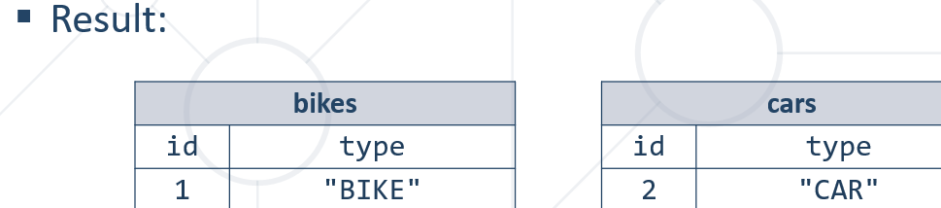

За няколко класа от общия abstract-ен клас Vehicle пази таблица **hibernate_sequences** в базата данни, която следи за поредното id на абстрактния клас Vehicle.



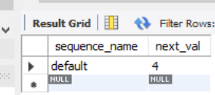

#### Table Per Class Strategy: Conclusion

* **Disadvantages**:
  + Repeating information in each table
  + Changes in super class involves changes in all subclass tables – промяна в една таблица, промяна във таблиците навързани по йерархията
  + No foreign keys involved (unrelated tables)
* **Advantages**:
  + No NULL values – no unneeded fields
  + Simple style to implement inheritance mapping

### 2. ***JOINED*** Strategy

* **Table is defined for each class in the inheritance hierarchy**
  + Storing of that class **only the local attributes**
  + Each table must store object's **primary key**

#### Example:

@Entity  
@Table(name = **"vehicles"**)  
@Inheritance(strategy = InheritanceType.***JOINED***)  
**public abstract class** Vehicle {  
 @Id *// auto_increment*  
 @GeneratedValue(strategy = GenerationType.***TABLE***) //*пазим уникални ключове измежду много таблици*  
 **private int id**;  
  
 @Basic  
 **private** String **type**;  
  
 **private double price**;

@MappedSuperclass *//нещо междинно го анотира, няма таблица за SQL от този клас да има***public abstract class** TransportationVehicle **extends** Vehicle{  
 **private int loadCapacity**;  
  
 **public** TransportationVehicle() {  
 }  
  
 **public** TransportationVehicle(String type, **double** price, **int** loadCapacity) {  
 **super**(type, price);  
 **this**.**loadCapacity** = loadCapacity;  
 }

@Entity  
@Table(name = **"trucks"**)  
**public class** Truck **extends** TransportationVehicle {  
 **private static final** String ***TRUCK_TYPE*** = **"Truck"**;  
  
 **public** Truck(**double** price, **int** loadCapacity) {  
 **super**(***TRUCK_TYPE***, price, loadCapacity);  
 }  
}

main

Bike bike = **new** Bike(21);  
Car car = **new** Car(5);  
Truck truck = **new** Truck(25000, 40000);  
  
entityManager.persist(bike);  
entityManager.persist(car);  
entityManager.persist(truck);

#### Results – Joined Strategy

* **Disadvantages**:
  + Multiple JOINS - for deep hierarchies it may give poor performance
* **Advantages**:
  + No NULL values
  + No repeating information
  + Foreign keys involved
  + Reduced changes in schema on superclass changes – ако има промяна в truck, промяната се отразява само в trucks таблицата в базата данни

The joined table approach maps each class of the inheritance hierarchy to its own database table. This sounds similar to the table per class strategy. But this time, also the abstract superclass Publication gets mapped to a database table. This table contains columns for all shared entity attributes. The tables of the subclasses are much smaller than in the table per class strategy. They hold only the columns specific for the mapped entity class and a primary key with the same value as the record in the table of the superclass.

### 3. ***SINGLE_TABLE*** Strategy – **най-използваната/предпочитаната**

The single table strategy maps all entities of the inheritance structure to the same database table. This approach makes polymorphic queries very efficient and provides the best performance.

* **Simplest** and typically the best performing and best solution
  + A single table is used to store all the instances of the **entire** **inheritance hierarchy**
  + A column for every attribute of every class
  + A **discriminator column** is used to determine to which class the particular row belongs to

Когато типа е колело, то от началото до края типа е колело в рамките на SQL базата данни!

When you persist all entities in the same table, Hibernate needs a way to determine the entity class each record represents. This is information is stored in a discriminator column which is not an entity attribute. You can either define the column name with a @DiscriminatorColumn annotation on the superclass or Hibernate will use DTYPE as its default name.

#### Example

@Entity  
@Table(name = **"vehicles"**)  
@Inheritance(strategy = InheritanceType.***SINGLE_TABLE***)  
@DiscriminatorColumn(name = **"type"**) //указваме коя колона от базата данни следи за типовете  
**public abstract class** Vehicle {  
 @Id  
 @GeneratedValue(strategy = GenerationType.***TABLE***) *//може в случая и .IDENTITY, за да не пазим уникални ключове измежду много таблици*

**private int id**;  
  
 @Basic  
 @Column(insertable = **false**, updatable = **false**)  
 **private** String **type**;  
  
 **private double price**;  
  
 **public** Vehicle() {  
 }  
  
 **public** Vehicle(String type, **double** price) {  
 **this**.**type** = type;  
 **this**.**price** = price;  
 }

@MappedSuperclass *//нещо междинно го анотира, няма таблица за SQL от този клас да има***public abstract class** TransportationVehicle **extends** Vehicle{  
 **private int loadCapacity**;  
  
 **public** TransportationVehicle() {  
 }  
  
 **public** TransportationVehicle(String type, **double** price, **int** loadCapacity) {  
 **super**(type, price);  
 **this**.**loadCapacity** = loadCapacity;  
 }

You should also provide a @DiscriminatorValue annotation. It specifies the discriminator value for this specific entity class so that your persistence provider can map each database record to a concrete entity class.

As I explained at the beginning of this section, the single table strategy allows easy and efficient data access. All attributes of each entity are stored in one table, and the query doesn’t require any join statements. The only thing that Hibernate needs to add to the SQL query to fetch a particular entity class is a comparison of the discriminator value.

@Entity  
@Table(name = **"trucks"**)  
@DiscriminatorValue(**"truck"**) //какво да пише в дискриминационната колона type  
**public class** Truck **extends** TransportationVehicle {  
 **private static final** String ***TRUCK_TYPE*** = **"Truck"**;  
  
 **public** Truck(**double** price, **int** loadCapacity) {  
 **super**(***TRUCK_TYPE***, price, loadCapacity);  
 }  
}

@Entity  
@Table(name = **"bikes"**)  
@DiscriminatorValue(**"bike"**) //какво да пише в дискриминационната колона type  
**public class** Bike **extends** Vehicle {  
 **private static final** String ***BIKE_TYPE*** = **"Bike"**;  
  
 **private int gearCount**;  
  
 **public** Bike(**int** gearCount) {  
 **super**(***BIKE_TYPE***, 250);  
 **this**.**gearCount** = gearCount;  
 }

@Entity  
@Table(name = **"cars"**)  
@DiscriminatorValue(**"car"**) //какво да пише в дискриминационната колона type  
**public class** Car **extends** Vehicle {  
 **private static final** String ***CAR_TYPE*** = **"Car"**;  
  
 **private int doors**;  
  
 **public** Car(**int** doors) {  
 **super**(***CAR_TYPE***, 2500);  
 **this**.**doors** = doors;  
 }

main

Bike bike = **new** Bike(21);  
Car car = **new** Car(5);  
Truck truck = **new** Truck(25000, 40000);  
  
entityManager.persist(bike);  
entityManager.persist(car);  
entityManager.persist(truck);

#### Results – Single Table Strategy

Създава само една таблица **vehicles,** и hibernate_sequences както обикновено



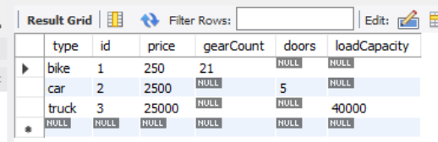

Polymorphic queries no drama here. All entities of the inheritance hierarchy are mapped to the same table and can be selected with a simple query

Hibernate не е прост, той ще задейства за даден тип само определените колони!

### 4. Choosing strategy

* If you require the best performance and need to use polymorphic queries and relationships, you should choose the single table strategy. But be aware, that you can’t use not null constraints on subclass attributes which increase the risk of data inconsistencies.
* If data consistency is more important than performance and you need polymorphic queries and relationships, the joined strategy is probably your best option.
* If you don’t need polymorphic queries or relationships, the table per class strategy is most likely the best fit. It allows you to use constraints to ensure data consistency and provides an option of polymorphic queries. But keep in mind, that polymorphic queries are very complex for this table structure and that you should avoid them.

## 4.2. Table Relations - връзки

**В който entity клас създадем допълнително поле, на което задаваме релация, това допълнително поле се добавя в базата данни.(т.н. foreign key).**

Как разбираме ЛЕСНО кога да използваме mappedBy и кога не – пишем @OneToMany() и кликаме Alt+Enter и то ни излиза какво можем да добавим.

Ако не използваме mappedBy, то вариантът е да използваме в допълнение @JoinColumn

Винаги има вариант да използваме само и единствено една анотация за релация(@ManyToMany или другите) и то без параметри, и persistence се справя!

**С mappedBy казваме, че връзката ни е Bidirectional**

Реално имаме mappedBy само от едната страна на връзката.

Но за двупосочна връзка си пишем съответните анотации и от двете страни, и Hybernate си знае за връзката като сме задали от едната страна mappedBy.

Когато създадем унидиректионал еднопосочна връзка, то е добре да я направим bidirectional и в двете посоки. Не е ок да получаваме две отделни връзки за едно и също нещо….?

### Database Relationships

<https://thorben-janssen.com/complete-guide-inheritance-strategies-jpa-hibernate/?fbclid=IwAR0lDIMrbasNhcij4oKen4GjxLFpU0bpDoboEwdP1wGeAEcVdxpMSHMEenc>

There are several types of database relationships:

* **One to One** Relationships
* **One to Many** and **Many to One** Relationships
* **Many to Many** Relationships
* **Self Referencing** Relationships

По спецификация винаги трябва да имаме празен конструктор. Операцията persist не го изисква. Но съгласно custom-orm, при търсене примерно find създаваме getDeclaredConstructor().newInstance(); и тук търси празен конструктор, който ние трябва да сме декларирали ръчно също.

**Правило – да ги държим връзките еднопосочни по възможност!**

**Която таблица е по-важна, там държим връзката. В случая, шампоанът логично е по значим от съставките и от production batch-a.**

### One-To-One – Unidirectional - Еднопосочно

**Шампоана знае към кой етикет се отнася, но и етикетът НЕ знае към кой шампоан е**

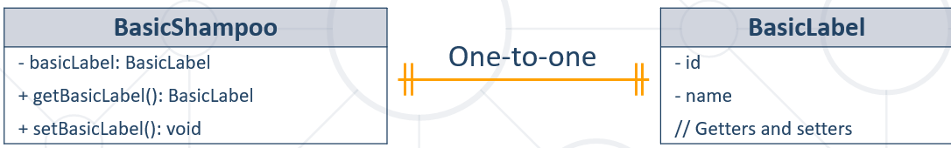

@Entity  
@Table(name = **"shampoos"**)  
**public class** BasicShampoo {  
 @Id  
 @GeneratedValue(strategy = GenerationType.***IDENTITY***)  
 **private int id**;  
  
 **private** String **name**;  
  
 @OneToOne(optional = **false**) //**Runtime evaluation false няма право(NOT NULL в SQL)**  
 @JoinColumn(name = **"label_id"**, referencedColumnName = **"id"**) *//name е при нашата таблица, referencedColumnName е отсрещната таблица* //**Column name in table shampoos, referencedColumnName in table labels****private** BasicLabel **label**;

main

BasicLabel label = **new** BasicLabel(**"blue"**);  
BasicShampoo shampoo = **new** BasicShampoo(**"shower"**, label);  
  
entityManager.persist(label); //първо създаваме label  
entityManager.persist(shampoo); //след това създаваме shampoo

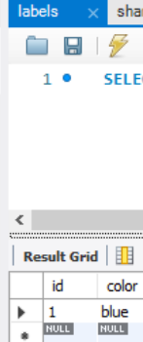 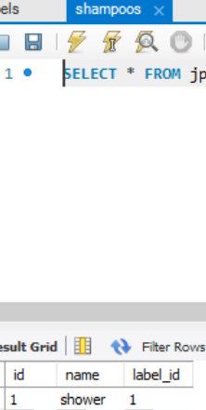

### One-To-One – Bidirectional – двупосочна

**Шампоанът знае към кой етикет се отнася, но и етикетът знае към кой шампоан е**

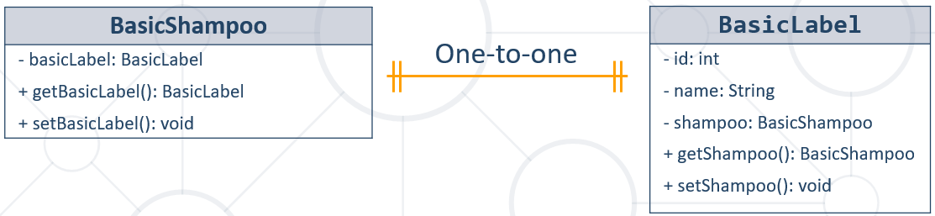

@Entity  
@Table(name = **"shampoos"**)  
**public class** BasicShampoo {  
 @Id  
 @GeneratedValue(strategy = GenerationType.***IDENTITY***)  
 **private int id**;  
  
 **private** String **name**;  
  
 @OneToOne(optional = **false**) **false няма право(NOT NULL в SQL)**  
 @JoinColumn(name = **"label_id"**, referencedColumnName = **"id"**) *//name е при нашата таблица, referencedColumnName е отсрещната таблица* **private** BasicLabel **label**;

@Entity  
@Table(name = **"labels"**)  
**public class** BasicLabel {  
 @Id  
 @GeneratedValue(strategy = GenerationType.***IDENTITY***)  
 **private int id**;  
 **private** String **color**;

**С mappedBy казваме, че връзката ни е Bidirectional**  
 @OneToOne(mappedBy = **"label"**, //**Field in entity BasicShampoo (не е колона от базата данни)**

targetEntity = BasicShampoo.**class**) // **Entity for the mapping**  
 **private** BasicShampoo **shampoo**;

main

BasicLabel label = **new** BasicLabel(**"blue"**);  
BasicShampoo shampoo = **new** BasicShampoo(**"shower"**, label);  
  
entityManager.persist(label); //първо създаваме label  
entityManager.persist(shampoo); //след това създаваме shampoo

Създава се същите таблици, но вече имаме двустранна връзка

### Many-To-One – Unidirectional

Много шампоани като всеки от тях има production batch.

**Полето ForeignKey е от Many страната на релацията.**

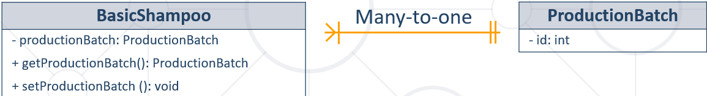

@Entity  
@Table(name = **"batches"**)  
**public class** ProductionBatch {  
 @Id  
 @GeneratedValue(strategy = GenerationType.***IDENTITY***)  
 **private int id**;  
  
 @Column(name = **"created_at"**)  
 **private** LocalDate **createdAt**;

@Entity  
@Table(name = **"shampoos"**)  
**public class** BasicShampoo {  
 @Id  
 @GeneratedValue(strategy = GenerationType.***IDENTITY***)  
 **private int id**;  
  
 **private** String **name**;  
  
 @OneToOne(optional = **false**) **//имам ли право да има NULL стойност в базата, false няма право(NOT NULL в SQL)**  
 @JoinColumn(name = **"label_id"**, referencedColumnName = **"id"**) *//name е при нашата таблица, referencedColumnName е отсрещната таблица* **private** BasicLabel **label**;

*//Все едно външен ключ foreign key създава*  
 *//много шампони да принадлеждат на една партида* @ManyToOne(optional = **false**) **//имам ли право да има NULL стойност в базата, false няма право (NOT NULL в SQL)**  
 @JoinColumn(name = **"batch_id"**, referencedColumnName = **"id"**) // **Column name in   
table shampoos, Column name in table batches**

**private** ProductionBatch **batch**;

**main**

ProductionBatch batch = **new** ProductionBatch(LocalDate.*now*());  
BasicLabel label = **new** BasicLabel(**"blue"**);  
BasicShampoo shampoo = **new** BasicShampoo(**"shower"**, label, batch);  
  
entityManager.persist(batch);  
entityManager.persist(label);  
entityManager.persist(shampoo);

### One-To-Many – Bidirectional

**Полето ForeignKey е от Many страната на релацията.**

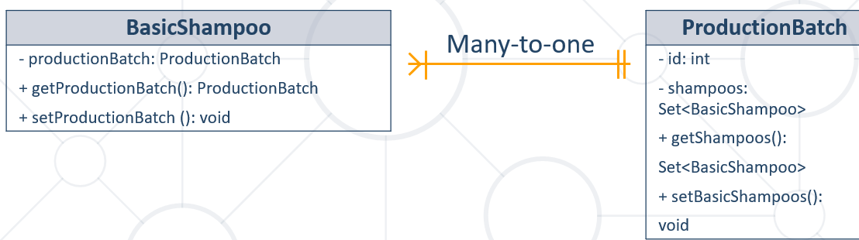

@Entity  
@Table(name = **"batches"**)  
**public class** ProductionBatch {  
 @Id  
 @GeneratedValue(strategy = GenerationType.***IDENTITY***)  
 **private int id**;  
  
 @Column(name = **"created_at"**)  
 **private** LocalDate **createdAt**;

**С mappedBy казваме, че връзката ни е Bidirectional**  
 *//един batch да знае, че има много шампоани* @OneToMany (mappedBy = **"batch"**, targetEntity = BasicShampoo.**class**, **//поле на класа и кой е класа** fetch = FetchType.***LAZY***, *//не ги вземай/зареждай всички шампоани всеки път //FetchType.EAGER е обратното* cascade = CascadeType.***ALL***) *//ако изтриеш batch да изтрие/прави със свързаните неща/записи*

{CascadeType.***REFRESH,*** CascadeType.***PERSIST}*** //можем да изброяваме няколко каскадни типа наведнъж**private** Set<BasicShampoo> **shampoos**;

**main**

ProductionBatch batch = **new** ProductionBatch(LocalDate.*now*());  
BasicLabel label = **new** BasicLabel(**"blue"**);  
BasicShampoo shampoo = **new** BasicShampoo(**"shower"**, label, batch);  
  
entityManager.persist(batch);  
entityManager.persist(label);  
entityManager.persist(shampoo);  
  
ProductionBatch productionBatch = entityManager.find(ProductionBatch.**class**, 1);  
Set<BasicShampoo> shampoos = productionBatch.getShampoos();  
  
System.***out***.println(shampoos);

### Many-To-Many – Unidirectional

**Прави трета mapping таблица с primary composite key от primary keys на първоначалните две таблици.**

@Entity  
@Table(name = **"ingredients"**)  
**public class** BasicIngredient {  
 @Id  
 @GeneratedValue(strategy = GenerationType.***IDENTITY***)  
 **private int id**;  
  
 **private double quantity**;  
  
 @Column(name = **"chemical_name"**, nullable = **false**) //NOT NULL, трябва да има стойност  
 **private** String **chemicalName**;  
  
 **public** BasicIngredient() {  
 }  
  
 **public** BasicIngredient(**double** quantity, String chemicalName) {  
 **this**.**quantity** = quantity;  
 **this**.**chemicalName** = chemicalName;  
 }

@Entity  
@Table(name = **"shampoos"**)  
**public class** BasicShampoo {  
 @Id  
 @GeneratedValue(strategy = GenerationType.***IDENTITY***)  
 **private int id**;  
  
 **private** String **name**;  
  
 @OneToOne(optional = **false**)  
 @JoinColumn(name = **"label_id"**, referencedColumnName = **"id"**)  
 *//name е при нашата таблица, referencedColumnName е отсрещната таблица* **private** BasicLabel **label**;  
  
 *//много шампони да принадлеждат на една партида* @ManyToOne(optional = **false**)  
 @JoinColumn(name = **"batch_id"**, referencedColumnName = **"id"**)  
 **private** ProductionBatch **batch**;  
  
 @ManyToMany  
 @JoinTable(name = **"shampoos_ingredients"**,  
 joinColumns = @JoinColumn(name = **"shampoo_id"**, referencedColumnName = **"id"**), //текущия клас - //работи с SQL колоните от базата, id реално не е анотирано с Column и с различно име в базата  
 inverseJoinColumns = @JoinColumn(name = **"ingredient_id"**, referencedColumnName = **"id"**)) //класът, който реферираме, а именно BasicIngredient  
 **private** Set<BasicIngredient> **ingredients**;  
  
 **public** BasicShampoo() {  
 }  
  
 **public** BasicShampoo(String name, BasicLabel label, ProductionBatch batch) {  
 **this**.**name** = name;  
 **this**.**label** = label;  
 **this**.**batch** = batch;  
 **this**.**ingredients** = **new** HashSet<>();  
 }  
  
 **public void** addIngredient(BasicIngredient basicIngredient){  
 **this**.**ingredients**.add(basicIngredient);  
 }  
  
 **public** Set<BasicIngredient> getIngredients() {  
 **return** Collections.*unmodifiableSet*(**this**.**ingredients**); //да не можем да го модифицираме  
 }

main

ProductionBatch batch = **new** ProductionBatch(LocalDate.*now*());  
BasicLabel label = **new** BasicLabel(**"blue"**);  
BasicShampoo shampoo = **new** BasicShampoo(**"shower"**, label, batch);  
  
BasicIngredient ingredient = **new** BasicIngredient(100, **"B12"**);  
BasicIngredient ingredient2 = **new** BasicIngredient(2, **"Violet"**);  
  
shampoo.addIngredient(ingredient);  
shampoo.addIngredient(ingredient2);  
entityManager.persist(ingredient);  
entityManager.persist(ingredient2);  
  
entityManager.persist(batch);  
entityManager.persist(label);  
entityManager.persist(shampoo);

Mapping таблицата

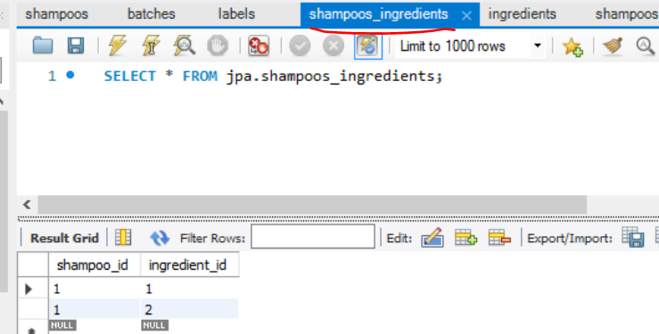

### Many-To-Many – Bidirectional

**Прави трета mapping таблица с primary composite key от primary keys на първоначалните две таблици.**

Ако искаме да знаем със съставка лавандула в колко вида шампоана е използвана, може да направим и обратна връзка.

@Entity  
@Table(name = **"ingredients"**)  
**public class** BasicIngredient {  
 @Id  
 @GeneratedValue(strategy = GenerationType.***IDENTITY***)  
 **private int id**;  
  
 **private double quantity**;  
  
 @Column(name = **"chemical_name"**, nullable = **false**) //NOT NULL, трябва да има стойност  
 **private** String **chemicalName**;

**С mappedBy казваме, че връзката ни е Bidirectional**

//Обратната връзка  
 @ManyToMany(mappedBy = **"ingredients"**, targetEntity = BasicShampoo.**class**) **//поле на класа и кой е класа**  
 **private** Set<BasicShampoo> **shampoos**;

@Entity  
@Table(name = **"shampoos"**)  
**public class** BasicShampoo {  
 @Id  
 @GeneratedValue(strategy = GenerationType.***IDENTITY***)  
 **private int id**;  
  
 **private** String **name**;  
  
 @OneToOne(optional = **false**)  
 @JoinColumn(name = **"label_id"**, referencedColumnName = **"id"**) //работи с SQL колоните от базата, id реално не е анотирано с Column и с различно име в базата  
 *//name е при нашата таблица, referencedColumnName е отсрещната таблица* **private** BasicLabel **label**;  
  
 *//много шампони да принадлеждат на една партида* @ManyToOne(optional = **false**)  
 @JoinColumn(name = **"batch_id"**, referencedColumnName = **"id"**)  
 **private** ProductionBatch **batch**;  
  
 @ManyToMany  
 @JoinTable(name = **"shampoos_ingredients"**,  
 joinColumns = @JoinColumn(name = **"shampoo_id"**, referencedColumnName = **"id"**), //от текущия клас  
 inverseJoinColumns = @JoinColumn(name = **"ingredient_id"**, referencedColumnName = **"id"**)) //от класа BasicIngredient  
 **private** Set<BasicIngredient> **ingredients**;

### Self-Reference

@Entity  
@Table(name = **"employees"**)  
**public class** Employee {  
 **private** Integer **id**;  
 **private** String **firstName**;  
 **private** String **lastName**;  
 **private** Employee **manager**;  
  
  
 @Id  
 @GeneratedValue(strategy = GenerationType.***IDENTITY***)  
 @Column(name = **"employee_id"**)  
 **public** Integer getId() {  
 **return id**;  
 }  
  
 **public void** setId(Integer id) {  
 **this**.**id** = id;  
 }  
  
 @Column(name = **"first_name"**)  
 **public** String getFirstName() {  
 **return firstName**;  
 }  
  
 **public void** setFirstName(String firstName) {  
 **this**.**firstName** = firstName;  
 }  
  
 @Column(name = **"last_name"**)  
 **public** String getLastName() {  
 **return lastName**;  
 }  
  
 **public void** setLastName(String lastName) {  
 **this**.**lastName** = lastName;  
 }  
  
  
  **@ManyToOne**  
 **@JoinColumn**(name = **"manager_id"**, referencedColumnName = **"employee_id"**) **//работи с SQL колоните от базата, id реално тук Е анотирано с Column анотация и с различно име в базата (“employee_id”) спрямо полето на текущия клас** **public** Employee getManager() {  
 **return manager**;  
 }

### По изчистен вариант само с Many-To-One връзки

Релацията One-To-Many прави допълнителна таблица.

Релацията Many-to-One не прави допълнителна помощна таблица.

Ако използваме само Many-To-One релацията, то таблицата откъм One страната реално не е свързана с таблицата откъм Many страната. Или с други думи ако искаме да вземем данни от таблицата откъм One страната заедно с данни от таблицата откъм Many страната, то правим две заявки към базата - за двете таблици. Или всяка таблица поотделно си вземаме данните.

### Използване на @ElementCollection

@Entity  
@Table(name = **"shampoos"**)  
**public class** BasicShampoo {  
 @Id  
 @GeneratedValue(strategy = GenerationType.***IDENTITY***)  
 **private int id**;  
  
 **private** String **name**;  
  
………………  
 *//Ако ни трябват група от елементи, които нямат отсрещна таблица* @ElementCollection  
 **private** List<String> **someNames**;  
  
 **public void** setSomeNames(List<String> someNames) {  
 **this**.**someNames** = someNames;  
 }

main

ProductionBatch batch = **new** ProductionBatch(LocalDate.*now*());  
BasicLabel label = **new** BasicLabel(**"blue"**);  
BasicShampoo shampoo = **new** BasicShampoo(**"shower"**, label, batch);  
  
BasicIngredient ingredient = **new** BasicIngredient(100, **"B12"**);  
BasicIngredient ingredient2 = **new** BasicIngredient(2, **"Violet"**);  
  
shampoo.addIngredient(ingredient);  
shampoo.addIngredient(ingredient2);  
entityManager.persist(ingredient);  
entityManager.persist(ingredient2);  
  
entityManager.persist(batch);  
entityManager.persist(label);  
entityManager.persist(shampoo);  
  
ProductionBatch productionBatch = entityManager.find(ProductionBatch.**class**, 1);  
Set<BasicShampoo> shampoos = productionBatch.getShampoos();  
  
List<String> names = Arrays.*asList*(**"Pesho"**, **"Gosho"**, **"Kiro"**);  
shampoo.**setSomeNames**(names);

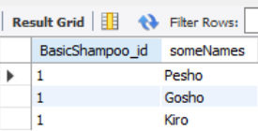

### Lazy Loading – Fetch Types

* Fetching – retrieve objects from the database
  + Fetched entities are stored in the **Persistence Context** as cache
* Retrieval of an entity object might cause automatic retrieval of **additional** entity objects

### Fetching Strategies

* Fetching Strategies
  + EAGER – retrieves all entity objects reachable through fetched entity
    - Can cause **slowdown** when used with a big data source

@ManyToOne e default fetch type EAGER

* + **LAZY** – retrieves all reachable entity objects **only when fetched entity's getter method is called** (използва се при @One**ToMany**)

@OneToMany e default fetch type LAZY

@ManyToMany

University **university** = em.find((**long**) 1); *// collection students = null  
  
// The collection holding the students is populated when the getter is called*university.getStudents();

Когато почнем да принтираме например, чак тогава ги вика всичките!!!

### Cascading

* JPA translates **entity state transitions** to database **DML (Data Manipulation Language)** statements
  + This behavior is configured through the **CascadeType** mappings
* **CascadeType.PERSIST**: means that save() or persist() operations cascade to related entities – когато се опитваме да save-нем обект, който в себе си има друг обект, то с CascadeType.PERSIST ще се запишат в базата както глобалния обект, така и вложения обект ако не съществува
* **CascadeType.MERGE**: means that related entities are merged into managed state when the owning entity is merged
* **CascadeType.REFRESH**: does the same thing for the refresh() operation
* **CascadeType.REMOVE**: removes all related entities association with this setting when the owning entity is deleted – като изтривам обект, първи изтрива вложените обекти, и след това обекта, който изтривам
* **CascadeType.DETACH**: detaches all related entities if a "manual detach" occurs
* **CascadeType.ALL**: is shorthand for all of the above cascade operations – да не се налага да се записвам първо запис в едната таблица(обект да persist-нем в Java), след това определен друг запис(persist) в друга таблиц, и т.н. – с **CascadeType.ALL всичко върви без значение кое след кое записваме или изтриваме при вложени обекти.**

## 4.3. @Column анотация

@Entity  
@Table(name = **"_01_wizzards_deposits"**)  
**public class** WizzardDeposits {  
 @Id  
 @GeneratedValue(strategy = GenerationType.***IDENTITY***)  
 **private int id**;  
  
 @Column(name = **"first_name"**, length = 50)  
 **private** String **firstName**;  
  
 */*  
 @Lob  
 @Column(name = "last_name", length = 60, nullable = false, columnDefinition = "BLOB NOT NULL")*

@Column(columnDefinition = **"TEXT"**)

*// @Column(columnDefinition = "LONGTEXT")*@Lob *//работи и като longtext*

*private String lastName;*/* @Column(name = **"last_name"**, length = 60, nullable = **false**)  
 **private** String **lastName**;  
  
 @Column(length = 1000)  
 **private** String **notes**;  
  
 **private int age**; *//равносилно на NOT NULL. Ако използваме Integer, тогавам можем да имаме NULL, т.е. типа му е Optional един вид на бащиния Integer от Java към SQL-a.*

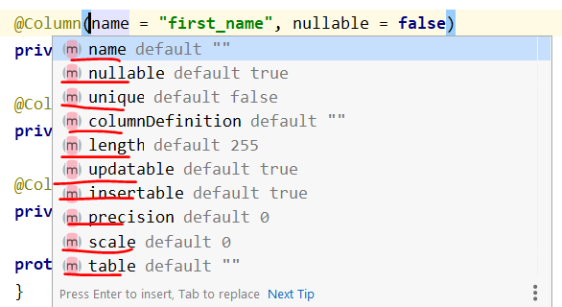

## 4.3. Пример с Inheritance и с Relations strategies

### Пример 1:

@Entity  
@Table(name = **"ingredients"**)  
@Inheritance(strategy = InheritanceType.SINGLE_TABLE)  
@DiscriminatorColumn(name = **"type"**, discriminatorType = DiscriminatorType.STRING)  
**public abstract class** BasicIngredient **implements** Ingredient {  
*//…* @ManyToMany(mappedBy = **"ingredients"**, targetEntity = BasicShampoo.**class**)  
 **private** Set<BasicShampoo> **shampoos**;  
*//…*}

### Пример 2 - Bills Payment System:

**public class** _05Main {  
 **public static void** main(String[] args) {  
 EntityManagerFactory emf = Persistence.*createEntityManagerFactory*(**"jpa_relations_exc"**);  
 EntityManager entityManager = emf.createEntityManager();  
  
 entityManager.getTransaction().begin();  
  
 User user1 = **new** User(**"Bash"**, **"Maistora"**, **"mymail@abv.bg"**, **"mypassword"**);  
 User user2 = **new** User(**"Svilen"**, **"Velikov"**, **"svill@abv.bg"**, **"mypasswordYee"**);  
  
 *//user 1* BillingDetail billingDetail1 = **new** CreditCard(**"987654321"**, user1, **"MASTERCARD"**,  
 **"08"**, **"24"**);  
  
 BillingDetail billingDetail2 = **new** BankAccount(**"111222333"**, user1, **"OBB"**,  
 **"UBBS12D4"**);  
 user1.addBillingDetail(billingDetail1);  
 user1.addBillingDetail(billingDetail2);  
  
 *//user 2* BillingDetail billingDetail3 = **new** CreditCard(**"12345678"**, user2, **"VISA"**,  
 **"10"**, **"23"**);  
 BillingDetail billingDetail4 = **new** BankAccount(**"333222111"**, user2, **"Bulbank"**,  
 **"BBBU12Z4"**);  
 BillingDetail billingDetail5 = **new** BankAccount(**"999888777"**, user2, **"Bulbank"**,  
 **"BBBU12Z4"**);  
 user2.addBillingDetail(billingDetail3);  
 user2.addBillingDetail(billingDetail4);  
 user2.addBillingDetail(billingDetail5);  
  
 entityManager.persist(user1);  
 entityManager.persist(user2);  
  
 entityManager.persist(billingDetail1);  
 entityManager.persist(billingDetail2);  
 entityManager.persist(billingDetail3);  
 entityManager.persist(billingDetail4);  
 entityManager.persist(billingDetail5);  
  
 entityManager.getTransaction().commit();  
 entityManager.close();  
 }  
}

@Entity  
@Table(name = **"_05_users"**)  
**public class** User {  
 @Id  
 @GeneratedValue(strategy = GenerationType.***IDENTITY***)  
 **private int id**;  
  
 @Column(name = **"first_name"**, nullable = **false**)  
 **private** String **firstName**;  
  
 @Column(name = **"last_name"**, nullable = **false**)  
 **private** String **lastName**;  
  
 @Column(nullable = **false**)  
 **private** String **email**;  
  
 @Column(nullable = **false**)  
 **private** String **password**;  
  
 **@OneToMany** *//OneToMany пак може да има свързваща* mapping таблица  
 **private** Set<BillingDetail> **billingDetailsSet** = **new** HashSet<>();  
  
 **public** Set<BillingDetail> getBillingDetailsSet() {  
 **return** Collections.*unmodifiableSet*(**billingDetailsSet**);  
 }  
  
 **public void** addBillingDetail(BillingDetail bl) {  
 **this**.**billingDetailsSet**.add(bl);  
 }  
  
 **public** User() {  
 }  
  
 **public** User(String firstName, String lastName, String email, String password) {  
 **this**.**firstName** = firstName;  
 **this**.**lastName** = lastName;  
 **this**.**email** = email;  
 **this**.**password** = password;  
 }  
  
 **public int** getId() {  
 **return id**;  
 }  
  
 **public void** setId(**int** id) {  
 **this**.**id** = id;  
 }  
  
 **public** String getFirstName() {  
 **return firstName**;  
 }  
  
 **public void** setFirstName(String firstName) {  
 **this**.**firstName** = firstName;  
 }  
  
 **public** String getLastName() {  
 **return lastName**;  
 }  
  
 **public void** setLastName(String lastName) {  
 **this**.**lastName** = lastName;  
 }  
  
 **public** String getEmail() {  
 **return email**;  
 }  
  
 **public void** setEmail(String email) {  
 **this**.**email** = email;  
 }  
  
 **public** String getPassword() {  
 **return password**;  
 }  
  
 **public void** setPassword(String password) {  
 **this**.**password** = password;  
 }  
}

*//@MappedSuperclass //нещо междинно го анотира, няма таблица за SQL от този клас да има,* will not be managed by the persistence provider@Entity  
@Table(name = **"_05_billing_details"**)  
@Inheritance(strategy = InheritanceType.***JOINED***)  
**public abstract class** BillingDetail {  
 @Id  
 @GeneratedValue(strategy = GenerationType.***IDENTITY***)  
 **private int id**;  
  
 @Column(nullable = **false**, unique = **true**)  
 **private** String **number**;  
  
 @ManyToOne  
 **private** User **owner**;  
  
 **protected** BillingDetail() {  
 }  
  
 **protected** BillingDetail(String number, User owner) {  
 **this**.**number** = number;  
 **this**.**owner** = owner;  
 }  
  
 **public int** getId() {  
 **return id**;  
 }  
  
 **public void** setId(**int** id) {  
 **this**.**id** = id;  
 }  
  
 **public** String getNumber() {  
 **return number**;  
 }  
  
 **public void** setNumber(String number) {  
 **this**.**number** = number;  
 }  
  
 **public** User getOwner() {  
 **return owner**;  
 }  
  
 **public void** setOwner(User owner) {  
 **this**.**owner** = owner;  
 }  
}

@Entity  
@Table(name = **"_05_bank_accounts"**)  
**public class** BankAccount **extends** BillingDetail {  
 @Column(name = **"bank_name"**, nullable = **false**)  
 **private** String **bankName**;  
  
 @Column(name = **"swift_code"**, nullable = **false**)  
 **private** String **swiftCode**;  
  
 **public** BankAccount() {  
 **super**();  
 }  
  
 **public** BankAccount(String number, User owner, String bankName, String swiftCode) {  
 **super**(number, owner);  
 **this**.**bankName** = bankName;  
 **this**.**swiftCode** = swiftCode;  
 }  
  
 **public** String getBankName() {  
 **return bankName**;  
 }  
  
 **public void** setBankName(String bankName) {  
 **this**.**bankName** = bankName;  
 }  
  
 **public** String getSwiftCode() {  
 **return swiftCode**;  
 }  
  
 **public void** setSwiftCode(String swiftCode) {  
 **this**.**swiftCode** = swiftCode;  
 }  
}

@Entity  
@Table(name = **"_05_credit_cards"**)  
**public class** CreditCard **extends** BillingDetail {  
 @Column(name = **"card_type"**, nullable = **false**)  
 **private** String **cardType**;  
  
 @Column(name = **"expiration_month"**, nullable = **false**, length = 2)  
 **private** String **expirationMonth**;  
  
 @Column(name = **"expiration_year"**, nullable = **false**, length = 2)  
 **private** String **expirationYear**;  
  
 **public** CreditCard() {  
 **super**();  
 }  
  
 **public** CreditCard(String number, User owner, String cardType, String expirationMonth, String expirationYear) {  
 **super**(number, owner);  
 **this**.**cardType** = cardType;  
 **this**.**expirationMonth** = expirationMonth;  
 **this**.**expirationYear** = expirationYear;  
 }  
  
 **public** String getCardType() {  
 **return cardType**;  
 }  
  
 **public void** setCardType(String cardType) {  
 **this**.**cardType** = cardType;  
 }  
  
 **public** String getExpirationMonth() {  
 **return expirationMonth**;  
 }  
  
 **public void** setExpirationMonth(String expirationMonth) {  
 **this**.**expirationMonth** = expirationMonth;  
 }  
  
 **public** String getExpirationYear() {  
 **return expirationYear**;  
 }  
  
 **public void** setExpirationYear(String expirationYear) {  
 **this**.**expirationYear** = expirationYear;  
 }  
}

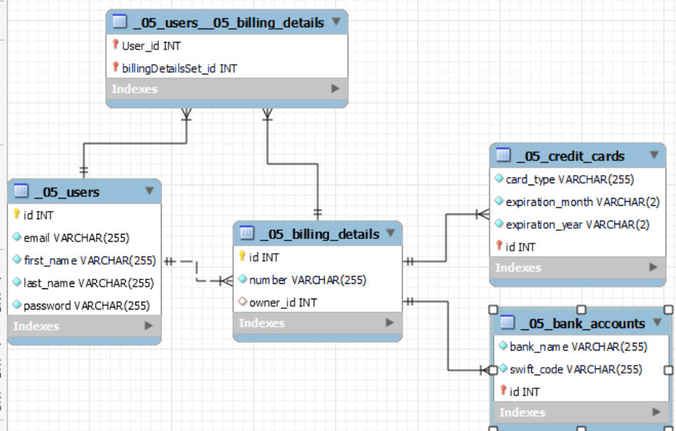

### Пример 3 – отново Bills Payment System:

**@MappedSuperclass** *//нещо междинно го анотира, няма таблица за SQL от този клас да има*  
**public abstract class** BaseEntity {  
 **private** Long **id**;  
   
 **public** BaseEntity() {  
 }  
  
 @Id  
 @GeneratedValue(strategy = GenerationType.***IDENTITY***)  
 **public** Long getId() {  
 **return id**;  
 }  
  
 **public void** setId(Long id) {  
 **this**.**id** = id;  
 }  
}

@Entity  
@Table(name = **"billing_details"**)  
**@Inheritance**(strategy = InheritanceType.***JOINED***)  
**public abstract class** BillingDetails **extends** BaseEntity {  
  
 **private** String **number**;  
 **private** BankUser **owner**;  
  
 **public** BillingDetails() {  
 }  
  
 @Column(name = **"number"**, length = 50, nullable = **false**, unique = **true**)  
 **public** String getNumber() {  
 **return number**;  
 }  
  
 **public void** setNumber(String number) {  
 **this**.**number** = number;  
 }  
  
 **@ManyToOne**  
 **public** BankUser getOwner() {  
 **return owner**;  
 }  
  
 **public void** setOwner(BankUser owner) {  
 **this**.**owner** = owner;  
 }  
}

@Entity  
@Table(name = **"credit_card"**)  
**public class** CreditCard **extends** BillingDetails {  
 **private** String **cardType**;  
 **private** Integer **expirationMonth**;  
 **private** Integer **expirationYear**;  
  
 **public** CreditCard() {  
 **super**();  
 }  
  
 @Column(name = **"card_type"**, length = 60)  
 **public** String getCardType() {  
 **return cardType**;  
 }  
  
 **public void** setCardType(String cardType) {  
 **this**.**cardType** = cardType;  
 }  
  
 @Column(name = **"expiration_month"**)  
 **public** Integer getExpirationMonth() {  
 **return expirationMonth**;  
 }  
  
 **public void** setExpirationMonth(Integer expirationMonth) {  
 **this**.**expirationMonth** = expirationMonth;  
 }  
  
 @Column(name = **"expiration_year"**)  
 **public** Integer getExpirationYear() {  
 **return expirationYear**;  
 }  
  
 **public void** setExpirationYear(Integer expirationYear) {  
 **this**.**expirationYear** = expirationYear;  
 }  
}

@Entity  
@Table(name = **"bank_account"**)  
**public class** BankAccount **extends** BillingDetails{  
 **private** String **bankName**;  
 **private** String **swiftCode**;  
  
 **public** BankAccount() {  
 **super**();  
 }  
  
 @Column(name = **"bank_name"**, length = 60, nullable = **false**)  
 **public** String getBankName() {  
 **return bankName**;  
 }  
  
 **public void** setBankName(String bankName) {  
 **this**.**bankName** = bankName;  
 }  
  
 @Column(name = **"swift_code"**, length = 50, nullable = **false**)  
 **public** String getSwiftCode() {  
 **return swiftCode**;  
 }  
  
 **public void** setSwiftCode(String swiftCode) {  
 **this**.**swiftCode** = swiftCode;  
 }  
}

@Entity  
@Table(name = **"bank_users"**)  
**public class** BankUser **extends** BaseEntity {  
  
 **private** String **firstName**;  
 **private** String **lastName**;  
 **private** String **email**;  
 **private** String **password**;  
  
 **public** BankUser() {  
 }  
  
 @Column(name = **"first_name"**, length = 50, nullable = **false**)  
 **public** String getFirstName() {  
 **return firstName**;  
 }  
  
 **public void** setFirstName(String firstName) {  
 **this**.**firstName** = firstName;  
 }  
  
 @Column(name = **"last_name"**, length = 60, nullable = **false**)  
 **public** String getLastName() {  
 **return lastName**;  
 }  
  
 **public void** setLastName(String lastName) {  
 **this**.**lastName** = lastName;  
 }  
  
 @Column(name = **"email"**, length = 60)  
 **public** String getEmail() {  
 **return email**;  
 }  
  
 **public void** setEmail(String email) {  
 **this**.**email** = email;  
 }  
  
 @Column(name = **"password"**, nullable = **false**)  
 **public** String getPassword() {  
 **return password**;  
 }  
  
 **public void** setPassword(String password) {  
 **this**.**password** = password;  
 }  
}

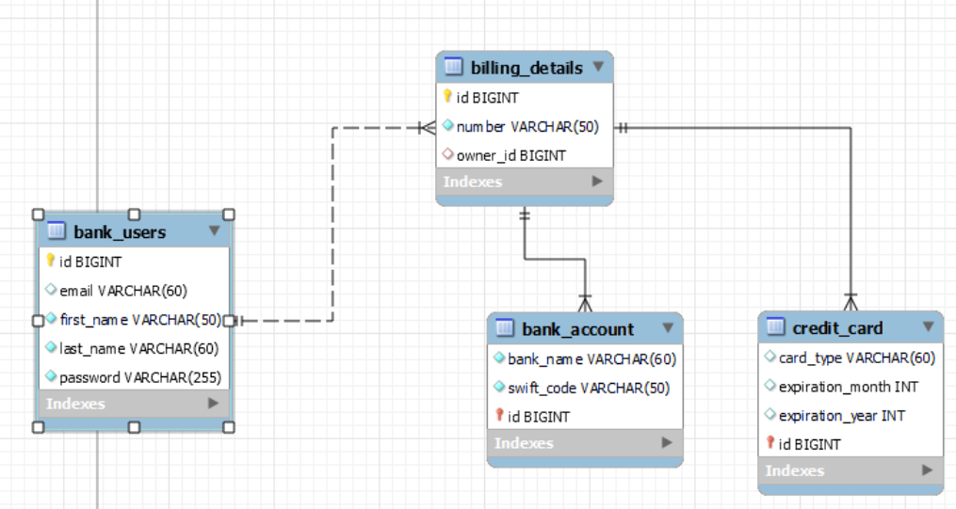

## 4.4. Използване на Enumertion

**package** _00_EnumDemo;  
  
**public enum** AccountType {

//ако тук разместим подредбата, да не ги взема по index, а по value!  
 ***FREE***(**"FREE"**),  
 ***SILVER***(**"SILVER"**),  
 ***GOLD***(**"GOLD"**),  
 ***TRIAL***(**"TRIAL"**);  
  
 **private** String **value**;  
  
 AccountType(String value) {  
 **this**.**value** = value;  
 }  
  
 **public** String getValue() {  
 **return this**.**value**;  
 }  
}

@Entity(name = **"demos"**)  
**public class** User {  
 @Id  
 @GeneratedValue(strategy = GenerationType.***IDENTITY***)  
 **private int id**;  
  
 **private** String **username**;  
  
*// @Enumerated(EnumType.ORDINAL) //по индекс* @Enumerated(EnumType.***STRING***) *//по стойност value* **private** AccountType **type**;  
  
 **public** User() {  
 }

**public** User(String username, AccountType type) {  
 **this**.**username** = username;  
 **this**.**type** = type;  
}  
  
**public** AccountType getType() {  
 **return type**;  
}

main

User user = **new** User(**"Marina"**, AccountType.***GOLD***);  
entityManager.persist(user);  
  
User found = entityManager.find(User.**class**, 1);  
System.***out***.println(found.getType().toString());

## 4.5. Default value

На wrapper класовете е null. – затова им задаваме тук nullable = **false**

На примитивния int е 0. – затова int никога не може да бъде NULL

# 5. Spring Data Introduction

## 5.0. Inversion of Control принципа

Iversion of Control принципът се реализира по няколко начина в Spring без да пипаме source кода/компонентите. В контейнера има само interface-и на различните компоненти/:

### Dependency Injection е първия подход

#### Annotation Driven

@Autowired **//Look up??? Не е - прилагане на Inversion of control principle**

#### With external XML file (Annotation Driven) Dependency Injection

#### Progamming (configuration class or with builder шаблон) Dependency Injection

### Look up е втория подход

С някакво минимално API да намираме необходимите Beans по техния интерфейс.

## 5.1. Framework

### Framework

* Platform for **developing software applications**
* Provides a **foundation** on which **software developers** can **build programs** for a **specific platform**
* Similar **to an API**
  + A Framework **includes an API**
* May include **code libraries**, a **compiler**, and other programs **used in the software development process**

## 5.2. Spring Platform

### Spring Platform

* Spring makes **programming Java quicker, easier, and safer(ще ни предпази от грешки) for everybody**
* Spring's **focus is on speed, simplicity, and productivity** built by multiple Spring Projects
  + Spring **Boot**
  + Spring **Framework**
  + Spring **Data**

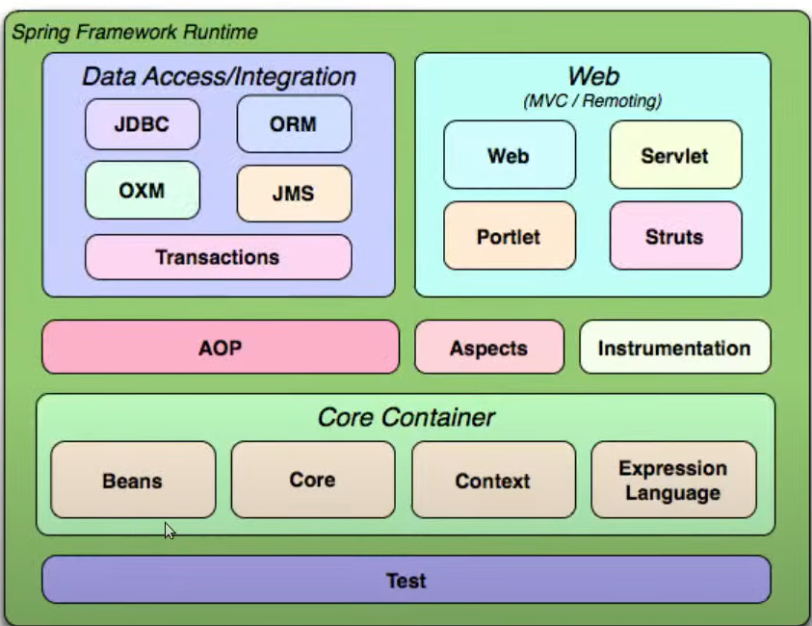

### Spring Module

* Spring **Core Container**
  + The base module of Spring and provides Spring containers
* **Aspect-Oriented Programming**
  + Enables implementing cross-cutting concerns
* **Authentication and Authorization**
* **Data Access**
  + Working with **RDBMS using JDBC and ORM tools**
* **IoC Container(Inversion of control Containers)**
  + Configuration of application **components and lifecycle management of Java objects**, done mainly via **dependency injection**
* **Testing**
  + Support classes for writing **unit tests and integration tests**

## 5.3. Spring Projects

### Spring Projects

#### Spring **Boot**

* + Makes it easy to **create stand-alone**, **production-grade Spring based Applications**
  + Бял лист с нарисувано първата картинка. Докато още се уча – ползвам книжката за оцветяване

#### Spring Framework

* + Provides a **comprehensive programming and configuration model** for modern Java-based enterprise applications - on any kind of deployment platform
  + Абсолютно бял лист

#### Spring **Data**

* + Spring Data's mission is to **provide a familiar and consistent**, Spring-based **programming model for data access** while still retaining the special traits of the underlying data store

#### Spring **Cloud**

* + Spring Cloud **provides tools for developers to quickly build** some of the **common patterns in distributed systems**

## 5.4. Spring Boot Architecture

* **Opinionated view** of building production-ready Spring applications

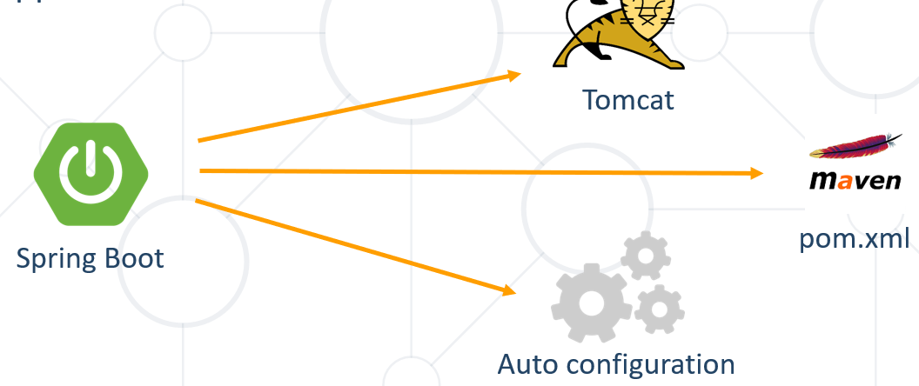

<https://www.javatpoint.com/spring-boot-architecture>

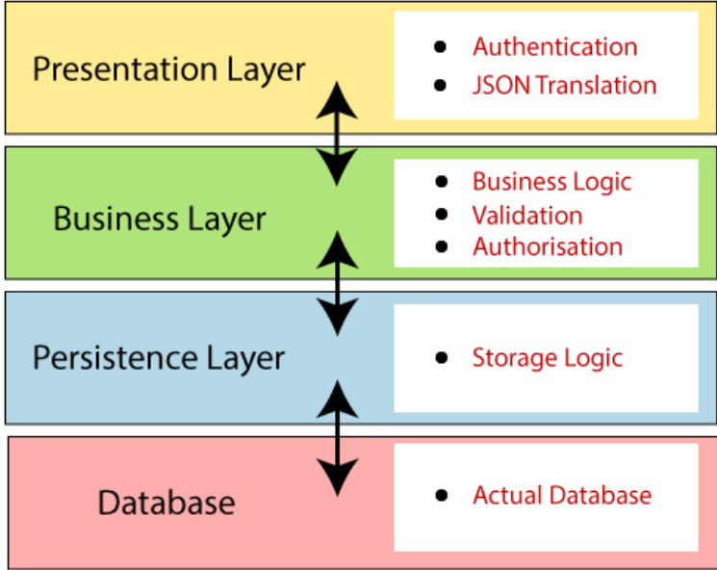

**Presentation Layer:** The presentation layer handles the HTTP requests, translates the JSON parameter to object, and authenticates the request and transfer it to the business layer. In short, it consists of **views** i.e., frontend part.

**Business Layer:** The business layer handles all the **business logic**. It consists of service classes and uses services provided by data access layers. It also performs **authorization** and **validation**.

**Persistence Layer:** The persistence layer contains all the **storage logic** and translates business objects from and to database rows.

**Database Lay** med.**er:** In the database layer, **CRUD** (create, retrieve, update, delete) operations are performed.

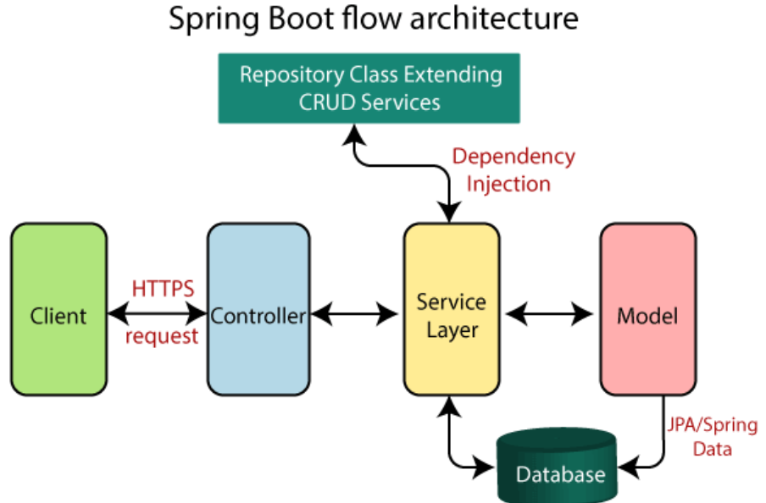

## 5.5. Spring Framework

* **Open-Source Application framework** and **inversion of control container** for the Java platform
* Core features can be used by any Java application **extensions** for building web applications **on top of the Java EE specification**
* **Spring е имплементация на Java EE specification**

## 5.6. Spring Data Framework

### What is Spring Framework

* Application framework for the Java Platform
  + Technology stack - includes several modules that provide a range of services

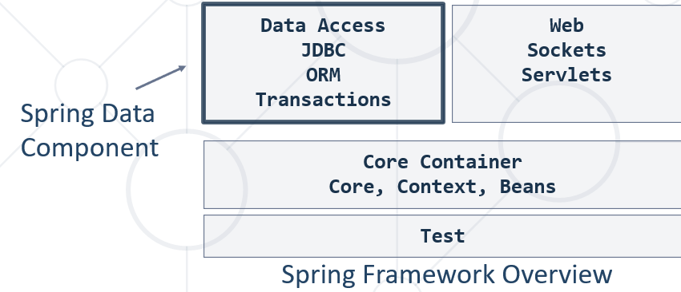

#### Beans and Context

Обикновени JAVA обекти/елементи, които са анотирани, за да могат да бъдат менъджирани от framework-a в техния жизнен цикъл.

Чрез scope анотация, можем да дефинираме типа на Bean-а или неговия context!

##### Singleton контекст на Bean-a – само по една инстанция, по default са Singleton обикновено

##### Prototype контекст на Bean-a – всеки път да се вика нова инстанция

В Web частта има още

##### Request контекст

Сами по себе си REST заявките са state-less

##### Session контекст – примера с пазаруването от сайта

Най-често чрез cookies

и

##### Application context

#### Web контекст – специфични за различни технологии

##### Servlet – класическата JAVA web архитектура е базирана върху тези Servlet технологии

GET, POST, PUT, DELETE, options, заявки

##### Sockets – bi-directional real time servlets

##### Asynchronous architecture with React Api (with Flux functional programming for example)

### What is Spring Data

* Library that adds an **extra layer of abstraction** on the top of our **JPA**(Java Persistence API(Application Programming Interface)) provider
* Provides:
  + Dynamic query derivation from repository method names
  + Possibility to integrate custom repositories and many more
* What Spring Data is not:
  + **Spring Data JPA is not a JPA provider**

### Spring Data Role

Extra layer of abstraction over the used ORM

**Spring Data**

**Hibernate, EclipseLink etc.**

**JPA (Java Persistence API)**

**RDBMS(relational)**

**NRDBMS(non-relational)**

### Spring Boot – **Advantage of** **Convention Over Configuration – предимство на конвенция пред конфигурация**

* Creates stand-alone Spring applications
  + Provide opinionated 'starter' POMs to simplify your Maven configuration
* Automatically configure Spring whenever possible
* Absolutely no code generation and no requirement for XML configuration

### Dependencies in Maven

#### pom.xml

<**build**>  
 <**plugins**>  
 <**plugin**>  
 <**groupId**>org.apache.maven.plugins</**groupId**>  
 <**artifactId**>maven-compiler-plugin</**artifactId**>  
 <**version**>3.6.1</**version**>  
 <**configuration**>  
 <**source**>14</**source**>  
 <**target**>14</**target**>  
 </**configuration**>  
 </**plugin**>  
 </**plugins**>  
</**build**>  
  
  
<**parent**> //служи за вземане на базови настройки на базов pom.xml файл. На базовия има по-базов, и там има persistence  
 <**groupId**>org.springframework.boot</**groupId**>  
 <**version**> 2.3.8.RELEASE</**version**>  
 <**artifactId**>spring-boot-starter-parent</**artifactId**>  
</**parent**>  
  
  
<**dependencies**>  
 <**dependency**>  
 <**groupId**>org.springframework.boot</**groupId**>  
 <**artifactId**>spring-boot-starter-data-jpa</**artifactId**> //тук са ни оставили опция какво да ползваме, може да не е ORM data-jpa, a JDBC примерно, или пък non-relational db  
 <**version**>2.6.3</**version**>  
 </**dependency**>  
  
 <**dependency**>  
 <**groupId**>mysql</**groupId**>  
 <**artifactId**>mysql-connector-java</**artifactId**>  
 <**version**>8.0.28</**version**>  
 <**scope**>runtime</**scope**>  
 </**dependency**>  
</**dependencies**>

### Configuration

* Spring boot configurations are held in an **application.properties** file

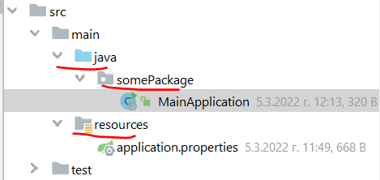

#### application.properties

*#Data Source Properties***spring.datasource.driverClassName** = **com.mysql.cj.jdbc.Driver**

**spring.datasource.url** = **jdbc:mysql://localhost:3306/school?useSSL=false**

**Или**

**spring.datasource.url** = **jdbc:mysql://localhost:3306/bookshop?createDatabaseIfNotExist=true&useSSL=false**

**spring.datasource.username** = **root  
spring.datasource.password** =

**spring.datasource.password** = **12345**

**Изпълняване на SQL заявки при стартиране (execute SQL / run SQL automatically)**

*#spring.datasource.initialization-mode = always  
#spring.sql.init.mode = always  
  
#spring.datasource.data=classpath:insert-data.sql  
#spring.sql.init.data-locations=classpath:insert-data.sql*

*#JPA Properties***spring.jpa.properties.hibernate.dialect** = **org.hibernate.dialect.MySQL8Dialect  
spring.jpa.properties.hibernate.show_sql** = **TRUE**

**spring.jpa.properties.hibernate.format_sql** = **TRUE**

**spring.jpa.properties.hibernate.use_sql_comments** = **TRUE**

**spring.jpa.hibernate.ddl-auto** = **create-drop***###Logging Levels  
# Disable the default loggers – двете долу ако са активирани, скриват доста от default логовете***logging.level.org** = **WARN //контролираме логовете  
logging.level.blog** = **WARN //контролираме логовете***#Show SQL executed with parameter bindings***logging.level.org.hibernate.SQL** = **DEBUG  
logging.level.org.hibernate.type.descriptor** = **TRACE**

*# Spring actuator settings - service monitoring metrics  
#management.endpoints.web.base-path=/***management.endpoints.web.exposure.include**=**info, health, httptrace, metrics, threaddump, heapdump, shutdown, beans  
management.trace.http.enabled**=**true  
management.endpoint.health.show-details**=*always***info.app.name**=**Article repository application  
info.app.description**=**This sample application allows to manage articles and users  
info.app.version**=**1.0.0**

*#Change server port  
#server.port=8000*

<http://localhost:8080/actuator>

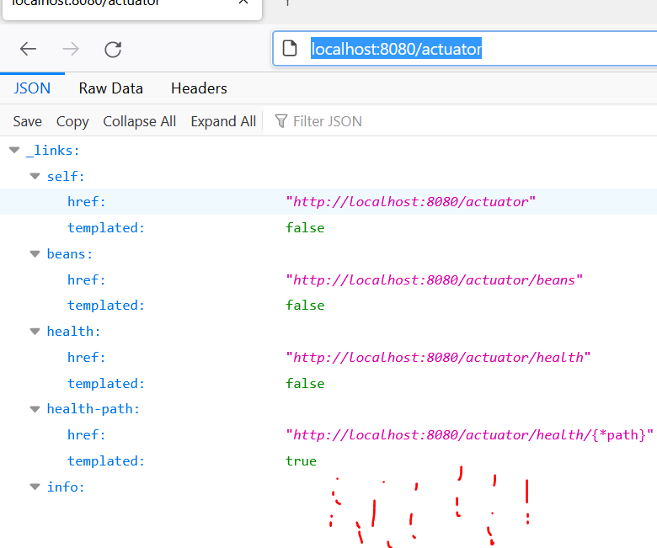

#### main – задължително си правим някаква папка/пакет и в него хакаме MainApplication

**package** somePackage;  
  
**import** org.springframework.boot.SpringApplication;  
**import** org.springframework.boot.autoconfigure.SpringBootApplication;  
  
@SpringBootApplication  
**public class** MainApplication {  
 **public static void** main(String[] args) {  
 SpringApplication.*run*(MainApplication.**class**,args);  
 }  
}

## 5.7. Spring Data Repositories

### Spring Repository – вдигане на абстракцията още

Repository-то ни дава всичко, което работи с базата

* Abstraction to significantly reduce the amount of boilerplate code required to implement data access layers
  + **Perform CRUD Operations**
  + **Automatically generates JPQL/SQL code**
  + Highly customizable

### Built-in CRUD Operations

Едно такова repository ще отговаря за един клас

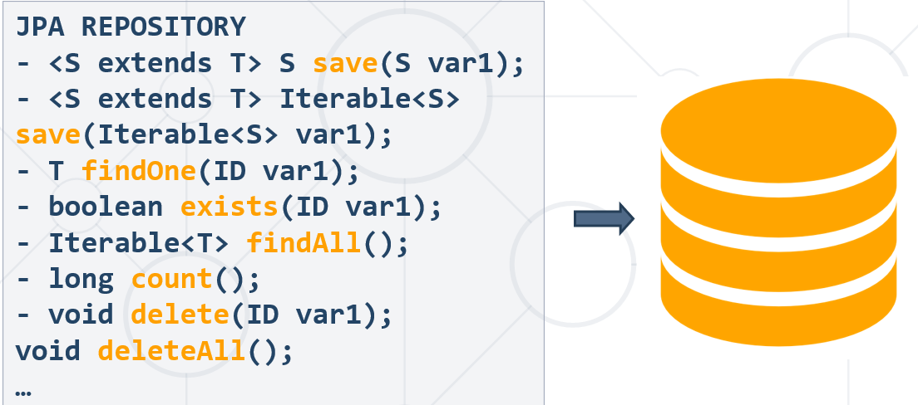

## 5.8. Spring Data Query Creation

### Query Creation

* Queries are created via a query builder mechanism built into Spring Data
  + Strips the prefixes like **find…By**, **read…By**, **query…By** and starts parsing the rest of it
* Spring Data JPA will do a property check and traverse nested properties
* **Спираме да пише SQL/JPQL заявки**

### Custom CRUD Operations

**//Custom method**

@Repository  
**public interface** StudentRepository **extends** CrudRepository<Student, Long> {  
 List<Student> findByMajor(Major major);  
}

@Repository  
**public interface** StudentRepository **extends** JpaRepository<Student, Long> {  
 List<Student> findByMajor(Major major);  
}

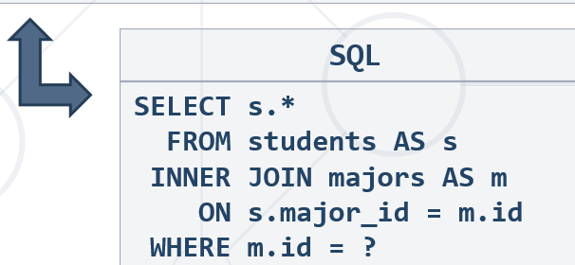

### Query Lookup Strategies

[**https://docs.spring.io/spring-data/jpa/docs/current/reference/html/#jpa.query-methods.query-creation**](https://docs.spring.io/spring-data/jpa/docs/current/reference/html/#jpa.query-methods.query-creation)

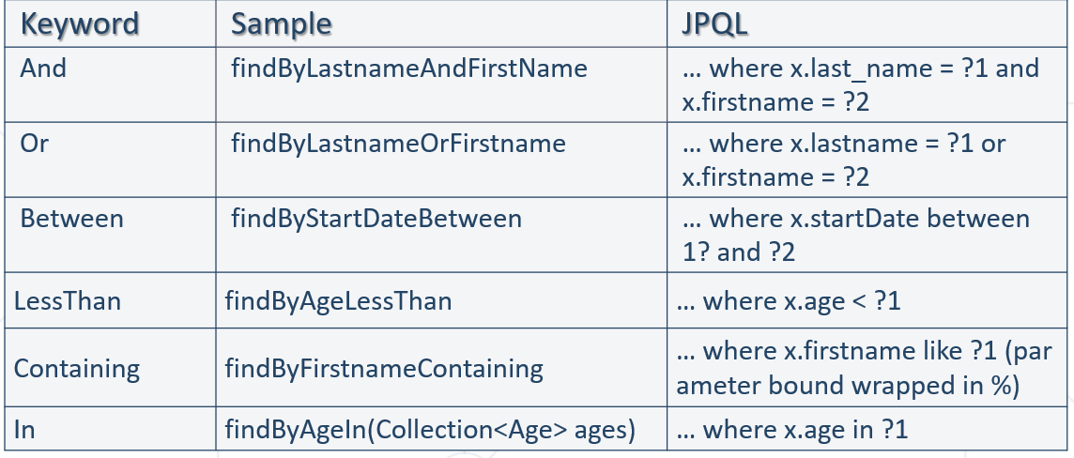

## 5.9. Spring Data Services - Encapsulating Business Logic

Service-а ни дава всичко, което е бизнес логика след като сме взели данните от базата данни.

Service-а използва Repository-та, които от своя страна си говорят с базата данни.

### Service Pattern

* Service Layer is a design pattern of organizing business logic into layers
  + Service classes are categorized into a particular layer and share functionality
* Main concept is **not exposing details** of internal processes on entities
  + Services **interact closely** with Repositories

### Spring Data Architecture

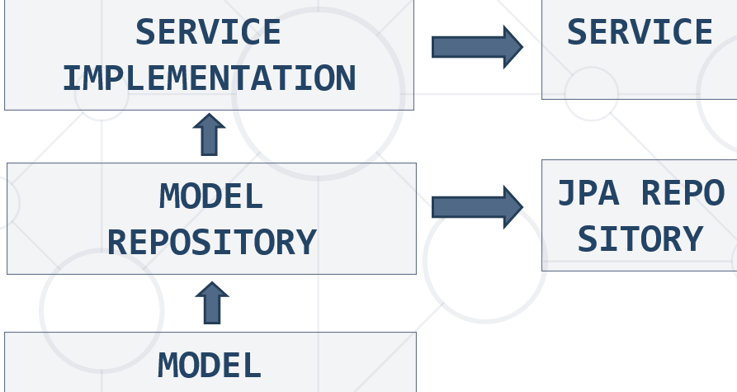

### Services

**public interface** AccountService {  
 **void** withdrawMoney(BigDecimal amount, Long id);  
  
 **void** depositMoney(BigDecimal amount, Long id);  
}

**import** org.springframework.beans.factory.annotation.Autowired;  
**import** org.springframework.stereotype.Service;  
**import** softuni.repositories.AccountRepository;  
**@Service(“AccountServ”) //можем да му зададем име на service-а в Spring-a да бъде bean, но реално не го използваме**

*/**  
 * The value may indicate a suggestion for a logical component name,  
 * to be turned into a Spring bean in case of an autodetected component.  
 \** ***@return*** *the suggested component name, if any (or empty String otherwise)  
 */*@AliasFor(annotation = Component.**class**)  
String value() **default ""**;

**public class** AccountServiceImpl **implements** AccountService {  
 **private final** AccountRepository **accountRepository**;  
  
 **@Autowired** – през конструктора  
 **public** AccountServiceImpl(AccountRepository accountRepository) {  
 **this**.**accountRepository** = accountRepository;  
 }  
  
 @Override  
 **public void** withdrawMoney(BigDecimal amount, Long id) { }  
  
 @Override  
 **public void** depositMoney(BigDecimal amount, Long id) { }  
}

Освен с **@Autowired**, можем да ползваме **@Inject** и **@Resource**, но при @Autowired можем да ползваме Optional.

Optional<String> name = …

String str = name.get(); //взема резултата ако го има

### Entry Point

#### main – задължително си правим някаква папка/пакет и в него хакаме MainApplication

**package** somePackage;  
  
**import** org.springframework.boot.SpringApplication;  
**import** org.springframework.boot.autoconfigure.SpringBootApplication;  
  
@SpringBootApplication  
**public class** MainApplication {  
 **public static void** main(String[] args) {  
 SpringApplication.*run*(MainApplication.**class**,args);  
 }  
}

### Command Line Runner

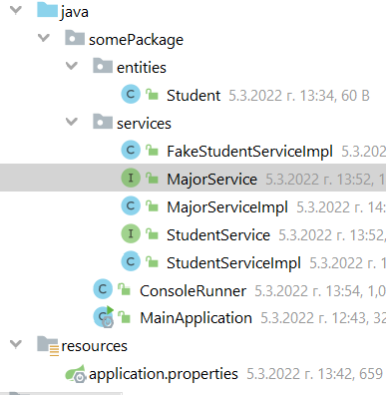

**public interface** StudentService {  
 **void** register();  
}

**public interface** MajorService {  
 **void** register();  
}

**import** org.springframework.stereotype.Service;  
  
@Service  
**public class** StudentServiceImpl **implements** StudentService {  
 @Override  
 **public void** register() {  
*// studentRepository.register(); //благодарение на Спринг, пропускаме този ред да го пишем* }  
}

**import** org.springframework.stereotype.Service;  
  
@Service  
**public class** MajorServiceImpl **implements** MajorService {  
 @Override  
 **public void** register() {  
 *// studentRepository.register(); //благодарение на Спринг, пропускаме този ред да го пишем* }  
}

**import** org.springframework.beans.factory.annotation.Autowired;  
**import** org.springframework.boot.CommandLineRunner;  
**import** org.springframework.stereotype.Component;  
**import** somePackage.services.MajorService;  
**import** somePackage.services.StudentService;  
  
**@Component**  
**public class** ConsoleRunner **implements** CommandLineRunner {  
*// @Autowired* **private** StudentService **studentService**;  
  
*// @Autowired* **private** MajorService **majorService**;  
  
 **@Autowired** //може и през конструктора да го auto-wire-нем  
 **public** ConsoleRunner(StudentService studentService, MajorService majorService) {  
 **this**.**studentService** = studentService;  
 **this**.**majorService** = majorService;  
 }  
  
 @Override  
 **public void** run(String... strings) **throws** Exception {  
 System.***out***.println(**"ha ha ha"**);  
 **this**.**studentService**.register();  
 **this**.**majorService**.register();  
*// Major major = new Major("Java DB Fundamentals");  
// Student student = new Student("John",new Date(), major);  
// majorService.create(major);  
// studentService.register(student);* }  
}

## 5.10.0. Creating project via start.spring.io

start.spring.io

Избираме си от сайта какво искаме – горе долу същите неща като през IntelliJ

## 5.10. Creating project via Spring initializer (in IntelliJ Iltimate or a plug-in should be installed)

(not Maven, but it is like Maven again)

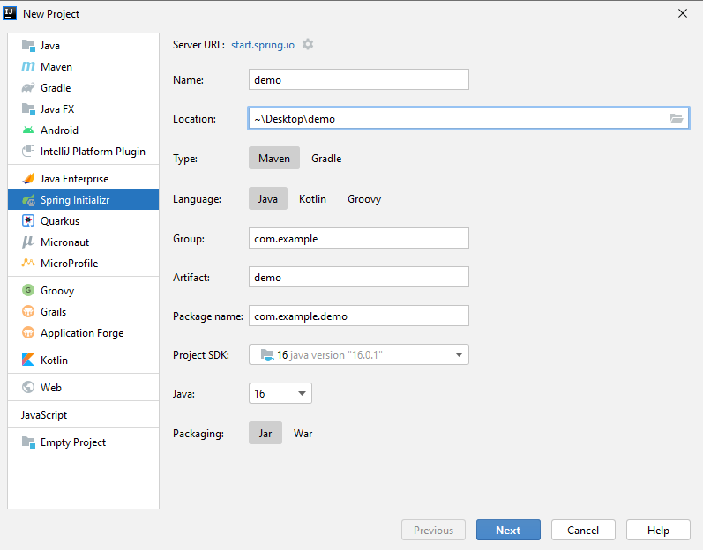

### Add name and version:

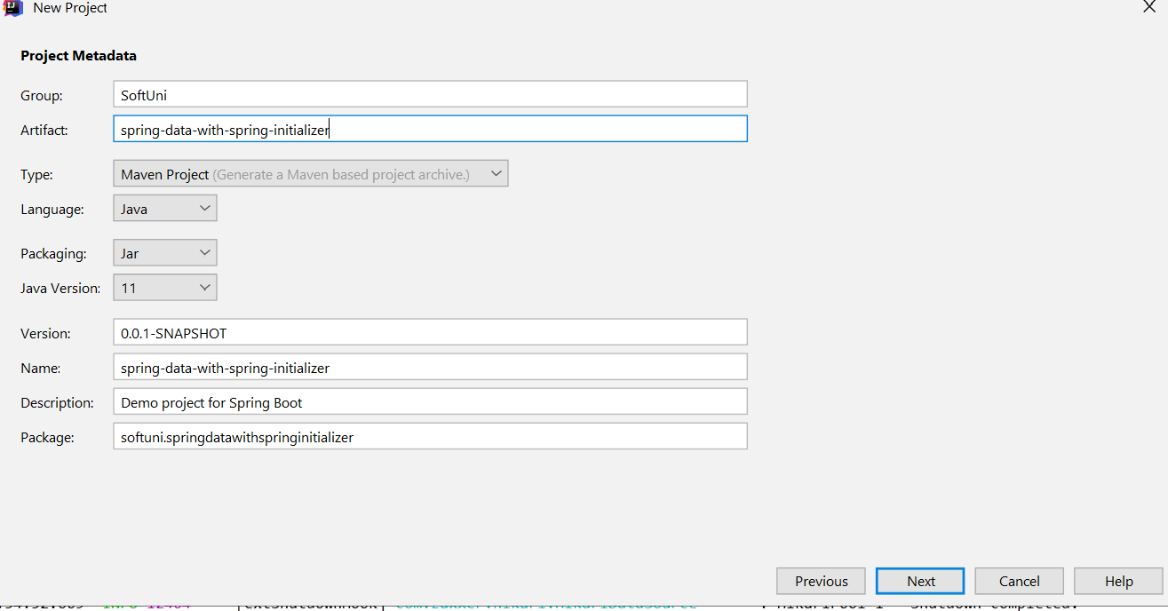

### Add Spring Data JPA and MySQL Driver (in the pom.xml file in reality):

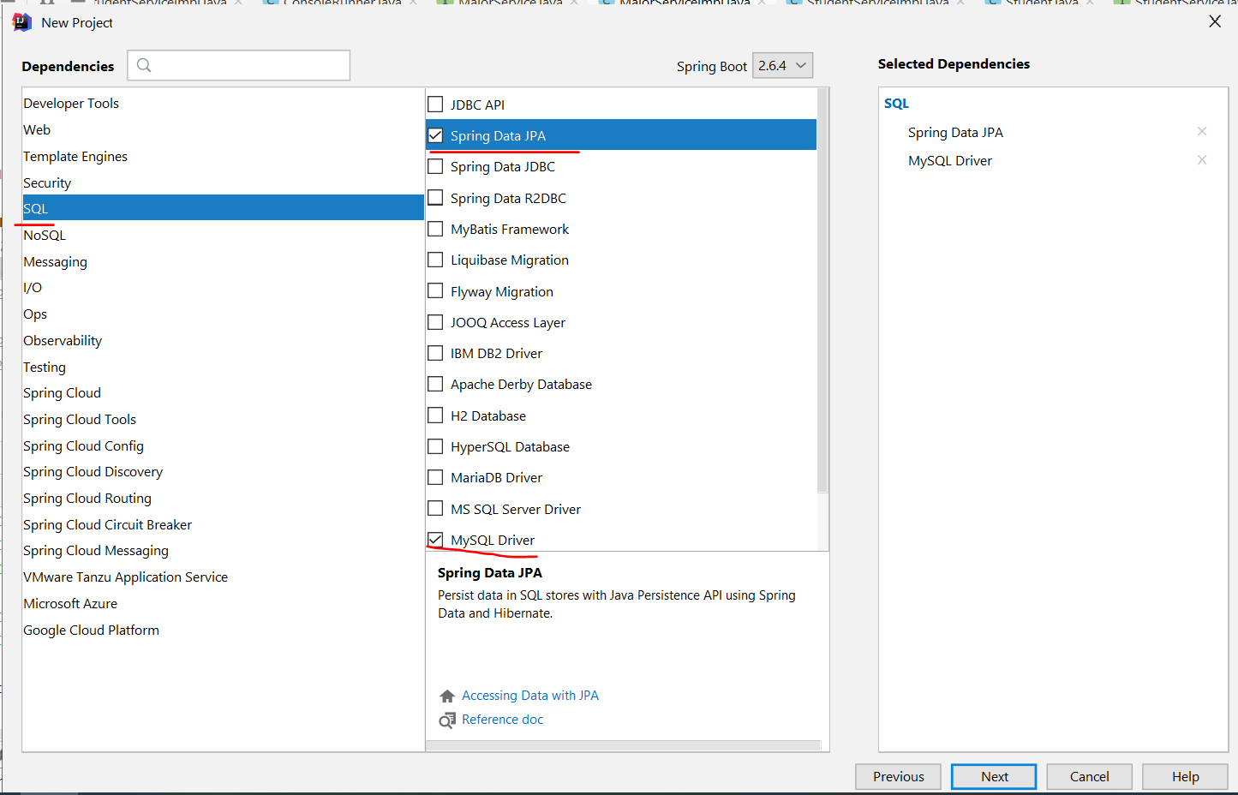

**Actuator ни служи за опресняване на данните и следи здравето на нашето приложение, да не се налага да даваме refresh прекалено често**

] 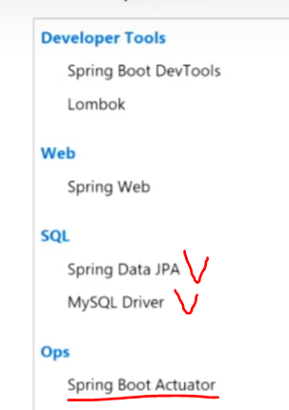

### applications.properties

In the resources folder, add new **applications.properties** file, which will hold the Spring configuration of the project:

*#Data Source Properties***spring.datasource.driverClassName** = **com.mysql.cj.jdbc.Driver  
spring.datasource.url** = **jdbc:mysql://localhost:3306/bookshop?createDatabaseIfNotExist=true&useSSL=false  
spring.datasource.username** = **root  
spring.datasource.password** =  
  
*#JPA Properties***spring.jpa.properties.hibernate.dialect** = **org.hibernate.dialect.MySQL8Dialect  
spring.jpa.properties.hibernate.show_sql** = **TRUE**

**spring.jpa.properties.hibernate.format_sql** = **TRUE**

**spring.jpa.properties.hibernate.use_sql_comments** = **TRUE**

**spring.jpa.hibernate.ddl-auto** = **create-drop**

**spring.jpa.hibernate.ddl-auto** = **create //реално drop и след това create**

**spring.jpa.hibernate.ddl-auto** = **update***###Logging Levels  
# Disable the default loggers – двете долу ако са активирани, скриват доста от default логовете***logging.level.org** = **WARN //контролираме логовете  
logging.level.blog** = **WARN //контролираме логовете***#Show SQL executed with parameter bindings***logging.level.org.hibernate.SQL** = **DEBUG  
logging.level.org.hibernate.type.descriptor** = **TRACE**

*# Spring actuator settings - service monitoring metrics  
#management.endpoints.web.base-path=/***management.endpoints.web.exposure.include**=**info, health, httptrace, metrics, threaddump, heapdump, shutdown, beans  
management.trace.http.enabled**=**true  
management.endpoint.health.show-details**=*always***info.app.name**=**Article repository application  
info.app.description**=**This sample application allows to manage articles and users  
info.app.version**=**1.0.0**

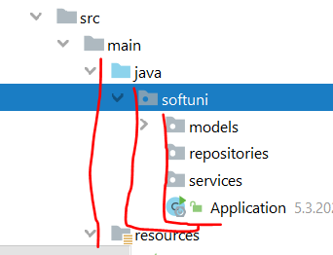

### persistence(javax.persistence) за Релациите

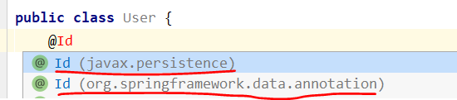

## 5.11. Demo Lab

Една анотация на един Interface ни дава тонове информация наготово

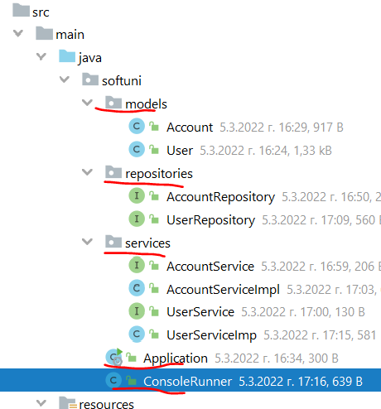

### models

**import** javax.persistence.*;  
**import** java.math.BigDecimal;  
@Entity(name = **"accounts"**)  
**public class** Account {  
 @Id  
 @GeneratedValue(strategy = GenerationType.***IDENTITY***)  
 **private int id**;  
  
 @Column(nullable = **false**)  
 **private** BigDecimal **balance**;  
  
 @ManyToOne  
 **private** User **user**;  
  
 **public** Account() {  
 }

@Entity(name = **"users"**)  
**public class** User {  
 @Id  
 @GeneratedValue(strategy = GenerationType.***IDENTITY***)  
 **private int id**;  
  
 @Column(unique = **true**, nullable = **false**)  
 **private** String **username**;  
  
 **private int age**;  
  
 @OneToMany(targetEntity = Account.**class**, mappedBy = **"user"**)  
 **private** Set<Account> **accounts**;  
  
 **public** User() {  
 **this**.**accounts** = **new** HashSet<>();  
 }

### Repositories, customs repositories(Custom CRUD Operations)

*/* @param <T> the domain type the repository manages  
 * @param <ID> the type of the id of the entity the repository manages */*@Repository *//наготово получаваме всички (CRUD) create, read, update, delete операции наготово***public interface** UserRepository **extends** JpaRepository<User, Integer> {  
 User findByUsername(String username);  
}

**import** org.springframework.data.jpa.repository.JpaRepository;  
**import** org.springframework.stereotype.Repository;  
**import** softuni.models.Account;  
**@Repository**  
**public interface** AccountRepository **extends** JpaRepository<Account, Integer> {  
}

The JpaRepository interface contains methods like:

* save(E entity)
* findOne(Id primaryKey)
* findAll()
* count()
* delete(E entity)
* exists(Id primaryKey)
* You can define a **custom repository**, which extends the JpaRepository and defines several methods for operating with data besides those exposed by the greater interface. The query builder mechanism of Spring Data requires following several rules when you define custom methods. Query creation is done by parsing method names by prefixes like find…By, read…By, query…By, count…By, and get…By. You can add more criteria by concatenating And and Or or apply ordering with OrderBy with sorting direction Asc or Desc.

<https://docs.spring.io/spring-data/jpa/docs/current/reference/html/#jpa.query-methods.query-creation>



### services

In bigger applications mixing business logic and crud operations to the database is not wanted. Having a repository objects is implementing the **Domain Driven Design**. Repositories are classes responsible **only for write/transactional operations** towards the data source. Any business logic like validation, calculations and so on is implemented by **a Service Layer**. One of the most important concepts to keep in mind is that a **service** should **never expose details of the internal processes,** or the business entities used within the application.

Implement those services with classes AccountServiceImpl and UserServiceImpl. Those classes will do the business logic of the application. To do that, they should have certain type of Repository available – AccountRepository or UserRepository according to the service type.

The implementation of the methods is up to you. Here are some several tips:

* AccountServiceImpl
  + Money withdrawal – should only happen if account **is present** in the database, **belongs to user** and **has enough balance**
  + Money transfer – should only happen if **account belongs to user** and transfer value **is not negative**
* UserServiceImpl
  + User registration – should only happen if user does not exist in the database

**public interface** AccountService {  
 **void** withdrawMoney(BigDecimal amount, Long id);  
  
 **void** depositMoney(BigDecimal amount, Long id);  
}

**import** org.springframework.beans.factory.annotation.Autowired;  
**import** org.springframework.stereotype.Service;  
**import** softuni.repositories.AccountRepository;  
**@Service**  
**public class** AccountServiceImpl **implements** AccountService {  
 **private final** AccountRepository **accountRepository**;  
  
 **@Autowired** – през конструктора  
 **public** AccountServiceImpl(AccountRepository accountRepository) {  
 **this**.**accountRepository** = accountRepository;  
 }  
  
 @Override  
 **public void** withdrawMoney(BigDecimal amount, Long id) { }  
  
 @Override  
 **public void** depositMoney(BigDecimal amount, Long id) { }  
}

**public interface** UserService {  
 **void** registerUser(User user);  
}

**import** org.springframework.beans.factory.annotation.Autowired;  
**import** org.springframework.stereotype.Service;  
**import** softuni.models.User;  
**import** softuni.repositories.UserRepository;  
**@Service**  
**public class** UserServiceImp **implements** UserService {  
  
 **@Autowired**  
 **private** UserRepository **userRepository**;  
  
 @Override  
 **public void** registerUser(User user) {

//checking if user exists in the database  
 User found = **this**.**userRepository**.**findByUsername**(user.getUsername());  
  
 **if** (found == **null**) {  
 **this**.**userRepository**.save(user);  
 }  
 }  
}

### ConsoleRunner

In Spring Data Framework, the usage of @Service, @Repository or @Component annotations is needed to separate different “**layers**” in the application. They are mainly used for programmers to know a class’s role and which logical layer it belongs to.

The @Autowired annotation is required when **injecting a resource**, e.g., **Repository** to **Service** or **Service to Component.**

**import** org.springframework.beans.factory.annotation.Autowired;  
**import** org.springframework.boot.CommandLineRunner;  
**import** org.springframework.stereotype.Component;  
**import** softuni.models.User;  
**import** softuni.services.UserService;  
  
**@Component**  
**public class** ConsoleRunner **implements CommandLineRunner** {  
 **@Autowired**  
 **private** UserService **userService**;  
  
 @Override  
 **public void** run(String... args) **throws** Exception {  
 User first = **new** User(**"Qna"**, 22);  
 **userService**.registerUser(first);  
  
 User second = **new** User(**"Qna"**, 22);  
 **userService**.registerUser(second);  
 }  
}

### main – задължително си правим някаква папка/пакет и в него хакаме MainApplication

**package** somePackage;  
  
**import** org.springframework.boot.SpringApplication;  
**import** org.springframework.boot.autoconfigure.SpringBootApplication;  
  
**@SpringBootApplication**  
**public class** MainApplication {  
 **public static void** main(String[] args) {  
 SpringApplication.*run*(MainApplication.**class**,args);  
 }  
}

## 5.12. Откъде четем не absolut path

**Започвайки от папка src**

**private static final** String ***RESOURCE_PATH*** = **"src/main/resources/files"**;  
**private static final** String ***AUTHORS_FILE_PATH*** = ***RESOURCE_PATH*** + **"/authors.txt"**;

## 5.13. Примери за customs repositories(Custom CRUD Operations)

Освен специалните думички като find, get, OrderBy, And, то използваме както имената на полетата, така и типовете на тези полета.

Като аргумент очаква типа на полето, което сме цитирали в името на метода.

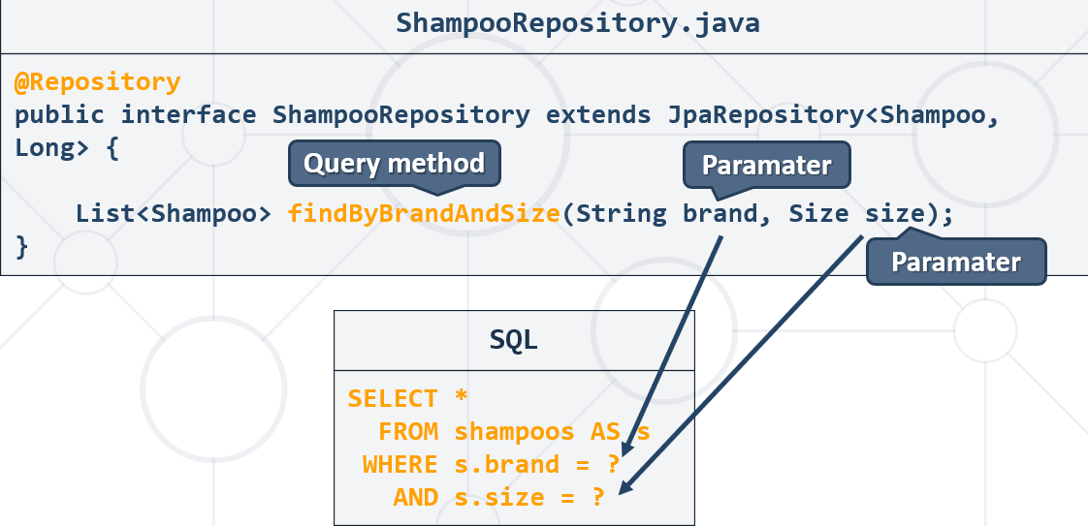

### 0. Подсказки – Automated JPA queries - Query look up

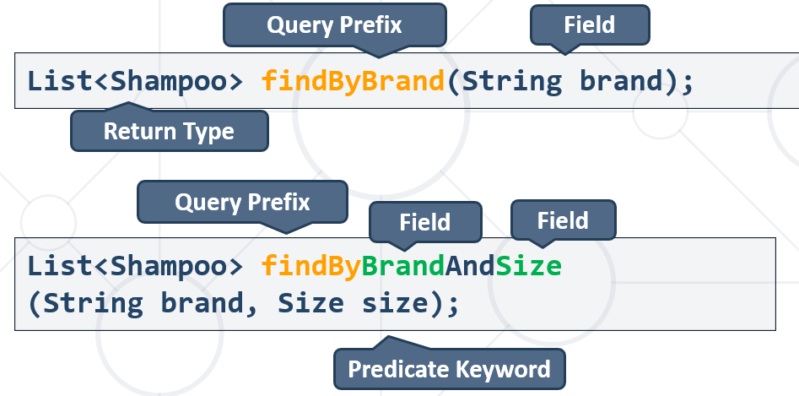

##### Реално ми излизат подсказки за имената на custom методите!! - яко

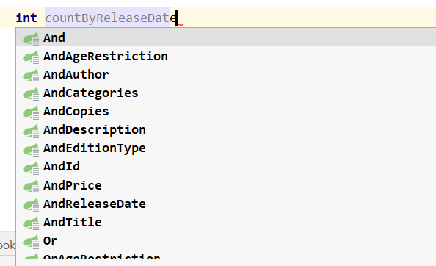

##### Долната черта показва, че влизаме в полето на класа:

List<ProductEntity> findAllByCategory**_**Name(CategoryName categoryName);

@Entity  
@Table(name = **"products"**)  
**public class** ProductEntity {  
 @ManyToOne  
 **private** CategoryEntity **category**;

@Entity  
@Table(name = **"categories"**)  
**public class** CategoryEntity {  
 @Column(unique = **true**, nullable = **false**)  
 @Enumerated(EnumType.***STRING***)  
 **private** CategoryName **name**;

### 1. countByReleaseDateAfter

Get all books after the year 2000. Print only their titles.

**@Repository**  
**public interface** BookRepository **extends** JpaRepository<Book, Integer> {  
 List<Book> **findByReleaseDateAfter**(LocalDate releaseDate);

**int countByReleaseDateAfter**(LocalDate releaseDate);

}

**@Component**  
**public class** ConsoleRunner **implements** CommandLineRunner {  
 **private final** SeedService **seedService**;  
 **private final** BookRepository **bookRepository**;  
  
 @Autowired  
 **public** ConsoleRunner(SeedService seedService, BookRepository bookRepository) {  
 **this**.**seedService** = seedService;  
 **this**.**bookRepository** = bookRepository;  
 }  
  
 **private void** _01_booksAfter2000() {  
 LocalDate yearAfter = LocalDate.*of*(2000, 1, 1 );  
 List<Book> books = **bookRepository**.**findByReleaseDateAfter**(yearAfter);  
  
 books.forEach(b -> System.***out***.println(b.getReleaseDate() + **" "** + b.getTitle()));

System.***out***.println(**"Total count result: "** + **bookRepository**.**countByReleaseDateAfter**(yearAfter));

}  
  
 @Override  
 **public void** run(String... args) **throws** Exception {  
 System.***out***.println(**"Starting"**);  
*// this.seedService.seedAuthors();  
// this.seedService.seedCategories();  
// this.seedService.seedAll();* **this**._01_booksAfter2000();  
 }

### 2. findDistinctByBooksReleaseDateBefore

Get all authors with at least one book with release date before 1990. Print their first name and last name.

@Component  
**public class** ConsoleRunner **implements** CommandLineRunner {  
 **private final** SeedService **seedService**;  
 **private final** BookRepository **bookRepository**;  
 **private final** AuthorRepository **authorRepository**;  
  
 @Autowired  
 **public** ConsoleRunner(SeedService seedService, BookRepository bookRepository, AuthorRepository authorRepository) {  
 **this**.**seedService** = seedService;  
 **this**.**bookRepository** = bookRepository;  
 **this**.**authorRepository** = authorRepository;  
 }  
  
  
 @Override  
 **public void** run(String... args) **throws** Exception {  
*// this._01_booksAfter2000();* **this**._02_allAuthorsWithBookBefore1990();  
 }  
  
 **private void** _02_allAuthorsWithBookBefore1990() {  
 LocalDate year1990 = LocalDate.*of*(1990, 1, 1);  
 List<Author> authors = **this**.**authorRepository**.**findDistinctByBooksReleaseDateBefore**(year1990);  
  
 authors.forEach(a -> System.***out***.println(a.getFirstName() + **" "** + a.getLastName()));  
 }

@Repository  
**public interface** AuthorRepository **extends** JpaRepository<Author, Integer> {  
 List<Author> **findDistinctByBooksReleaseDateBefore**(LocalDate releaseDate);  
}

### 3. find… – метод на JpaRepository – връща lazy

#### 3.1. Aко искаме да ни върши работа, заявяваме го EAGER

@Entity(name = **"authors"**)  
**public class** Author {

@OneToMany(targetEntity = Book.**class**, mappedBy = **"author"**, fetch = FetchType.***EAGER***)  
**private** Set<Book> **books**;

**import** demo.entities.Author;  
**import** demo.entities.Book;  
**import** demo.repositories.AuthorRepository;  
**import** demo.repositories.BookRepository;  
**import** demo.services.SeedService;  
**import** org.springframework.beans.factory.annotation.Autowired;  
**import** org.springframework.boot.CommandLineRunner;  
**import** org.springframework.stereotype.Component;  
  
**import** java.time.LocalDate;  
**import** java.util.List;  
  
@Component  
**public class** ConsoleRunner **implements** CommandLineRunner {  
 **private final** SeedService **seedService**;  
 **private final** BookRepository **bookRepository**;  
 **private final** AuthorRepository **authorRepository**;  
  
 @Autowired  
 **public** ConsoleRunner(SeedService seedService, BookRepository bookRepository, AuthorRepository authorRepository) {  
 **this**.**seedService** = seedService;  
 **this**.**bookRepository** = bookRepository;  
 **this**.**authorRepository** = authorRepository;  
 }  
  
 @Override  
 **public void** run(String... args) **throws** Exception {  
 System.***out***.println(**"Starting"**);  
**this**._03_allAuthorsOrderedByBookCount();  
 }  
  
 **private void** _03_allAuthorsOrderedByBookCount() {  
 List<Author> authors = **this**.**authorRepository**.**findAll()**; //тук не взема всички автори ако е lazy  
 authors.stream()  
 .sorted((f, s) -> Integer.*compare*(s.getBooks().size(), f.getBooks().size()))  
 .forEach(a -> System.***out***.printf(**"%s %s -> %d%n"**, a.getFirstName(),  
 a.getLastName(), a.getBooks().size()));  
 }  
}

#### 3.2. Втори вариант е да използваме Transactional анотация

Тогаваме няма нужда да използваме EAGER

@Entity(name = **"authors"**)  
**public class** Author {

@OneToMany(targetEntity = Book.**class**, mappedBy = **"author"**)  
**private** Set<Book> **books**;

**import** demo.entities.Author;  
**import** demo.entities.Book;  
**import** demo.repositories.AuthorRepository;  
**import** demo.repositories.BookRepository;  
**import** demo.services.SeedService;  
**import** org.springframework.beans.factory.annotation.Autowired;  
**import** org.springframework.boot.CommandLineRunner;  
**import** org.springframework.stereotype.Component;  
  
**import** java.time.LocalDate;  
**import** java.util.List;  
  
@Component  
**public class** ConsoleRunner **implements** CommandLineRunner {  
 **private final** SeedService **seedService**;  
 **private final** BookRepository **bookRepository**;  
 **private final** AuthorRepository **authorRepository**;  
  
 @Autowired  
 **public** ConsoleRunner(SeedService seedService, BookRepository bookRepository, AuthorRepository authorRepository) {  
 **this**.**seedService** = seedService;  
 **this**.**bookRepository** = bookRepository;  
 **this**.**authorRepository** = authorRepository;  
 }

//и двата transactional бачкат  
 @Override

***@Transactional*** *-* **import** javax.transaction.Transactional;**@Transactional** - **import** org.springframework.transaction.annotation.Transactional;  
 **public void** run(String... args) **throws** Exception {  
 System.***out***.println(**"Starting"**);  
**this**._03_allAuthorsOrderedByBookCount();  
 }  
  
 **private void** _03_allAuthorsOrderedByBookCount() {  
 List<Author> authors = **this**.**authorRepository**.findAll(); //тук не взема всички автори ако е lazy, но с иползването на Transactional в run метода минава  
 authors.stream()  
 .sorted((f, s) -> Integer.*compare*(s.getBooks().size(), f.getBooks().size()))  
 .forEach(a -> System.***out***.printf(**"%s %s -> %d%n"**, a.getFirstName(),  
 a.getLastName(), a.getBooks().size()));  
 }  
}

#### 3.3. findByFirstNameAndLastName

**private void** _04_GetAllBooksByAuthorname() {  
 String[] nameOfAuthor = **"George Powell"**.split(**"\\s+"**);  
 Author author = **this**.**authorRepository**.**findByFirstNameAndLastName**(nameOfAuthor[0], nameOfAuthor[1]);  
 List<Book> allBooksByAuthor = **this**.**bookRepository**.findAllByAuthorId(author.getId());  
 allBooksByAuthor.stream()  
 .sorted((f, s) -> {  
 **int** i = s.getReleaseDate().compareTo(f.getReleaseDate());  
 **if** (i == 0) {  
 i = f.getTitle().compareTo(s.getTitle());  
 }  
  
 **return** i;  
 })  
 .forEach(book -> System.***out***.printf(**"Book: %s, Release Date: %s%n"**, book.getTitle(), book.getReleaseDate()));  
}

### 4. OrderBy… - метод на JpaRepository

@Override  
**public** List<String> getAllBooksFromAuthorOrderedByReleaseDateDescAndBookTitleAscending  
 (String firstName, String lastName) {  
  
 List<String> bookInfo = **new** ArrayList<>();  
 **bookRepository** .**findAllByAuthorOrderByReleaseDateDescTitle**(**authorService**.getAuthor(firstName, lastName))  
 .forEach(book -> {  
 bookInfo.add(String.*format*(**"%s %s %d"** , book.getTitle()  
 , book.getReleaseDate()  
 , book.getCopies()  
 ));  
 });  
  
 **return** bookInfo;  
}

### 5. LessThanOrGreaterThan

List<Book> findByPriceLessThanOrPriceGreaterThan(BigDecimal lowerBound, BigDecimal upperBound);

### 6. Between

### 7. EndingWith/StartingWith

List<Author> findByFirstNameEndingWith(String endsWith);

List<Book> findByAuthorLastNameStartingWith(String search);

### 8. Containing – работи case-insensitive

List<Book> findByTitleContaining(String search);

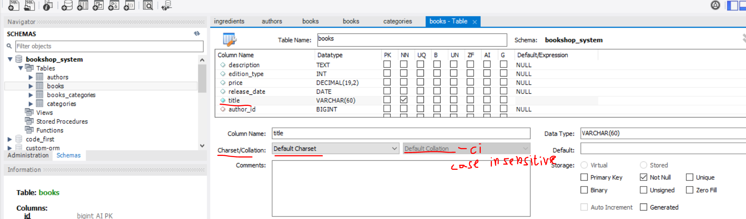

## 5.14. Transactions

Има изпълнение в две насоки:

* На база едно и също proxy
* На база една и съща инстанция

Ако използваме @Transactional от друг клас(класа ConsoleRunner и метода run) както в горния пример, то няма да се бърка.

Много е вероятно ако викаме на един service клас на различните му методи една и съща анотация @Transactional, то транзакциите да не се изпълнят правилно.

AccountServiceImpl.java

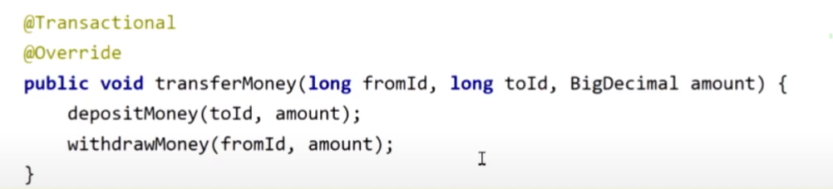

## 5.15. Използване на ApplicationRunner вместо на CommandLineRunner interface

**import** org.springframework.beans.factory.annotation.Autowired;  
**import** org.springframework.boot.ApplicationArguments;  
**import** org.springframework.boot.ApplicationRunner;  
**import** org.springframework.stereotype.Component;  
  
  
**@Component**  
**public class** AppRunner **implements** ApplicationRunner {  
 **private final** SeedService **seedService**;  
 **private final** BookRepository **bookRepository**;  
 **private final** AuthorRepository **authorRepository**;  
  
 @Autowired  
 **public** AppRunner(SeedService seedService, BookRepository bookRepository, AuthorRepository authorRepository) {  
 **this**.**seedService** = seedService;  
 **this**.**bookRepository** = bookRepository;  
 **this**.**authorRepository** = authorRepository;  
 }  
  
 @Override  
 **public void** run(ApplicationArguments args) **throws** Exception {  
 System.***out***.println(**"Starting"**);  
*// this.seedService.seedAuthors();  
// this.seedService.seedCategories();  
// this.seedService.seedAll();  
  
// this._01_booksAfter2000();  
// this._02_allAuthorsWithBookBefore1990();  
// this._03_allAuthorsOrderedByBookCount();* **this**._04_GetAllBooksByAuthorname();  
 }

# 6. Spring Data Advanced Querying

Стратегия – пишем от по-общото (от run() метода) към по частното, за да може IntelliJ да ни създаде лесно в съответните методи на различните layers методите!

## 6.1. Custom DSL Automated Queries

Domain Specific language (DSL) – такъв език за специфична система, който като напишем нещо с findBy, OrderBy и т.н. системата го разбира.

Освен специалните думички като find, get, OrderBy, And, то използваме както имената на полетата, така и типовете на тези полета.

Като аргумент очаква типа на полето, което сме цитирали в името на метода.



Query look up



## 6.2. Custom Manual JPQL query

@Query анотацията се изпълнява без значение дали името съвпада с custom automated query на Spring

### Пример 1:

**@Component**  
**public class** Runner **implements** CommandLineRunner {  
 **private final** ShampooRepository **shampooRepository**;  
  
 @Autowired  
 **public** Runner(ShampooRepository shampooRepository) {  
 **this**.**shampooRepository** = shampooRepository;  
 }  
  
 @Override  
 **public void** run(String... args) **throws** Exception {  
_0007_SelectShampoosbyIngredients();  
 }

**private void** _0007_SelectShampoosbyIngredients() {  
 Scanner sc = **new** Scanner(System.***in***);  
 String first = sc.nextLine();  
 String second = sc.nextLine();  
  
 Set<String> names = Set.*of*(first, second);  
 Set<String> collect = **this**.**shampooService**._07_selectByIngredientsNames(names)  
 .stream()  
 .map(s -> s.getBrand())  
 .collect(Collectors.*toSet*());  
  
collect.forEach(System.***out***::println);

}

}

@Repository  
**public interface** ShampooRepository **extends** JpaRepository<Shampoo, Long> {

**@Query**(**"SELECT s FROM Shampoo s"** +  
 **" JOIN s.ingredients AS i"**+  
 **" WHERE i.name IN :ingredientNames"**) //ако някоя от съставките за даден шампоан е в списъка с търсени съставки  
List<Shampoo> findByIngredientsNames(  
 **@Param**(value = **"ingredientNames"**) Set<String> ingredientNames); //може и без value

@Query(**"SELECT s FROM Shampoo s"** +  
 **" WHERE s.ingredients.size < :count"**) //deprecated syntax for size

**или " WHERE size(s.ingredients) < :count"**)  
List<Shampoo> findByIngredientCountLessThan(@Param(value = **"count"**)**int** count); //може и без value

}

### Пример 2:

@Repository  
**public interface** IngredientRepository **extends** JpaRepository<Ingredient, Long>{  
  
 @Query(value = **"select s from Shampoo s "** +  
 **"join s.ingredients i where i in :ingredients"**)  
 List<Shampoo> findByIngredientsIn(@Param(value = **"ingredients"**)  
 Set<Ingredient> ingredients);  
}

## 6.3. Java Persistence Query Language - JPQL

### JPQL

* **Object-oriented** query language – не оперираме с таблицата от базата данни, а с класа/обекта
  + Part of the Java Persistence API
  + Used to make queries against entities stored in a relational database
  + SQL syntax **operating with entities**, not tables in the data source

## 6.4. JPQL Custom queries - functionalities

### Insert

Insert e persist реално

### Select

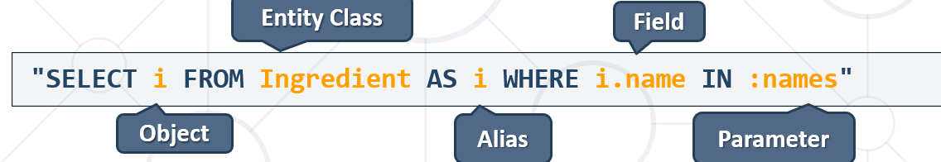

Оказва се, че в Spring Data JPQL лесно работи освен с цял обект на клас, то и с определени полета от класа! В Hibernate JPA беше по-трудно!!!

В следната заявка, JPQL връща java.lang.String, и ние сме го писали List<String> което си съответства.

@Repository  
**public interface** BookRepository **extends** JpaRepository<Book, Long> {  
  
  
 **@Query**(**"SELECT b.title FROM Book b WHERE b.ageRestriction = :ageRestriction"**)  
 List<String> findTitleByAgeRestriction(@Param(value = **"ageRestriction"**) AgeRestriction restriction); //може и без value

### Update

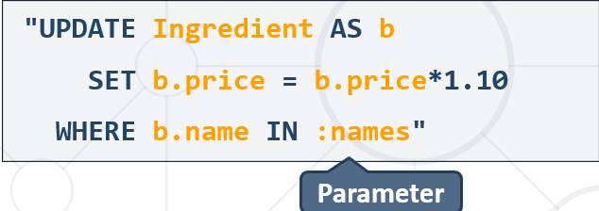

@Component  
**public class** Runner **implements** CommandLineRunner {  
 **private final** ShampooService **shampooService**;  
 **private final** IngredientService **ingredientService**;  
  
 @Autowired  
 **public** Runner(ShampooService shampooService, IngredientService ingredientService) {  
 **this**.**shampooService** = shampooService;  
 **this**.**ingredientService** = ingredientService;  
 }  
  
 @Override  
 **public void** run(String... args) **throws** Exception {  
_10_UpdateIngredientsbyPrice();  
 }

**private void** _10_UpdateIngredientsbyPrice() {  
 **this**.**ingredientService**.increasePriceByPercentage(0.1);  
}

}

**public interface** IngredientService {  
 **void** increasePriceByPercentage(**double** v);  
}

@Service  
**public class** IngredientServiceImpl **implements** IngredientService {  
 @Autowired  
 **private** IngredientRepository **ingredientRepository**;  
  
 **public** IngredientServiceImpl(IngredientRepository ingredientRepository) {  
 **this**.**ingredientRepository** = ingredientRepository;  
 }  
  
 @Override  
 **@Transactional //Ако има повече операции в сервиса, го слагаме тук**  
 **public void** increasePriceByPercentage(**double** percent) {  
 BigDecimal actualPercent = BigDecimal.*valueOf*(1 + percent); *//преобразуване на данни в сервиса* **this**.**ingredientRepository**.increasePriceByPercent(actualPercent);  
 }

}

@Repository  
**public interface** IngredientRepository **extends** JpaRepository<Ingredient, Long> {  
  
 **@Modifying**

**@Transactional //Ако е единична операция, го слагаме тук. Т.е. се стараем да слагаме transactional максимално навътре/надолу в долните layers**  
 @Query(**"UPDATE Ingredient i SET i.price = i.price * :multiplier"**) *//тук си го умножава BigDecimal без проблем. Типовете се валидират в Java, но @Query се изпълнява на ниво база данни.* **void** increasePriceByPercent(@Param(value = **"multiplier"**) BigDecimal percent);

@Modifying //върви заедно само с @Query  
@Query(**"UPDATE Ingredient i SET i.price = i.price * :multiplier WHERE i.name IN :listIngr"**)  
**void** increasePriceByPercentByAGivenList(@Param(value = **"multiplier"**) BigDecimal percent,  
 @Param(value = **"listIngr"**) Set<String> ingredients);

//може и без value  
}

### Delete

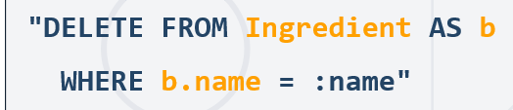

@Repository  
**public interface** BookRepository **extends** JpaRepository<Book, Long> {  
  
 **@Transactional** //в случая тук няма нужда от @Modifying, защото нямаме @Query  
 **int** deleteByCopiesLessThan(**int** amountCopies);  
}

### Join

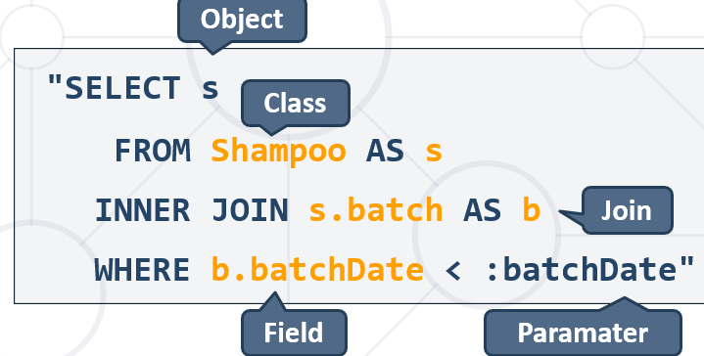

@Repository  
**public interface** ShampooRepository **extends** JpaRepository<Shampoo, Long> {

**@Query**(**"SELECT s FROM Shampoo s"** +  
 **" JOIN s.ingredients AS i"**+  
 **" WHERE i.name IN :ingredientNames"**) //ако някоя от съставките за даден шампоан е в списъка с търсени съставки  
List<Shampoo> findByIngredientsNames(  
 **@Param**(value = **"ingredientNames"**) Set<String> ingredientNames); //може и без value

@Query(**"SELECT s FROM Shampoo s"** +  
 **" WHERE s.ingredients.size < :count"**) //deprecated syntax for size

**или " WHERE size(s.ingredients) < :count"**)  
List<Shampoo> findByIngredientCountLessThan(@Param(value = **"count"**)**int** count); //може и без value

}

### :параметри и ?1 ?2 позиционни параметри

Това не работи

@Query(**"UPDATE Ingredient i SET i.price = i.price * ?1 WHERE i.name IN ?2"**)  
**void** increasePriceByPercentByAGivenList(@Param(value = **"multiplier"**) BigDecimal percent,  
 @Param(value = **"listIngr"**) Set<String> ingredients);

**Това работи**

TypedQuery<Customer> **typedQuery** = em.createQuery(**"SELECT c FROM Customer c WHERE c.firstName = ?1"**, Customer.**class**);  
typedQuery.setParameter(1,**"Mike"**);

List<Customer> customers=typedQuery.getResultList();

## 6.5. Repository Inheritance

#### Repository Inheritance

* In bigger applications, we have **similar entities**, extending an **abstract class**
* Their base attributes and actions, towards them, are the same regardless of their differences
* We can set up a **base repository** to reduce query and code duplication
* It can be **inherited** to clear up specifics - можем последващ клас да имплементира както JpaRepository, CRUDRepository, така и нашия CustomRepository

Example:

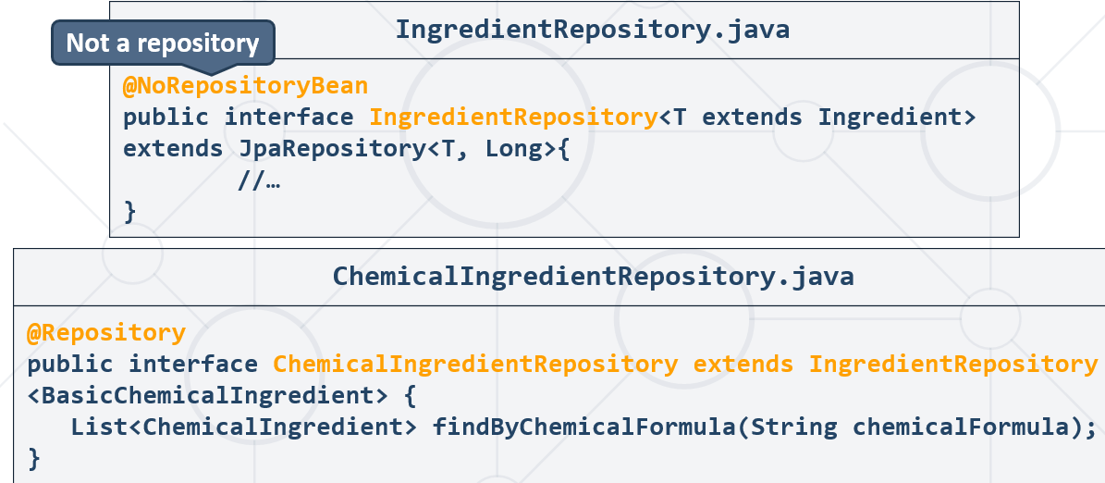

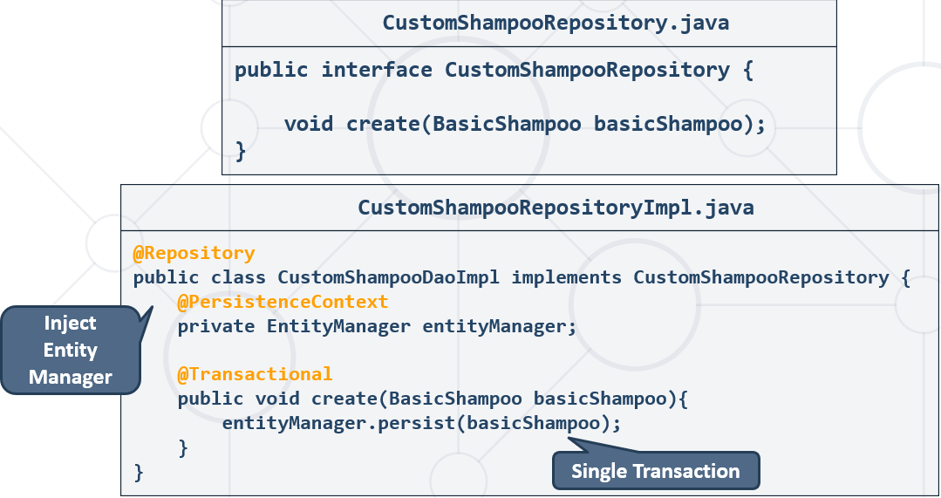

## 6.5. Spring Custom Configuration

### Application Properties configuration

* So far, we've configured our project with a spring properties file:

#### application.properties

*#Data Source Properties***spring.datasource.driverClassName**=**com.mysql.cj.jdbc.Driver  
spring.datasource.url**=**jdbc:mysql://localhost:3306/shampoo_company?useSSL=false&createDatabaseIfNotExist=true  
spring.datasource.username**=**root  
spring.datasource.password**=  
  
*#JPA Properties***spring.jpa.properties.hibernate.dialect** = **org.hibernate.dialect.MySQL8Dialect  
spring.jpa.properties.hibernate.format_sql** = **TRUE  
spring.jpa.hibernate.ddl-auto** = **update  
spring.jpa.open-in-view**=**false***###Logging Levels  
# Disable the default loggers – двете долу ако са активирани, скриват доста от default логовете***logging.level.org** = **WARN  
logging.level.blog** = **WARN***#Show SQL executed with parameter bindings***logging.level.org.hibernate.SQL** = **DEBUG  
logging.level.org.hibernate.type.descriptor** = **TRACE**

*#Change server port  
#server.port=8000*

### Java-Based Configuration

При започнал вече проект обикновено се използва

#### JavaConfig.java

**import** org.springframework.beans.factory.annotation.Autowired;  
**import** org.springframework.context.annotation.Bean;  
**import** org.springframework.context.annotation.Configuration;  
**import** org.springframework.context.annotation.PropertySource;  
**import** org.springframework.core.env.Environment;  
**import** org.springframework.data.jpa.repository.config.EnableJpaRepositories;  
**import** org.springframework.jdbc.datasource.DriverManagerDataSource;  
**import** org.springframework.orm.jpa.JpaTransactionManager;  
**import** org.springframework.orm.jpa.LocalContainerEntityManagerFactoryBean;  
**import** org.springframework.orm.jpa.vendor.Database;  
**import** org.springframework.orm.jpa.vendor.HibernateJpaVendorAdapter;  
**import** org.springframework.transaction.PlatformTransactionManager;  
**import** org.springframework.transaction.annotation.EnableTransactionManagement;  
  
**import** javax.persistence.EntityManagerFactory;  
**import** javax.sql.DataSource;  
**import** java.util.Properties;  
  
@Configuration *//Configuration class*@EnableJpaRepositories(basePackages = **"advquerying.repositories"**) *//repositories directory*@EnableTransactionManagement  
@PropertySource(value = **"application.properties"**)  
**public class** JavaConfig {  
 *//Add configuration* @Autowired **//Look up прилагане на Inversion of control principle**  
 **private** Environment **environment**;  
  
 *//Data Source Connection* @Bean  
 **public** DataSource dataSource() {  
 DriverManagerDataSource driverManagerDataSource = **new** DriverManagerDataSource();  
  
 driverManagerDataSource.setDriverClassName(**environment**.getProperty(**"spring.datasource.driverClassName"**));  
 driverManagerDataSource.setUrl(**environment**.getProperty(**"spring.datasource.url"**));  
 driverManagerDataSource.setUsername(**environment**.getProperty(**"spring.datasource.username"**));  
 driverManagerDataSource.setPassword(**environment**.getProperty(**"spring.datasource.password"**));  
  
 **return** driverManagerDataSource;  
 }  
  
 *//JPA Configuration* @Bean  
 **public** EntityManagerFactory entityManagerFactory() {  
 HibernateJpaVendorAdapter vendorAdapter = **new** HibernateJpaVendorAdapter();  
 vendorAdapter.setDatabase(Database.***MYSQL***);  
 vendorAdapter.setGenerateDdl(**true**);  
 vendorAdapter.setShowSql(**true**);  
  
 LocalContainerEntityManagerFactoryBean factory = **new** LocalContainerEntityManagerFactoryBean();  
 factory.setJpaVendorAdapter(vendorAdapter);  
 factory.setPackagesToScan(**"advquerying"**);  
 factory.setDataSource(dataSource());  
  
 Properties jpaProperties = **new** Properties();  
 jpaProperties.setProperty(**"hibernate.hbm2ddl.auto"**, **"validate"**);  
 jpaProperties.setProperty(**"hibernate.format_sql"**, **"true"**);  
  
 factory.setJpaProperties(jpaProperties);  
 factory.afterPropertiesSet();  
  
 **return** factory.getObject();  
 }  
  
 *//Transaction Manager Configuration* @Bean  
 **public** PlatformTransactionManager transactionManager() {  
 JpaTransactionManager txManager = **new** JpaTransactionManager();  
 txManager.setEntityManagerFactory(entityManagerFactory());  
 **return** txManager;  
 }  
}

## 6.6. Правилен подход при custom JPQL queries

Важи както за SpringData JPQL, така и за Hybernate JPA JPQL, така и за Hybernate HQL, така и за JDBC API SQL.

Вариант 3 и вариант 4 са правилните!!!

### Вариант 1 – CONCAT и java.lang.String class

@Query(**"SELECT CONCAT(a.firstName, ' ', a.lastName, ' ', SUM(b.copies)), SUM(b.copies) AS totalCopies"** +  
 **" FROM Author a"** +  
 **" JOIN a.books AS b"** +  
 **" GROUP BY b.author"** +  
 **" ORDER BY totalCopies DESC"**)  
List<String> getWithTotalCopies();

### Вариант 2 – Object[]

Виж търси по Object[] в този, за да го намериш лесно

### Вариант 3 – Closed Projection с използване на interface – не сработва с GSON

**public interface** AuthorNamesWithTotalCopies {  
 String getFirstName();  
 String getLastName();  
 **long** getTotalCopies();  
}

@Repository  
**public interface** AuthorRepository **extends** JpaRepository<Author, Long> {  
  
 @Query(**"SELECT a FROM Author a ORDER BY a.books.size DESC"**) *//Deprecated, новия JPQL синтаксис е SIZE(a.books), но става и чрез COUNT(a.books)*

@Query(**"SELECT a FROM Author a ORDER BY size(a.books) DESC"**)  
 List<Author> findAllByBooksSizeDESC();  
  
 List<Author> findByFirstNameEndingWith(String endsWith);  
 *//Използваме Alias тук спрямо интерфейс имената на getters* @Query(**"SELECT a.firstName AS firstName, a.lastName AS lastName, SUM(b.copies) AS totalCopies"** +  
 **" FROM Author a"** +  
 **" JOIN a.books AS b"** +  
 **" GROUP BY b.author"** +  
 **" ORDER BY totalCopies DESC"**)  
 List<AuthorNamesWithTotalCopies> getWithTotalCopies();  
}

**public interface** AuthorService {  
 List<AuthorNamesWithTotalCopies> _10_getWithTotalCopies();  
}

@Service  
**public class** AuthorServiceImpl **implements** AuthorService {  
 **private final** AuthorRepository **authorRepository**;  
  
 @Autowired  
 **public** AuthorServiceImpl(AuthorRepository authorRepository) {  
 **this**.**authorRepository** = authorRepository;  
 }  
  
 @Override  
 **public** List<AuthorNamesWithTotalCopies> _10_getWithTotalCopies() {  
 **return this**.**authorRepository**.getWithTotalCopies();  
 }  
}

@Component  
**public class** CommandLineRunnerImpl **implements** CommandLineRunner {  
  
 **private final** CategoryService **categoryService**;  
 **private final** AuthorService **authorService**;  
 **private final** BookService **bookService**;  
  
 @Autowired  
 **public** CommandLineRunnerImpl(CategoryService categoryService, AuthorService authorService, BookService bookService) {  
 **this**.**categoryService** = categoryService;  
 **this**.**authorService** = authorService;  
 **this**.**bookService** = bookService;  
 }  
  
 @Override  
 **public void** run(String... args) **throws** Exception {  
 **this**.**authorService**._10_getWithTotalCopies()  
 .forEach(a -> System.***out***.println(a.getFirstName() + **" "** + a.getLastName() + **" - "** + a.getTotalCopies()));  
 }

}

### Вариант 4 – Open Projection – отново с използване на interface - не сработва с GSON

**public interface** ProductWithoutBuyerDTO {  
 String getName();  
  
 BigDecimal getPrice();  
  
 ***//Open projection***@Value(**"#{target.seller.firstName + ' ' + target.seller.lastName}"**)  
 String getSeller();  
}

@Override  
 **public void** run(String... args) **throws** Exception {  
*// this.seedService.seedAll();* List<ProductWithoutBuyerDTO> productsForSell = **this**.**productService**.getProductsInPriceRangeForSell(500.0f, 1000.0f);

productsForSell  
 .forEach(p -> System.***out***.println(String.*format*(**"Product name: %s --- Product price: %.2f --- Seller full name: %s"**,  
 p.getName(), p.getPrice(), p.getSeller())));

Gson не го харесва при този сценарий с Open Projection !!!

}

@Override  
**public** List<ProductWithoutBuyerDTO> getProductsInPriceRangeForSell(**float** from, **float** to) {  
 BigDecimal rangeStart = BigDecimal.*valueOf*(from);  
 BigDecimal rangeEnd = BigDecimal.*valueOf*(to);  
  
 **return this**.**productRepository**.findAllByPriceBetweenAndBuyerIsNullOrderByPriceAsc(rangeStart, rangeEnd);  
}

@Repository  
**public interface** ProductRepository **extends** JpaRepository<Product, Integer> {  
 List<ProductWithoutBuyerDTO> findAllByPriceBetweenAndBuyerIsNullOrderByPriceAsc  
 (BigDecimal rangeStart, BigDecimal rangeEnd);  
}

### Вариант 5 – с използване на class

Class based projections do not work with native queries. As a workaround you may use named queries with ResultSetMapping or the Hibernate specific [ResultTransformer](https://docs.jboss.org/hibernate/orm/6.0/javadocs/org/hibernate/transform/ResultTransformer.html)

Извикваме new конструктор с целия път все едно – работело така, ама не е ок като цяло

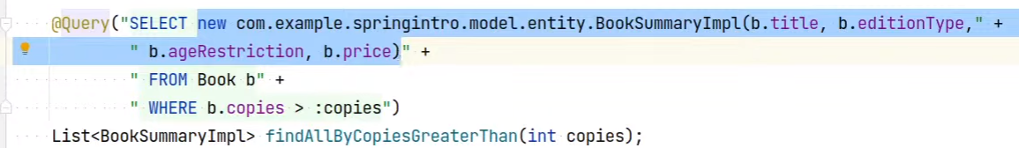

#### Пример:

**public class** ProductWithoutBuyerDTO {  
 **private** String **name**;  
 **private** BigDecimal **price**;  
 **private** String **seller**;  
  
 **public** ProductWithoutBuyerDTO(String name, BigDecimal price, String firstName, String lastName) {  
 **this**.**name** = name;  
 **this**.**price** = price;  
  
 **if** (firstName == **null**) {  
 **this**.**seller** = lastName;  
 } **else** {  
 **this**.**seller** = firstName + **" "** + lastName;  
 }  
 }  
  
 **public** String getName() {  
 **return name**;  
 }  
  
 **public** BigDecimal getPrice() {  
 **return price**;  
 }  
  
 **public** String getSeller() {  
 **return seller**;  
 }  
}

@Repository  
**public interface** ProductRepository **extends** JpaRepository<Product, Integer> {

//цитираме целият път на класа, понеже @Query заявката не го намира иначе   
 @Query(**"SELECT new com.example.json_ex.productsshop.entities.products.ProductWithoutBuyerDTO("** +  
 **" p.name, p.price, p.seller.firstName, p.seller.lastName)"** +  
 **" FROM Product AS p"** +  
 **" WHERE p.price >= :rangeStart AND p.price <= :rangeEnd AND p.buyer IS NULL"** +  
 **" ORDER BY p.price ASC"**)  
 List<ProductWithoutBuyerDTO> findAllByPriceBetweenAndBuyerIsNullOrderByPriceAsc  
 (BigDecimal rangeStart, BigDecimal rangeEnd);  
}

@Entity  
@Table(name = **"products"**) //за да върви горната заявка, то иска @Table  
**public class** Product {  
 @Id  
 @GeneratedValue(strategy = GenerationType.***IDENTITY***)  
 **private int id**;  
  
 @Column(nullable = **false**)  
 **private** String **name**;  
  
 @Column(nullable = **false**)  
 **private** BigDecimal **price**;  
  
 @ManyToOne  
*// @JoinColumn(name = "seller_id")* **private** User **seller**;  
  
 @ManyToOne  
*// @JoinColumn(name = "buyer_id")* **private** User **buyer**;  
  
 @ManyToMany  
 **private** Set<Category> **categories**;  
  
 **public** Product() {  
 **this**.**categories** = **new** HashSet<>();  
 }  
  
 **public** Product(String name, BigDecimal price) {  
 **this**();  
  
 **this**.**name** = name;  
 **this**.**price** = price;  
 }

### Вариант 6 – следващата тема за DTO(Data Transfer Object) в комбинация с ModelMapper и Converter

* We can **map entity objects to DTOs** using ModelMapper – вземаме обекта/листа от обекти от базата от repository-то , и го мапваме към специфично DTO

**Да използваме method reference пише в документацията за вътрешната команда.map**

@Service  
**public class** ProductServiceImpl **implements** ProductService {  
 **private final** ProductRepository **productRepository**;  
 **private final** ModelMapper **mapper**;  
 **private final** TypeMap<Product, ProductWithAttributesDTO> **productToDtoMapping**;  
  
 @Autowired  
 **public** ProductServiceImpl(ProductRepository productRepository) {  
 **this**.**productRepository** = productRepository;  
 **this**.**mapper** = **new** ModelMapper();  
  
 *//seller -> firstName + lastName  
 //от User на Стринг* Converter<User, String> userToFullNameConverter = context ->  
 context.getSource() == **null** ? **null** : context.getSource().getFullName();

//getSource() реално извиква инстанцията на User класа  
  
 TypeMap<Product, ProductWithAttributesDTO> typeMap = **this**.**mapper**.createTypeMap(Product.**class**, ProductWithAttributesDTO.**class**);  
  
 **this**.**productToDtoMapping** = typeMap.addMappings(m -> m  
 .using(userToFullNameConverter)  
 .map(Product::getSeller, ProductWithAttributesDTO::setSeller));

ИЛИ

*// <V> void map(SourceGetter<S> sourceGetter, DestinationSetter<D, V> destinationSetter);* **this**.**productToDtoMapping** = typeMap.addMappings(m -> m  
*// .when(Objects::nonNull)* .using(userToFullNameConverter)  
*// .map(Product::getSeller, ProductWithAttributesDTO::setSeller));* .map(Product::getSeller, ((destination, value) -> destination.setSeller((String) value))));

**this**.**mapper**.addConverter(userToFullNameConverter);  
 }  
  
 @Override  
 **public** ExportProductsInRangeDTO getInRange(**float** from, **float** to) {  
 BigDecimal rangeFrom = BigDecimal.*valueOf*(from);  
 BigDecimal rangeTo = BigDecimal.*valueOf*(to);  
  
 List<Product> products = **this**.**productRepository**.findAllByPriceBetweenAndBuyerIsNullOrderByPriceDesc(rangeFrom, rangeTo);  
 **List<ProductWithAttributesDTO>** dtos = products  
 .stream()  
 .map(p -> **this**.**productToDtoMapping**.map(p))  
 .collect(Collectors.*toList*());  
  
 **return new** ExportProductsInRangeDTO(dtos);  
 }  
}

@Entity  
@Table(name = **"users"**)  
**public class** User {  
 @Id  
 @GeneratedValue(strategy = GenerationType.***IDENTITY***)  
 **private int id**;  
  
 @Column(name = **"first_name"**, length = 255)  
 **private** String **firstName**;  
  
 @Column(name = **"last_name"**, nullable = **false**, length = 255)  
 **private** String **lastName**;  
  
 **private** Integer **age**;  
  
 @OneToMany(targetEntity = Product.**class**, mappedBy = **"seller"**)  
 **private** List<Product> **sellingItems**;  
  
 @OneToMany(targetEntity = Product.**class**, mappedBy = **"buyer"**)  
 **private** List<Product> **itemsBought**;  
  
 @ManyToMany  
 **private** Set<User> **friends**;  
  
  
 **public** User() {  
 **this**.**sellingItems** = **new** ArrayList<>();  
 **this**.**itemsBought** = **new** ArrayList<>();  
 **this**.**friends** = **new** HashSet<>();  
 }  
  
 **public** User(String firstName, String lastName, Integer age) {  
 **this**();  
  
 **this**.**firstName** = firstName;  
 **this**.**lastName** = lastName;  
 **this**.**age** = age;  
 }  
  
 **public** String **getFullName**() {  
 **if** (**this**.**firstName** == **null**) {  
 **return this**.**lastName**;  
 } **else** {  
 **return this**.**firstName** + **" "** + **this**.**lastName**;  
 }  
 }  
}

### Вариант 7 – следващата тема за DTO(Data Transfer Object) и чрез извикване на конструктора на DTO-то

**public class** EmployeeSpringDto {  
 **private** String **name**;  
 **private** String **lastName**;  
  
 **public** EmployeeSpringDto(Employee employee) {  
 **this**.**name** = **employee.getFirstName() + “ ” + employee.getLastName();**  
 }

**Пълен пример е следния:**

@Controller  
**public class** ExportController {  
 **private final** EmployeeService **employeeService**;  
 **private final** Gson **gson**;  
  
 @Autowired  
 **public** ExportController(ProjectService projectService, EmployeeService employeeService, Gson gson) {  
 **this**.**projectService** = projectService;  
 **this**.**employeeService** = employeeService;  
 **this**.**gson** = gson;  
 }  
  
 @GetMapping(**"/export/employees-above"**)  
 **public** ModelAndView showEmployeesAbove25(){  
 ModelAndView modelAndView = **new** ModelAndView(**"export/export-employees-with-age"**);  
  
 List<ExportEmployeeDTO> employeesAbove25 = **this**.**employeeService**.getEmployeesAbove25();  
  
 StringBuilder sb = **new** StringBuilder();  
 **this**.**gson**.toJson(employeesAbove25, sb);  
  
 modelAndView.addObject(**"employeesAbove"**, sb.toString());  
  
 **return** modelAndView;  
 }  
}

**public class** ExportEmployeeDTO {  
 **private** String **fullName**;  
 **private int age**;  
 **private** String **projectName**;  
  
 **public** ExportEmployeeDTO(Employee employee){  
 **this**.**fullName** = **employee.getFirstName() + " " + employee.getLastName();**  
 **this**.**age** = employee.getAge();  
 **this**.**projectName** = employee.getProject().getName();  
 }

}

@Service  
**public class** EmployeeService {  
 **private final** Path **xmlPath** = Path.*of*(**"src/main/resources/files/xmls/employees.xml"**);  
 **private final** EmployeeRepository **employeeRepository**;  
  
 @Autowired  
 **public** EmployeeService(EmployeeRepository employeeRepository) {  
 **this**.**employeeRepository** = employeeRepository;  
 }  
  
 **public** List<**ExportEmployeeDTO**> getEmployeesAbove25() {  
 List<Employee> employees = **this**.**employeeRepository**.findByAgeGreaterThanOrderByProjectNameAsc(25);  
  
 **return** employees.stream()  
 .map(**e -> new ExportEmployeeDTO(e)**)  
 .collect(Collectors.*toList*());  
 }  
}

@Repository  
**public interface** EmployeeRepository **extends** JpaRepository<Employee, Long> {  
 List<Employee> findByAgeGreaterThanOrderByProjectNameAsc(**int** i);  
}

## 6.7. Stored procedures in Spring data JPA repositories

Some method to our repository that call stored procedure

### 1. Map a Stored Procedure Name Directly

* We can define a stored procedure method using the @Procedure annotation, and map the stored procedure name directly.

@Procedure

**int** **GET_TOTAL_CARS_BY_MODEL**(String model);

* If we want to define a different method name, we can put the stored procedure name as the element of the @Procedure annotation:

@Procedure("GET_TOTAL_CARS_BY_MODEL")

**int** **getTotalCarsByModel**(String model);

* **We can also use the**procedureName**attribute to map the stored procedure name:**

@Procedure(procedureName = "GET_TOTAL_CARS_BY_MODEL")

**int** **getTotalCarsByModelProcedureName**(String model);

* Finally, we can use the value attribute to map the stored procedure name:

@Procedure(value = "GET_TOTAL_CARS_BY_MODEL")

**int** **getTotalCarsByModelValue**(String model);

### 2. Reference a Stored Procedure Defined in Entity

We can also use the @NamedStoredProcedureQuery annotation to define a stored procedure in the entity class:

@Entity

@NamedStoredProcedureQuery(name = "Car.getTotalCardsbyModelEntity",

procedureName = "GET_TOTAL_CARS_BY_MODEL", parameters = {

@StoredProcedureParameter(mode = ParameterMode.IN, name = "model_in", type = String.class),

@StoredProcedureParameter(mode = ParameterMode.OUT, name = "count_out", type = Integer.class)})

**public** **class** **Car** { // class definition }

Then we can reference this definition in the repository:

@Procedure(name = "Car.getTotalCardsbyModelEntity")

**int** **getTotalCarsByModelEntiy**(@Param("model_in") String model);

@Procedure(name=**"udp_get_books_count_by_author"**)  
**int** getBooksCountByAuthor(@Param(**"first_name"**) String firstName, @Param(**"last_name"**) String lastName);

We use the name attribute to reference the stored procedure defined in the entity class. For the repository method, we use @Param to match the input parameter of the stored procedure. We also match the output parameter of the stored procedure to the return value of the repository method.

### 3. Reference a Stored Procedure With the @Query Annotation

In SQL database, we create the stored procedure

DELIMITER $$

CREATE PROCEDURE totalAmountOfBooksByAuthor(authorNames VARCHAR(45))

BEGIN

SELECT count(*) FROM books AS b

JOIN authors AS a

ON a.id = b.author_id

WHERE CONCAT(a.first_name, ' ', a.last_name) = authorNames;

END $$

CALL totalAmountOfBooksByAuthor('Amanda Rice');

We can also call a stored procedure directly with the @Query annotation:

In this method, we use a native query to call the stored procedure. We store the query in the value attribute of the annotation.

Similarly, we use @Param to match the input parameter of the stored procedure. We also map the stored procedure output to the int.

@Query(value = **"CALL totalAmountOfBooksByAuthor(:authorNames);"**, nativeQuery = **true**)  
**int** findCountBooksAnAuthorWrote(String authorNames);

## 6.8. Special parameter handling – Pagable, Slice and Sort

<https://docs.spring.io/spring-data/jpa/docs/current/reference/html/#repositories.special-parameters>

**Using**Pageable**,**Slice**, and**Sort**in query methods**

Page<User> findByLastname(String lastname, Pageable pageable);

Slice<User> findByLastname(String lastname, Pageable pageable);

List<User> findByLastname(String lastname, Sort sort);

List<User> findByLastname(String lastname, Pageable pageable);

### Разписване за Pageable

@Override  
**public void** _12PrintInPages5() {  
 Page<Shampoo> page = **shampooRepository**.findAll(PageRequest.*of*(0, 5));  
  
 System.***out***.printf(**"Page %d of %d:%n--------------%n"**,  
 page.getNumber()+1, page.getTotalPages() //брои ги от 0, затова добавям + 1  
 );  
  
 page.forEach(s -> System.***out***.printf(**"%s %s %s %.2f %s%n"**,  
 s.getBrand(), s.getSize(), s.getLabel().getTitle(), s.getPrice(),  
 s.getIngredients().stream().map(Ingredient::getName).collect(Collectors.*toList*())));  
  
 **while** (page.hasNext()) {  
 page = **shampooRepository**.findAll(page.nextPageable());  
 System.***out***.printf(**"Page %d of %d:%n--------------%n"**,  
 page.getNumber()+1, page.getTotalPages() //брои ги от 0, затова добавям + 1  
 );  
  
 page.forEach(s -> System.***out***.printf(**"%s %s %s %.2f %s%n"**,  
 s.getBrand(), s.getSize(), s.getLabel().getTitle(), s.getPrice(),  
 s.getIngredients().stream().map(Ingredient::getName).collect(Collectors.*toList*())));  
 }  
}

# 7. Auto Mapping Objects DTO (Data Transfer Object)

## 7.1. Data Transfer Objects

Transmitting Aggregated Data from Entities

### Data Transfer Object Concept

* Domain objects are mapped to view models – **DTO**s
  + A DTO is a **container class – но само с исканите полета от потребителя**
  + Exposes only properties, **not methods – няма методи, които да вършат нещо**
* In **simple** applications, domain objects can be used in the meaning of DTOs
  + Otherwise, we accomplish nothing but **object replication**

### Entity Usage

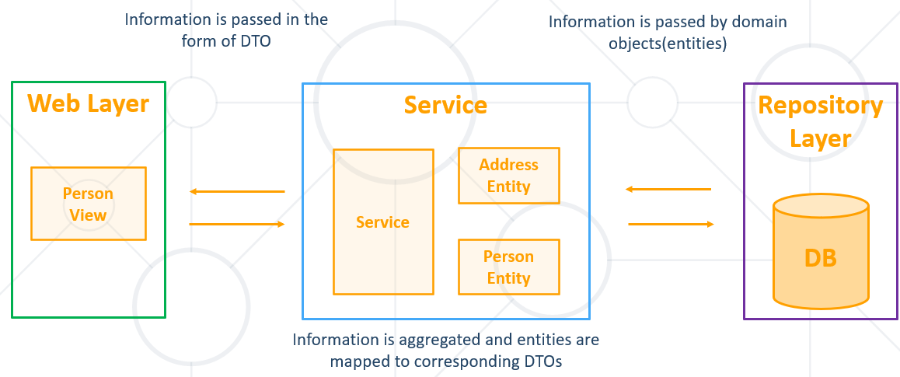

### DTO Usage

Част от полета на различни наши класове, които потребителят иска да вземе като информация от web страницата примерно:

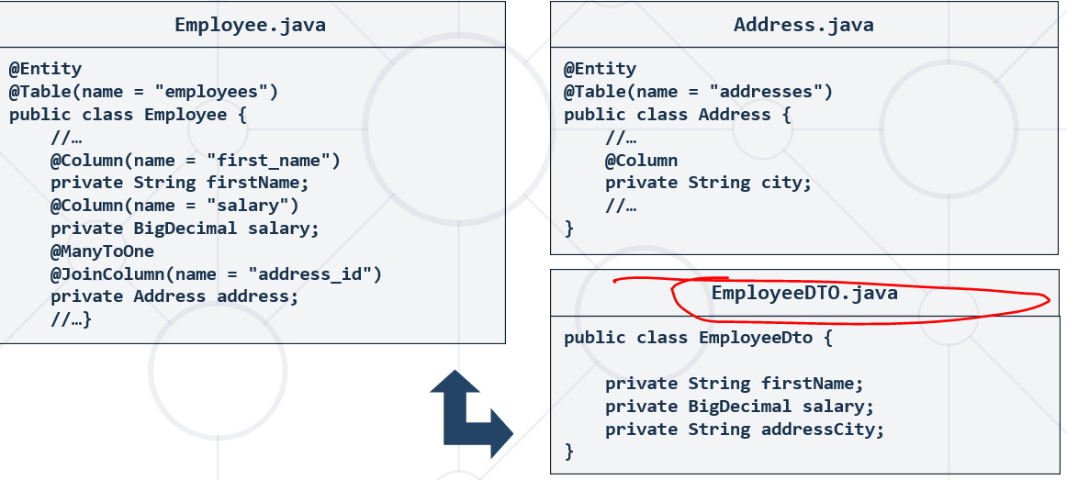

## 7.2. Model Mapping - Converting Entity Objects to DTOs

### Model Mapping

* We often want to map data between **objects with similar structure**
* Model mapping is an easy way to **convert one model to another**
* Separate **models** must **remain segregated**
* We can **map entity objects to DTOs** using ModelMapper – вземаме обекта/листа от обекти от базата от repository-то , и го мапваме към специфично DTO
* Uses **conventions** to determine how properties and values are mapped to each other

### Model Mapper

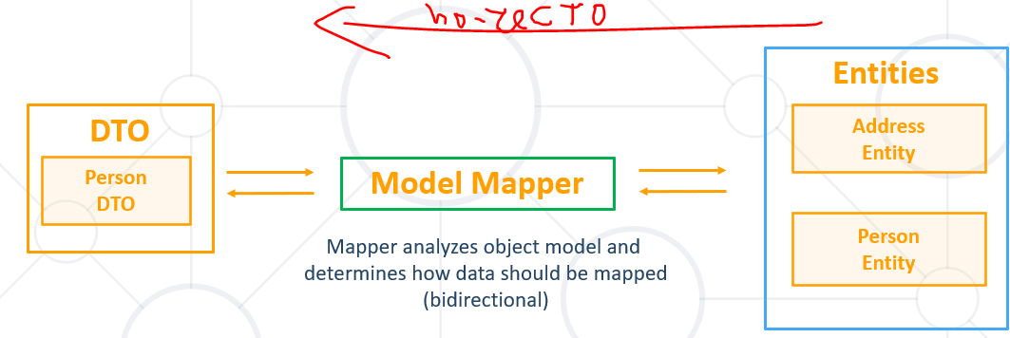

<http://modelmapper.org/getting-started/>

И в двете посоки можем да го използваме.

**1. Ако вземаме данни от базата, то от Entity към EntityDTO.**

**2. Ако записваме в базата данни, то от EntityDTO към Entity. (RegisterDTO -> Register) (LoginDTO -> Login).**

**3. Ако вземаме данни от JSON (файл), то от JSON към EntityDTO.**

@Override  
**public void** seedCategories() **throws** FileNotFoundException {  
 FileReader fileReader = **new** FileReader(***CATEGORIES_JSON_PATH***);  
 CategoryImportDTO[] categoriesImportDTOS = **this**.**gson**.fromJson(fileReader, CategoryImportDTO[].**class**); //вземи данни от JSON и ги съхрани в масив от DTO-та.

//масива от DTO-та го преобразувай на лист от Обекти, които са с формат тези на базата(в случая класа Category)  
 List<Category> categories = Arrays.*stream*(categoriesImportDTOS)  
 .map(importDTO -> **this**.**modelMapper**.map(importDTO, Category.**class**))  
 .collect(Collectors.*toList*());  
  
 **this**.**categoryRepository**.saveAll(categories);  
}

### Adding Model Mapper

#### Add as maven dependency - pom.xml

<**dependency**>  
 <**groupId**>org.modelmapper</**groupId**>  
 <**artifactId**>modelmapper</**artifactId**>  
 <**version**>3.0.0</**version**>  
</**dependency**>

#### Create object:

**import** org.modelmapper.ModelMapper;  
   
ModelMapper mapper = **new** ModelMapper();  
  
Address address = **new** Address(**"boris 3"**, 3, **"Sofia"**, **"Bulgaria"**);  
Employee source = **new** Employee(**"first"**, **"last"**,  
BigDecimal.***TEN***, LocalDate.*now*(), address);  
  
EmployeeDTO dto = mapper.map(source, EmployeeDTO.**class**);  
}

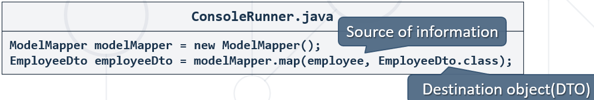

### Simple Mapping Entity to DTO

**ВАЖНО – да използваме същите имена и в двата класа и то camelCase - за да ги разпознва Spring и modellMapper-а.**

От Employee го мапни на DTO EmployDto.java

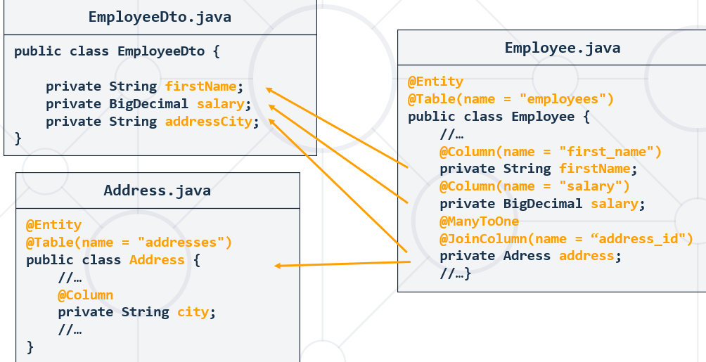

**import** org.modelmapper.ModelMapper;  
  
**public class** MapperMain {  
 **public static void** main(String[] args) {  
 ModelMapper mapper = **new** ModelMapper();  
  
 Address address = **new** Address(**"boris 3"**, 3, **"Sofia"**, **"Bulgaria"**);  
 Employee source = **new** Employee(**"first"**, **"last"**,  
 BigDecimal.***TEN***, LocalDate.*now*(), address);  
  
 EmployeeDTO dto = mapper.map(source, EmployeeDTO.**class**);  
  
 System.***out***.println(dto);

//EmployeeDTO{firstName='first', lastName='last', salary=10, city='Sofia'}  
 }  
}

**public class** Employee {  
 **private int id**;  
 **private** String **firstName**;  
 **private** String **lastName**;  
 **private** BigDecimal **salary**;  
 **private** LocalDate **birthday**;  
 **private** Address **address**;

….

}

**public class** Address {  
 **private int id**;  
 **private** String **street**;  
 **private int streetNumber**;  
 **private** String **city**;  
 **private** String **country**;

…..

}

**public class** EmployeeDTO {  
 **private** String **firstName**;  
 **private** String **lastName**;  
 **private** BigDecimal **salary**;  
 **private** String **addressCity**; //тук го задаваме нарочно address и City слято

……….

**getters (and setters sometimes) obligatory – сетъри слагаме особено за modellMapper-a**

**empty constructor forbidden!!! – за .xml и за .json обаче задължително**

**Normal constructor – maybe no – в единия случай не го хареса, че има конструктор**

**Class-based Projections (DTOs)7**

Another way of defining projections is by using value type DTOs (Data Transfer Objects) that hold properties for the fields that are supposed to be retrieved. These DTO types can be used in exactly the same way projection interfaces are used, except that no proxying happens and no nested projections can be applied.

**If the store optimizes the query execution by limiting the fields to be loaded, the fields to be loaded are determined from the parameter names of the constructor that is exposed.**

……….

}

### Manual(Explicit) Model Mapping

* ModelMapper uses **conventions** to map objects
  + Sometimes fields differ and mapping **won't be done properly**
  + In this case some manual mapping is needed

#### Java 6/7

ModelMapper modelMapper = **new** ModelMapper();  
PropertyMap<EmployeeDto, Employee> employeeMap = **new** PropertyMap<EmployeeDto, Employee>() {  
 @Override  
 **protected void** configure() {  
 map().setFirstName(source.getName());  
 *// Add mappings for other fields* map().setAddressCity(source.getAddress().getCity().getName());  
 }  
};  
  
modelMapper.addMappings(employeeMap).map(employeeDto, employee);

#### Java 8 and later

##### Пример 1:

ModelMapper modelMapper = **new** ModelMapper();  
TypeMap<Employee, EmployeeDto > typeMap = mapper.createTypeMap(Employee.**class,** EmployeeDto.**class**);  
typeMap.addMappings(m -> m.map(src -> src.getName(), Employee::setFirstName));

същото като (**(destination, value)** -> **destination**.setFirstName(**value**))));  
typeMap.map(employeeDto);

##### Пример 2:

ModelMapper mapper = **new** ModelMapper();  
 TypeMap<Employee, EmployeeSpringDto> typeMap = //source - target

mapper.createTypeMap(Employee.**class**, EmployeeSpringDto.**class**);

typeMap.addMappings(**m** -> **m**.map(  
 source -> source.getManager().getLastName().length(),  
 (**(destination, value)** -> **destination**.setManagerLastNameLength(**value**))));

същото като (EmployeeSpringDto::setManagerLastNameLength)));

**Минаваме и през Converter, за да не ни кара value да бъде от тип Object**

**//от Employee към Integer**

Converter<Employee, Integer> getLastNameLength =  
 ctx -> ctx.getSource() == **null** ? **null** : ctx.getSource().getLastName().length();  
  
employeeToCustom.addMappings(mapping ->  
 mapping.when(Objects::*nonNull*)  
 .using(getLastNameLength)  
 .map(Employee::getManager,  
 EmployeeSpringDto::setManagerLastNameLength)  
);

all  
 .stream()  
 .map(e -> employeeToCustom.map(e))  
 .forEach(System.***out***::println);

### Validation

ModelMapper modelMapper = **new** ModelMapper();  
modelMapper.createTypeMap(EmployeeDto.**class**, Employee.**class**); //source - target  
modelMapper.validate();

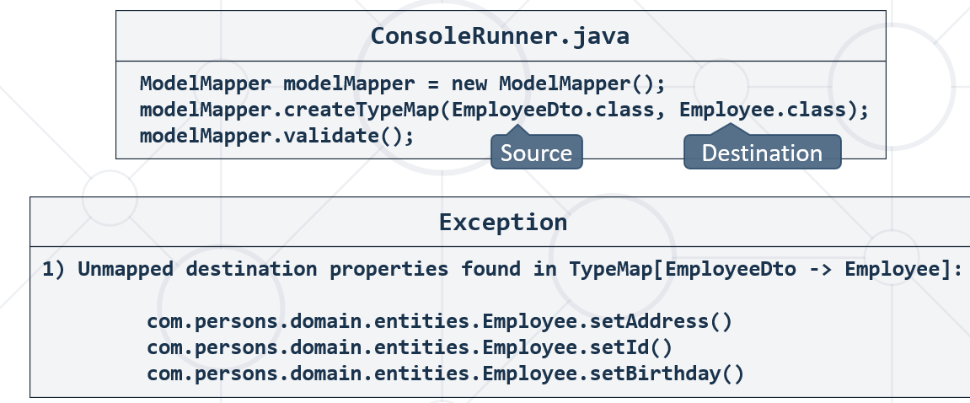

### Skipping Properties

#### Java 6/7

ModelMapper modelMapper = **new** ModelMapper();  
PropertyMap<EmployeeDto, Employee> employeeMap = **new** PropertyMap<EmployeeDto, Employee>() {  
 @Override  
 **protected void** configure() {  
 skip().setSalary(**null**); //skipping salary  
 }  
};  
  
modelMapper.addMappings(employeeMap).map(employeeDto, employee);

#### Java 8 and later

typeMap.addMappings(mapper -> mapper.skip(Employee::setSalary));  
typeMap.map(employeeDto);

### Converting Properties

#### Java 6/7

##### Пример 1:

ModelMapper modelMapper = **new** ModelMapper();  
Converter<String, String> stringConverter = **new** AbstractConverter<String, String>() {  
 @Override  
 **protected** String convert(String s) {  
 **return** s == **null** ? **null** : s.toUpperCase(); //Convert Strings to Upper Case  
 }  
};  
  
PropertyMap<EmployeeDto, Employee> employeeMap = **new** PropertyMap<EmployeeDto, Employee>() {  
 @Override  
 **protected void** configure() {  
 using(stringConverter).map().setFirstName(source.getName()); //Use Convertion  
 }  
};  
  
modelMapper.addMappings(employeeMap).map(employeeDto, employee);

##### Пример 2:

*//от User на Стринг*Converter<User, String> userToFullNameConverter = **new** Converter<User, String>() {  
 @Override  
 **public** String convert(MappingContext<User, String> context) {  
 **return** context.getSource() == **null** ? **null** : context.getSource().getFullName();

//getSource() реално извиква инстанцията на User класа  
 }  
};

#### Java 8 and later

##### Пример 1:

ModelMapper modelMapper = **new** ModelMapper();

//от String в String  
Converter<String, String> toUppercase = ctx -> ctx.getSource() == **null** ? **null** : ctx.getSource().toUpperCase();

TypeMap<EmployeeDto, Employee> typeMap = mapper.createTypeMap(EmployeeDto.**class**, Employee.**class**)  
 .addMappings(mapper -> mapper.using(toUppercase).map(EmployeeDto::getName, Employee::setFirstName));

typeMap.map(employeeDto);

##### Пример 2:

*//от User на Стринг*Converter<User, String> userToFullNameConverter = context ->   
 context.getSource() == **null** ? **null** :

context.getSource() //getSource() реално извиква инстанцията на User класа

.getFullName();

### Дървен ръчен вариант за mapping – чрез конструктор на DTO класа

**public class** EmployeeSpringDto {  
 **private** String **firstName**;  
 **private** String **lastName**;  
  
 **public** EmployeeSpringDto(Employee employee) {  
 **this**.**firstName** = employee.getFirstName();  
 **this**.**lastName** = employee.getLastName();  
 }

### CustomModelMapper, TypeMap, Converter, addMappings using the converter

**Да използваме method reference пише в документацията за вътрешната команда.map**

@Service  
**public class** ProductServiceImpl **implements** ProductService {  
 **private final** ProductRepository **productRepository**;  
 **private final** ModelMapper **mapper**;  
 **private final** TypeMap<Product, ProductWithAttributesDTO> **productToDtoMapping**;  
  
 @Autowired  
 **public** ProductServiceImpl(ProductRepository productRepository) {  
 **this**.**productRepository** = productRepository;  
 **this**.**mapper** = **new** ModelMapper();  
  
 *//seller -> firstName + lastName  
 //от User на Стринг* Converter<User, String> userToFullNameConverter = context ->  
 context.getSource() == **null** ? **null** : context.getSource().getFullName();

//getSource() реално извиква инстанцията на User класа  
  
 TypeMap<Product, ProductWithAttributesDTO> typeMap = **this**.**mapper**.createTypeMap(Product.**class**, ProductWithAttributesDTO.**class**);  
  
 **this**.**productToDtoMapping** = typeMap.addMappings(m -> m  
 .using(userToFullNameConverter)  
 .**map**(Product::getSeller, ProductWithAttributesDTO::setSeller));

ИЛИ

*// <V> void map(SourceGetter<S> sourceGetter, DestinationSetter<D, V> destinationSetter);* **this**.**productToDtoMapping** = typeMap.addMappings(m -> m  
*// .when(Objects::nonNull)* .using(userToFullNameConverter)  
*// .map(Product::getSeller, ProductWithAttributesDTO::setSeller));* .map(Product::getSeller, ((destination, value) -> destination.setSeller((String) value))));

**this**.**mapper**.addConverter(userToFullNameConverter);  
 }

@Override  
 **public** ExportProductsInRangeDTO getInRange(**float** from, **float** to) {  
 BigDecimal rangeFrom = BigDecimal.*valueOf*(from);  
 BigDecimal rangeTo = BigDecimal.*valueOf*(to);  
  
 List<Product> products = **this**.**productRepository**.findAllByPriceBetweenAndBuyerIsNullOrderByPriceDesc(rangeFrom, rangeTo);  
 **List<ProductWithAttributesDTO>** dtos = products  
 .stream()  
 .map(p -> **this**.**productToDtoMapping**.map(p))  
 .collect(Collectors.*toList*());  
  
 **return new** ExportProductsInRangeDTO(dtos);  
 }  
}

@Entity  
@Table(name = **"users"**)  
**public class** User {  
 @Id  
 @GeneratedValue(strategy = GenerationType.***IDENTITY***)  
 **private int id**;  
  
 @Column(name = **"first_name"**, length = 255)  
 **private** String **firstName**;  
  
 @Column(name = **"last_name"**, nullable = **false**, length = 255)  
 **private** String **lastName**;  
  
 **private** Integer **age**;  
  
 @OneToMany(targetEntity = Product.**class**, mappedBy = **"seller"**)  
 **private** List<Product> **sellingItems**;  
  
 @OneToMany(targetEntity = Product.**class**, mappedBy = **"buyer"**)  
 **private** List<Product> **itemsBought**;  
  
 @ManyToMany  
 **private** Set<User> **friends**;  
  
  
 **public** User() {  
 **this**.**sellingItems** = **new** ArrayList<>();  
 **this**.**itemsBought** = **new** ArrayList<>();  
 **this**.**friends** = **new** HashSet<>();  
 }  
  
 **public** User(String firstName, String lastName, Integer age) {  
 **this**();  
  
 **this**.**firstName** = firstName;  
 **this**.**lastName** = lastName;  
 **this**.**age** = age;  
 }  
  
 **public** String **getFullName**() {  
 **if** (**this**.**firstName** == **null**) {  
 **return this**.**lastName**;  
 } **else** {  
 **return this**.**firstName** + **" "** + **this**.**lastName**;  
 }  
 }  
}

### ModelMapper and addConverter on it – from String to Date

Добавяне на един или повече converter-и на нашия modelMapper – като срещне поле от единия клас от String в другия клас Date, и да си се оправя/конвъртва.

#### Java 8 and later

**private final** ModelMapper **modelMapper**;

*//this works :)***this**.**modelMapper**.addConverter((Converter<String, LocalDate>)  
 ctx -> LocalDate.*parse*(ctx.getSource(), DateTimeFormatter.*ofPattern*(**"dd/MM/yyyy"**)),  
 String.**class**, LocalDate.**class**);  
  
*//this also works :)***this**.**modelMapper**.addConverter(ctx -> LocalDate.*parse*(ctx.getSource(), DateTimeFormatter.*ofPattern*(**"dd/MM/yyyy"**)),  
 String.**class**, LocalDate.**class**);

#### Java 6-7

//this one also works

@Bean //@Component също върши работа ако е главен клас  
**public** ModelMapper modelMapper() {  
 ModelMapper modelMapper = **new** ModelMapper();  
   
 modelMapper.addConverter(**new** Converter<String, LocalDate>() {  
 @Override  
 **public** LocalDate convert(MappingContext<String, LocalDate> mappingContext) {  
 **return** LocalDate.*parse*(mappingContext.getSource(), DateTimeFormatter.*ofPattern*(**"dd/MM/yyyy"**));  
 }  
 });  
  
 modelMapper.addConverter(**new** Converter<String, LocalDateTime>() {  
 @Override  
 **public** LocalDateTime convert(MappingContext<String, LocalDateTime> mappingContext) {  
 **return** LocalDateTime.*parse*(mappingContext.getSource(), DateTimeFormatter.*ofPattern*(**"yyyy-MM-dd HH:mm:ss"**));  
 }  
 });  
  
 **return** modelMapper;  
}

# 8. JSON

Exporting and Importing Data from JSON Format

<https://www.json.org/json-en.html>

## 8.1. JSON

Transmitting Data Objects Via Attribute-value Pairs

JSON служи най-вече предаване на данни. Например в браузъра.

Но е възможно да служи и като настройка файл за дадена програма, или за извличане от SQL бази данни или за съхранение на данни в браузъра (в случаите когато данни не се предават по мрежата, а се генерират в бразуъра от интеракцията с потребителя).

Можем да пазим и log файлове с JSON формат.

JSON не поддържа хипервръзки. Използва се по-скоро за дървовидна структура

### JSON

* **J**ava**S**cript **O**bject **N**otation
  + Human-readable format to transmit **data objects** consisting of **attribute–value pairs** and **arrays**
  + Subset of **JavaScript** syntax
* Supports several data types:
  + Number, String, Boolean, Array, Object, null

#### Key-Value

{  
 **"firstName"**: **"Daniel"**,  
 **"lastName"**: **"Sempre"**,  
 **"age"**: 24,  
 **"isMarried"**: **true**}

#### With Array type value:

{  
 **"firstName"**: **"Daniel"**,  
 **"lastName"**: **"Sempre"**,  
 **"age"**: 24,  
 **"courses"**: [  
 {  
 **"name"**: **"Java DB" no comma here** },  
 {  
 **"name"**: **"HTML" no comma here** }  
 ]  
}

### JSON Function

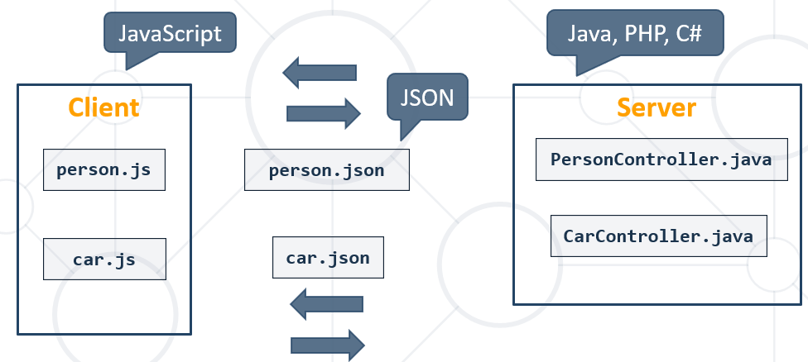

### JSON Structure

* Data is represented in **name/value** pairs
* Curly braces hold objects
* Square brackets hold **arrays**

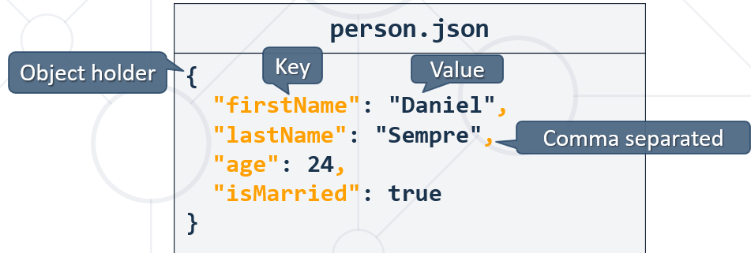

{  
 **"firstName"**: **"John"**,  
 **"lastName"**: **"Snow"**,  
 **"address"**: {  
 **"country"**: **"Spain"**,  
 **"city"**: **"Barcelona"**,  
 **"street"**: **"Barcelona"** },  
 **"phoneNumbers"**: [  
 {  
 **"number"**: **"1e341341"** },  
 {  
 **"number"**: **"542152"** }  
 ]  
}

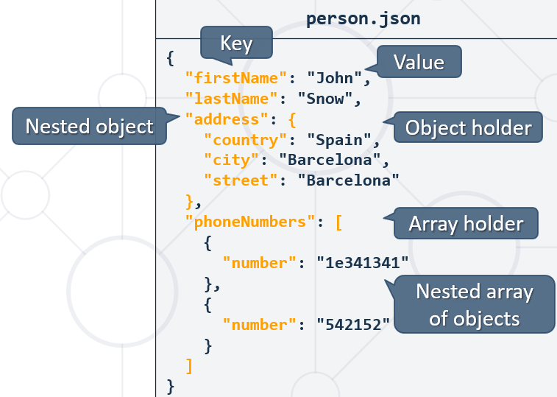

## 8.2. GSON parser

Serialize and De-serialize objects with Java

### GSON parser intro

* Java library to operate with JSON files
* Provides easy to use mechanisms to convert **Java to JSON** and vice-versa
  + Originally developed by Google
* Generates compact and readability JSON output

#### pom.xml

<**dependencies**>  
 *<!-- https://mvnrepository.com/artifact/com.google.code.gson/gson -->* <**dependency**>  
 <**groupId**>com.google.code.gson</**groupId**>  
 <**artifactId**>gson</**artifactId**>  
 <**version**>2.9.0</**version**>  
 </**dependency**>  
  
</**dependencies**>

### GSON Initialization

* Gson objects are responsible for the JSON manipulations
  + GsonBuilder creates an instance of GSON
  + **excludeFieldsWithoutExposeAnnotation()** – excludes fields without **@Expose** annotation
  + **setPrettyPrinting()** – aligns and justifies the created JSON format
  + **create()** – creates an instance of Gson

**import** com.google.gson.Gson;  
**import** com.google.gson.GsonBuilder;  
  
**public class** Main {  
 **public static void** main(String[] args) {  
 Gson gson = **new** GsonBuilder()  
 .excludeFieldsWithoutExposeAnnotation()  
 .setPrettyPrinting()  
 .create();  
 }  
}

### Serializartion and Deserialization

Сериализираме от обекта към JSON string пренос формата на данни

Десериализираме от JSON string към съответния искан формат на обекта

### Expose варианти:

**@Expose**(serialize = **false**, deserialize = **true**) //от обекта към JSON стринг не го вземай това поле  
@NonNull //от lombok  
@NotNull *//jakarta validation javax.validation.constraints на Java класа полето да не е null,* Accepts any type, including Enum

@NotBlank - *//jakarta validation javax.validation.constraints* The annotated element must not be null and must contain at least one non-whitespace character. Accepts any type, including Enum

@Length(min = 4, max = 30) *//полето в JAVA средата да е с тези ограничения; @Length не включва notNull, org.hibernate.validator.constraints.Length; - in pom.xml file added*@Column(unique = **true**, nullable = **false**) *//за базата SQL ограничение при създаването***private** String **password**;

### Export Single Object to JSON (Serializartion)

**import** com.google.gson.annotations.Expose;  
  
**import** java.io.Serializable;  
  
**public class** AddressJsonDto **implements** Serializable {  
 @Expose //The field will be imported/exported  
 **private** String **country**;  
 @Expose //The field will be imported/exported  
 **private** String **city**;  
 @Expose //The field will be imported/exported  
 **private** String **street**;  
}

**import** com.google.gson.Gson;  
**import** com.google.gson.GsonBuilder;  
  
**public class** Main {  
 **public static void** main(String[] args) {  
 Gson gson = **new** GsonBuilder()  
 .excludeFieldsWithoutExposeAnnotation()  
 .setPrettyPrinting()  
 .create();  
  
 AddressJsonDto addressJsonDto = **new** AddressJsonDto();  
 addressJsonDto.setCountry(**"Bulgaria"**);  
 addressJsonDto.setCity(**"Sofia"**);  
 addressJsonDto.setStreet(**"Mladost 4"**);  
 String content = gson.toJson(addressJsonDto);  
  
 System.***out***.println(content);  
 }  
}

Отпечатва се:

{

"country": "Bulgaria",

"city": "Sofia",

"street": "Mladost 4"

}

### Export Multiple Object to JSON (Serializartion)

**import** com.google.gson.annotations.Expose;  
  
**import** java.io.Serializable;  
  
**public class** AddressJsonDto **implements** Serializable {  
 @Expose //The field will be imported/exported  
 **private** String **country**;  
 @Expose //The field will be imported/exported  
 **private** String **city**;  
 @Expose //The field will be imported/exported  
 **private** String **street**;  
}

**import** com.google.gson.Gson;  
**import** com.google.gson.GsonBuilder;  
  
**import** java.util.ArrayList;  
**import** java.util.List;  
  
**public class** Main {  
 **public static void** main(String[] args) {  
 Gson gson = **new** GsonBuilder()  
 .excludeFieldsWithoutExposeAnnotation() //ако използваме expose на полетата на класа  
 .setPrettyPrinting()  
 .create();  
  
 AddressJsonDto addressJsonDtoBulgaria = **new** AddressJsonDto();  
 addressJsonDtoBulgaria.setCountry(**"Bulgaria"**);  
 addressJsonDtoBulgaria.setCity(**"Sofia"**);  
 addressJsonDtoBulgaria.setStreet(**"Mladost 4"**);  
  
 AddressJsonDto addressJsonDtoSpain = **new** AddressJsonDto();  
 addressJsonDtoSpain.setCountry(**"Spain"**);  
 addressJsonDtoSpain.setCity(**"Barcelona"**);  
 addressJsonDtoSpain.setStreet(**"Las Ramblas"**);  
  
 List<AddressJsonDto> addressJsonDtos = **new** ArrayList<>();  
 addressJsonDtos.add(addressJsonDtoBulgaria);  
 addressJsonDtos.add(addressJsonDtoSpain);  
 String content = gson.toJson(addressJsonDtos);  
  
 System.***out***.println(content);  
 }  
}

Отпечатва се:

[

{

"country": "Bulgaria",

"city": "Sofia",

"street": "Mladost 4"

},

{

"country": "Spain",

"city": "Barcelona",

"street": "Las Ramblas"

}

]

### Export Nested Multiple Object to JSON (Serializartion)

**public class** CustomerOutputToJSONDto {  
 **private** String **firstName**;  
 **private** String **lastName**;  
 **private** String **email**;  
 **private** TownJsonDto **town**;

**public** CustomerOutputToJSONDto() {  
}

}

**public class** TownJsonDto {  
 **private** String **name**;  
  
 **public** TownJsonDto() {  
 }

}

**public class** Main {  
 **public static void** main(String[] args) **throws** IOException {  
 Gson gson = **new** GsonBuilder()  
*// .excludeFieldsWithoutExposeAnnotation() //ако използваме expose на полетата на класа* .setPrettyPrinting()  
 .create();  
  
 CustomerOutputToJSONDto entry1 = **new** CustomerOutputToJSONDto();  
 entry1.setFirstName(**"Ivan"**);  
 entry1.setLastName(**"Petkov"**);  
 entry1.setEmail(**"ivan@abv.bg"**);  
 TownJsonDto tn1 = **new** TownJsonDto();  
 tn1.setName(**"Pazardjik"**);  
 entry1.setTown(tn1);  
  
 CustomerOutputToJSONDto entry2 = **new** CustomerOutputToJSONDto();  
 entry2.setFirstName(**"Svilen"**);  
 entry2.setLastName(**"Velikov"**);  
 entry2.setEmail(**"svilen@abv.bg"**);  
 TownJsonDto tn2 = **new** TownJsonDto();  
 tn2.setName(**"Shumen"**);  
 entry2.setTown(tn2);  
  
 List<CustomerOutputToJSONDto> toJSONDtos = **new** ArrayList<>();  
 toJSONDtos.add(entry1);  
 toJSONDtos.add(entry2);  
  
 String content = gson.toJson(toJSONDtos);  
  
 Path path = Path.*of*(**"src/main/resources/output/outputToJSON.json"**);  
  
 FileWriter fileWriter = **new** FileWriter(String.*valueOf*(path));  
 fileWriter.write(content);  
 fileWriter.close();  
 }  
}

Изхода е следния:

[  
 {  
 **"firstName"**: **"Ivan"**,  
 **"lastName"**: **"Petkov"**,  
 **"email"**: **"ivan@abv.bg"**,  
 **"town"**: {  
 **"name"**: **"Pazardjik"** }  
 },  
 {  
 **"firstName"**: **"Svilen"**,  
 **"lastName"**: **"Velikov"**,  
 **"email"**: **"svilen@abv.bg"**,  
 **"town"**: {  
 **"name"**: **"Shumen"** }  
 }  
]

### Export via appendable one or more Objects or nested objects

@GetMapping(**"/export/employees-above"**)  
**public** ModelAndView showEmployeesAbove25(){  
 ModelAndView modelAndView = **new** ModelAndView(**"export/export-employees-with-age"**);  
  
 List<ExportEmployeeDTO> employeesAbove25 = **this**.**employeeService**.getEmployeesAbove25();  
  
 StringBuilder sb = **new** StringBuilder();  
 **this**.**gson**.toJson(employeesAbove25, sb); //това е void!!!!  
  
 modelAndView.addObject(**"employeesAbove"**, sb.toString());  
  
 **return** modelAndView;  
}

### Import Single Object from JSON (Deserializartion)

**import** com.google.gson.annotations.Expose;  
  
**import** java.io.Serializable;  
  
**public class** AddressJsonDto **implements** Serializable {  
 @Expose //The field will be imported/exported  
 **private** String **country**;  
 @Expose //The field will be imported/exported  
 **private** String **city**;  
 @Expose //The field will be imported/exported  
 **private** String **street**;  
}

**import** com.google.gson.Gson;  
**import** com.google.gson.GsonBuilder;  
  
**public class** Main {  
 **private static final** String ***jsonText*** = **""" //text block from Java 15  
 {  
 "country": "Bulgaria",  
 "city": "Sofia",  
 "street": "Mladost 4"  
 }"""**;  
  
 **public static void** main(String[] args) {  
 Gson gson = **new** GsonBuilder()  
 .excludeFieldsWithoutExposeAnnotation()  
 .setPrettyPrinting()  
 .create();  
  
AddressJsonDto addressJsonDto =  
 gson.fromJson(***jsonText***, AddressJsonDto.**class**);  
  
 }  
}

### Import Multiple Object from JSON (Deserializartion)

**import** com.google.gson.annotations.Expose;  
  
**import** java.io.Serializable;  
  
**public class** AddressJsonDto **implements** Serializable {  
 @Expose //The field will be imported/exported  
 **private** String **country**;  
 @Expose //The field will be imported/exported  
 **private** String **city**;  
 @Expose //The field will be imported/exported  
 **private** String **street**;  
}

**import** com.google.gson.Gson;  
**import** com.google.gson.GsonBuilder;  
  
**public class** Main {  
 **private static final** String ***jsonText*** = **""" //text block from Java 15  
 [  
 {  
 "country": "Bulgaria",  
 "city": "Sofia",  
 "street": "Mladost 4"  
 },  
 {  
 "country": "Spain",  
 "city": "Barcelona",  
 "street": "Las Ramblas"  
 }  
 ]"""**;  
  
 **public static void** main(String[] args) {  
 Gson gson = **new** GsonBuilder()  
 .excludeFieldsWithoutExposeAnnotation()  
 .setPrettyPrinting()  
 .create();

// Object Array  
AddressJsonDto[] addressJsonDtos =  
 gson.fromJson(***jsonText***, AddressJsonDto[].**class**);  
  
 }  
}

### Import Nested Multiple Object from JSON (Deserializartion)

[  
 {  
 **"firstName"**: **"A"**,  
 **"lastName"**: **"Duell"**,  
 **"email"**: **"aduell0@nifty.com"**,  
 **"registeredOn"**: **"26/07/2020"**,  
 **"town"**: {  
 **"name"**: **"Rome"** }  
 },  
 {  
 **"firstName"**: **"Lorne"**,  
 **"lastName"**: **"C"**,  
 **"email"**: **"lcurtayne1@nbcnews.com"**,  
 **"registeredOn"**: **"27/06/2020"**,  
 **"town"**: {  
 **"name"**: **"Kyiv"** }  
 }

]

**public class** CustomerSeedFromJSONDto {  
 @Size(min = 2)  
 **private** String **firstName**;  
  
 @Size(min = 2)  
 **private** String **lastName**;  
  
 @Email  
 **private** String **email**;  
  
 **private** String **registeredOn**;  
  
 **private TownJsonDto** **town**;  
  
 **public** CustomerSeedFromJSONDto() {  
 }

}

**public class** TownJsonDto {  
 **private** String **name**;  
  
 **public** TownJsonDto() {  
 }

}

@Service  
**public class** CustomerServiceImpl **implements** CustomerService {  
 **private static final** String ***CUSTOMERS_FILE_PATH*** = **"src/main/resources/files/json/customers.json"**;  
 **private final** CustomerRepository **customerRepository**;  
 **private final** TownService **townService**;  
  
 **private final** Gson **gson**;  
 **private final** ModelMapper **modelMapper**;  
 **private final** ValidationUtil **validationUtil**;  
  
 @Autowired  
 **public** CustomerServiceImpl(CustomerRepository customerRepository, TownService townService, Gson gson, ModelMapper modelMapper, ValidationUtil validationUtil) {  
 **this**.**customerRepository** = customerRepository;  
 **this**.**townService** = townService;  
 **this**.**gson** = gson;  
 **this**.**modelMapper** = modelMapper;  
 **this**.**validationUtil** = validationUtil;  
 }  
  
 @Override  
 **public boolean** areImported() {  
 **return this**.**customerRepository**.count() > 0;  
 }  
  
 @Override  
 **public** String readCustomersFileContent() **throws** IOException {  
 **return** Files.*readString*(Path.*of*(***CUSTOMERS_FILE_PATH***));  
 }  
  
 @Override  
 **public** String importCustomers() **throws** IOException {  
 CustomerSeedFromJSONDto[] customersSeedDtos = **gson**.fromJson(**this**.readCustomersFileContent(), CustomerSeedFromJSONDto[].**class**);  
  
 **return** Arrays.*stream*(customersSeedDtos)  
 .map(**this**::importOneCustomer)  
 .collect(Collectors.*joining*(**"\n"**));  
 }  
  
 **private** String importOneCustomer(CustomerSeedFromJSONDto dto) {  
 **boolean** isValid = **this**.**validationUtil**.isValid(dto);  
 **if** (!isValid) {  
 **return "Invalid customer"**;  
 }  
  
 Optional<Customer> optCustomer = **this**.**customerRepository**.findByEmail(dto.getEmail());  
 **if** (optCustomer.isPresent()) {  
 **return "Invalid customer"**; *//customer already exists* }  
  
 Optional<Town> optTown = **this**.**townService**.findTownByName(dto.getTown().getName());  
  
 Customer customer = **this**.**modelMapper**.map(dto, Customer.**class**);  
 customer.setTown(optTown.get());  
 **this**.**customerRepository**.save(customer);  
  
 **return "Successfully imported Customer "** +  
 dto.getFirstName() + **" "** + dto.getLastName() + **" - "** + dto.getEmail();  
 }  
}

@Configuration  
*//Indicates that a class declares one or more @Bean methods and may be processed by the Spring container to generate bean definitions and service requests for those beans at runtime, for example:***public class** ApplicationBeanConfiguration {  
 @Bean *//Indicates that a method produces a bean to be managed by the Spring container* **public** Gson gson() {  
 **return new** GsonBuilder()  
*// .excludeFieldsWithoutExposeAnnotation()* .setPrettyPrinting()  
 .create();  
 }  
  
 @Bean *//Indicates that a method produces a bean to be managed by the Spring container* **public** ModelMapper modelMapper() {  
 ModelMapper modelMapper = **new** ModelMapper();  
  
 modelMapper.addConverter(**new** Converter<String, LocalDate>() {  
 @Override  
 **public** LocalDate convert(MappingContext<String, LocalDate> mappingContext) {  
 **return** LocalDate.*parse*(mappingContext.getSource(), DateTimeFormatter.*ofPattern*(**"dd/MM/yyyy"**));  
 }  
 });  
  
 modelMapper.addConverter(**new** Converter<String, LocalDateTime>() {  
 @Override  
 **public** LocalDateTime convert(MappingContext<String, LocalDateTime> mappingContext) {  
 **return** LocalDateTime.*parse*(mappingContext.getSource(), DateTimeFormatter.*ofPattern*(**"yyyy-MM-dd HH:mm:ss"**));  
 }  
 });

modelMapper.addConverter(**new** Converter<String, LocalTime>() {  
 @Override  
 **public** LocalTime convert(MappingContext<String, LocalTime> mappingContext) {  
 **return** LocalTime.*parse*(mappingContext.getSource(), DateTimeFormatter.*ofPattern*(**"HH:mm:ss"**));  
 }  
});

**return** modelMapper;  
 }  
}

### GSON and Projection

**GSON does not work with interface type projections!!!!**

### TypeToken class helping GSON when serialize/deserialize collection of generic type object

## 8.3. Примерен проект – две свързани DTO-та

Задача: Get all users who have **at least 1 item sold** with a **buyer**. Order them by **last name**, then by **first name**. Select the person's **first** and **last name**. For each of the **products** **sold** (products with buyers), select the product's **name**, **price** and the buyer's **first** and **last name**.

**public class** SoldProductDTO {  
 **private** String **name**;  
 **private** BigDecimal **price**;  
 **private** String **buyerFirstName**;  
 **private** String **buyerLastName**;

}

**public class** UserWithSoldProductsDTO {  
 **private** String **firstName**;  
 **private** String **lastName**;  
 **private** List<SoldProductDTO> **itemsBought**;

}

@Repository  
**public interface** UserRepository **extends** JpaRepository<User, Integer> {  
 @Query(**"SELECT u FROM User u"** +  
 **" JOIN u.sellingItems AS pr"** +  
 **" WHERE pr.buyer IS NOT NULL"**)  
 List<User> findAllWithSoldProducts();

}

**public interface** UserService {  
 List<UserWithSoldProductsDTO> getUsersWithSoldProducts();

}

@Service  
**public class** UserServiceImpl **implements** UserService {  
 **private final** UserRepository **userRepository**;  
 **private final** ModelMapper **modelMapper**;  
  
 @Autowired  
 **public** UserServiceImpl(UserRepository userRepository) {  
 **this**.**userRepository** = userRepository;  
 **modelMapper** = **new** ModelMapper();  
 }  
  
 @Override  
 @Transactional  
 **public** List< UserWithSoldProductsDTO> getUsersWithSoldProducts() {  
 List<User> allWithSoldProducts = **this**.**userRepository**.findAllWithSoldProducts();

List<UserWithSoldProductsDTO> allMappedToDTO = allWithSoldProducts.stream()  
 .map(u -> **this**.**modelMapper**.map(u, UserWithSoldProductsDTO.**class**))  
 .collect(Collectors.*toList*());  
  
 **return** allMappedToDTO;  
 }

}

@Component  
**public class** ProductShopRunner **implements** CommandLineRunner {  
 **private final** SeedService **seedService**;  
 **private final** ProductService **productService**;  
 **private** UserService **userService**;  
  
 **private final** Gson **gson**;  
  
  
 @Autowired  
 **public** ProductShopRunner(SeedService seedService, ProductService productService, UserService userService) {  
 **this**.**seedService** = seedService;  
 **this**.**productService** = productService;  
 **this**.**userService** = userService;  
 **gson** = **new** GsonBuilder()  
 .setPrettyPrinting()  
 .create();  
 }  
  
 @Override  
 **public void** run(String... args) **throws** Exception {  
*// this.seedService.seedAll();  
// _01_Query_ProductsInRange();  
 _02_Query_SuccessfullySoldProducts();  
// _03_Query_CategoriesByProductsCount();  
//* _04_Query_UsersAndProducts();  
 }  
  
 **private void** _02_Query_SuccessfullySoldProducts() {  
 List<UserWithSoldProductsDTO> usersWithSoldProducts = **this**.**userService**.getUsersWithSoldProducts();  
 String jsonContent = **this**.**gson**.toJson(usersWithSoldProducts);  
 System.***out***.println(jsonContent);  
 }

}

**Вариант с изход във файл:**

@Component  
**public class** CommandLineRunnerImpl **implements** CommandLineRunner {  
  
 **private final** CategoryService **categoryService**;  
 **private final** UserService **userService**;  
 **private final** ProductService **productService**;  
 **private final** BufferedReader **bufferedReader**;  
 **private final** Gson **gson**;  
 **private static final** String ***JSON_OUT_PATH*** = **"src/main/resources/files/out/"**;  
 **private static final** String ***SOLD_PRODUCTS_FILE_NAME*** = **"sold-products.json"**;  
  
 **public** CommandLineRunnerImpl(CategoryService categoryService, UserService userService, ProductService productService, Gson gson) {  
 **this**.**categoryService** = categoryService;  
 **this**.**userService** = userService;  
 **this**.**productService** = productService;  
 **this**.**gson** = gson;  
 **this**.**bufferedReader** = **new** BufferedReader(**new** InputStreamReader(System.***in***));  
 }  
  
  
 @Override  
 **public void** run(String... args) **throws** Exception {  
 seedData();  
 System.***out***.println(**"Enter query number (1-4)"**);  
 String input = **bufferedReader**.readLine();  
 **switch** (input) {  
 **case "1"** -> productsInRange();  
 **case "2"** -> soldProducts();  
 **case "3"** -> categoriesCount();  
 **case "4"** -> userWithSoldProducts();  
 }  
  
 }  
  
  
 **private void** soldProducts() **throws** IOException {  
 List<UserSellerDto> userSellerDtos = **userService**.getAllUsersWithAtLeastOneProductSold();  
 String infoOut = **gson**.toJson(userSellerDtos);  
 Files.*writeString*(Path.*of*(***JSON_OUT_PATH*** + ***SOLD_PRODUCTS_FILE_NAME***), infoOut);  
 }

}

## 8.4. Annotation Type SerializedName

<https://www.javadoc.io/doc/com.google.code.gson/gson/2.6.2/com/google/gson/annotations/SerializedName.html>

An annotation that indicates this member should be serialized to JSON with the provided name value as its field name.

Here is an example of how this annotation is meant to be used:

public class MyClass {

@SerializedName("name") String a;

@SerializedName(value="name1", alternate={"name2", "name3"}) String b;

String c;

public MyClass(String a, String b, String c) {

this.a = a;

this.b = b;

this.c = c;

}

}

The following shows the output that is generated when serializing an instance of the above example class:

MyClass target = new MyClass("v1", "v2", "v3");

Gson gson = new Gson();

String json = gson.toJson(target);

System.out.println(json);

===== OUTPUT =====

{"name":"v1","name1":"v2","c":"v3"}

NOTE: The value you specify in this annotation must be a valid JSON field name.

While deserializing, all values specified in the annotation will be deserialized into the field. For example:

MyClass target = gson.fromJson("{'name1':'v1'}", MyClass.class);

assertEquals("v1", target.b);

target = gson.fromJson("{'name2':'v2'}", MyClass.class);

assertEquals("v2", target.b);

target = gson.fromJson("{'name3':'v3'}", MyClass.class);

assertEquals("v3", target.b);

Note that MyClass.b is now deserialized from either name1, name2 or name3.

## 8.5. JACKSON parser intro – part of MVC Spring

Dependencies

<**dependency**>  
 <**groupId**>com.fasterxml.jackson.core</**groupId**>  
 <**artifactId**>jackson-databind</**artifactId**>  
 <**version**>2.13.0</**version**>  
</**dependency**>

<https://www.baeldung.com/jackson-object-mapper-tutorial>

**import** com.fasterxml.jackson.annotation.JsonIgnore;  
**import** com.fasterxml.jackson.annotation.JsonProperty;  
**import** com.fasterxml.jackson.annotation.JsonView;  
**import** com.google.gson.annotations.Expose;  
**import** lombok.*;  
**import** org.hibernate.validator.constraints.Length;  
**import** org.hibernate.validator.constraints.URL;  
  
**import** javax.persistence.*;  
**import** javax.validation.constraints.NotNull;  
  
**import** java.util.ArrayList;  
**import** java.util.Collection;  
**import** java.util.Date;  
  
**import static** javax.persistence.GenerationType.***IDENTITY***;  
  
  
@Entity  
@Data  
@NoArgsConstructor  
@RequiredArgsConstructor  
@AllArgsConstructor  
@EqualsAndHashCode(onlyExplicitlyIncluded = **true**)  
**public class** User {  
 **public static final** String ***ROLE_USER*** = **"ROLE_USER"**;  
 **public static final** String ***ROLE_ADMIN*** = **"ROLE_ADMIN"**;  
  
*// @JsonView(Views.Post.class)* @Expose  
 @Id  
 @GeneratedValue(strategy = ***IDENTITY***)  
 @EqualsAndHashCode.Include  
 **private** Long **id**;  
  
*// @JsonView(Views.Post.class)* @Expose  
 @NonNull  
 @Length(min = 2, max = 60)  
 **private** String **firstName**;  
  
*// @JsonView(Views.Post.class)* @Expose  
 @NonNull  
 @Length(min = 2, max = 60)  
 **private** String **lastName**;  
  
 @Expose  
 @NonNull  
 @Length(min = 3, max = 60)  
 @Column(unique = **true**, nullable = **false**)  
 @NotNull  
 @EqualsAndHashCode.Include  
 **private** String **username**;  
  
 @Expose(serialize = **false**)  
 @NonNull  
 @Length(min = 4, max = 80)  
 @Column(nullable = **false**)  
 @NotNull  
 @JsonProperty(access = JsonProperty.Access.***WRITE_ONLY***) *//Jackson* **private** String **password**;  
  
 @Expose  
 @NonNull  
 @NotNull  
 **private** String **roles**;  
  
*// @JsonView(Views.Post.class)* @Expose  
 @NonNull  
 @Length(min=8, max=512)  
 @URL  
 **private** String **imageUrl**;  
  
 **private boolean active** = **true**;  
  
 @OneToMany(mappedBy = **"author"**)  
 @ToString.Exclude  
 @JsonIgnore *//Jackson way com.fasterxml.jackson.annotation;* @Expose(serialize = **false**, deserialize = **false**)  
 **private** Collection<Post> **posts** = **new** ArrayList<Post>();  
  
 @Expose  
 **private** Date **created** = **new** Date();  
 @Expose  
 **private** Date **modified** = **new** Date();  
}

**import** com.example.restdemo.model.Post;  
**import** com.example.restdemo.service.PostService;  
**import** com.example.restdemo.service.UserService;  
**import** lombok.extern.slf4j.Slf4j;  
**import** org.springframework.beans.factory.annotation.Autowired;  
**import** org.springframework.http.ResponseEntity;  
**import** org.springframework.web.bind.annotation.*;  
**import** org.springframework.web.servlet.mvc.method.annotation.MvcUriComponentsBuilder;  
  
**import** java.net.URI;  
**import** java.util.Collection;  
  
*//The Jackson way*@RestController *//се сериализира като Response body*@RequestMapping(**"api/posts"**) *//http://localhost:8080/api/posts*@CrossOrigin(**"http://localhost:3000"**) *//match other port*@Slf4j  
**public class** PostController {  
 @Autowired  
 **private** PostService **postService**;  
  
 @Autowired  
 **private** UserService **userService**;  
  
 @GetMapping  
 **public** Collection<Post> getPosts() {  
 **return postService**.getPosts();  
 }  
  
 @PostMapping  
 **public** ResponseEntity<Post> addPost(@RequestBody Post post){  
 Post created = **postService**.createPost(post);  
 URI location = MvcUriComponentsBuilder.*fromMethodName*(PostController.**class**, **"addPost"**, post)  
 .pathSegment(**"{id}"**).buildAndExpand(created.getId()).toUri();  
  
 ***log***.info(**"New Post created: {}"**, created);  
 **return** ResponseEntity.*created*(location).body(created);  
 }  
}

**import** com.example.restdemo.gson.PostGsonDeserializer;  
**import** com.example.restdemo.gson.PostGsonSerializer;  
**import** com.example.restdemo.model.Post;  
**import** com.example.restdemo.service.PostService;  
**import** com.google.gson.Gson;  
**import** com.google.gson.GsonBuilder;  
**import** lombok.extern.slf4j.Slf4j;  
**import** org.springframework.beans.factory.annotation.Autowired;  
**import** org.springframework.http.MediaType;  
**import** org.springframework.http.ResponseEntity;  
**import** org.springframework.web.bind.annotation.*;  
**import** org.springframework.web.servlet.mvc.method.annotation.MvcUriComponentsBuilder;  
**import** org.springframework.web.servlet.support.ServletUriComponentsBuilder;  
  
**import** javax.annotation.PostConstruct;  
**import** java.net.URI;  
  
*//The Gson way*@CrossOrigin(origins = **"http://localhost:4000"**, maxAge = 3600)  
@RestController *//org.springframework.web.bind.annotation*@RequestMapping(**"/api/simple"**) *//org.springframework.web.bind.annotation //http://localhost:8080/api/simple*@Slf4j  
**public class** SimplePostController {  
 @Autowired  
 **private** PostService **postService**;  
  
 **private** Gson **gson**;  
  
 @PostConstruct *//javax.annotation - one such method only in a class can be annotated with this annotation* **private void** init() {  
 **gson** = **new** GsonBuilder()  
 .excludeFieldsWithoutExposeAnnotation()  
 .setPrettyPrinting()  
 .registerTypeAdapter(Post.**class**, **new** PostGsonSerializer())  
 .registerTypeAdapter(Post.**class**, **new** PostGsonDeserializer())  
 .create();  
 }  
  
 *//org.springframework.web.bind.annotation  
 //org.springframework.http* @GetMapping(produces = MediaType.***APPLICATION_JSON_VALUE***)  
 **public** String getPosts() {  
 **return gson**.toJson(**postService**.getPosts());  
 }  
  
 *//org.springframework.web.bind.annotation  
 //org.springframework.http* @PostMapping(produces = MediaType.***APPLICATION_JSON_VALUE***)  
 **public** ResponseEntity<String> addPost(@RequestBody String body) {  
 ***log***.info(**"Body received: {}"**, body);  
 Post post = **gson**.fromJson(body, Post.**class**);  
 ***log***.info(**"Post deserialized: {}"**, post);  
 Post created = **postService**.createPost(post);  
 URI uri = ServletUriComponentsBuilder  
 .*fromCurrentRequest*()  
 .pathSegment(**"{id}"**).buildAndExpand(created.getId()).toUri();  
 **return** ResponseEntity.*created*(uri).body(**gson**.toJson(created)); *//response 201* }  
}

## 8.6. The DAO Pattern in Java

The Data Access Object (DAO) pattern is a structural pattern that allows us **to isolate the application/business layer from the persistence layer (usually a relational database but could be any other persistence mechanism) using an abstract API.**

Let's define a basic DAO layer so we can see how it can keep the domain model completely decoupled from the persistence layer.

**public interface** Dao<T> {  
  
 Optional<T> get(**long** id);  
  
 List<T> getAll();  
  
 **void** save(T t);  
  
 **void** update(T t, String[] params);  
  
 **void** delete(T t);  
}

# 9. XML Processing

Exporting and Importing Data from XML Format

## 9.1. XML Processing

### XML Specifics

* E**X**tensible **M**ark-up **L**anguage
  + Lightweight format that is used for **data interchanging**
  + XML is language independent
* Primarily used to transmit data between a server and web application

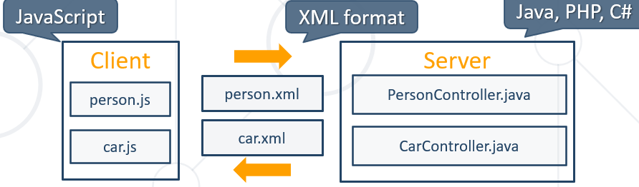

XML е базовия език, който слага едни базови правила, а HTML-а е подвид на XML-a с допълнени правила.

XML е по-рано залегнал(по-стар е) в сравнение с JSON.

Но JSON се е наложил в web страниците заради лекотата си.

### XML Markup and Content

* An XML document consists of strings that:
  + Constitute **markup** – usually begin with **<** and end with **>**
  + Are **content** – placed between markup(**tags**)

### XML Structure

* XML documents are formed as **element trees**
* An XML tree starts at a **root element** and branches from the root to **sub elements**
  + All elements can have child elements:

### An XML element

is everything from (including) the element's start tag to (including) the element's end tag.

An element can contain:

* text
* attributes
* other elements
* or a mix of the above

<bookstore>  
  <book category="children">  
    <title>Harry Potter</title>  
    <author>J K. Rowling</author>  
    <year>2005</year>  
    <price>29.99</price>  
  </book>  
  <book category="web">  
    <title>Learning XML</title>  
    <author>Erik T. Ray</author>  
    <year>2003</year>  
    <price>39.95</price>  
  </book>  
</bookstore>

XML elements must follow these naming rules:

• Element names are case-sensitive

• Element names must start with a letter or underscore

• Element names cannot start with the letters xml (or XML, or Xml, etc)

• Element names can contain letters, digits, hyphens, underscores, and periods

• Element names cannot contain spaces

Any name can be used, no words are reserved (except xml).

XML elements can be extended to carry more information.

Look at the following XML example:

<note>  
  <to>Tove</to>  
  <from>Jani</from>  
  <body>Don't forget me this weekend!</body>  
</note>

Imagine that the author of the XML document added some extra information to it:

<note>  
  <date>2008-01-10</date>  
  <to>Tove</to>  
  <from>Jani</from>  
  <heading>Reminder</heading>  
  <body>Don't forget me this weekend!</body>  
</note>

Should the application break or crash?

No. The application should still be able to find the <to>, <from>, and <body> elements in the XML document and produce the same output.

This is one of the beauties of XML. It can be extended without breaking applications.

<https://www.w3schools.com/xml/xml_elements.asp>

Security Assertion Markup Language is an open standard for exchanging authentication and authorization data between parties, in particular, between an identity provider and a service provider. SAML is an XML-based markup language for security assertions.

## 9.2. JAXB parser intro

### JAXB

* Processes the schema of the XML **document into a set of Java classes** that represent it
* Generates compact and readable XML output

pom.xml

<**dependency**>  
 <**groupId**>javax.xml.bind</**groupId**>  
 <**artifactId**>jaxb-api</**artifactId**>  
 <**version**>2.3.1</**version**>  
</**dependency**>

<**dependency**>  
 <**groupId**>javax.activation</**groupId**>  
 <**artifactId**>activation</**artifactId**>  
 <**version**>1.1</**version**>  
</**dependency**>

<**dependency**>  
 <**groupId**>org.glassfish.jaxb</**groupId**>  
 <**artifactId**>jaxb-runtime</**artifactId**>  
 <**version**>2.3.6</**version**>  
</**dependency**>

### JAXB Basics

* **Marshalling** - converting a Java Object to XML
* **Unmarshalling** - converting XML to Java Object
* We need to annotate the Java Object to provide instructions for XML reading or creation:

### JAXB Annotations

* **@XmlRootElement**
  + Defines XML root object
* **@XmlAccessorType**
  + XmlAccessType.**FIELD**
  + XmlAccessType.**PROPERTY**
  + XmlAccessType.**PUBLIC_MEMBER**
* **@XmlAttribute**
  + Marks the field as an attribute to the object
* **@XmlElement**
  + Marks the field as an element
* **@XmlElementWrapper(name = "…")**
  + Wraps the array of objects – използва се за масив от обекти
* **@XmlTransient**
  + The field won't be exported/imported

### XmlAccessType

**public enum** XmlAccessType {  
 */**  
 \***Every getter/setter pair in a JAXB-bound class will be automatically  
 * bound to XML, unless annotated by {****@link*** *XmlTransient}.  
 *  
 * Fields are bound to XML only when they are explicitly annotated  
 * by some of the JAXB annotations.  
 */* ***PROPERTY***,  
 */**  
 * Every non static, non transient field in a JAXB-bound class will be automatically  
 * bound to XML, unless annotated by {****@link*** *XmlTransient}.  
 *  
 * Getter/setter pairs are bound to XML only when they are explicitly annotated  
 * by some of the JAXB annotations.  
 */* ***FIELD***,  
 */**  
 * Every public getter/setter pair and every public field will be  
 * automatically bound to XML, unless annotated by {****@link*** *XmlTransient}.  
 *  
 * Fields or getter/setter pairs that are private, protected, or   
 * defaulted to package-only access are bound to XML only when they are  
 * explicitly annotated by the appropriate JAXB annotations.  
 */* ***PUBLIC_MEMBER***,  
 */**  
 * None of the fields or properties is bound to XML unless they  
 * are specifically annotated with some of the JAXB annotations.  
 */* ***NONE***}

### JAXB Initialization

* **JAXBContext** objects are responsible for the XML manipulations
* JAXBContext.newInstance(object.getClass()) - creates an **instance** of JAXBContext
* **object.getClass** is the class that we will export/import
  + E.g. User, Address, Employee…

**this**.jaxbContext = JAXBContext.newInstance(object.getClass());

### Export Single Object to XML (Marshalling = Serialization)

**import** javax.xml.bind.annotation.XmlAccessType;  
**import** javax.xml.bind.annotation.XmlAccessorType;  
**import** javax.xml.bind.annotation.XmlElement;  
**import** javax.xml.bind.annotation.XmlRootElement;  
**import** java.math.BigDecimal;  
  
@XmlRootElement(name = **"category"**)  
@XmlAccessorType(value = XmlAccessType.***FIELD***)  
**public class** XMLCategoryStatsDTO {  
 @XmlElement(name = **"name"**) //ако е зададено XmlAccessType.***FIELD****, то няма нужда от анотация XmlElement. В случая искаме да променим името*   
 **private** String **category**;  
  
 **private long productsCount**;  
  
 **private double averagePrice**;  
  
 **private** BigDecimal **totalRevenue**;  
  
 **public** XMLCategoryStatsDTO() { //задължително празен конструктор иска!  
 }  
  
 **public** XMLCategoryStatsDTO(CategoryStatsDTO other) {  
 **this**.**category** = other.getCategory();  
 **this**.**productsCount** = other.getProductsCount();  
 **this**.**averagePrice** = other.getAveragePrice();  
 **this**.**totalRevenue** = other.getTotalRevenue();  
 }  
}

**public class** CategoryStatsDTO { //DTO за вземане от базата данни  
 **private** String **category**;  
 **private long productsCount**;  
 **private double averagePrice**;  
 **private** BigDecimal **totalRevenue**;

}

List<CategoryStatsDTO> result = **productService**.getCategoryStatistics()  
*// String json = this.gson.toJson(result);  
// System.out.println(json);* XMLCategoryStatsDTO first = **new** XMLCategoryStatsDTO(result.get(0));  
  
 JAXBContext context = JAXBContext.*newInstance*(XMLCategoryStatsDTO.**class**);  
 Marshaller marshaller = context.createMarshaller();  
 marshaller.setProperty(Marshaller.***JAXB_FORMATTED_OUTPUT***, **true**); //format output  
 marshaller.marshal(first, System.***out***);

резултатът

<?xml version="1.0" encoding="UTF-8" standalone="yes"?>

<category>

<name>Drugs</name>

<productsCount>79</productsCount>

<averagePrice>862.052911</averagePrice>

<totalRevenue>68102.18</totalRevenue>

</category>

*\* {  
* "category": "Drugs",  
* "productsCount": 79,  
* "averagePrice": 862.052911,  
* "totalRevenue": 68102.18  
* }  
*  
* <categories-stats>  
* <category>  
* <name>Drugs</name>  
* <productsCount>79</productsCount>  
* <averagePrice>836</averagePrice>  
* <totalRevenue>56912.80</totalRevenue>  
* </category>  
* </categories-stats>  
*/*

### Export Multiple Objects to XML (Marshalling = Serializartion)

Нужда от създаване на допълнителен клас DTO за колекцията

**import** javax.xml.bind.annotation.XmlAccessType;  
**import** javax.xml.bind.annotation.XmlAccessorType;  
**import** javax.xml.bind.annotation.XmlElementWrapper;  
**import** javax.xml.bind.annotation.XmlRootElement;  
**import** java.util.List;  
  
@XmlRootElement(name = **"categories-stats"**)  
@XmlAccessorType(value = XmlAccessType.***FIELD***)  
**public class** XMLCategoryStats**List** {  
 */**  
 * Usage  
 * The @XmlElementWrapper annotation can be used with the following program elements:  
 * JavaBean property  
 * non static, non transient field  
 * The usage is subject to the following constraints:  
 * The property must be a collection property  
 * This annotation can be used with the following annotations: XmlElement, XmlElements, XmlElementRef, XmlElementRefs, XmlJavaTypeAdapter.  
 */* @XmlElementWrapper(name = **"categories"**)

**private** List<XMLCategoryStatsDTO> **stats**;  
  
 **public** XMLCategoryStatsList() { //задължително празен конструктор иска!  
 }  
  
 **public** XMLCategoryStatsList(List<XMLCategoryStatsDTO> stats) {  
 **this**.**stats** = stats;  
 }  
}

**import** javax.xml.bind.annotation.XmlAccessType;  
**import** javax.xml.bind.annotation.XmlAccessorType;  
**import** javax.xml.bind.annotation.XmlElement;  
**import** javax.xml.bind.annotation.XmlRootElement;  
**import** java.math.BigDecimal;  
  
@XmlRootElement(name = **"category"**)  
@XmlAccessorType(value = XmlAccessType.***FIELD***)  
**public class** XMLCategoryStatsDTO {  
 @XmlElement(name = **"name"**) //ако е зададено XmlAccessType.***FIELD****, то няма нужда от анотация XmlElement. В случая искаме да променим името*   
 **private** String **category**;  
  
 **private long productsCount**;  
  
 **private double averagePrice**;  
  
 **private** BigDecimal **totalRevenue**;  
  
 **public** XMLCategoryStatsDTO() { //задължително празен конструктор иска!  
 }  
  
 **public** XMLCategoryStatsDTO(CategoryStatsDTO other) {  
 **this**.**category** = other.getCategory();  
 **this**.**productsCount** = other.getProductsCount();  
 **this**.**averagePrice** = other.getAveragePrice();  
 **this**.**totalRevenue** = other.getTotalRevenue();  
 }  
}

**public class** CategoryStatsDTO { //DTO за вземане от базата данни  
 **private** String **category**;  
 **private long productsCount**;  
 **private double averagePrice**;  
 **private** BigDecimal **totalRevenue**;

}

List<CategoryStatsDTO> result = **this**.**productService**.getCategoryStatistics();  
*// String json = this.gson.toJson(result);  
// System.out.println(json);* List<XMLCategoryStatsDTO> xmlResult = result  
 .stream()  
 .map(XMLCategoryStatsDTO::**new**)  
 .collect(Collectors.*toList*());  
  
 XMLCategoryStatsList xmlCategoryStatsList = **new** XMLCategoryStatsList(xmlResult);  
  
 JAXBContext context = JAXBContext.*newInstance*(XMLCategoryStatsList.**class**);  
 Marshaller marshaller = context.createMarshaller();  
 marshaller.setProperty(Marshaller.***JAXB_FORMATTED_OUTPUT***, **true**);  
 marshaller.marshal(xmlCategoryStatsList, System.***out***);

### Export Nested Multiple Objects to XML (Marshalling = Serializartion)

@XmlRootElement(name = **"shops"**)  
@XmlAccessorType(XmlAccessType.***FIELD***)  
**public class** ShopsRootExportToXMLDto {  
 @XmlElement(name = **"shop"**)  
 **private** List<ShopOneExportToXMLDto> **shops**;  
  
 **public** ShopsRootExportToXMLDto() {  
 }  
  
 **public** List<ShopOneExportToXMLDto> getShops() {  
 **return shops**;  
 }  
  
 **public** ShopsRootExportToXMLDto(List<ShopOneExportToXMLDto> shops) {  
 **this**.**shops** = shops;  
 }  
}

@XmlRootElement(name = **"shop"**) **//за извеждането на xml файл задължително ни трябва тази анотация в случая**@XmlAccessorType(XmlAccessType.***FIELD***)  
**public class** ShopOneExportToXMLDto {  
 @XmlElement  
 **private** String **name**;  
  
 @XmlElement  
 **private** String **address**;  
  
 @XmlElement(name = **"employee-count"**)  
 **private int employeeCount**;  
  
 @XmlElement(name = **"shop-area"**)  
 **private int shopArea**;  
  
 @XmlElement(name = **"town"**)  
 **private** TownToXmlDto **town**;  
  
 **public** ShopOneExportToXMLDto() {  
 }

}

@XmlRootElement(name = **"town"**)  
@XmlAccessorType(XmlAccessType.***FIELD***)  
**public class** TownToXmlDto {  
 @XmlElement  
 **private** String **name**;  
  
 **public** TownToXmlDto() {  
 }

}

**public class** Main {  
 **public static void** main(String[] args) **throws** IOException, JAXBException {  
 ShopOneExportToXMLDto entry1 = **new** ShopOneExportToXMLDto();  
 entry1.setName(**"Bai Kirovata krychma"**);  
 entry1.setAddress(**"u nas si"**);  
 entry1.setEmployeeCount(8);  
 entry1.setShopArea(200);  
 TownToXmlDto tn1 = **new** TownToXmlDto();  
 tn1.setName(**"Sofia"**);  
 entry1.setTown(tn1);  
  
 ShopOneExportToXMLDto entry2 = **new** ShopOneExportToXMLDto();  
 entry2.setName(**"Emi\'s shop"**);  
 entry2.setAddress(**"Prava polqna 18"**);  
 entry2.setEmployeeCount(14);  
 entry2.setShopArea(150);  
 TownToXmlDto tn2 = **new** TownToXmlDto();  
 tn2.setName(**"Plovdiv"**);  
 entry2.setTown(tn2);  
  
 List<ShopOneExportToXMLDto> outputList = **new** ArrayList<>();  
 outputList.add(entry1);  
 outputList.add(entry2);  
  
 ShopsRootExportToXMLDto allShops = **new** ShopsRootExportToXMLDto(outputList);  
  
 JAXBContext context = JAXBContext.*newInstance*(ShopsRootExportToXMLDto.**class**);  
 Marshaller marshaller = context.createMarshaller();  
 marshaller.setProperty(Marshaller.***JAXB_FORMATTED_OUTPUT***, **true**);  
  
 Path path = Path.*of*(**"src/main/resources/output/outputToXML.xml"**);  
 FileWriter fileWriter = **new** FileWriter(path.toString());  
  
 marshaller.marshal(allShops, fileWriter);  
  
 fileWriter.close();  
 }  
}

Изхода е:

*<?***xml version="1.0" encoding="UTF-8" standalone="yes"***?>*<**shops**>  
 <**shop**>  
 <**name**>Bai Kirovata krychma</**name**>  
 <**address**>u nas si</**address**>  
 <**employee-count**>8</**employee-count**>  
 <**shop-area**>200</**shop-area**>  
 <**town**>  
 <**name**>Sofia</**name**>  
 </**town**>  
 </**shop**>  
 <**shop**>  
 <**name**>Emi's shop</**name**>  
 <**address**>Prava polqna 18</**address**>  
 <**employee-count**>14</**employee-count**>  
 <**shop-area**>150</**shop-area**>  
 <**town**>  
 <**name**>Plovdiv</**name**>  
 </**town**>  
 </**shop**>  
</**shops**>

### Import Single Object from XML (Unmarshalling = Deserializartion)

**private void** xmlDemo() **throws** JAXBException {

Проверяваме дали правилно сме изписали файла xml  
 String xml = **"<?xml version=\"1.0\" encoding=\"UTF-8\"?>\n"** +  
 **" <category>\n"** +  
 **" <name>Drugs</name>\n"** +  
 **" <productsCount>79</productsCount>\n"** +  
 **" <averagePrice>836</averagePrice>\n"** +  
 **" <totalRevenue>56912.80</totalRevenue>\n"** +  
 **" </category>"**;  
  
 JAXBContext context = JAXBContext.*newInstance*(XMLCategoryStatsDTO.**class**);  
 Unmarshaller unmarshaller = context.createUnmarshaller();  
  
*// InputStream inputStream = getClass().getResourceAsStream("src/main…./files/input/xml/  
address.xml");  
// BufferedReader bfr = new BufferedReader(new InputStreamReader(inputStream));* ByteArrayInputStream inputStream = **new** ByteArrayInputStream(xml.getBytes());  
 XMLCategoryStatsDTO result = (XMLCategoryStatsDTO) unmarshaller.unmarshal(inputStream);  
  
 System.***out***.println(result);  
 }

@XmlRootElement(name = **"category"**)  
@XmlAccessorType(value = XmlAccessType.***FIELD***)  
**public class** XMLCategoryStatsDTO {  
 @XmlElement(name = **"name"**)  
 **private** String **category**;  
  
 **private long productsCount**;  
  
 **private double averagePrice**;  
  
 **private** BigDecimal **totalRevenue**;  
  
 **public** XMLCategoryStatsDTO() {  
 }  
  
 **public** XMLCategoryStatsDTO(CategoryStatsDTO other) {  
 **this**.**category** = other.getCategory();  
 **this**.**productsCount** = other.getProductsCount();  
 **this**.**averagePrice** = other.getAveragePrice();  
 **this**.**totalRevenue** = other.getTotalRevenue();  
 }  
  
 @Override  
 **public** String toString() {  
 **return "XMLCategoryStatsDTO{"** +  
 **"category='"** + **category** + **'\''** +  
 **", productsCount="** + **productsCount** +  
 **", averagePrice="** + **averagePrice** +  
 **", totalRevenue="** + **totalRevenue** +  
 **'}'**;  
 }  
}

Изхода:

XMLCategoryStatsDTO{category='Drugs', productsCount=79, averagePrice=836.0, totalRevenue=56912.80}

### Import Multiple Objects from XML(Unmarshalling = Deserializartion)

#### Пример 0:

JAXBContext **jaxbContext** = JAXBContext.newInstance(AddressesDto.**class**);  
InputStream **inputStream** = getClass().getResourceAsStream(**"***src/main***/files/input/xml/addresses.xml"**);

BufferedReader **bfr** = **new** BufferedReader(**new** InputStreamReader(**inputStream**));

или

**private static final** Path ***USERS_XML_PATH*** =  
 Path.*of*(**"src"**, **"main"**, **"resources"**, **"productsshopInit"**, **"users.xml"**);

BufferedReader xmlReader = Files.*newBufferedReader*(***USERS_XML_PATH***);

или

Unmarshaller **unmarshaller** = **jaxbContext**.createUnmarshaller();  
Address**es**Dto **addressesDto** = (Address**es**Dto) **unmarshaller**.unmarshal(**bfr**);

@Component  
**public class** XmlParserImpl **implements** XmlParser {  
  
 @Override  
 @SuppressWarnings(**"unchecked"**)  
 **public** <T> T fromFile(String filePath, Class<T> tClass) **throws** JAXBException, FileNotFoundException {  
 JAXBContext jaxbContext = JAXBContext.*newInstance*(tClass);  
 Unmarshaller unmarshaller = jaxbContext.createUnmarshaller();  
  
 **return** (T) unmarshaller.unmarshal(**new** FileReader(filePath));

(ImportEmployeesRootDTO) unmarshaller.unmarshal(**new File**(**xmlPath**.toString()));

}  
}

#### Пример 1 - //вариант без ModelMapper, а чрез извикване на конструктор:

*<?***xml version='1.0' encoding='UTF-8'***?>*<**categories**>  
 <**category**>  
 <**name**>Drugs</**name**>  
 </**category**>  
 <**category**>  
 <**name**>Adult</**name**>  
 </**category**>  
 <**category**>  
 <**name**>Other</**name**>  
 </**category**>  
</**categories**>

**import static** javax.xml.bind.annotation.XmlAccessType.*;  
@XmlRootElement(name = **"categories"**) //един главен root елемент categories  
@XmlAccessorType(***FIELD***)  
**public class** CategoriesImportDTO {  
  
 @XmlElement(name = **"category"**) //поделемент category  
 **private** List<CategoryNameDTO> **categories**;  
  
 **public** CategoriesImportDTO() {  
 }  
  
 **public** List<CategoryNameDTO> getCategories() {  
 **return categories**;  
 }  
}

**import** javax.xml.bind.annotation.*;

**import static** javax.xml.bind.annotation.XmlAccessType.***FIELD***;  
@XmlRootElement(name = **"category"**) //един главен root елемент categor**y**  
@XmlAccessorType(***FIELD***)  
**public class** CategoryNameDTO {  
 @XmlElement //поделемент name  
 **private** String **name**;  
  
 **public** CategoryNameDTO() {  
 }  
  
 **public** String getName() {  
 **return name**;  
 }  
}

@Override  
**public void** seedCategories() **throws** FileNotFoundException, JAXBException {  
 JAXBContext context = JAXBContext.*newInstance*(CategoriesImportDTO.**class**);  
 Unmarshaller unmarshaller = context.createUnmarshaller();  
  
 FileReader xmlReader = **new** FileReader(***CATEGORIES_XML_PATH***.toAbsolutePath().toString());  
 CategoriesImportDTO importDTO = (CategoriesImportDTO) unmarshaller.unmarshal(xmlReader);

//вариант без ModelMapper, а чрез извикване на конструктор  
 List<Category> entities = importDTO  
 .getCategroies()  
 .stream()  
 .map(catName -> **new** Category(catName.getName()))  
 .collect(Collectors.*toList*());  
  
 **this**.**categoryRepository**.saveAll(entities);  
}

#### Пример 2 - //вариант с modelMapper:

*<?***xml version='1.0' encoding='UTF-8'***?>*<**users**>  
 <**user first-name="Eugene" last-name="Stewart" age="65"**/>  
 <**user first-name="Fred" last-name="Allen" age="57"**/>  
 <**user first-name="Clarence" last-name="Fowler" age="50"**/>

</**users**>

**import** javax.xml.bind.annotation.*;

@XmlRootElement(name = **"users"**) //един главен root елемент всички users  
@XmlAccessorType(XmlAccessType.***FIELD***)  
**public class** UsersImportDTO {  
  
 @XmlElement(name = **"user"**) //поделемент колекция от един user  
 **private** List<OneUserImportDTO> **users**;  
  
 **public** UsersImportDTO() {  
 }  
  
 **public** List<OneUserImportDTO> getUsers() {  
 **return users**;  
 }  
}

**import** javax.xml.bind.annotation.*;

@XmlRootElement(name = **"user"**) //всеки единичен user  
@XmlAccessorType(XmlAccessType.***FIELD***)  
**public class** OneUserImportDTO {  
 @XmlAttribute(name = **"first-name"**) //името на атрибута на тага  
 **private** String **firstName**;  
  
 @XmlAttribute(name = **"last-name"**) //името на атрибута на тага  
 **private** String **lastName**;  
  
 @XmlAttribute //името на атрибута на тага е същия като името на полето на класа  
 **private int age**;  
  
 **public** OneUserImportDTO() {  
 }  
}

@Override  
**public void** seedUsers() **throws** IOException, JAXBException {  
 JAXBContext context = JAXBContext.*newInstance*(UsersImportDTO.**class**);  
 Unmarshaller unmarshaller = context.createUnmarshaller();  
  
 BufferedReader xmlReader = Files.*newBufferedReader*(***USERS_XML_PATH***);  
 UsersImportDTO usersDTO = (UsersImportDTO) unmarshaller.unmarshal(xmlReader);

//вариант с modelMapper  
 List<User> entities = usersDTO.getUsers()  
 .stream()  
 .map(dto -> **this**.**modelMapper**.map(dto, User.**class**))  
 .collect(Collectors.*toList*());  
  
 **this**.**userRepository**.saveAll(entities);  
}

### Import Nested Multiple Objects from XML(Unmarshalling = Deserializartion)

*<?***xml version='1.0' encoding='UTF-8'***?>*<**shops**>  
 <**shop**>  
 <**address**>04 Pond Junction</**address**>  
 <**employee-count**>47</**employee-count**>  
 <**income**>625273</**income**>  
 <**name**>Er</**name**>  
 <**shop-area**>278</**shop-area**>  
 <**town**>  
 <**name**>Hamburg</**name**>  
 </**town**>  
 </**shop**>  
 <**shop**>  
 <**address**>779 Parkside Park</**address**>  
 <**employee-count**>48</**employee-count**>  
 <**income**>10</**income**>  
 <**name**>Raynor</**name**>  
 <**shop-area**>108</**shop-area**>  
 <**town**>  
 <**name**>Birmingham</**name**>  
 </**town**>  
 </**shop**>

</**shops**>

*<?***xml version="1.0" encoding="UTF-8" standalone="yes"***?>*<**projects**>  
 <**project**>  
 <**name**>HealthCare</**name**>  
 <**description**>Pharmacy web app</**description**>  
 <**start-date**>2017-07-12</**start-date**>  
 <**is-finished**>true</**is-finished**>  
 <**payment**>10000.00</**payment**>  
 <**company name="Phoenix"**/>  
 </**project**>  
 <**project**>  
 <**name**>MMA</**name**>  
 <**description**>Mixed martial arts club web site</**description**>  
 <**start-date**>2018-09-21</**start-date**>  
 <**is-finished**>true</**is-finished**>  
 <**payment**>7000.00</**payment**>  
 <**company name="Vallor"**/> //тук пак използваме вложено DTO, атрибута не е проста единична стойност  
 </**project**>

</**projects**>

@XmlRootElement(name = **"shops"**)  
@XmlAccessorType(XmlAccessType.***FIELD***)  
**public class** ShopsRootImportFromXMLDto {  
 @XmlElement(name = **"shop"**)  
 **private** List<ShopOneImportFromXMLDto> **shops**;  
  
 **public** ShopsRootImportFromXMLDto() {  
 }  
  
 **public** List<ShopOneImportFromXMLDto> getShops() {  
 **return shops**;  
 }  
}

@XmlRootElement(name = **"shop"**)  
@XmlAccessorType(XmlAccessType.***FIELD***)  
**public class** ShopOneImportFromXMLDto {  
 @XmlElement  
 @Size(min = 4)  
 **private** String **address**;  
  
 @XmlElement(name = **"employee-count"**)  
 @Min(value = 1)  
 @Max(50)  
 **private int employeeCount**;  
  
 @XmlElement  
 @Min(value = 20000)  
 **private** BigDecimal **income**;  
  
 @XmlElement  
 @Size(min = 4)  
 **private** String **name**;  
  
 @XmlElement(name = **"shop-area"**)  
 @Min(150)  
 **private int shopArea**;  
  
 @XmlElement(name = **"town"**)  
 **private** TownDto **town**;  
  
 **public** ShopOneImportFromXMLDto() {  
 }

}

@XmlRootElement(name = **"town"**)  
@XmlAccessorType(XmlAccessType.***FIELD***)  
**public class** TownDto {  
  
 @XmlElement  
 **private** String **name**;  
  
 **public** TownDto() {  
 }

}

@Service  
**public class** ShopServiceImpl **implements** ShopService {  
 **private final** String **SHOPS_PATHSTRING_XML** = **"src/main/resources/files/xml/shops.xml"**;  
  
 **private final** ShopRepository **shopRepository**;  
 **private final** TownService **townService**;  
 **private final** ModelMapper **modelMapper**;  
 **private final** ValidationUtil **validationUtil**;  
 **private final** XmlParser **xmlParser**;  
  
 @Autowired  
 **public** ShopServiceImpl(ShopRepository shopRepository, TownService townService, ModelMapper modelMapper,  
 ValidationUtil validationUtil, XmlParser xmlParser) {  
 **this**.**shopRepository** = shopRepository;  
 **this**.**townService** = townService;  
 **this**.**modelMapper** = modelMapper;  
 **this**.**validationUtil** = validationUtil;  
 **this**.**xmlParser** = xmlParser;  
 }  
  
 @Override  
 **public boolean** areImported() {  
 **return this**.**shopRepository**.count() > 0;  
 }  
  
 @Override  
 **public** String readShopsFileContent() **throws** IOException {  
 **return** Files.*readString*(Path.*of*(**SHOPS_PATHSTRING_XML**));  
 }  
  
 @Override  
 **public** String importShops() **throws** JAXBException, FileNotFoundException {  
 ShopsRootImportFromXMLDto shops = **xmlParser**.fromFile(**SHOPS_PATHSTRING_XML**,  
 ShopsRootImportFromXMLDto.**class**);  
  
 **return** shops.getShops()  
 .stream()  
 .map(**this**::importShop)  
 .collect(Collectors.*joining*(**"\n"**));  
 }  
  
 **private** String importShop(ShopOneImportFromXMLDto dto) {  
 **boolean** isValid = **this**.**validationUtil**.isValid(dto);  
 **if** (!isValid) {  
 **return "Invalid shop"**;  
 }  
  
 Optional<Shop> optShop = **this**.**shopRepository**.findByName(dto.getName());  
 **if** (optShop.isPresent()) {  
 **return "Invalid shop"**;  
 }  
  
 Optional<Town> optTown = **this**.**townService**.findTownByName(dto.getTown().getName());  
  
 Shop shop = **this**.**modelMapper**.map(dto, Shop.**class**);  
 shop.setTown(optTown.get());  
 **this**.**shopRepository**.save(shop);  
  
 **return "Successfully imported Shop "** + shop.getName() + **" - "** + shop.getIncome();  
 }  
}

@Configuration  
*//Indicates that a class declares one or more @Bean methods and may be processed by the Spring container to generate bean definitions and service requests for those beans at runtime, for example:***public class** ApplicationBeanConfiguration {  
 @Bean *//Indicates that a method produces a bean to be managed by the Spring container* **public** Gson gson() {  
 **return new** GsonBuilder()  
*// .excludeFieldsWithoutExposeAnnotation()* .setPrettyPrinting()  
 .create();  
 }  
  
 @Bean *//Indicates that a method produces a bean to be managed by the Spring container* **public** ModelMapper modelMapper() {  
 ModelMapper modelMapper = **new** ModelMapper();  
  
 modelMapper.addConverter(**new** Converter<String, LocalDate>() {  
 @Override  
 **public** LocalDate convert(MappingContext<String, LocalDate> mappingContext) {  
 **return** LocalDate.*parse*(mappingContext.getSource(), DateTimeFormatter.*ofPattern*(**"dd/MM/yyyy"**));  
 }  
 });  
  
 modelMapper.addConverter(**new** Converter<String, LocalDateTime>() {  
 @Override  
 **public** LocalDateTime convert(MappingContext<String, LocalDateTime> mappingContext) {  
 **return** LocalDateTime.*parse*(mappingContext.getSource(), DateTimeFormatter.*ofPattern*(**"yyyy-MM-dd HH:mm:ss"**));  
 }  
 });

modelMapper.addConverter(**new** Converter<String, LocalTime>() {  
 @Override  
 **public** LocalTime convert(MappingContext<String, LocalTime> mappingContext) {  
 **return** LocalTime.*parse*(mappingContext.getSource(), DateTimeFormatter.*ofPattern*(**"HH:mm:ss"**));  
 }  
});

**return** modelMapper;  
 }  
}

@Component  
**public class** XmlParserImpl **implements** XmlParser {  
 @Override  
 @SuppressWarnings(**"unchecked"**)  
 **public** <T> T fromFile(String filePath, Class<T> tClass) **throws** JAXBException, FileNotFoundException {  
 JAXBContext jaxbContext = JAXBContext.*newInstance*(tClass);  
 Unmarshaller unmarshaller = jaxbContext.createUnmarshaller();  
  
 **return** (T) unmarshaller.unmarshal(**new** FileReader(filePath));  
 }  
}

### XmlJavaTypeAdapter example

**public class** CarSeedFromJSONDto {  
 @Expose  
 **private** String **make**;  
  
 @Expose  
 **private** String **model**;  
  
 @Expose  
 **private** Integer **kilometers**;  
  
*// @Expose  
// private String registeredOn;* @Expose  
 @XmlJavaTypeAdapter(**LocalDateAdapter.class**)  
 **private** LocalDate **registeredOn**;

}

**package** softuni.exam.adapters;  
  
**import** javax.xml.bind.annotation.adapters.XmlAdapter;  
**import** java.time.LocalDate;  
**import** java.time.format.DateTimeFormatter;  
  
**public class** LocalDateAdapter **extends** XmlAdapter<String, LocalDate> {  
  
 @Override  
 **public** LocalDate unmarshal(String src) **throws** Exception {  
 **return** LocalDate.*parse*(src, DateTimeFormatter.*ofPattern*(**"dd/MM/yyyy"**));  
 }  
  
 @Override  
 **public** String marshal(LocalDate date) **throws** Exception {  
 **return** date.toString();  
 }  
}

# JPABuddy in minimalistic mode:

Alt + Enter – Show JPA inspector – слага анотации на полета и на класове, edit relations, edit columns

Alt + Ins – generate все едно – JPA Pallete – getters, setters, new Class Entity, New Relation for a new field и т.н.

<https://www.jpa-buddy.com/documentation/minimalistic-mode/>

# HashCode and equals

ВАЖНО: В света на Java и без използване на други framework-ци, имаме ли Set, то трябва задължително да си имплементираме всеки път equals() и hashCode() методите – от Alt + Insert за по-лесно! Иначе, примерно ако създаваме random обекти, два различни обекта може да се окаже че има еднакъв hashCode.

Обаче ако използваме Hibernate, то ние четем вече записан обект от базата, който пристига като managed entity, също така не даваме new в java-та. И т.е. нямаме нужда от hashCode и equals. Единственото дублиране, което изобщо е възможно е ако имаме detached entity, което се опитваме да импортираме/запишем в базата наново.

**import** javax.persistence.*;  
**import** java.util.Objects;  
  
@Entity(name = **"categories"**)  
**public class** Category {  
 @Id  
 @GeneratedValue(strategy = GenerationType.***IDENTITY***)  
 **private int id**;  
  
 @Column(nullable = **false**, length = 15)  
 **private** String **name**;  
  
 **public** Category() {  
 }  
  
 **public** Category(String name) {  
 **this**.**name** = name;  
 }  
  
 @Override  
 **public boolean** equals(Object o) {  
 **if** (**this** == o) **return true**;  
 **if** (o == **null** || getClass() != o.getClass()) **return false**;  
 Category category = (Category) o;  
 **return id** == category.**id**; *//сравняваме по уникалност само ключово поле id, защото само то е уникално в SQL базата  
 //дори да променим името на категорията, то тя все още е една и съща категория за базата данни* }  
  
 @Override  
 **public int** hashCode() {  
 **return** Objects.*hash*(**id**);  
 }  
}

**private** Product sendRandomcategories(Product product) {  
 Random random = **new** Random();  
 **long** categoriesDbCount = **this**.**categoryRepository**.count();  
  
 **int** count = random.nextInt((**int**) categoriesDbCount) + 1;  
  
 **Set**<Category> categories = **new** HashSet<>();  
 **for** (**int** i = 0; i < count; i++) {  
 **int** randomId = random.nextInt((**int**) categoriesDbCount) + 1;  
  
 Optional<Category> randomCategory = **this**.**categoryRepository**.findById(randomId);  
 categories.**add**(randomCategory.get()); //при добавянето се бърка защото за Java си има различен hashCode, но за базата hashCode трябва да го построим само по Id, а не по id и name.

.get() връща от Optional<Category> само Category  
 }  
  
 product.setCategories(categories);  
 **return** product;  
}

List<Product> products = Arrays.*stream*(productsImportDTOS)  
 .map(importDTO -> **this**.**modelMapper**.map(importDTO, Product.**class**))  
 .map(**this**::setRandomSeller)  
 .map(**this**::setRandomBuyer)  
 .map(**this**::**sendRandomcategories**)  
 .collect(Collectors.*toList*());  
**this**.**productRepository**.saveAll(products);

# Annotation Type Embeddable and Embedded

## Пример 1

[@Documented](http://docs.oracle.com/javase/7/docs/api/java/lang/annotation/Documented.html?is-external=true)

[@Target](http://docs.oracle.com/javase/7/docs/api/java/lang/annotation/Target.html?is-external=true)([value](http://docs.oracle.com/javase/7/docs/api/java/lang/annotation/Target.html?is-external=true#value--)=[TYPE](http://docs.oracle.com/javase/7/docs/api/java/lang/annotation/ElementType.html?is-external=true#TYPE))

[@Retention](http://docs.oracle.com/javase/7/docs/api/java/lang/annotation/Retention.html?is-external=true)([value](http://docs.oracle.com/javase/7/docs/api/java/lang/annotation/Retention.html?is-external=true#value--)=[RUNTIME](http://docs.oracle.com/javase/7/docs/api/java/lang/annotation/RetentionPolicy.html?is-external=true#RUNTIME))

public @interface **Embeddable**

Specifies a class whose instances are stored as an intrinsic part of an owning entity and share the identity of the entity. Each of the persistent properties or fields of the embedded object is mapped to the database table for the entity.

Note that the [Transient](https://docs.oracle.com/javaee/7/api/javax/persistence/Transient.html" \o "annotation in javax.persistence) annotation may be used to designate the non-persistent state of an embeddable class.

Example 1:

**@Embeddable** public class EmploymentPeriod {

@Temporal(DATE) java.util.Date startDate;

@Temporal(DATE) java.util.Date endDate;

...

}

Example 2:

**@Embeddable** public class PhoneNumber {

protected String areaCode;

protected String localNumber;

**@ManyToOne** PhoneServiceProvider provider;

...

}

@Entity public class PhoneServiceProvider {

@Id protected String name;

...

}

Example 3:

**@Embeddable** public class Address {

protected String street;

protected String city;

protected String state;

**@Embedded** protected Zipcode zipcode;

}

**@Embeddable** public class Zipcode {

protected String zip;

protected String plusFour;

}

**Since:**

Java Persistence 1.0

## Пример 2

Take your time and inspect the new entity com.vidasoft.magman.model.CreditCard. It is declared to

be @Embeddable. And the Subscriber entity has a field of this type, which in turns is declared to be

@Embedded. What this all means is that the JPA provider will not create a separate table for the

CreditCard entity. It will rather add its fields as columns to the entity, where it is embedded

**@Embeddable**

public class CreditCard implements Serializable {

   private String number;

   @Enumerated(EnumType.*STRING*)

   private CreditCardType creditCardType;

@Entity

public class Subscriber extends User {

   private String streetAddress;

   @Future

   private LocalDate subscribedUntil;

**@Embedded**

   private CreditCard creditCard;

# @Size, @Length, @Column(length = 50)

<https://www.baeldung.com/jpa-size-length-column-differences>

Simply put, all of these annotations are meant to **communicate the size of a field.**

@Size and @Length are similar. We can use either **to validate the size of a JAVA class field**. The first is a [Java-standard annotation](https://docs.oracle.com/javaee/7/tutorial/bean-validation001.htm) (javax.validation)

 and the second is [specific to Hibernate](http://docs.jboss.org/ejb3/app-server/HibernateAnnotations/api/org/hibernate/validator/Length.html).

@Column, though, is a [JPA annotation](https://docs.oracle.com/javaee/7/api/javax/persistence/Column.html) that we use to control DDL statements.

We'll use @Column to **indicate specific characteristics of the physical database column.** Note that we'll use @Column only to specify table column properties**as it doesn't provide validations.**

@Entity  
**public class** User {  
  
 @Column(length = 3)  
 **private** String **firstName**;  
  
 *// ...*}

Consequently, the resulting column would be generated as a *VARCHAR(3)* and trying to insert a longer string would result in an SQL error.

Note that we'll use *@Column* only to specify table column properties**as it doesn't provide validations.**

Of course, **we can use *@Column* together with *@Size*** to specify database column property with bean validation.

@Entity  
**public class** User {  
  
 *// ...* @Column(length = 5) //custom-изира SQL базата  
 @Size(min = 3, max = 5) **import** javax.validation.constraints.Size; via Maven library

@Length(min = 3, max = 15) **import** org.hibernate.validator.constraints.Length; - in pom.xml file added

**private** String **city**;  
  
 *// ...*}

*<!-- https://mvnrepository.com/artifact/org.hibernate/hibernate-validator -->*<**dependency**>  
 <**groupId**>org.hibernate</**groupId**>  
 <**artifactId**>hibernate-validator</**artifactId**>  
 <**version**>6.2.3.Final</**version**>  
</**dependency**>

@NonNull - това е от Lombok, който не било хубаво да го ползвам  
@Length(min = 3, max = 60) *//@Length на Java класа полето не включва notNull*@Column(unique = **true**, nullable = **false**) *//****за базата*** *ограничение при създаването*@NotNull *//jakarta validation javax.validation.constraints на Java класа полето да не е null***private** String **username**;

# Javax.validation - http://hibernate.org/validator/

**import** javax.validation.Validation;  
**import** javax.validation.Validator;

<**dependency**>  
 <**groupId**>org.springframework.boot</**groupId**>  
 <**artifactId**>spring-boot-starter-validation</**artifactId**>  
</**dependency**>

<**dependency**>  
 <**groupId**>org.hibernate.validator</**groupId**>  
 <**artifactId**>hibernate-validator</**artifactId**>  
 <**version**>6.2.3.Final</**version**>  
 <**scope**>compile</**scope**>  
</**dependency**>

@Service  
**public class** TownServiceImpl **implements** TownService {  
 **private final** TownRepository **townRepository**;  
 **private final** Gson **gson**;  
 **private final** Validator **validator**;  
 **private final** ModelMapper **modelMapper**;  
  
 @Autowired  
 **public** TownServiceImpl(TownRepository townRepository) {  
 **this**.**townRepository** = townRepository;  
 **this**.**gson** = **new** GsonBuilder().create();  
  
 **this**.**validator** = Validation  
 .*buildDefaultValidatorFactory*()  
 .getValidator();  
  
 **this**.**modelMapper** = **new** ModelMapper();  
 }  
  
 @Override  
 **public boolean** areImported() {  
 **return this**.**townRepository**.count() > 0;  
 }  
  
 @Override  
 **public** String readTownsFileContent() **throws** IOException {  
 Path path = Path.*of*(**"src"**, **"main"**, **"resources"**, **"files"**, **"json"**, **"towns.json"**);  
  
 **return** String.*join*(**"\n"**, **Files.*readAllLines*(path)**);  
 }

@Override  
**public** String readCarsFileContent() **throws** IOException {  
 **return Files.*readString*(Path.*of*(*CARS_FILE_PATH*)**);  
}

@Override  
 **public** String importTowns() **throws** IOException {  
 String json = **this**.readTownsFileContent();  
 ImportTownDTO[] importTownDTOS = **this**.**gson**.fromJson(json, ImportTownDTO[].**class**);  
  
 List<String> result = **new** ArrayList<>();  
 **for** (ImportTownDTO iTDTO : importTownDTOS) {  
 *//Ако използваме javax.validation анотации в ImportTownDTO, то използваме следното за да видим дали има грешка* Set<ConstraintViolation<ImportTownDTO>> validationErrors = **this**.**validator**.validate(iTDTO);

Set<ConstraintViolation<T>> errors = validator.validate(configuration);

if (!errors.isEmpty()) {

logger.error("YAML configuration failed validation");

for (ConstraintViolation<?> error : errors) {

logger.error(**error.getPropertyPath()** + ": " **+ error.getMessage()**);

}

**if** (validationErrors.isEmpty()) {  
 *//valid* Optional<Town> optTown = **this**.**townRepository**.findByName(iTDTO.getName());  
  
 **if** (optTown.isEmpty()) {  
 Town town = **this**.**modelMapper**.map(iTDTO, Town.**class**);  
 **this**.**townRepository**.save(town);  
 result.add(String.*format*(**"Successfully imported Town %s - %d"**,  
 town.getName(), town.getPopulation()));  
 } **else** {  
 result.add(**"Invalid town"**);  
 }  
 } **else** {  
 result.add(**"Invalid town"**);  
 }  
 }  
  
 **return** String.*join*(**"\n"**, result);  
 }  
}

**import** javax.validation.constraints.Min;  
**import** javax.validation.constraints.Positive;  
**import** javax.validation.constraints.Size;  
  
**public class** ImportTownDTO {  
 @Size(min = 2) //дължина на стринга  
 **private** String **name**;  
  
 @Positive  
 @Min(value = 10000)  
 **private int population**;  
  
 @Size(min = 10, max = 19)  
 **private** String **travelGuide**;  
  
 **public** ImportTownDTO() {  
 }  
  
 **public** String getName() {  
 **return name**;  
 }  
  
 **public int** getPopulation() {  
 **return population**;  
 }  
  
 **public** String getTravelGuide() {  
 **return travelGuide**;  
 }  
}

@NotNull *//jakarta validation javax.validation.constraints на Java класа полето да не е null,* Accepts any type, including Enum

@NotBlank - *//jakarta validation javax.validation.constraints* The annotated element must not be null and must contain at least one non-whitespace character. Accepts any type, including Enum

[  
 {  
 **"macAddress"**: **"B5-42-0A-AC-F0-19"**,  
 **"cpuSpeed"**: 1.46,  
 **"ram"**: 128,  
 **"storage"**: 128,  
 **"description"**: **"Aenean lectus. Pellentesque eget nunc."**,  
 **"price"**: 4081.54,  
 **"warrantyType"**: **"PREMIUM"**,  
 **"shop"**: {  
 **"name"**: **"Jacobi and Bayer"** }  
 },  
 {  
 **"macAddress"**: **"B5-42-0A-AC-F0-19"**,  
 **"cpuSpeed"**: 1.46,  
 **"ram"**: 128,  
 **"storage"**: 128,  
 **"description"**: **"Aenean lectus. Pellentesque eget nunc."**,  
 **"price"**: 4081.54,  
 **"warrantyType"**: **"PREMIUM"**,  
 **"shop"**: {  
 **"name"**: **"Jacobi and Bayer"** }  
 }  
]

**public enum** WarrantyType { ***BASIC***, ***PREMIUM***, ***LIFETIME*** }

@Entity  
@Table(name = **"laptops"**)  
**public class** Laptop {  
 @Id  
 @GeneratedValue(strategy = GenerationType.***IDENTITY***)  
 **private long id**;  
  
 @Column(name = **"mac_address"**, nullable = **false**, unique = **true**)  
 **private** String **macAddress**;  
  
 @Column(name = **"cpu_speed"**, nullable = **false**)  
 **private double cpuSpeed**;  
  
 @Column  
 **private int ram**;  
  
 @Column  
 **private int storage**;  
  
 @Column(columnDefinition = **"TEXT"**)  
 **private** String **description**;  
  
 @Column(nullable = **false**)  
 **private** BigDecimal **price**;  
  
 @Column(name = **"warranty_type"**)  
 @Enumerated(**EnumType.*ORDINAL***) // в базата записваме или ORDINAL или STRING според задачата  
 **private** WarrantyType **warrantyType**;

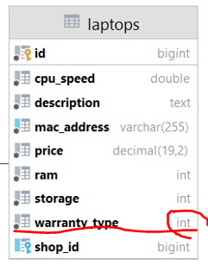

}

**Проверките на javax.validation го правим в Dto-класа**

**public class** LaptopSeedFromJSONDto {  
 @Size(min = 9)  
 **private** String **macAddress**;  
  
 @Positive  
 **private double cpuSpeed**;  
  
 @Min(8)  
 @Max(128)  
 **private int ram**;  
  
 @Min(128)  
 @Max(1024)

@Range(min = 1, max = 120)  
 **private int storage**;  
  
 @Size(min = 10)  
 **private** String **description**;  
  
 **@Positive**(message = **"Price must be positive"**)  
**@DecimalMin**(value = **"0"**, message = **"Price must be positive"**)  
 **private** BigDecimal **price**;  
  
 @NotNull //ако .ORDINAL или .STRING не е това което четем, то хвърля null, и ние тук проверяваме ако е null, да я хванем грешката и да не записваме в базата  
 **private** WarrantyType **warrantyType**; *//String value, not ordinal!!!*

@XmlElement  
@Email //проверява за е-мейл

@Pattern() //проверява по Regex

@Pattern(regexp = **""**, message = **"INVALID_EMAIL_ADDRESS_MESSAGE"**)  
**private** String **email**;

# Custom Validation - Spring MVC

## Вариант 1 – с полета на анотацията

@Retention(value = RetentionPolicy.***RUNTIME***)  
@Target(ElementType.***FIELD***)  
@Constraint(validatedBy = {PasswordValidator.**class**})  
**public** @**interface** Password {  
 String message() **default "Default message for @Password annotation"**;  
  
 Class<?>[] groups() **default** {};  
  
 Class<? **extends** Payload>[] payload() **default** {};  
  
 **int** minLength() **default** 8;  
  
 **int** maxLength() **default** 150;  
  
 **boolean** shouldContainDigit() **default false**;  
  
 **boolean** shouldContainLowercase() **default false**;  
  
 **boolean** shouldContainUppercase() **default false**;  
  
 **boolean** shouldContainSpecialSymbol() **default false**;  
}

**public class** PasswordValidator **implements** ConstraintValidator<Password, String> {  
 **private** Password **password**;  
 **private** ConstraintValidatorContext **context**;  
 **private** String **value**;  
 **private int violationsCount** = 0;  
  
 **private static final** List<Character> ***specialSymbols*** = Arrays.*asList*(**'!'**, **'@'**, **'#'**, **'$'**, **'%'**, **'^'**, **'&'**, **'*'**, **'('**, **')'**, **'_'**, **'+'**, **'<'**, **'>'**, **'?'**);  
  
 **private static final** String ***PASSWORD_TOO_SHORT*** = **"Password should be at least %d characters"**;  
 **private static final** String ***PASSWORD_MIN_MAX_LENGTH_MISMATCH*** = **"Password min length cannot be greater than max length"**;  
 **private static final** String ***PASSWORD_TOO_LONG*** = **"Password should be no longer than %d characters"**;  
 **private static final** String ***PASSWORD_NO_DIGIT*** = **"Password should contain at least 1 digit"**;  
 **private static final** String ***PASSWORD_NO_LOWERCASE*** = **"Password should contain at least 1 lowercase letter"**;  
 **private static final** String ***PASSWORD_NO_UPPERCASE*** = **"Password should contain at least 1 uppercase letter"**;  
 **private static final** String ***PASSWORD_NO_SPECIAL_SYMBOL*** = **"Password should contain at least 1 special symbol ("** +  
 ***specialSymbols***.stream().map(e -> e + **""**).collect(Collectors.*joining*(**", "**)) + **")"**;  
  
  
 @Override  
 **public void** initialize(Password constraintAnnotation) {  
 ConstraintValidator.**super**.initialize(constraintAnnotation);  
 **this**.**password** = constraintAnnotation;  
 }  
  
 @Override  
 **public boolean** isValid(String value, ConstraintValidatorContext context) {  
 **this**.**value** = value;  
 **this**.**context** = context;  
 context.disableDefaultConstraintViolation();  
  
 **if** (**this**.**password**.minLength() > **this**.**password**.maxLength()) {  
 setMessage(***PASSWORD_MIN_MAX_LENGTH_MISMATCH***);  
 **violationsCount**++;  
 }  
  
 **if** (**this**.**value**.length() < **this**.**password**.minLength()) {  
 setMessage(String.*format*(***PASSWORD_TOO_SHORT***, **this**.**password**.minLength()));  
 **violationsCount**++;  
 }  
  
 **if** (**this**.**value**.length() > **this**.**password**.maxLength()) {  
 setMessage(String.*format*(***PASSWORD_TOO_LONG***, **this**.**password**.maxLength()));  
 **violationsCount**++;  
 }  
  
 **if** (!doesContainDigit()) {  
 **violationsCount**++;  
 setMessage(***PASSWORD_NO_DIGIT***);  
 }  
  
 **if** (!doesContainLowercase()) {  
 **violationsCount**++;  
 setMessage(***PASSWORD_NO_LOWERCASE***);  
 }  
  
 **if** (!doesContainUppercase()) {  
 **violationsCount**++;  
 setMessage(***PASSWORD_NO_UPPERCASE***);  
 }  
  
 **if** (!doesContainSpecialSymbol()) {  
 **violationsCount**++;  
 setMessage(***PASSWORD_NO_SPECIAL_SYMBOL***);  
 }  
  
 **if** (**violationsCount** == 0) {  
 **return true**;  
} **else** {  
 **violationsCount** = 0;  
 **return false**;  
}

}  
  
 **private void** setMessage(String message) {  
 **this**.**context**.buildConstraintViolationWithTemplate(message).addConstraintViolation();  
 }

}

@Entity  
@Table(name = **"users"**)  
**public class** User {  
 @Id  
 @GeneratedValue(strategy = GenerationType.***IDENTITY***)  
 **private int id**;  
  
 @Column(nullable = **false**, unique = **true**)  
 @Size(min = 4, max = 30)  
 **private** String **username**;  
  
 **@Password**(minLength = 16,  
 shouldContainSpecialSymbol = **true**,  
 shouldContainLowercase = **true**,  
 shouldContainUppercase = **true**,  
 shouldContainDigit = **true**)  
 @Column(nullable = **false**)  
 **private** String **password**;  
  
 @Email  
 @Column(nullable = **false**)  
 **private** String **email**;  
  
 @Column(name = **"registered_on"**, nullable = **false**)  
 **private** LocalDateTime **registeredOn**;  
  
 @Column(name = **"last_login_time"**, nullable = **false**)  
 **private** LocalDateTime **lastLoginTime**;  
  
 @Range(min = 1, max = 120)  
 @Column(nullable = **false**)  
 **private int age**;  
  
 **private boolean deleted** = **false**;  
  
 @Column(name = **"first_name"**)  
 **private** String **firstName**;  
  
 @Column(name = **"last_name"**)  
 **private** String **lastName**;  
  
 **public** User() {  
 }  
  
 **public** User(String username, String password, String email, **int** age) {  
 **this**();  
 **this**.**username** = username;  
 **this**.**password** = password;  
 **this**.**email** = email;  
 **this**.**age** = age;  
 **this**.**registeredOn** = LocalDateTime.*now*();  
 **this**.**lastLoginTime** = **this**.**registeredOn**;  
 }  
}

@Component  
**public class** Application **implements** CommandLineRunner {  
 **private final** UserRepositoty **userRepositoty**;

@Override  
**public void** run(String... args) **throws** Exception {

List<User> users = **new** ArrayList<>() {{  
 add(**new** User(**"IvanBegachkata"**, **"password"**, **"ivan@abv.bg"**, 15));  
 add(**new** User(**"dragan"**, **"password"**, **"dragan@abv.bg"**, 20));  
 add(**new** User(**"perkan"**, **"password"**, **"perkan@abv.bg"**, 6));  
}};

**try** {

**userRepositoty**.saveAll(users);

}

**catch** (ConstraintViolationException e) {  
 e.getConstraintViolations().forEach(System.***out***::println);  
}

}

@SpringBootApplication  
**public class** UserSystem {  
 **public static void** main(String[] args) {  
 SpringApplication.*run*(UserSystem.**class**, args);  
 }  
}



## Вариант 2 – само с анотация @Password без полета на анотацията

**@Password**  
@Column(nullable = **false**)  
**private** String **password**;

@Retention(value = RetentionPolicy.***RUNTIME***)  
@Target(ElementType.***FIELD***)  
@Constraint(validatedBy = {PasswordValidator.**class**})  
**public** @**interface** Password {  
 String message() **default "Default message for @Password annotation"**;  
 Class<?>[] groups() **default** {};  
 Class<? **extends** Payload>[] payload() **default** {};}

**public class** PasswordValidator **implements** ConstraintValidator<Password, String> {  
 **private** Password **password**;  
 **private** ConstraintValidatorContext **context**;  
 **private** String **value**;  
 **private int violationsCount** = 0;  
  
 **private static final** List<Character> ***specialSymbols*** = Arrays.*asList*(**'!'**, **'@'**, **'#'**, **'$'**, **'%'**, **'^'**, **'&'**, **'*'**, **'('**, **')'**, **'_'**, **'+'**, **'<'**, **'>'**, **'?'**);  
  
 **private static final** String ***PASSWORD_TOO_SHORT*** = **"Password should be at least %d characters"**;  
 **private static final** String ***PASSWORD_MIN_MAX_LENGTH_MISMATCH*** = **"Password min length cannot be greater than max length"**;  
 **private static final** String ***PASSWORD_TOO_LONG*** = **"Password should be no longer than %d characters"**;  
 **private static final** String ***PASSWORD_NO_DIGIT*** = **"Password should contain at least 1 digit"**;  
 **private static final** String ***PASSWORD_NO_LOWERCASE*** = **"Password should contain at least 1 lowercase letter"**;  
 **private static final** String ***PASSWORD_NO_UPPERCASE*** = **"Password should contain at least 1 uppercase letter"**;  
 **private static final** String ***PASSWORD_NO_SPECIAL_SYMBOL*** = **"Password should contain at least 1 special symbol ("** +  
 ***specialSymbols***.stream().map(e -> e + **""**).collect(Collectors.*joining*(**", "**)) + **")"**;  
  
 **private static final int *MINLENGTH*** = 16;  
 **private static final int *MAXLENGTH*** = 30;  
 **private static final boolean *CONTAINSDIGIT*** = **true**;  
 **private static final boolean *CONTAINSLOWERCASE*** = **true**;  
 **private static final boolean *CONTAINSUPPERCASE*** = **true**;  
 **private static final boolean *CONTAINSSPECIALSYMBOL*** = **true**;  
  
  
 @Override  
 **public void** initialize(Password constraintAnnotation) {  
 ConstraintValidator.**super**.initialize(constraintAnnotation);  
 **this**.**password** = constraintAnnotation;  
 }  
  
 @Override  
 **public boolean** isValid(String value, ConstraintValidatorContext context) {  
 **this**.**value** = value;  
 **this**.**context** = context;  
 context.disableDefaultConstraintViolation();

**if** (**this**.**value**.length() < ***MINLENGTH***) {  
 setMessage(String.*format*(***PASSWORD_TOO_SHORT***, ***MINLENGTH***));  
 **violationsCount**++;  
 }  
  
 **if** (**this**.**value**.length() > ***MAXLENGTH***) {  
 setMessage(String.*format*(***PASSWORD_TOO_LONG***, ***MAXLENGTH***));  
 **violationsCount**++;  
 }  
  
 **if** (!doesContainDigit()) {  
 **violationsCount**++;  
 setMessage(***PASSWORD_NO_DIGIT***);  
 }  
  
 **if** (!doesContainLowercase()) {  
 **violationsCount**++;  
 setMessage(***PASSWORD_NO_LOWERCASE***);  
 }  
  
 **if** (!doesContainUppercase()) {  
 **violationsCount**++;  
 setMessage(***PASSWORD_NO_UPPERCASE***);  
 }  
  
 **if** (!doesContainSpecialSymbol()) {  
 **violationsCount**++;  
 setMessage(***PASSWORD_NO_SPECIAL_SYMBOL***);  
 }  
  
 **if** (**violationsCount** == 0) {  
 **return true**;  
} **else** {  
 **violationsCount** = 0;  
 **return false**;  
}  
  
**private void** setMessage(String message) {  
 **this**.**context**.buildConstraintViolationWithTemplate(message).addConstraintViolation();  
}

}



## Вариант 3 – валидация с анотация **@Valid** в Web частта

<https://www.baeldung.com/spring-mvc-custom-validator>

@PostMapping(value = **"/users/register"**)  
 **public** String doRegister(**@Valid** RegistrationDTO dto, BindingResult validationResult) {  
*// RegistrationDTO dto = new RegistrationDTO("user", "pass", "pass", "mail@abv.bg");* **if** (validationResult.hasErrors()) {  
 **return "user/register"**;  
 }  
  
 **userService**.register(dto);  
  
 **return "user/login"**;  
 }

}

# Creating @Beans = annotating as @Component - example

**import** org.springframework.context.annotation.Bean;  
**import** org.springframework.context.annotation.Configuration;  
  
@Configuration *//Indicates that a class declares one or more @Bean methods and may be processed by the Spring container to generate bean definitions and service requests for those beans at runtime, for example:***public class** ApplicationBeanConfiguration {  
 @Bean *//Indicates that a method produces a bean to be managed by the Spring container* **public** Gson gson() {  
 **return new** GsonBuilder()  
 .excludeFieldsWithoutExposeAnnotation()  
 .setPrettyPrinting()  
 .create();  
 }  
  
 @Bean *//Indicates that a method produces a bean to be managed by the Spring container* **public** ModelMapper modelMapper() {  
 ModelMapper modelMapper = **new** ModelMapper();  
   
 modelMapper.addConverter(**new** Converter<String, LocalDate>() {  
 @Override  
 **public** LocalDate convert(MappingContext<String, LocalDate> mappingContext) {  
 **return** LocalDate.*parse*(mappingContext.getSource(), DateTimeFormatter.*ofPattern*(**"dd/MM/yyyy"**));  
 }  
 });  
  
 modelMapper.addConverter(**new** Converter<String, LocalDateTime>() {  
 @Override  
 **public** LocalDateTime convert(MappingContext<String, LocalDateTime> mappingContext) {  
 **return** LocalDateTime.*parse*(mappingContext.getSource(), DateTimeFormatter.*ofPattern*(**"yyyy-MM-dd HH:mm:ss"**));  
 }  
 });

modelMapper.addConverter(**new** Converter<String, LocalTime>() {  
 @Override  
 **public** LocalTime convert(MappingContext<String, LocalTime> mappingContext) {  
 **return** LocalTime.*parse*(mappingContext.getSource(), DateTimeFormatter.*ofPattern*(**"HH:mm:ss"**));  
 }  
});

**return** modelMapper;  
 }  
}

@Component  
**public class** ValidationUtilImpl **implements** ValidationUtil {  
 **private** Validator **validator**;  
  
 **public** ValidationUtilImpl() {  
 **this**.**validator** = Validation.*buildDefaultValidatorFactory*().getValidator();  
 }  
  
 @Override  
 **public** <E> **boolean** isValid(E dto) {  
 Set<ConstraintViolation<E>> validationErrors = **this**.**validator**.validate(dto);  
  
 **if** (validationErrors.isEmpty()) {  
 **return true**; *//no errors, we can input this object ~~(no such dto in the database)~~* } **else** {  
 **return false**; *//errors present, cannot input this object into the db ~~(there is such a dto already in the database)~~* }  
 }  
}

@Component  
**public class** XmlParserImpl **implements** XmlParser {  
  
 @Override  
 @SuppressWarnings(**"unchecked"**)  
 **public** <T> T fromFile(String filePath, Class<T> tClass) **throws** JAXBException, FileNotFoundException {  
 JAXBContext jaxbContext = JAXBContext.*newInstance*(tClass);  
 Unmarshaller unmarshaller = jaxbContext.createUnmarshaller();  
  
 **return** (T) unmarshaller.unmarshal(**new** FileReader(filePath));  
 }  
}

## Можем и така за валидатора – без Component:

**public class** MyValidator {  
 **private final** Validator **validator**;  
  
 **public** MyValidator() {  
 **this**.**validator** = Validation.*buildDefaultValidatorFactory*().getValidator();  
 }  
  
 **public** <E> **boolean** isValid(E dto) {  
 Set<ConstraintViolation<E>> validationErrors = **this**.**validator**.validate(dto);  
  
 **if** (validationErrors.isEmpty()) {  
 **return true**; *//no such dto in the database* } **else** {  
 **return false**; *//there is such a dto already in the database* }  
 }  
}

@Configuration  
**public class** BeanConfiguration {  
 @Bean  
 **public** MyValidator getValidator(){  
 **return new** MyValidator();  
 }  
  
}

# Два modelMappers

Когато не искаме всеки път modelMapper-а да има едни и същи екстра converter-и – за много обекти може да не се налага всеки път по един и съши начин да се convert-в и това е начина да разграничим.

@Configuration  
**public class** BeanConfiguration {  
 **@Bean(name = "default")**

**@Primary** *//ако не сме оказали Qualifier, то винаги ползвай тази инстанция*

**public** ModelMapper getModelMapper(){  
 **return new** ModelMapper();  
 }  
  
 **@Bean(name = "alternative")**  
 **public** ModelMapper getAlternativeModelMapper(){  
 **return new** ModelMapper();  
 }  
}

@Service  
**public class** UserService {  
 **private** ModelMapper **modelMapper**;  
 **private** UserRepository **userRepository**;  
  
 @Autowired  
 **public** UserService(**@Qualifier**(value = **"alternative"**) ModelMapper modelMapper, UserRepository userRepository) {  
 **this**.**modelMapper** = modelMapper;  
 **this**.**userRepository** = userRepository;  
 }

}

# Java 17 да се подкара със Switch expression:

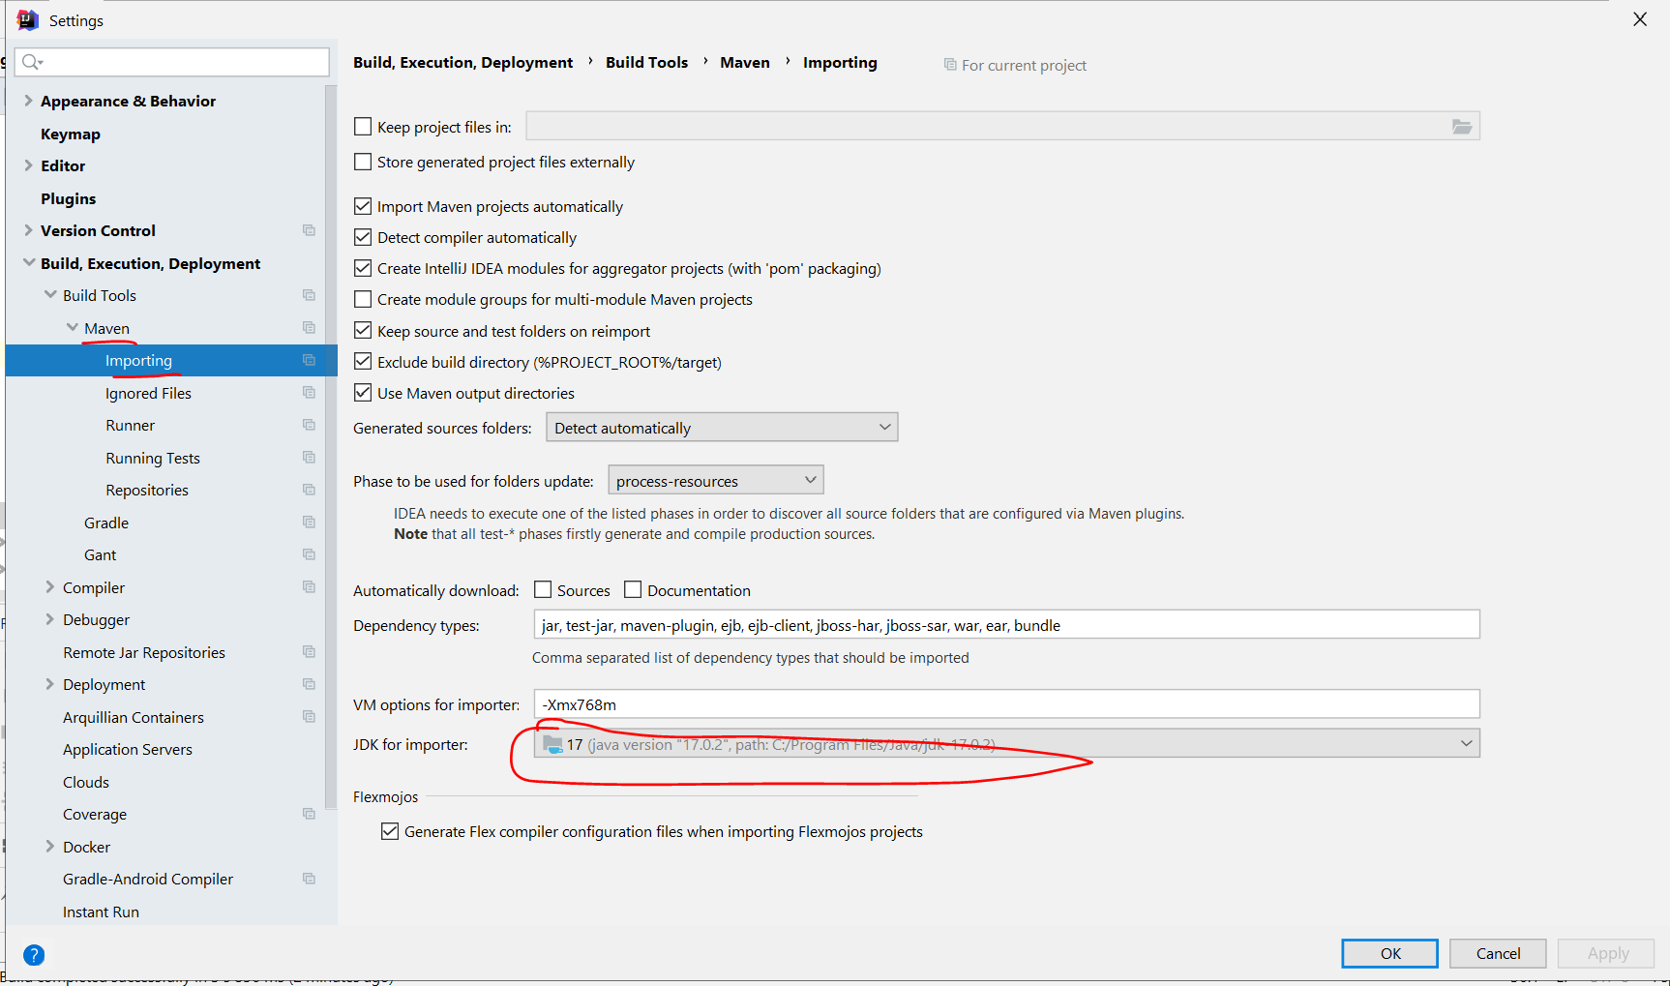

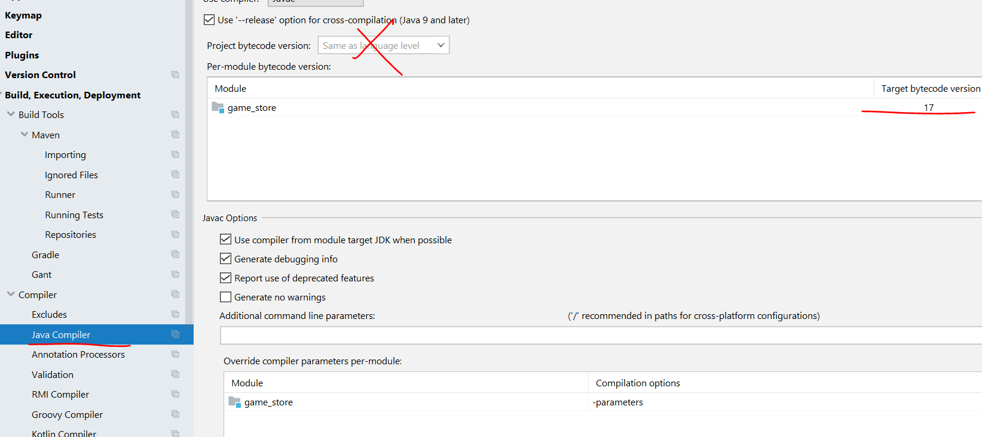

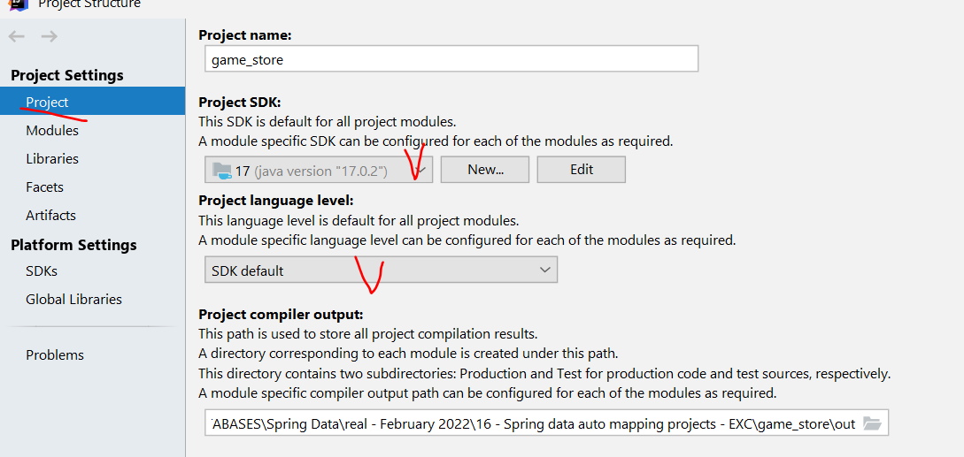

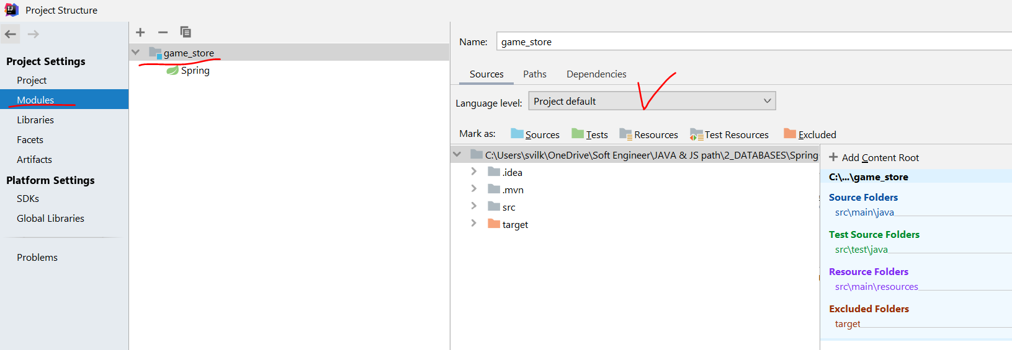

Pom.xml

<**parent**>  
 <**groupId**>org.springframework.boot</**groupId**>  
 <**artifactId**>spring-boot-starter-parent</**artifactId**>  
 <**version**>2.6.4</**version**>  
 <**relativePath**/> *<!-- lookup parent from repository -->* </**parent**>  
 <**groupId**>com.example</**groupId**>  
 <**artifactId**>demo</**artifactId**>  
 <**version**>0.0.1-SNAPSHOT</**version**>  
 <**name**>demo</**name**>  
 <**description**>Demo project for Spring Boot</**description**>

<**properties**>  
 <**java.version**>17</**java.version**>  
 </**properties**>

<**dependencies**>  
 <**dependency**>  
 <**groupId**>org.springframework.boot</**groupId**>  
 <**artifactId**>spring-boot-starter-data-jpa</**artifactId**>  
 </**dependency**>  
  
 <**dependency**>  
 <**groupId**>mysql</**groupId**>  
 <**artifactId**>mysql-connector-java</**artifactId**>  
 <**scope**>runtime</**scope**>  
 </**dependency**>  
  
 <**dependency**>  
 <**groupId**>org.springframework.boot</**groupId**>  
 <**artifactId**>spring-boot-starter-test</**artifactId**>  
 <**scope**>test</**scope**>  
 </**dependency**>  
  
 <**dependency**>  
 <**groupId**>org.modelmapper</**groupId**>  
 <**artifactId**>modelmapper</**artifactId**>  
 <**version**>3.0.0</**version**>  
 </**dependency**>  
  
 </**dependencies**>  
  
 <**build**>  
 <**plugins**>  
 <**plugin**>  
 <**groupId**>org.springframework.boot</**groupId**>  
 <**artifactId**>spring-boot-maven-plugin</**artifactId**>  
 </**plugin**>  
 </**plugins**>  
 </**build**>  
  
</**project**>

# Invalidate caches

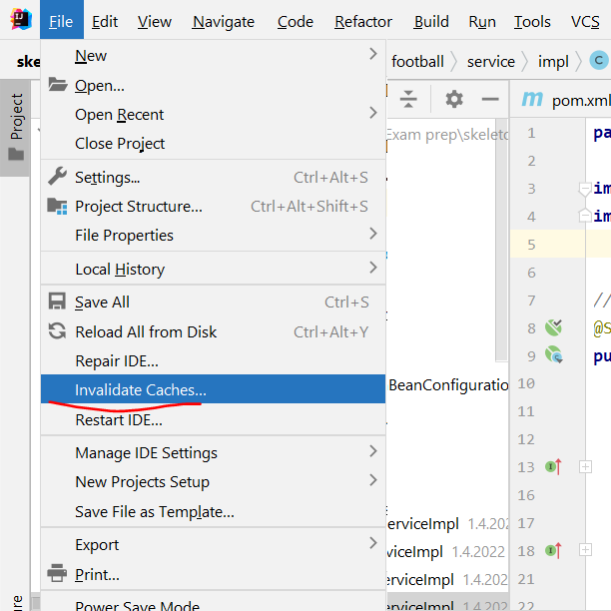

# LAZY и EAGER

.lazy = on demand – използва се когато имаме връзка 1 към 1 000 000 примерно. Когато detach-нем обект, тези 1 000 000 записа се губят като достъп.

.eager – когато detach-нем обекта, тези 1 000 000 записа са взети вече и стоят в хеша.

@OneToMany e default fetch type LAZY

@ManyToMany

@ManyToOne e default fetch type EAGER

**Избягвай EAGER loading-a**. Ако ти трябва в някой случай, в който извличаш ентитито, и негова колекция, по-добре напиши @Query в репозиторито, което прави JOIN FETCH. Например:

@Query("SELECT u FROM User u JOIN FETCH u.roles r WHERE u.username = :username");

User getByUsername(String username);

# UUID

**UUID** – A universally unique identifier (UUID) is a 128-bit label used for information in computer systems. The term globally unique identifier (GUID) is also used. When generated according to the standard methods, UUIDs are, for practical purposes, unique.



**Не е добра идея да слагаме UUID като primary key – прекалено бавно стават insert-е поради проблем с A-B дърво алгоритми.**

# Other

Zero-days vulnarabilities – не се знае от колко време е бил пробивът и колко хора са имали достъп/изтривали нещо/добавяли нещо

В Spring класове анотирани с @Configuration заместват .xml конфигурациите

csv – comma separated value file (при адресни книги го има)

Не трябва да се разминават схемите между Java И базата!!!

Интеграционни тестове – тестове за повече от един unit/метод

DTO vs DAO – нямат нищо общо

Data Transfer Object – обикновено свързано със заявка на потребител

Data Access Object (DAO) – сходно на Repository – отново отговарят да комуникират с базата

Embeddable JPA Javadoc – вместо вградени класове

javax.persistence

# Composite primary key in JPA

## Option 1 – with two @Id and implements Serializable

**public class** UserPK **implements** Serializable {

@GeneratedValue(strategy = GenerationType.***IDENTITY***)  
 **private long id**;

@Column(nullable = **false**, unique = **true**)  
 **private** String **username**;  
}

@Entity  
@Table(name = **"users"**)  
**@IdClass**(UserPK.**class**)  
**public class** User **implements** Serializable {  
 @Id //визуално да са тук   
 **private long id**;  
  
 @Id   
 **private** String **username**;

## Option 2 – using **@Embeddable**

**import** javax.persistence.Embeddable;  
**import** java.io.Serializable;  
  
**@Embeddable**  
**public class** UserPK **implements** Serializable {  
 **private long id**;  
 **private** String **username**;  
}

@Entity  
@Table(name = **"users"**)  
**public class** User **implements** Serializable {  
**@EmbeddedId**  
 **private** UserPK **primaryKey**;

**@AttributeOverride()**

**private** String **username**;

@Entity  
@Table(name = **"routes"**)  
**public class** Route {  
 @ManyToOne  
 **@MapsId**(**"id"**)  
 **private** User **author**;

WARN: Щом ще имаме композитен ключ в MySQL, то добре е да имплементираме в рамките на Java hasCode() и equals().

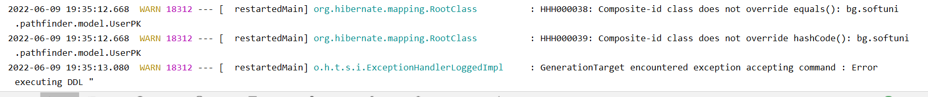

# Composite unique key, but not primary

**We may use this more often:**

@Entity  
@Table(name = **"users"**,

**uniqueConstraints** = **@UniqueConstraint**(**columnNames** = {**"username"**, **"email"**}))  
**public class** User **implements** Serializable {  
 @Id  
 @GeneratedValue(strategy = GenerationType.***IDENTITY***)  
 **private long id**;  
  
 @Column(nullable = **false**, unique = **true**)  
 **private** String **username**;  
  
 @Column(nullable = **false**)  
 **private** String **password**;  
  
 @Column(unique = **true**)  
 **private** String **email**;

# Schema DB in IntelliJ - JDBC connecting with our DB

Със синичко е unique

С долна точка е задължително not null

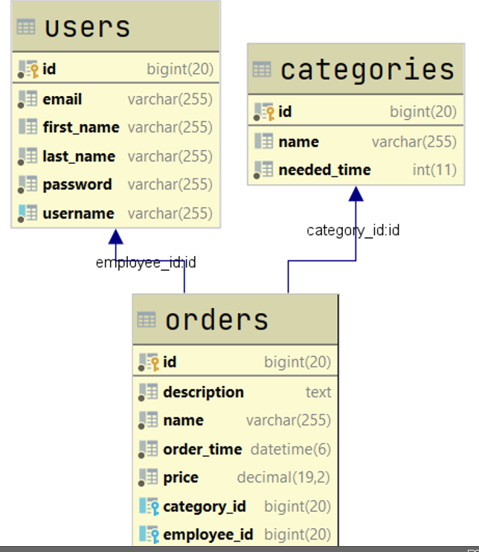

# ObjectMapper на Jackson на Spring

